Name…………………………………..…………… …………… Index No:………………………….

Candidate’s Signature ………………………..………. Date: …………………….……..……
232/2
PHYSICS
THEORY
PAPER 2

TIME: 2 HOURS

Kenya Certificate of Secondary Education (K.C.S.E.)

232/2
PHYSICS
PAPER 2
MARCH/APRIL 2015
TIME: 2 HOURS

INSTRUCTIONS TO THE CANDIDATES:

- Write your name and index number in the spaces provided above
- This paper consists of two sections A and B.
- Answer all the questions in section A and B in the spaces provided.
- All working must be clearly shown ; marks may be awarded for correct steps even if the answers are wrong
- Mathematical tables and silent electronic calculators may be used.
- Take gravitational acceleration =10m/s² and π=3.142
FOR EXAMINERS’ USE ONLY
SECTION | QUESTION | MAXIMUM SCORE | CANDIDATE’S SCORE
A | 1-12 | 25
B | 13 | 11
 | 14 | 12
 | 15 | 10
 | 16 | 13
 | 17 | 09
 | TOTAL | 80

This paper consists 8 of printed pages.
Candidates should check the question paper to ascertain all the pages are printed as indicated
And no questions are missing.
SECTION A – (25MARKS)
Answer all the questions in spaces provide.
- Distinguish between the angle of incidence and the angle of reflection as used in plane mirrors. (2mks)
………………………………………………………………………………………………………..
………………………………………………………………………………………………………..
- A positively charged rod is brought near the cap of a leaf electroscope. The cap is then earthed momentarily by touching with the finger. Finally the rod is withdrawn. The electroscope is found to be negatively charged. Explain how this charge is acquired. (2mks)
……………………………………………………………………………………….………………..
……………………………………………………………………………………………….………..
- Identify the two common defects in a simple cell and state how each can be minimized. (2mks)
………………………………………………………………………………………….……………..
……………………………………………………………………………………………….………..
- A transverse wave has a wavelength of 4 metres and a period of 2 seconds. Determine the velocity of the wave. (3mks)
………………………………………………………………………………………….……………..
………………………………………………………………………………………….……………..
……………………………………………………………………………………………….………..
- State two major similarities between a camera and the human eye. (2mks)
………………………………………………………………………………………….……………..
……………………………………………………………………………………………….………..
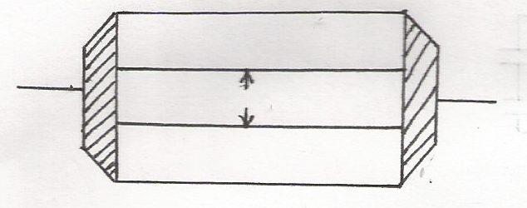
- Figure 1 shows how magnets are stored in pairs with keepers at the ends.
Keeper bar magnets
Fig 1
Keeper

Explain how this method of storing helps in retaining magnetism longer. (2mks)
………………………………………………………………………………………….……………..
……………………………………………………………………………………………….………..
- A light bulb is found to have a resistance of 800Ω when operating normally on 220V mains. find:
- The power rating of the bulb. (2mks)
………………………………………………………………………………………….……………..………………………………………………………………………………………………
- The value of the most suitable fuse for the bulb. (2mks)
………………………………………………………………………………………….…………
……………………………………………………………………………………………….……

- Mention any two ways of increasing the strength of an electromagnet. (2mks)
………………………………………………………………………………………….……………..
……………………………………………………………………………………………….………..
- What position should a small boy stand in front of a concave mirror to view his:
- Enlarged and upright image in a barber shop? (1mk)
………………………………………………………………………………………….………
……………………………………………………………………………………………….…
- Enlarged and inverted image in a fashion modeling room? (1mk)
………………………………………………………………………………………….………
………………………………………………………………………………………………….
- State Flemings right hand grip rule. (1mk)
………………………………………………………………………………………….……………..
……………………………………………………………………………………………….………..
- In the pipe below complete the diagram to show how air in the open pipe vibrate with a frequency of
first over tone. (1mk)
Open pipe

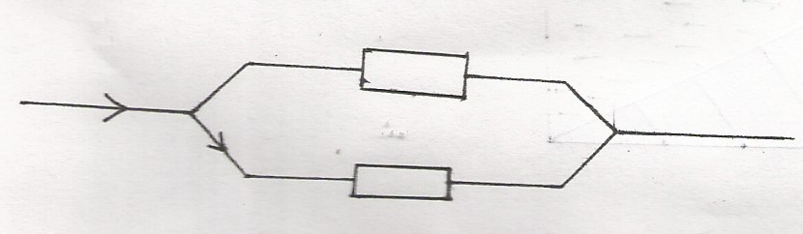
- In figure 2 below ,calculate the pd across resistor R. (2mks)
2A
3A
R
Fig 2
10Ω

SECTION B ( 55 MARKS)
Answer all the questions in this section.
- (a) Figure 3 shows a pear shaped conductor with positive charged on its surface.
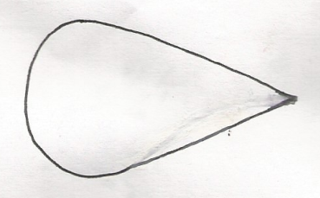
B
A

Fig. 3
A proof plane is used to touch side B of the conductor and then the cap of an uncharged
electroscope.
This is then repeated with side A.
- Give the observation made on the electroscope in each case. (2mks)
B…………………………………………………………………………….
A…………………………………………………………………………….
- What conclusion is drawn from the observation in (i) above. (1mk)
………………………………………………………………………………………….………
……………………………………………………………………………………………….…
- Draw on the diagram above the illustration of your conclusion in (ii) above (1mk)
- Name one application of such a conductor. (1mk)
………………………………………………………………………………………….………
……………………………………………………………………………………………….…
(b) Figure 4 shows an arrangement capautur connected to a 10V DC supply
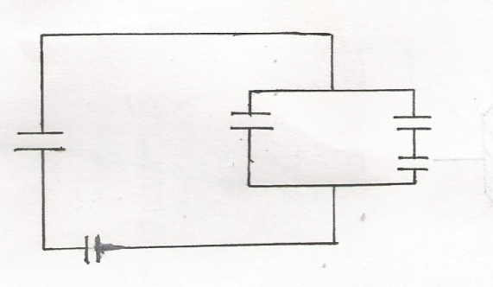
10 v
3μF
3μF
2μF

1μF
Determine
- The combine capacitance of the arrangement (3mks)

- The total energy stored. (3mks)

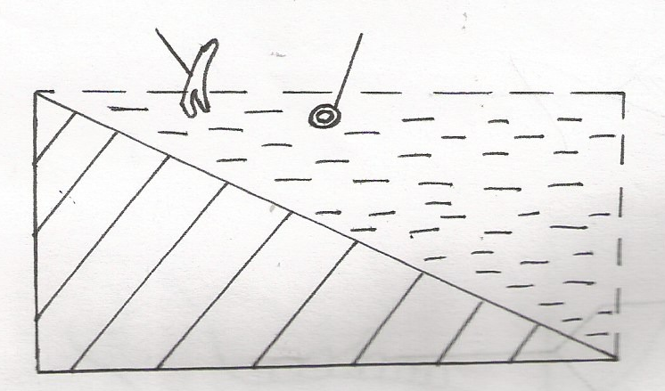
14 (a) Figure 5 shows the cross-section of a ripple tank full of water . A piece of cork floats on the surface of water and a straight edge vibrator placed at shallow end A to generate aves that travel to deep end B.
Vibrator
Cork
B
A

Fig. 5

- Name the type of waves generated on the water surface. (1mk)
………………………………………………………………………………………….………
……………………………………………………………………………………………….…

- The cork is observed to stay there despite passing water waves. Explain this observation.
(2mks)
………………………………………………………………………………………….………
……………………………………………………………………………………………….…
- It was estimated that successive waves pass the cork every 0.25 seconds. If the speed of wave is 0.28m/s, determine the frequency and wave length of the waves at that point. (4mks)
………………………………………………………………………………………….………
……………………………………………………………………………………………….…
………………………………………………………………………………………….………
……………………………………………………………………………………………….…
(b) (i) Describe the pulse-echo technique. (3mks)
………………………………………………………………………………………….………
……………………………………………………………………………………………….…
(ii) State two uses of the pulse-echo technique. (2mks)
………………………………………………………………………………………….………
……………………………………………………………………………………………….…
15 (a) Distinguish between real image and a virtual image. (2mks)
………………………………………………………………………………………….………
……………………………………………………………………………………………….…

(b) The distance between an upright image and the object produced by a curved mirror is 40cm. the
image is 3 times as tall as the object
(i) State the type of mirror used. (1mk)
………………………………………………………………………………………….………
………………………………………………………………………………………………….
(ii) determine the object distance (2mks)

iii) determine the radius of curvature of the mirror ( 4mks)
………………………………………………………………………………………….………
……………………………………………………………………………………………….…
………………………………………………………………………………………….………
……………………………………………………………………………………………….
(iv) State one application of the mirror as used in (b) above (1mk)
………………………………………………………………………………………….………
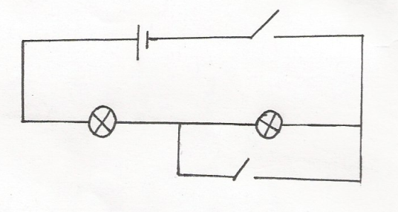
16. Study the circuit shown below.
S₂

Y
S₁
X

- State and explain what happens to the identical lamp x and y in the circuit shown when:
- Switch S₂ only is closed (2mks)
………………………………………………………………………………………….…
…………………………………………………………………………………………
- Switches S₁ and S₂ are closed. (2mks)
………………………………………………………………………………………….…
……………………………………………………………………………………………
- Graph A shown how potential difference a cross a battery varies with current supplied. Graph B shows how the current in a filament lamp varies with potential difference across it.
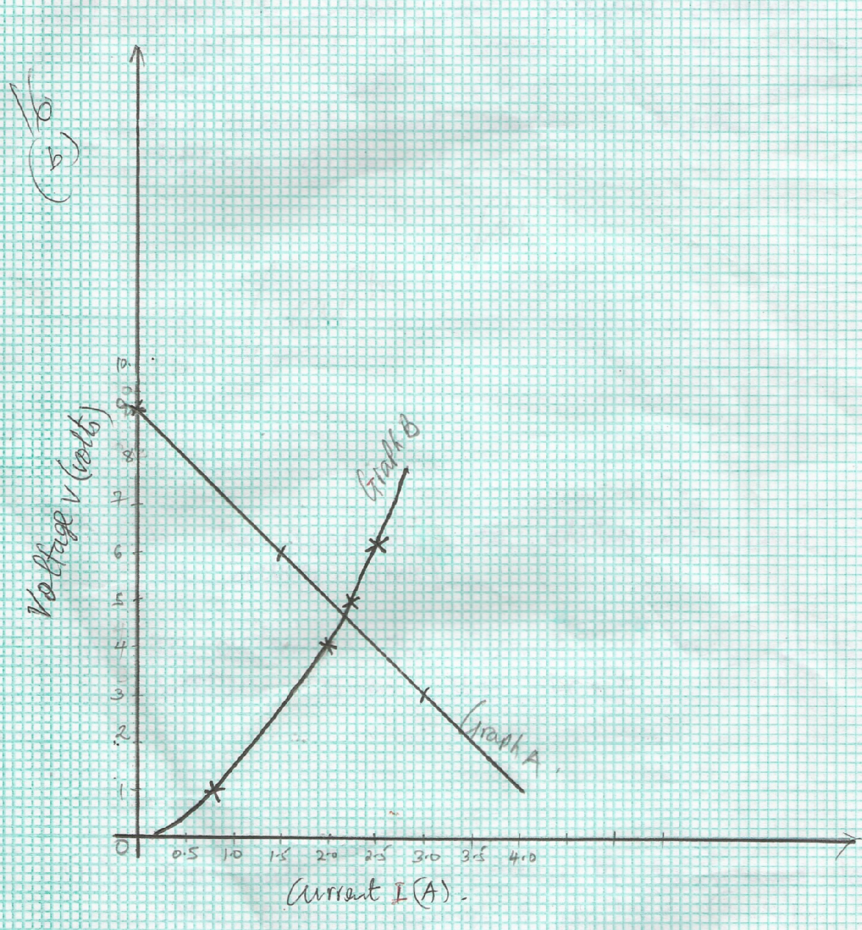

Voltage v (volts)

Current I (A)
- Use the graph A to determine e.m.f of the battery. (1mk)

- Determine the internal resistance of the battery given V = -Ir + E. (3mks)

- Calculate the resistance of the filament lamp when current through it is 1.5v. (3mks)

- Calculate the length of a nichrome resistance wire of cross – sectional area 7.00 x 10⁻⁸M² required to make a resistor of 10Ω
Take resistivity of nichrome = 1.10 x 10⁻⁶ΩM (2mks)

17. (a)(i) What causes long sightedness (1mk)
………………………………………………………………………………………….…
……………………………………………………………………………………………
(ii)Draw a diagram to show how long sightedness can be corrected. (2mks)

(b) Draw a ray diagram to show how a convex lens can be used as a magnifying glass (2mks)

(c) (i) State snell’s law (1mk)
………………………………………………………………………………………….…
……………………………………………………………………………………………
- the speed of light in a medium M, is 1.5x 10⁸m/s and in medium M2 is 2.0x 10⁸m/s. Calculate the
- refractive index of medium M1 with respect to medium M2. (3mks)

