# Empowering Students www.freekcsepastpapers.com

**NAME……………..………………………………………………ADMN NO………..**

**SCHOOL………………………………………………………….**

**DATE………..…………………………...**

**443/2**

**AGRICULTURE**

**PAPER 2**

**JULY/AUGUST**

**TIME: 2 HOURS**

**EXAMS**

**AGRICULTURE**

**PAPER 2**

**TIME: 2 HOURS**

**INSTRUCTIONS TO STUDENTS:**

* Write your name and admission number in the spaces provided above.
* Write the date of examination in the spaces provided above.
* This paper consists of **THREE** Sections **A**, **B** and **C**.
* Answer all questions in Section **A** and **B**.
* Answer **TWO QUESTIONS** in Section **C** in the spaces provided.

**FOR EXAMINERS USE ONLY**

|  |  |  |  |
| --- | --- | --- | --- |
| **SECTION** | **QUESTIONS** | **MAXIMUM SCORE** | **STUDENT SCORE** |
| **A** | **1-15** | **30** |  |
| **B** | **16-19** | **20** |  |
| **C** | **20-22** | **20** |  |
|  | **20** |  |
| **TOTAL** | | **90** |  |

**SECTION A (30 MARKS)**

*Answer* ***ALL*** *the questions in the spaces provided*

**1**. State **four** maintenance practices carried out on a sprinkler (2mks)

………………………………………………………………………………………………………………………………………………………………………………………………………………………………………………………………………………………………………………………………………………………………………………………………………………………………

**2.** State the functions of the following tools (2mks)

a) Secateurs

……………………………………………………………………………………………………..

b) Center punch

……………………………………………………………………………………………………

c) Wood rasp

………………………………………………………………………………………………………

d) Sickle

……………………………………………………………………………………………………

**3**. State **four** properties of concrete that make it more suitable in the construction of farm buildings (2mks)

………………………………………………………………………………………………………………………………………………………………………………………………………………………………………………………………………………………………………………………………………………………………………………………………………………………………

**4.** State **four** uses of greenhouses on a farm (2mks)

………………………………………………………………………………………………………………………………………………………………………………………………………………………………………………………………………………………………………………………………………………………………………………………………………………………………

**5.** Name **four** dual purpose breeds of cattle (2mks)

………………………………………………………………………………………………………………………………………………………………………………………………………………………………………………………………………………………………………………………………………………………………………………………………………………………………

**6.** State **four** characteristics of a broiler chicken (2mks)

………………………………………………………………………………………………………………………………………………………………………………………………………………………………………………………………………………………………………………………………………………………………………………………………………………………………

**7.** a) Name **two** causes of soft shelled eggs in chicken production (1mk)

………………………………………………………………………………………………………………………………………………………………………………………………………………

b) How can the above problem be solved? (1mk)

………………………………………………………………………………………………………………………………………………………………………………………………………………

**8. State four management practices to increase the output of fish production. (2mks)**

**…………………………………………………………………………………………………………………………………………………………………………………………………………………………………………………………………………………………………………………………………………………………………………………………………………………...................**

**9.** a) Give **two** systems of inbreeding that can be used to breed livestock (1mk)

………………………………………………………………………………………………………………………………………………………………………………………………………………

b) State **two** disadvantages on inbreeding in livestock production (1mk)

………………………………………………………………………………………………………………………………………………………………………………………………………………

**10.** a)What is the meaning of the term **‘selection’** as used in livestock production (1mk)

………………………………………………………………………………………………………………………………………………………………………………………………………………

b) Give any **two** methods used in the selection of livestock for breeding (1mk)

………………………………………………………………………………………………………………………………………………………………………………………………………………

**11.** Give **four** reasons why docking is done in sheep (2mks)

………………………………………………………………………………………………………………………………………………………………………………………………………………………………………………………………………………………………………………………………………………………………………………………………………………………………

**12.** State **four** reasons for steaming up in dairy cattle management (2mks)

………………………………………………………………………………………………………………………………………………………………………………………………………………………………………………………………………………………………………………………………………………………………………………………………………………………………

**13.** Give **four** symptoms that show that an animal has a respiratory disorder (2mks)

………………………………………………………………………………………………………………………………………………………………………………………………………………………………………………………………………………………………………………………………………………………………………………………………………………………………

**14.** Name **four** general effects of ectoparasites attack in livestock (2mks)

………………………………………………………………………………………………………………………………………………………………………………………………………………………………………………………………………………………………………………………………………………………………………………………………………………………………

15 Give four reasons why bees swarm. (2mks)

…………………………………………………………………………………………………………………………………………………………………………………………………………………………………………………………………………………………………………………………………………………………………………………………………………………………

**SECTION B (20MKS)**

*Answer* ***ALL*** *the questions in this section*

**16.** The diagrams below represent some poultry keeping structures.

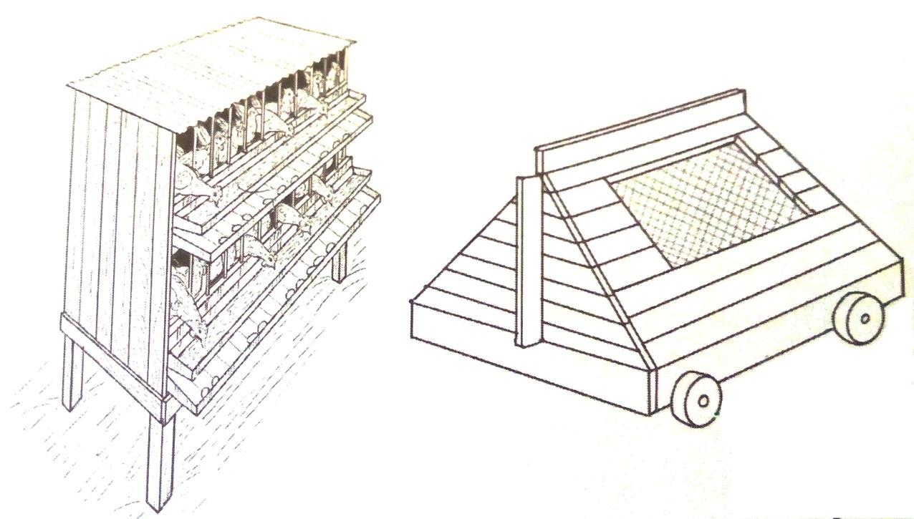

**U**

**D**

**C**

a) Identify the structure C . (1mk)

………………………………………………………………………………………………………

b) What is the function of the part labeled U in the structure labeled D? (1mk)

………………………………………………………………………………………………………

c) State **three** maintenance practices carried out on the structure D (3mks)

………………………………………………………………………………………………………………………………………………………………………………………………………………………………………………………………………………………………………………………………………………………………………………………………………………………………

**17.** A 100kg pig ration containing 18% crude protein was to be made from wheat bran (3% crude protein) and cotton seed cake (28% crude protein). Using the Pearson’s Square, calculate the amount of each feedstuff needed to prepare the ration. (3mks)

**18.** The diagram below shows the digestive system of a farm animal.

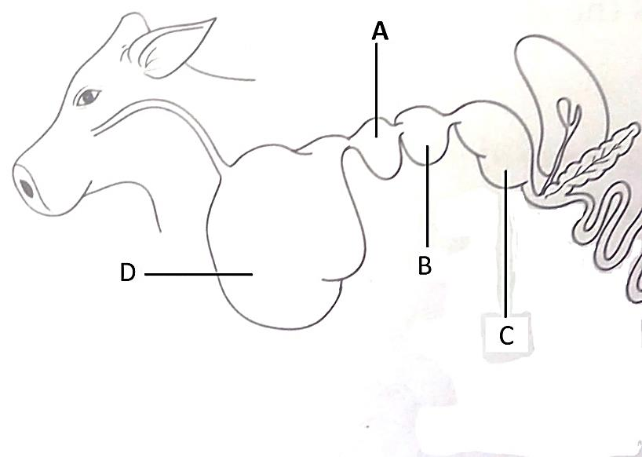

a) Identify the parts labeled A, B, C, & D (2mks)

………………………………………………………………………………………………………………………………………………………………………………………………………………………………………………………………………………………………………………………………………………………………………………………………………………………………

b) Name **three** farm animals that have the digestive system shown (3mks)

………………………………………………………………………………………………………………………………………………………………………………………………………………………………………………………………………………………………………………………

**19.** The diagram below illustrates a livestock parasite

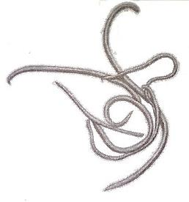

a) Identify the parasite (1mk)

………………………………………………………………………………………………………

b) Name four types of livestock attacked by the above parasite (4mks)

………………………………………………………………………………………………………………………………………………………………………………………………………………

……………………………………………………………………………………………………………………………………………………………………………………………………………..

**SECTION C (40MKS)**

**Attempt ONLY TWO questions from this section**

**20.** Describe the measures used to control livestock diseases (20mks)

**21.** Describe fish farming in a pond under the following subheadings

a) Site Selection (4mks)

b) Pond Construction (10mks)

c) Feeding (4mks)

d) Harvesting (2mks)

**22.** Discuss bee management under the following subheadings:

i. Location of the bee hive (10mks)

ii. Diseases of bees (4mks)

iii. Factors that determine the quality of honey (6mks)

…………………………………………………………………………………………………………………………………………………………………………………………………………………………………………………………………………………………………………………………………………………………………………………………………………………………………………………………………………………………………………………………………………………………………………………………………………………………………………………………………………………………………………………………………………………………………………………………………………………………………………………………………………………………………………………………………………………………………………………………………………………………………………………………………………………………………………………………………………………………………………………………………………………………………………………………………………………………………………………………………………………………………………………………………………………………………………………………………………………………………………………………………………………………………………………………………………………………………………………………………………………………………………………………………………………………………………………………………………………………………………………………………………………………………………………………………………………………………………………………………………………………………………………………………………………………………………………………………………………………………………………………………………………………………………………………………………………………………………………………………………………………………………………………………………………………………………………………………………………………………………………………………………………………………………………………………………………………………………………………………………………………………………………………………………………………………………………………………………………………………………………………………………………………………………………………………………………………………………………………………………………………………………………………………………………………………………………………………………………………………………………………………………………………………………………………………………………………………………………………………………………………………………………………………………………………………………………………………………………………………………………………………………………………………………………………………………………………………………………………………………………………………………………………………………………………………………………………………………………………………………………………………………………………………………………………………………………………………………………………………………………………………………………………………………………………………………………………………………………………………………………………………………………………………………………………………………………………………………………………………………………………………………………………………………………………………………………………………………………………………………………………………………………………………………………………………………………………………………………………………………………………………………………………………………………………………………………………………………………………………………………………………………………………………………………………………………………………………………………………………………………………………………………………………………………………………………………………………………………………………………………………………………………………………………………………………………………………………………………………………………………………………………………………………………………………………………………………………………………………………………………………………………………………………………………………………………………………………………………………………………………………………………………………………………………………………………………………………………………………………………………………………………………………………………………………………………………………………………………………………………………………………………………………………………………………………………………………………………………………………………………………………………………………………………………………………………………………………………………………………………………………………………………………………………………………………………………………………………………………………………………………………………………………………………………………………………………………………………………………………………………………………………………………………………………………………………………………………………………………………………………………………………………………………………………………………………………………………………………………………………………………………………………………………………………………………………………………………………………………………………………………………………………………………………………………………………………………………………………………………………………………………………………………………………………………………………………………………………………………………………………………………………………………………………………………………………………………………………………………………………………………………………………………………………………………………………………………........

………………………………………………………………………………………………………………………………………………………………………………………………………………………………………………………………………………………………………………………………………………………………………………………………………………………………………………………………………………………………………………………………………………………………………………………………………………………………………………………………………………………………………………………………………………………………………………………………………………………………………………………………………………………………………………………………………………………………………………………………………………………………………………………………………………………………………………………………………………………………………………………………………………………………………………………………………………………………………………………………………………………………………………………………………………………………………………………………………………………………………………………………………………………………………………………………………………………………………………………………………………………………………………………………………………………………………………………………………………………………………………………………………………………………………………………………………………………………………………………………………………………………………………………………………………………………………………………………………………………………………………………………………………………………………………………………………………………………………………………………………………………………………………………………………………………………………………………………………………………………………………………………………………………………………………………………………………………………………………………………………………………………………………………………………………………………………………………………………………………………………………………………………………………………………………………………………………………………………………………………………………………………………………………………………………………………………………………………………………………………………………………………………………………………………………………………………………………………………………………………………………………………………………………………………………………………………………………………………………………………………………………………………………………………………………………………………………………………………………………………………………………………………………………………………………………………………………………………………………………………………………………………………………………………………………………………………………………………………………………………………………………………………………………………………………………………………………………………………………………………………………………………………………………………………………………………………………………………………………………………………………………………………………………………………………………………………………………………………………………………………………………………………………………………………………………………………………………………………………………………………………………………………………………………………………………………………………………………………………………………………………………………………………………………………………………………………………………………………………………………………………………………………………………………………………………………………………………………………………………………………………………………………………………………………………………………………………………………………………………………………………………………………………………………………………………………………………………………………………………………………………………………………………………………………………………………………………………………………………………………………………………………………………………………………………………………………………………………………………………………………………………………………………………………………………………………………………………………………………………………………………………………………………………………………………………………………………………………………………………………………………………………………………………………………………………………………………………………………………………………………………………………………………………………………………………………………………………………………………………………………………………………………………………………………………………………………………………………………………………………………………………………………………………………………………………………………………………………………………………………………………………………………………………………………………………………………………………………………………………………………………………………………………………………………………………………………………………………………………………………………………………………………………………………………………………………………………………………………………………………………………………………………………………………………………………………………………………………………………………………………………………………………………………………………………………………………………………………………………………………………………………………………………………………………………………………………………………………………………………………………………………………………………………………………………………………………………………………………………………………………………………………………………………………………………………………………………………………………………………………………………………………………………………………………………………………………………………………………………………………………………………………………………………………………………………………………………………………………………………………………………………………………………………………………………………………………………………………………………………………………………………………………………………………………………………………………………………………………………………………………………………………………………………………………………………………………………………………………………………………………………………………………………………………………………………………………………………………………………………………………………………………………………………………………………………………………………………………………………………………………………………………………………………………………………………………………………………………………………………………………………………………………………………………………………………………………………………………………………………………………………………………………………………………………………………………………………………………………………………………………………………………………………………………………………………………………………………………………………………………………………………………………………………………………………………………………………………………………………………………………………………………………………………………………………………………………………………………………………………………………………………………………………………………………………………………………………………………………………………………………………………………………………………………………………………………………………………………………………………………………………………………………………………………………………………………………………………………………………………………………………………………………………………………………………………………………………………………………………………………………………………………………………………………………………………………………………………………………………………………………………………………………………………………………………………………………………………………………………………………………………………………………………………………………………………………………………………………………………………………………………………………………………………………………………………………………………………………………………………………………………………………………………………………………………………………………………………………………………………………………………………………………………………………………………………………………………………………………………………………………………………………………………………………………………………………………………………………………………………………………………………………………………………………………………………………………………………………………………………………………………………………………………………………………………………………………………………………………………………………………………………………………………………………………………………………………………………………………………………………………………………………………………………………………………………………………………………………………………………………………………………………………………………………………………………………………………………………………………………………………………………………………………………………………………………………………………………………………………………………………………………………………………………………………………………………………………………………………………………………………………………………………………………………………………………………………………………………………………………………………………………………………………………………………………………………………………………………………………………………………………………………………………………………………………………………………………………………………………………………………………………………………………………………………………………………………………………………………………………………………………………………………………………………………………………………………………………………………………………………………………………………………………………………………………………………………………………………………………………………………………………………………………………………………………………………………………………………………………………………………………………………………………………………………………………………………………………………………………………………………………………………………………………………

………………………………………………………………………………………………………………………………………………………………………………………………………………………………………………………………………………………………………………………………………………………………………………………………………………………………………………………………………………………………………………………………………………………………………………………………………………………………………………………………………………………………………………………………………………………………………………………………………………………………………………………………………………………………………………………………………………………………………………………………………………………………………………………………………………………………………………………………………………………………………………………………………………………………………………………………………………………………………………………………………………………………………………………………………………………………………………………………………………………………………………………………………………………………………………………………………………………………………………………………………………………………………………………………………………………………………………………………………………………………………………………………………………………………………………………………………………………………………………………………………………………………………………………………………………………………………………………………………………………………………………………………………………………………………………………………………………………………………………………………………………………………………………………………………………………………………………………………………………………………………………………………………………………………………………………………