Empowering Students www.freekcsepastpapers.com

Name:……………………………………………………... Adm no. ……………

School:……………………………………………………. Candidate’ Signature……………

Date: ……………………………………………………...

231/2
BIOLOGY
PAPER 2
(THEORY)
FORM 3
JULY
TIME: 2 HOURS

INSTRUCTIONS TO CANDIDATES:-
- Write your name and admission number in the spaces provided above.
- Sign and write the date of examination in the spaces provided above.
- This paper consists of two sections; A and B.
- Answer all the questions in Section A in the spaces provided.
- In section B, answer question 6(compulsory) and either question 7 or 8 in the spaces provided after question 8.

For Examiner’s Use Only:-

Section | Question | Maximum score | Candidates score
A | 1  2  3  4  5 | 8  8  8  8  8
B | 6  7 or  8 | 20  20  20
TOTAL SCORE |  | 80

This paper consists of 10 printed pages. Candidates should check to ascertain that all pages are printed as indicated and that no questions are missing. .

SECTION A: (40 MARKS)

Answer ALL the questions in this section in the spaces provided.

1. Examine the diagram below and use it to answer the questions that follow.
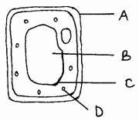

(a) Name the parts labeled. (3mks)

B …………………………………………………………………………………..

C ………………………………………………………………………………

D ……………………………………………………………………………..

(b) What substancemakes up part labeled A? (1mk)

…………………………………………………………………………………….

(c) Name the process by which mineral salts move into structure B. (1mk
………………………………………………………………………………………

(d) Explain what happens when a red blood cell is put in distilled water. (3mks
……………………………………………………………………………………………………………………………………………………………………………………………………………………………………………………………………………………………………………………………………………………………………………………………………………………………………………………………………………………………………………………………………….
2. In a Savanna grassland ecosystem, the following organisms were identified; grasses, squirrels, gazelles, lizards, insect larvae, wild dogs, snakes, hawks, vultures and lions, Energy flow in the ecosystem was also determined as follows.
HEAT LOSS TO THE
ENVIRONMENT
1500kJ
320kJ
Producers
Primary
Consumer
Secondary
Consumer
Tertiary
Consumers
A
500kJ
B
X
C
100kJ
1000kJ
1500kJ
2000kJ

a) Define the term ecosystem (1mrk)
………………………………………………………………………………………………
b) Name the process through which:
i) Producers convert sun’s energy into chemical energy (1mrk)
………………………………………..………………………….…………………………
ii) Living organisms convert chemical energy into heat energy lost to the environment (1mk)

……………………………………………………………………………………
c) Identify organism X(1mrk)
…………………………………………………………………………………………
d) Determine the amount of energy represented by A and B (2mrks) A…………………………………………………………………………………… B…………………………………………………………………………………….
e) If 75% of the energy in the tertiary consumers is lost as heat. Calculate the amount of energyrepresented by C(2mrks)
……………………………………………………………………………………………………………………………………………………………………………………………………………………………………………………………………………………………………………
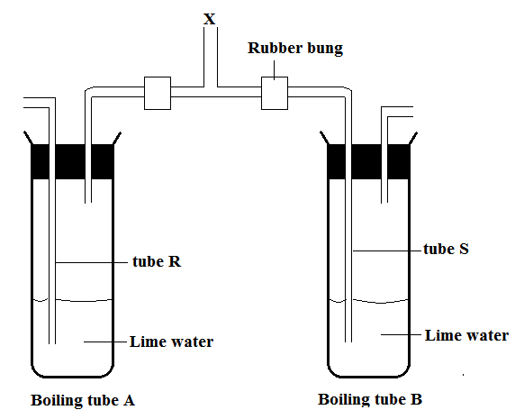
3. The apparatus whose diagram is given below can be used to demonstrateresults of a physiological process that occurs in a mammal. To use theapparatus, the experimenter places his mouthat the point marked X and then breathes in and out gently

a) State the observations made in the boiling tube when the experimenter
Breathes in
Boiling tube A (2mks)
……………………………………………………………………………………………………………………………………………………………………………………
Boiling tube B (1mark)
……………………………………………………………………………………………….………………………………………………………………..……………
Breathes out?
Boiling tube A (1mark)
………………………………………………………………………………………………………………………………………………..……………………..……………
Boiling tube B (1 mark)
…………………………………………………………………………………………………………………………………………..…………………………..……………
b) What conclusion can you draw from the results of this experiment( 2mks)
………………………………………………………………………………………………………………………………………………………………..…………………………….

c) What is the purpose of the boiling tube A? (1mark)
…………………………………………………………………………………………
4. Study the diagram below and answer the questions that follow.
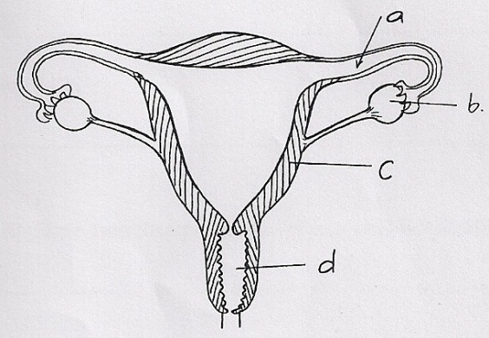
(i) Which part marked a, b, c and d, when defective after implantation may lead to miscarriage? (1mk)
……………………………………………………………………………………
(ii) Give a reason for your answer. (1mk)
…………………………………………………………………………………………………………………………………………………………………………………………
(iii) The part labeled b can be removed after 4 months of pregnancy without interfering with the pregnancy. Explain. (2mks)
……………………………………………………………………………………………………………………………………………………………………………………………………………………………….
(b) Under each of the following, state the name of the causative agent.
Syphilis (1mk)
………………………………………………………………………………
Gonorrhea (1mk)
……………………………………………………………………………
AIDS (1mk)
…………………………………………………………………………….
(c) State one disadvantage of external fertilization.(1mk)
……………………………………………………………………………………………………………………………………………………………………………………………
5. The diagram below represents the nitrogen cycle
Nitrogen in the air
Lightning
C
A
Feeding
D
Nitrates
Nitrogen in plants
Animals

Death and decay
Death and decay
B

Nitrifying bacteria
Ammonia

(a) State the process labeled
A ……………………………………………..(1mk)
D…………………………………………….. (1mk)
(b) Name the compound represented by B(1mk)
………………………………………………………………………………………
(c) Name the group of organisms labelled C (1mk)
………………………………………………………………………………………
(d) (i)Name the group of plants which promote process A(1mk)
……………………………………………………………………………………………………………………………………………………………………………………………..
(ii) State the part of the plant where process A takes place. (1mk)
……………………………………………………………………………
(e)How would excess pesticides in the soil interfere with process A (2mks)
…………………………………………………………………………………………………………………………………………………………………………………………………………………………………………………….......................................................
SECTION B: (40 MARKS)
Answer question 6 (compulsory) and EITHER question 7 or 8 in the spaces provided after question 8.

6. The table below shows how the quantities of sweat and urine vary with external temperature.

External temperature °C | Urine cm³/hr | Sweat cm³/hr
0 | 100 | 5
5 | 90 | 6
10 | 80 | 10
15 | 70 | 20
20 | 60 | 30
25 | 50 | 60
30 | 40 | 120
35 | 30 | 200

(a) On the same graph, plot the quantities of urine and sweat produced against the external temperature. (7mks)

(b) From your graph ,determine the temperature at which the amounts of sweat and urine produced are equal? (1mk)

………………………………………………………………………………………….

(c)What happens to the amount of sweat produced as the temperature rises? Explain theobservation (3mks)
…………………………………………………………………………………………………………………………………………………………………………………………………………………………………………………………………………………………………………………………………………………………………………………………………………………..
(d) Explain the observation made on the amount of urine produced as the temperature
increases.(3mks)
………………………………………………………………………………………………………………………………………………………………………………………………………………………………………………………………………………………………………………………………………………………………………………………………………………………………

(e) How is the skin adapted for temperature regulation? (6mks)
………………………………………………………………………………………………………………………………………………………………………………………………………………………………………………………………………………………………………………………………………………………………………………………………………………………………………………………………………………………………………………………………………………………………………………………………………………………………………………………………………………………………………………………………………………………………………………………………………………………………………………………………………………………………………………………………………………………………………………………………………………………………………………………………………………………………………………………………………………………………………………………

7. Explain various ways in which fruits and seeds are adapted to dispersal. (20mks)
8. (a)Describe the mechanism of inhalation in man. (10mks)
(b)Using photosynthetic theory explain the mechanics of opening of stomata. (10mks
………………………………………………………………………………………………………………………………………………………………………………………………………………………………………………………………………………………………………………………………………………………………………………………………………………………………………………………………………………………………………………………………………………………………………………………………………………………………………………………………………………………………………………………………………………………………………………………………………………………………………………………………………………………………………………………………………………………………………………………………………………………………………………………………………………………………………………………………………………………………………………………………………………………………………………………………………………………………………………………………………………………………………………………………………………………………………………………………………………………………………………………………………………………………………………………………………………………………………………………………………………………………………………………………………………………………………………………………………………………………………………………………………………………………………………………………………………………………………………………………………………………………………………………………………………………………………………………………………………………………………………………………………………………………………………………………………………………………………………………………………………………………………………………………………………………………………………………………………………………………………………………………………………………………………………………………………………………………………………………………………………………………………………………………………………………………………………………………………………………………………………………………………………………………………………………………………………………………………………………………………………………………………………………………………………………………………………………………………………………………………………………………………………………………………………………………………………………………………………………………………………………………………………………………………………………………………………………………………………………………………………………………………………………………………………………………………………………………………………………………………………………………………………………………………………………………………………………………………………………………………………………………………………………………………………………………………………………………………………………………………………………………………………………………………………………………………………………………………………………………………………........................................................................................................................................................................................................................................................................................................................................................................................................................................................................................................................................................................................................................................................................................................................................................................................................................................................................

