# Empowering Students www.freekcsepastpapers.com

**BIOLOGY PP1 EXAM**

**TERM THREE**

**231/1**

**BIOLOGY**

**PAPER 1**

**JULY/AUGUST**

**TIME: 2 HOURS**

**THEORY PAPER.**

**Name: ………………………………………………Admission no ……..….............................**

**School: ……………………………………………… Candidate’s sign …………………**

**Date: …………………………….**

**INSTRUCTIONS TO CANDIDATES:**

* *Write your* ***name*** *and****Admission number*** *in the spaces provided.*
* *Sign and write* ***date*** *of examination in the spaces provided above*
* *Answer* ***all*** *the questions in the spaces provided*
* *Use* ***English*** *only.*

***For Examiner’s Use Only:***

|  |  |  |
| --- | --- | --- |
| **QUESTIONS** | **MAXIMUM SCORE** | **CANDIDATE’S SCORE** |
| **1- 30** | **80** |  |

***This paper consists of printed pages. Candidates should check to ascertain that all papers are printed as indicated and that no questions are missing.***

1. State two reasons for classification. (2mks)

……………………………………………………………………………………………………………………………………….

………………………………………………………………………………………………………………………………………

………………………………………………………………………………………………………………………………………

2. Name the role of each of the following structures found in a mammalian heart. (a) coronary vessels. (1mrk

…………………………………………………………………………………………………………………………………………………………………………………………………………………………………………………………………………………

(b) Tendon (1mrk)

………………………………………………………………………………………………………………………………………………………………………………………………………………………………………………………………………………..

3. Give a reason why each of the following steps are followed when preparing a cross section of a leaf for examination under the light microscope.

a) Cutting very thin sections. (1mrk) ...........................................................................................................................................................................................................................................................................................

b) Using a sharp razor blade during cutting. (1mrk) ........................................................................................................................................................................................................................................................................................................................................................................................................................................

(c) Staining the sections with iodine before observing under the microscope. (1mrk) ............................................................................................................................................................................................................................................................................................

4. State the functions of the following cell organelles.

a) ribosomes (1mrk) ..........................................................................................................................................................................................................................................................................................

b) cell wall(1mark)

..........................................................................................................................................................................................................................................................................................

5. (a) State the site for photolysis in a plant cell. (1mk)

………………………………………………………………………………………………  
(b) State the role of light energy during photolysis. (1mk)  
………………………………………………………………………………………………………………………………..

6.Explain why carbon(II) oxide is a respiratory poison. (3mks)

...............................................................................................................................................................................................................................................................................................................................................................................................................................................

7.Explain why individuals with smaller body sizes requires more energy per kg of body weight than those with large body sizes. (3mrks) ……………………………………………………………………………………………….……………………………………………………………………………………………………………………………………………………………………………………………

…………………………………………………………………………………………………………………………………………………………………………………………………………………………………………………………………………………

8. State the functions of the following structures in a mammalian tooth.

1. pulp cavity. (1mrk)

..........................................................................................................................................................................................................................................................................................

b) enamel. (1mrk)

............................................................................................................................................................................................................................................................................................

9. Explain why enzymes trypsin and pepsin are produced by glands along the alimentary canal as **trypsinogen** and **pepsinogen** (2mks)

..............................................................................................................................................

................................................................................................................. …………………………

……………………………………………………………………………………………………………………………………

10. State **three** functions of mammalian blood other than transport of substances. (3mrks) ……………………………………………………………………………………………………………………………………………………………………………………………………………………………………………………………………………………………………………………………………………………………………………………………………………………………………………………………................................................................................................................

11.Give the function of the following parts of the microscope.

I. Diaphragm. (1mrk) …………………………………………………………………………………………………………………………………………………………………………………………………………………………………………………………………………………

(ii) Condenser. (1mrk)

………………………………………………………………………………………………….. …………………… ……….. 12. What is meant by the following terms below?

(a) Habitat (1mrk)

………………………………………………………………………………………………………………………………………………………………………………………………………………………………………………………………………………….

(b) Ecological niche (1mrk)

………………………………………………………………………………………………………………………………………..

(c) carrying capacity. (1mrk)

…………………………………………………………………………………………………………………………………………………………………………………………………………………………………………………………………………………

13.The diagram below represents the structure of a nephron. Study it and answer the questions that follow.

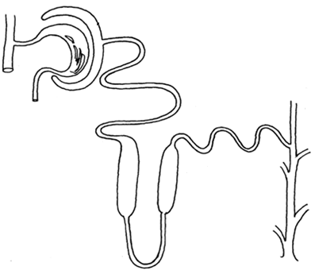

D

**C**

**C**

**B**

**X**

1. State the roles of the part labeled **B** and **C**. (2mks) ……………………………………………………………………………:…………………………………………………................................................................................ ………………………………………………………………………………………
2. Which hormone is involved in the function of the part labeled **c.** (1 mark)

……………………………………………………………………………………

1. Name the part labeled X. 1mrk)

………………………………………………………………………………………………………………………………..

14. (a) what is homeostasis?(1mrk)

……………………………………………………………………………………………………………………………………………………………………………………………………………………………………………………………………………………

(b) What is the role of sweat on human skin? (2mks)

………………………………………………………………………………………………………………………………………………………………………………………………………………………………………………………………………………..

15. Explain the importance of the following structures in the mammalian digestive system.

a) Rich network of blood capillaries. (1mrk)

………………………………………………………………………………………………………………………………………………………………………………………………………………………………………………………………………………..

(b) Thin epithelium (1mrk)

……………………………………………………………………………………………………………………………………………………………………………………………………………………………………………………………………………………

16. State the role of the following in human diet.

(ii) Iron (1mrk)

……………………………………………………………………………………………………………………………………………………………………………………………………………………………………………………………………………….

(ii) Iodine (1mrk)

……………………………………………………………………………………………………………………………………..

17. A process that occurs in plants is represented in the equation below.

**C6 H12 O62C 2H 5OH + C02+ Energy**

**(**Glucose)  (Ethanol) (Carbon (IV) oxide**)**

1. Name the process. (1mrk)

………………………………………………………………………………………………………………………………….

(b) State the economic importance of the named process in (a) above. (1mrk)

……………………………………………………………………………………………………………………………………….............................................................................................................................................................................................................................................................................................

18. How is the mammalian skin adapted to its protective functions? (4mrks)

………………………………………………………………………………………………………………………………………. …………………………………………………………………………………………………………………………………………………………………………………………………………………………………………………………………………………………………………………………………………………………………………………………………………………………………………………………………………………………………………………………………………………………………………19.. A student caught an organism and observed that it had the following characteristic features:

Body divided into two body parts; eight legs;

1. To which class does the organism belong? (1mrk) ………………………………………………………………………………………

(i)State another characteristic feature the members belonging to this class are likely to have. (1mark)

***…………………………………………………………………………………………………………………………………………………………………………………………..*** (i) Name the phylum whose members possess a notochord.(1mrk) …………………………………………………………………… 20. Explain how the lenticels are adapted to their function.(2mrks)

………………………………………………………………………………………………………………………………………………………………………………………………………………………………………………………………................................................

21. Form One student set up an experiment shown below to investigate a certain physiological process. The set up was left for 30 minutes.

Glass rod

Thread

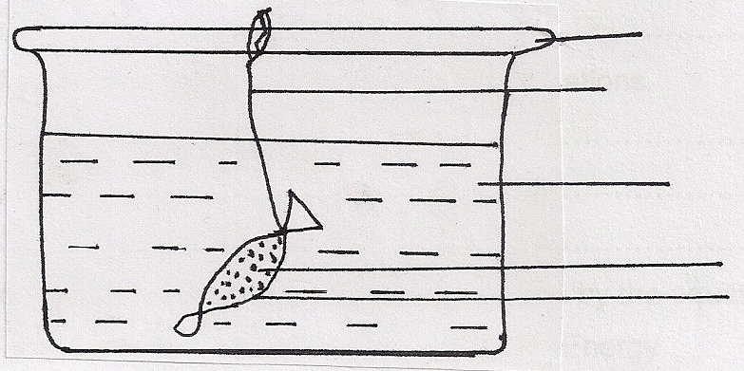 Distilled water

Sucrose solution

Visking Tubing

1. Name the process under study. (1mrk) ……………………………………………………………………………………………………………………………………………………………………………………
2. State and explain the expected results after 30 minutesin the above experiment(3marks)

………………………………………………………………………………………………………………………………………………………………………………………………………………………………………………………………………………………………………………………………………………………………………………………………………………………………………………………………………………………………

22. Below is an example of a food chain.

Nappier grass Mouse Snake Hawk

Identify the trophic level occupied by:

* + 1. (i) Nappier grass (1mrk) ……………………………………………………………………………………

(ii) Hawk (1mark)

………………………………………………………………………………………

* + 1. What would happen if snakes are removed from the food chain? (2 marks)

……………………………………………………………………………………………………………………………………………………………………………………………………………………………………………………………………….

23.The diagram below represents part of the human digestive system.

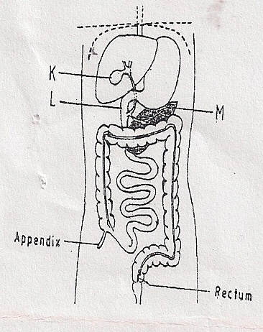

(a)Name the organs labeled L and M. (2marks)

L:……………………………………………………………………………………………

M:…………………………………………………………………………………………

(b) state the role of the part labeled K on the diagram above. (1mrk)

……………………………………………………………………………………………………………………………………………………………………………………………..

24.Differentiate between crossing over and synapsis as used in cell division. (2mrks)

……………………………………………………………………………............................................................................................................................................................................................................................................................................................................................

………………………………………………………………………………………………

25.Explain why plants do not require an elaborate excretory system. (2mrks)

……………………………………………………………………………………………………………………………………………………………………………………………………………………………………… ……………………………………………………

26. The diagram below shows the cross section of the root of plant as seen under a light microscope. Study it and answer the questions that follow.



(a) On the diagram,

(i) use a guideline and the letter **E** to label the epidermis. (1mrk)

(ii) use a guideline and the letter **P**to label the phloem. (1mrk)

(b) (i). State the class to which the plant from where this section was obtained belongs. (1mark)

……………………………………………………………………………………………

………………………………………………………………………………………………

(ii). Give a reason for your answer. (1mrk)

………………………………………………………………………………………

……………………………………………………………………………………….

…………………………………………………………………………………

27.Describe the characteristics of a population. (3mrks)

………………………………………………………………………………………………………………………………………………………………………………………………………………………………………………………………………………………………………………………………………………………………………………………………………………………………………………………………………………………………………………………………………………………………………………………………………………………………………………………………………………………………

28.. Classify the following into taxa shown below. (2 marks)

Maize Division……………………………………………………………………………………………………………….

Class……………………………………………………………………………………………………………………………

29.State three ways that can be used to control the spread of HIV and AIDS in Kenya. (3mrks).

…………………………………………………………………………………………………………………………………………………………………………………………………………………………………………………………………………………………………………………………………………………………………………………………………………………………………………………………………………………………………………………………………………………………………………

..............................................................................................................................................

30. The table below shows the concentration of sodium and iodine in sea water and cell sap of a plant.

|  |  |  |
| --- | --- | --- |
| Sodium ion  concentration | Iodide ion  Concentration. | |
| Sea water | 350 | 45 |
| Cell sap | 120 | 600 |

(i) Name the process through which the plant cells take up sodium ions. (1mrk)

…………………………………………………………………………………………………………..

(ii) Give a reason your answer in (a)(i) above. (1mrk)

……………………………………………………………………………………………………………………………………………………………………………………………………………………………………………..