Empowering Students www.freekcsepastpapers.com

Name ………………………………………Adm. No………….Class…………………

School …………………………………. Date………………Signature………………..

121/2
MATHEMATICS
Paper 2
July
TIME: 2¹/₂ Hours

NSTRUCTIONS TO CANDIDATES
- Write your name,admission number and class in the spaces provided above.
b) Sign and write the date of examination in the spaces provided above.
c) The paper contains TWO sections: Section I and Section II.
d) Answer ALL the questions in Section I and any five questions from Section II
e) All answers and working must be written on the question paper in the spaces providedbelow each question.
f)Show all the steps in your calculations, giving your answers at each stage in the
spaces below each question.
g)Non – programmable silent electronic calculators and KNEC Mathematical tables may be used, except where stated otherwise.

For Examiner’s use only

Section I
1 | 2 | 3 | 4 | 5 | 6 | 7 | 8 | 9 | 10 | 11 | 12 | 13 | 14 | 15 | 16 | Total

Section II
17 | 18 | 19 | 20 | 21 | 22 | 23 | 24 | Total

Grand Total

This paper consists of 14 printed pages
Candidates should check the question paper to ascertain
that all the pages are printed as indicated and no questions are missing.

SECTION 1(50 marks)

Answer all the questions in this section

- Use logarithms correct to 4 decimal places to evaluate
$$0.0034$$
0.0245Sin54.31
(3 marks)

- Evaluate:without using a calculator.(3marks)

- The height of cylindrical solid is three times the radius of the circular end. If the total surface area of the solid is 616 cm², find its radius. (3marks)

- PQRS is a trapezium in which PQ is parallel to SR, PQ = 6cm, SR = 12cm, ∠PSR = 40º and PS = 10cm.

S
P
R
Q
40°

Calculate the area of the trapezium.(3marks)

- Simplify
9t² – 25a²
6t² + 19at + 15a² (3 marks)

- The marked price of a pair of shoes is Sh. 2400. A customer buys the shoes and is offered a 10% discount and the seller still makes a profit of 20% on the cost of the shoes. Determine the cost price. (3 marks)

- The image of point A(1, 2) after a translation is A^{I} (-1, 2), what are the coordinates of a point P whose image P^{I} is (-3, -3)after this translation. (3 marks)

- Using a pair of compasses only construct angle PAB = 30⁰. By construction locate a point Q on AB such that AQ = $\frac{4}{9}$ AB.(4 marks)

A B

- Given that tan x = 2.4, evaluate without use of tables and calculator, sin x – cos x in the form $\frac{a}{b}$ where a and b are integers. (4 marks)

- $\frac{x}{x+2y } = \frac{3}{8}$ find the ratio x : y ( 2 marks)

- If$\frac{\sqrt{2}- \sqrt{3}}{\sqrt{2} + √3}$ = a +b$\sqrt{c}$where a, b and c are rational numbers find the value of b.
(3 marks)

- In the figure below, line AB = 4cm, BE = 8cm and DE = 4cm. Find the value of y. (3marks)
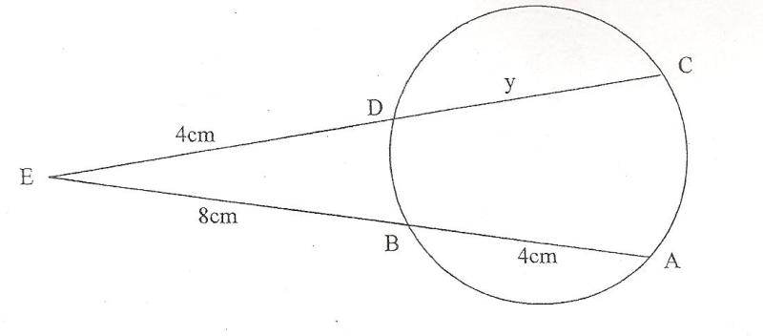

- In an election for a school captain, a number of students voted for Mandzu, Jamal and Biasha. In a pie chart, the total number of votes for Mandzu and Jamal were 81⁰ and 216⁰ respectively. If Biasha got 84 votes, how many votes did Jamal get?
(3 marks)

- Given that $\left(\begin{matrix}x-1 & x+1 \\ 3x & x\end{matrix}\right)$ is a singular matrix, find the possible values of x.
(3 marks)

- A rectangular tank of base 2.4m by 3.0m and a height of 3m initially contained 3600 litres of water. Water flows in the tank at the rate of 0.5 litres/second. Calculate the time in hours required to fill the tank.(4 marks)

.

- Factorise a² – b². Hence find the exact value of 2557² -2547²(3 marks )

SECTION II ( 50marks)
Answer any five questions in this section
- The minor arc PQ of a circle radius 21cm subtends an angle of 120⁰ at the centre of the circle as shown below

P

O 120⁰
Q

(a) Find the area of the minor sector POQ. (2 marks)

(b) Find the perimeter of the minor sector POQ. (3 marks)

(c) The minor sector POQ is folded to form a right circular cone. Calculate;
(i) The radius of the cone. (3 marks)

(ii) The height of the cone. (2 marks)

- Using a pair of compasses and a ruler only ;
- Construct triangle ABC such that AB = 8 cm, BC = 6cm and angle ABC = 30⁰
(3 marks)

- Measure the length AC. (1 mark)

- Draw a circle that touches the vertices A, B and C. (2 marks)
- Measure the radius of the circle. (1 mark)

- Hence calculate the area of the circle outside the triangle (3 marks)

- The figure below shows a circle centre O in which QOT is the diameter Angle, angleand angle, PTU and RSU are straight lines.
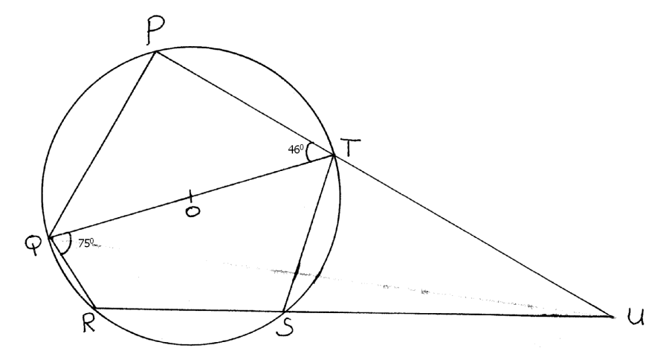
Determine the following, giving reasons in each case:
(a) Angle RST (2marks)

(b) Angle SUT (2marks)

(c) Angle PST (2marks)

(d) Obtuse angle ROT (2marks)

(e) Angle SQT (2marks)

- Abdullah bought some oranges worth Kshs 45 while Vivian spent the same amount of money but bought the oranges at a discount 0f 75 cents per orange.
- If Abdullah bought an orange at Kshs x, write down a simplified expression for the total number of oranges bought by Abdullah and Vivian. (3 marks)

- If Vivian bought 2 more oranges than Abdullah. Find how much each spent on an orange. (5 marks)

- Find the total number of oranges bought by Abdullah and Vivian.(2 marks)

- The figure below (not drawn to scale) shows a quadrilateral ABCD inscribed in a circle.AB = 5cm, BC = 8cm, CD = 7cm and AD = 8cm. AC is one of the diagonals of length 10cm.
B

A

C

D
- Find the size of angle ABC (3 marks)

- Find the radius of the circle. (2 marks)

- Hence calculate the area of the shaded region.(5 marks)

- A saleswoman is paid a commission of 2% on goods sold worth aboveKshs. 100, 000. She is also paid a monthly salary of Kshs 12, 000. In a certain month she sold 360 handbags at Ksh 500 each.
- Calculate the saleswoman’s earnings that month. (3 marks)

- The following month the sales woman’s monthly salary was increased by 10%. Her total earnings that month were Ksh. 17, 600.
Calculate:
- the total amount of money got from the sales of hand bags that month.
(5 marks)

- the number of hand bags sold that month. (2 marks)

- a) Find the equation of a straight line passing through the points (3, 2) and (-3, 6) giving your answer in the form $\frac{x}{a}$ + $\frac{y}{b}$ = 1 where a and b are constants. (4 marks)

- State the coordinates of points A and B at which the line in (a) above crosses the x-axis and y-axis respectively.(2 marks)

- Using the information in (a) and (b) above, find the area of triangle AOB where O is the origin (2 marks)

- Find the acute angle the line in (a) above makes with the x-axis.(2 marks)

- a) Complete the table below giving the answers correct to 2 decimal places(2 marks)

X⁰ | 0 | 30 | 60 | 90 | 120 | 150 | 180 | 210 | 240 | 270 | 300 | 330 | 360
Sin2x | 0 |  | 0.87 |  | -0,87 |  | 0 | 0.87 | 0.87 |  |  |  | 0
3cosx -2 | 1 | 0.60 |  | -2 | -3.5 |  |  | -4.60 |  |  | -0.5 |  | 1

- On the grid provided, draw the graphs of y = Sin2x and y = 3cosx -2for 0⁰≤ x ≤ 360⁰ on the same axes. Use the scale of 1 cm to represent 30⁰on the x-axis and 2 cm to represent 1 unit on y-axis.(5 marks)

- Use the graph in (b) above to solve the equations

- 3cosx –sin2x = 2 (1 marks)

- 3Cosx – 4 = 0(2 marks)

THIS IS THE LAST PRINTED PAGE

