CENTRAL KENYA NATIONAL SCHOOLS JOINT MOCK - 2016
Kenya Certificate of Secondary Education
232/1
PHYSICS
PAPER 1
(THEORY)
TIME: 2 HOURS
SECTION A: (25 MARKS)

1. Figure 1 below shows a burette that was initially filled to 12ml with a liquid of density 0.8g/cm³.
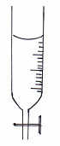

Figure 1

The liquid is allowed to run out for some time. If the volume of liquid removed from the burette has a mass of 14g, determine the final reading on the burette. (3mks)
2. If an umbrella is touched with a finger on inner surface when it is raining it allows the rain water to leak through. Give a reason. (1mk)
3. A vacuum pump was used to pump out air from the glass tube immersed in liquids as shown below.
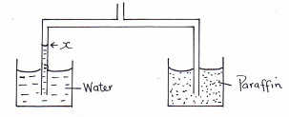

After sometime the level of water rose to position X. Mark Y the corresponding position for the paraffin level. Give a reason for your answer. (2mks)
4. Explain the reason why a dropping dust particle in a still room does not trace a straight vertical path. (1mk)
5. Figure 2 shows a flask filled with water. The flask is fitted with a cork through which a tube is inserted. When the flask is cooled, the water level rises slightly, and then falls steadily.
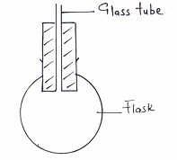

Explain this observation. (3mks)
6. Explain why copper is a better conductor of heat than iron. (1mk)
7. Two candles A and B of equal lengths and thickness are joined together and balanced horizontally as shown below. Candle A is lit.

State and explain what happens after a short time. (2mks)
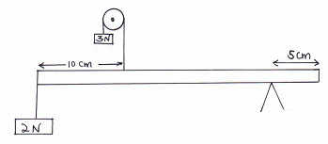
8. A uniform metre rule is supported by force of 3N and 2N as shown in figure 3 below.

Determine the weight of the half metre rule. (3mks)
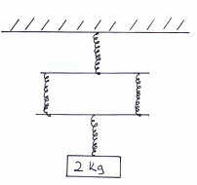
9. When a mass of 2kg is hang from a single spring, the spring extends by a distance χ = 5cm. Determine the total extension in the set up below given that the springs are identical and weightless. (2mks)

10. Trees planted along a busy road are observed to lean towards the road as they grow. Explain this observation. (2mks)
11. A particle starts from rest and accelerates uniformly in a straight line. After 3 seconds, it is at a distance of 9m from the starting point. Determine the acceleration of the particle. (3mks)
12. Bubbles of gas escaping from the bottom of a fish pond rises to the surface. It is observed that as bubbles rise, they get larger. Explain this observation. (2mks)
SECTION B: (55 MARKS)
13. (a) State Newton’s second law of motion in terms of in momentum. (1mk)

- A trolley of mass 5kg travelling to the right at 2m/s collides heads on with another trolley of mass 3kg travelling at 4m/s to the left. Find their velocity after collision if the collision is perfectly inelastic. (3mks)

- A bullet of mass 2g is fired with a velocity of 300m/s into a wooden block of mass 5kg suspended from a long string. The bullet sticks into the wood and the two moves together.
  - Find the velocity of the block and the bullet immediately after collision took place. (3mks)
(ii) Calculate the height to which both swings upwards. (3mks)
14. (a) State two factors that affect the efficiency of a pulley system. (2mks)
- Figure 5 below shows a pulley system with the load rising at uniform speed.
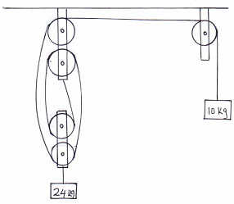

From the information given, calculate:
(i) The velocity ratio of the machine. (1mk)
(ii) Mechanical advantage of the machine. (2mks)
(iii) Efficiency of the machine. (3mks)
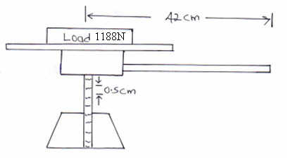
- The handle of the screw-jack in figure 6 below is 42cm long and the pitch of the screw is 0.5cm.

(i) Calculate the V.R of the screw jack. (2mks)
(ii) Calculate the effort needed to lift the load of 1188N. (2mks)
15. (a) Explain why a drop of methylated spirit on the back of the hand feels colder than a drop of water at the same
temperature. (2mks)
- A block of metal of mass 150g at 100°C is dropped into a lagged calorimeter of heat capacity 40J/k containing 100g of
water at 25°C. The temperature of the mixture is 34°C. (s.h.c of water = 4200J/kgK).
Determine:
(i) Heat gained by the calorimeter. (2mks)
(ii) Heat gained by water. (2mks)
(iii) Heat lost by the metal block. (2mks)
(iv) Specific heat capacity of the metal block. (3mks)
- A student heated some water and noticed that it boiled at 102ºC. State one possible reason for this observation. (1mk)
16. (a) Define angular velocity. (1mk)
- A string of length 70cm is used to whirl a stone of mass 0.5kg in a circle of a vertical plane at 5 rev/s. Determine.
(i) The period. (2mks)
(ii) The angular velocity. (3mks)
(iii) The centripetal force. (3mks)
(c) (i) Explain why bodies in a circular motion undergo acceleration even when their speed is constant. (1mk)
  - The figure below shows a container with small holes at the bottom in which wet clothes have been put.
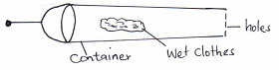

When the container is whirled in air at high speeds, it is observed that the clothes dry faster. Explain how the rotation of the container causes the clothes to dry faster. (2mks)
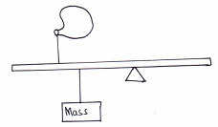
17. (a) The diagram below shows a uniform metre rule at equilibrium during a cold morning. State and explain the effect on the equilibrium when the weather becomes hot during the same day. (1mk)

- The diagram below shows a metallic metre rule at equilibrium. Study it and answer the questions that follow.
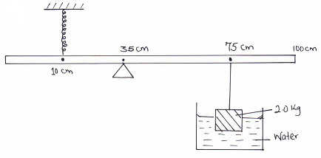

The spring had a constant of 25N/cm and stretched by 4mm at equilibrium. The 2kg mass was immersed halfway in the water. Determine the following.
(i) Tension in the spring. (2mks)
(ii) Upthrust. (3mks)
(iii) Density of the 2kg mass. (Density of water = 1g/cm³). (3mks)

CENTRAL KENYA NATIONAL SCHOOLS JOINT MOCK - 2016
Kenya Certificate of Secondary Education
232/2
PHYSICS
PAPER 2
(THEORY)
TIME: 2 HOURS
1. State the property of light associated with formation of shadows. (1mk)
2. Figure 1 below shows a negatively charged particle close to a positively charged plate.
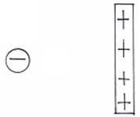

Draw the electric field pattern. (2mks)
3. Figure 2 below shows two identical bulbs connected in two circuits. The cells are of the same e.m.f.
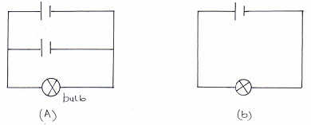

Compare the brightness of the bulbs in (a) and (b). (1mk)
4. Figure 3 below shows a block of copper placed between two poles of a magnet.
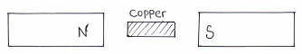

Sketch the magnetic field between the poles. (2mks)
5. Figure 4 below shows an object placed infront of a concave mirror.
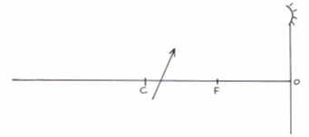

Use rays to locate the position of the image. (3mks)
6. Figure 5 below shows a metre rule suspended by a thread such that it is in equilibrium balanced by a permanent magnet attached to the metre rule and some weight.
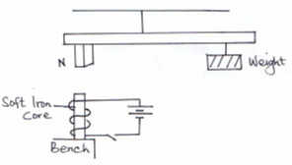

If the soft iron is fixed to the bench, state and explain the effect on the metre when the switch is closed. (2mks)
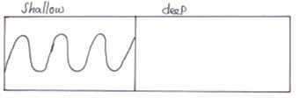
7. Figure 6 below shows a progressive wave incident from a shallow end to a deep end.

(a) Sketch the appearance of the wave in the deep region. (1mk)
(b) State the property of waves demonstrated in the figure above. (1mk)
8. A fathometer produces sound in a ship and receives two echo’s where there is a raised sea bed. One after 2.5 seconds and the other after 3.0 seconds. Find the height of the raised sea bank if the velocity of sound in water is 1460m/s. (4mks)
9. Figure 6 below shows the path of light through a transparent material placed in air.
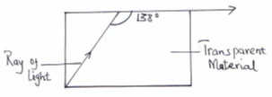

Calculate the refractive index of the transparent material. (3mks)

10. State the name of the eye defect corrected by convex lens. (1mk)
11. A heater of resistance R₁ is rated P watts, V volts while another of resistance R₂ is rated 2P watts, ^{V}/₂ volts. Determine the ratio R₁ to R₂. (3mks)
12. State one use of microwaves. (1mk)
13. Figure 7 below shows a diode D connected to a source of a.c current and a resistor.
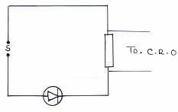

Sketch in the axis below the output observed in the C.R.O.

Time(s)
E.m.f

14. (a) State ohms law. (1mk)
- Figure 8 below shows a large battery connected a resistor of 1000Ω. The potential difference across the resistor is 50V.
50V

Determine:
(i) The ammeter reading (A). (3mks)
(ii) The electrical energy dissipated by the resistor in one minute. (3mks)
- Figure 9 below shows some resistors connected in part of a circuit.
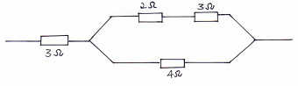

Determine the effective resistance. (3mks)
- Four 40w bulbs and six 100w bulbs were switched on for 2 hours in the morning and 3 hours at night each day for domestic use in a certain institution. Find the monthly bill for the consumer given that the cost of electricity in the country is at Sh.6.50 per unit. (Take one month to be of 30 days). (3mks)
15. (a) State two factors that affect capacitance of parallel plate capacitor. (2mks)

- Figure 10 below shows capacitors connected to 3v supply.
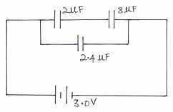

Calculate:
(i) The combined capacitance. (3mks)
(ii) The charged stored in the 2.4μF capacitor. (3mks)
(iii) The charge stored in 2μF capacitor. (2mks)
16. (a) State lenzes law of electromagnetic induction. (1mk)
- Figure 11 below show a magnet being pulled from a coil connected to a centre zero galvanometer.
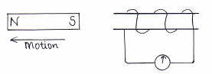

(i)\State the observation made. (1mk)
- Explain what would happen if the magnet was moved out faster. (1mk)
(iii)\Explain the observation in b(i) above. (2mks)
- (i) The turns ratio of primary to secondary coils in a 100% efficient transformer is 3: 1. Calculate the current through the primary coil if the current in the secondary coil is 5A. (3mks)
- State how the energy losses are minimized in a transformer.
I Eddy current. (1mk)
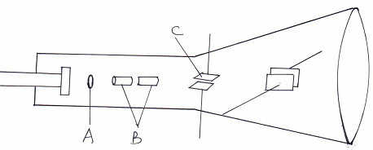
II Flux linkage. (1mk)
17. (a) Figure 12 below shows a cathode ray tube (C.R.O).

(i) Name the parts labelled A and B. (2mks)
(ii) What are the functions A and C? (2mks)
(iii) Explain how electrons are produced. (2mks)
(iv) Give a reason why the tube is evacuated. (1mk)
(b) State what determines the quality of X-rays in an X-rays tube. (1mk)
(c) State one use of X-rays in industry. (1mk)
(d) An X-ray tube operates with a p.d. of 200kv. Only 0.5% of the kinetic energy of the electrons is converted into X-rays.
Calculate the frequency of the X-rays produced, take planks constant = 6.63 x 10⁻³⁴Js. (3mks)
18. (a) Figure 13 below shows a diagram of a Geiger Muller tube connected to a power supply and a pulse counter.

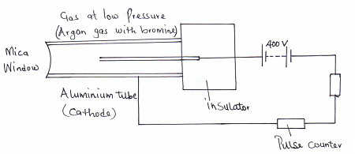

(i) Why should the argon gas be at low pressure? (1mk)
(ii) State the purpose of the bromine gas in the tube. (1mk)
(iii) Suggest one way of increasing the sensitivity of the tube. (1mk)
(iv) Find the value of a and b in the following equation. (2mks)

- In an experiment using a photocell, ultraviolet light of varying frequency strikes a metal surface. The maximum kinetic
energy (K.E max) of photoelectrons for each frequency, f, is measured. The graph below shows how the maximum kinetic energy varies with the frequency, f.
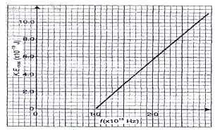

- Use the graph to determine:-
(i) Planck’s constant, h. (3mks)
(ii) Work function of the metal. (3mks)

CENTRAL KENYA NATIONAL SCHOOLS JOINT MOCK – 2016
232/3
PHYSICS
PAPER 3 (PRACTICAL)
CONFIDENTIAL
Question 1A
Each candidate requires the following items.
- Watch glass
- Plasticine
- Marbles.
- Stopwatch.
- Vernier calipers.
- Electronic balance (to be shared).
Question 1B
- Rectangular glass block.
- Optical pins.
- Soft board.
- Protractor
- 30cm ruler.
- Plain paper.
- Plane mirror
Question 2A
- 250ml beakers.
- Bunsen burner.
- Thermometers.
- Tripod stand and wire gauze.
- Stopwatch
- Measuring cylinder (100ml) and water.
Questions 2B
- A boiling tube
- Some dry sand.
- Water in a measuring cylinder labelled L.
- Vernier calipers.
- Half metre rule.
- Tissue paper.
- Weighing machine (to be shared).

CENTRAL KENYA NATIONAL SCHOOLS JOINT MOCK - 2016
Kenya Certificate of Secondary Education
232/3
PHYSICS
PAPER 3
(PRACTICAL)
TIME: 2½ HOURS
Question 1 (PART A)
You are provided with the following:
- A watch glass.
- A small piece of plasticine.
- A marble.
- A stopwatch.
- Vernier calipers.
- An electronic balance (to be shared).
- Measure the mass M of the marble.
M = …………………g (½mk)

- Place the watch glass flat on the table with a small piece of plasticine to fix it firmly to the table at the place it touches.
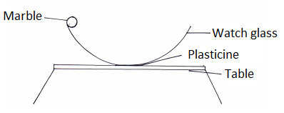
- Release the marble from one end of the watch glass and time 10 complete oscillations with a stop watch. Repeat this three times.

- Record your values in table 1 below
Table 1
 | Time for 10 oscillations | Periodic time T(s)
1
2
3 |  |  | (2mks)

Find the average periodic time T.
T = …………………. s. (½mk)
- Measure the diameter of the marble with the vernier callipers and hence find its radius.
Diameter d = …………………….. m (½mk)
Radius r = ……………………… m (½mk
- Determine the volume (V) of the marble given that:
(1mk)
- Calculate the radius of curvature of the watch glass R from the formula.
(2mks)
Where g = 9.8m/s² and π = 3.142.
QUESTION 1 (PART B)
You are provided with the following apparatus:
- A rectangular glass block.
- Four optical pins.
- A soft board.
- A protractor.
- 30cm ruler.
- 2 white plain papers.
- A plane mirror.
- A vernier calipers (to be shared)
PROCEDURE
- Trace the outline of the glass block on the white paper.
- Draw a normal ON, 2cm from point X on side XY.
- Measure an angle (i) 10º from the normal.
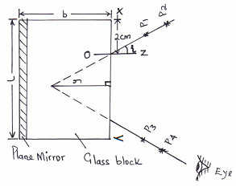
- Place back the glass block on the outline and fix a plane mirror vertically along the length of the glass block on the opposite side of XY using a cello tape as shown in the figure below.

- Fix two pins P₁ and P₂ as shown in the figure.
- By observing image of P₁ and P₂, locate two pins P₃ and P₄ such that they appear to be in line with images of P₁ and P₂.
- Remove the pins and the block. Join P₃P₄ and produce the line to meet line P₁P₂ produced
- Meause the perpendicular distance y.
- Repeat the same for angles of 15º, 20º, 25º, 30º, 35º and 40º and record the results in table 2 below.
(NB: The paper work must be submitted together with the question paper).
Table 2
Angle i | 10º | 15º | 20º | 25º | 30º | 35º | 40º
y(cm)
(4mks)
(j) Plot a graph of y(cm) against angle i. (5mks)
(i) Use the graph to determine y_{o} the value of y when i = 0º
y_{o} = ……………… cm (1mk)
- Measure and record the breadth (b) of the glass block
b = ……………. Cm (1mk)
- Determine the value of η given that
(2mks)

Question 2 (PART A)
You are provided with the following:-
- A 250ml glass beaker.
- A Bunsen burner.
- A thermometer.
- A stopwatch.
- A Tripod stand and a wire qauze.
- A measuring cylinder 100ml.
- Water.
Set the apparatus as shown in figure below.
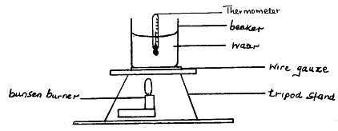

- Measure 100cm³ of water and pour it into the beaker. Take the initial temperature of the water.
T_{o} =……………… ºC. (1mk)
Now heat the water to a temperature of 75ºC. Switch off the gas tap and place a thermometer into the beaker and start the stopwatch when the temperature is 65ºC. Take the temperature TºC of water every two minutes. Record your results in the table 3 below.
Table 3
Time, t(minutes) | 2 | 4 | 6 | 8 | 10 | 12 | 14
Temperature, T(ºC)
(T – T_{o}) (ºC)
Log (T – T_{o}) |  |  |  |  |  |  |  | (5mks)

(b) Plot a graph of Log (T – T_{o}) against Time (t). (5mks)
(c) From the graph find the value of Q given that Q = log (T – T_{o}) when t = 0. (1mk)
(d) Determine P, where P is the antilog of Q. (1mk)
(e) Calculate the temperature of the surrounding T_{S} using expression
P = 65 - T_{S}. (2mks)
PART B
You are provided with the following:-
- A boiling tube.
- Some dry sand.
- A liquid in a measuring cylinder labelled L.
- Half metre rule.
- A vernier calipers (to be shared).
- A weighing machine (one per form).
- Tissue paper.
- A measuring cylinder.

Proceed as follows:
- Measure the length of the boiling tube.
h = ……………………. cm (½mk)
- Put a little amount of sand in the boiling tube and place it in the measuring cylinder which is almost filled with liquid L. Add sand, little by little until the tube floats upright as shown in figure below.
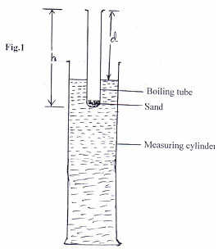

Measure the length, d, of the boiling tube which is above the liquid.
d = …………… cm (½mk)
- Determine the length, t, of the boiling tube which is immersed in the liquid.
t = ………….. cm (½mk)

- Remove the boiling tube from the measuring cylinder, wipe it dry (on the outside) and measure its mass, m, including the sand inside.
m = ………….. g (½mk)
- Measure the external diameter, D, of the boiling tube.
D = ………….. cm (½mk)
- Determine the external radius, R.
R = …………… cm (½mk)
(l) Using the formula m = 12ρπR², determine ρ for the liquid. (2mks)

