NAME ____________________________________ INDEX NO. _______________
SCHOOL ____________________________________ SIGNATURE _______________
DATE _______________

231/3
BIOLOGY
(PRACTICAL)

PAPER 3
JULY, 2017
TIME: 1¾ HOURS

231/3
BIOLOGY
(PRACTICAL)
PAPER 3
TIME: 1¾HOURS

INSTRUCTIONS TO CANDIDATES
- Write your name, school, index number, signature and date in the spaces provided above.
- Answer ALL the questions in spaces provided.
- You are required to spend the first 15 minutes of the 1¾ allowed for this paper reading the whole paper carefully before commencing your work.
- Answers must be written in the spaces provided in the question paper.
- Additional pages must not be inserted.
- This paper consists of 6 printed pages.
- Candidates should check to ensure that all pages are printed as indicated and no questions are missing.

FOR OFFICIAL USE ONLY
QUESTION | MAXIMUM SCORE | CANDIDATE’S SCORE
1 | 12
2 | 14
3 | 14
TOTAL SCORE | 40

- You are provided with a potato labelled R. Cut 4 equal pieces of the potato about 1cm³.
- Place one piece in a test-tube and label it A.
- Place a second piece onto a white tile or petri-dish and crush it into a paste using a motor or a glass rod. Put it into a second test-tube and label it B.
- To each of the two test tubes, add 2cm³ of hydrogen peroxide.
- Record your observations. (2 marks)
________________________________________________________________________________________________________________________________________________________________________________________________________________________________________________
- Put a third piece of potato onto the white tile and crush it into a paste using the motor and the pestle. Put it into a third test tube and label it C.
Add some little water to the paste and boil it for about 10 minutes. Let it cool.
Add 2cm³ of hydrogen peroxide.
- Record your observations. (1 mark)
________________________________________________________________________________________________________________________________________________________________________________________________________________________________________________
- Explain the results in (a) and (b) above. (4 marks)
________________________________________________________________________________________________________________________________________________________________________________________________________________________________________________________________________________________________________________________________________________________________________________________________________________
- Crush the fourth piece of potato and put it into a test-tube, add 2cm³ of hydrogen peroxide to it. Test the gas produced and record your observations. (1 mark)
________________________________________________________________________________
- Make a conclusion based on results in (d) above. (1 mark)
________________________________________________________________________________________________________________________________________________________________
- Write a word equation for the reaction that produces the gas. (1 mark)
________________________________________________________________________________
- Where in your body does such a reaction occur? (1 mark)
________________________________________________________________________________
- What is the importance of such a reaction in the body? (1 mark)
________________________________________________________________________________

- You are provided with specimens labelled A, B, C, D, E, F and G.
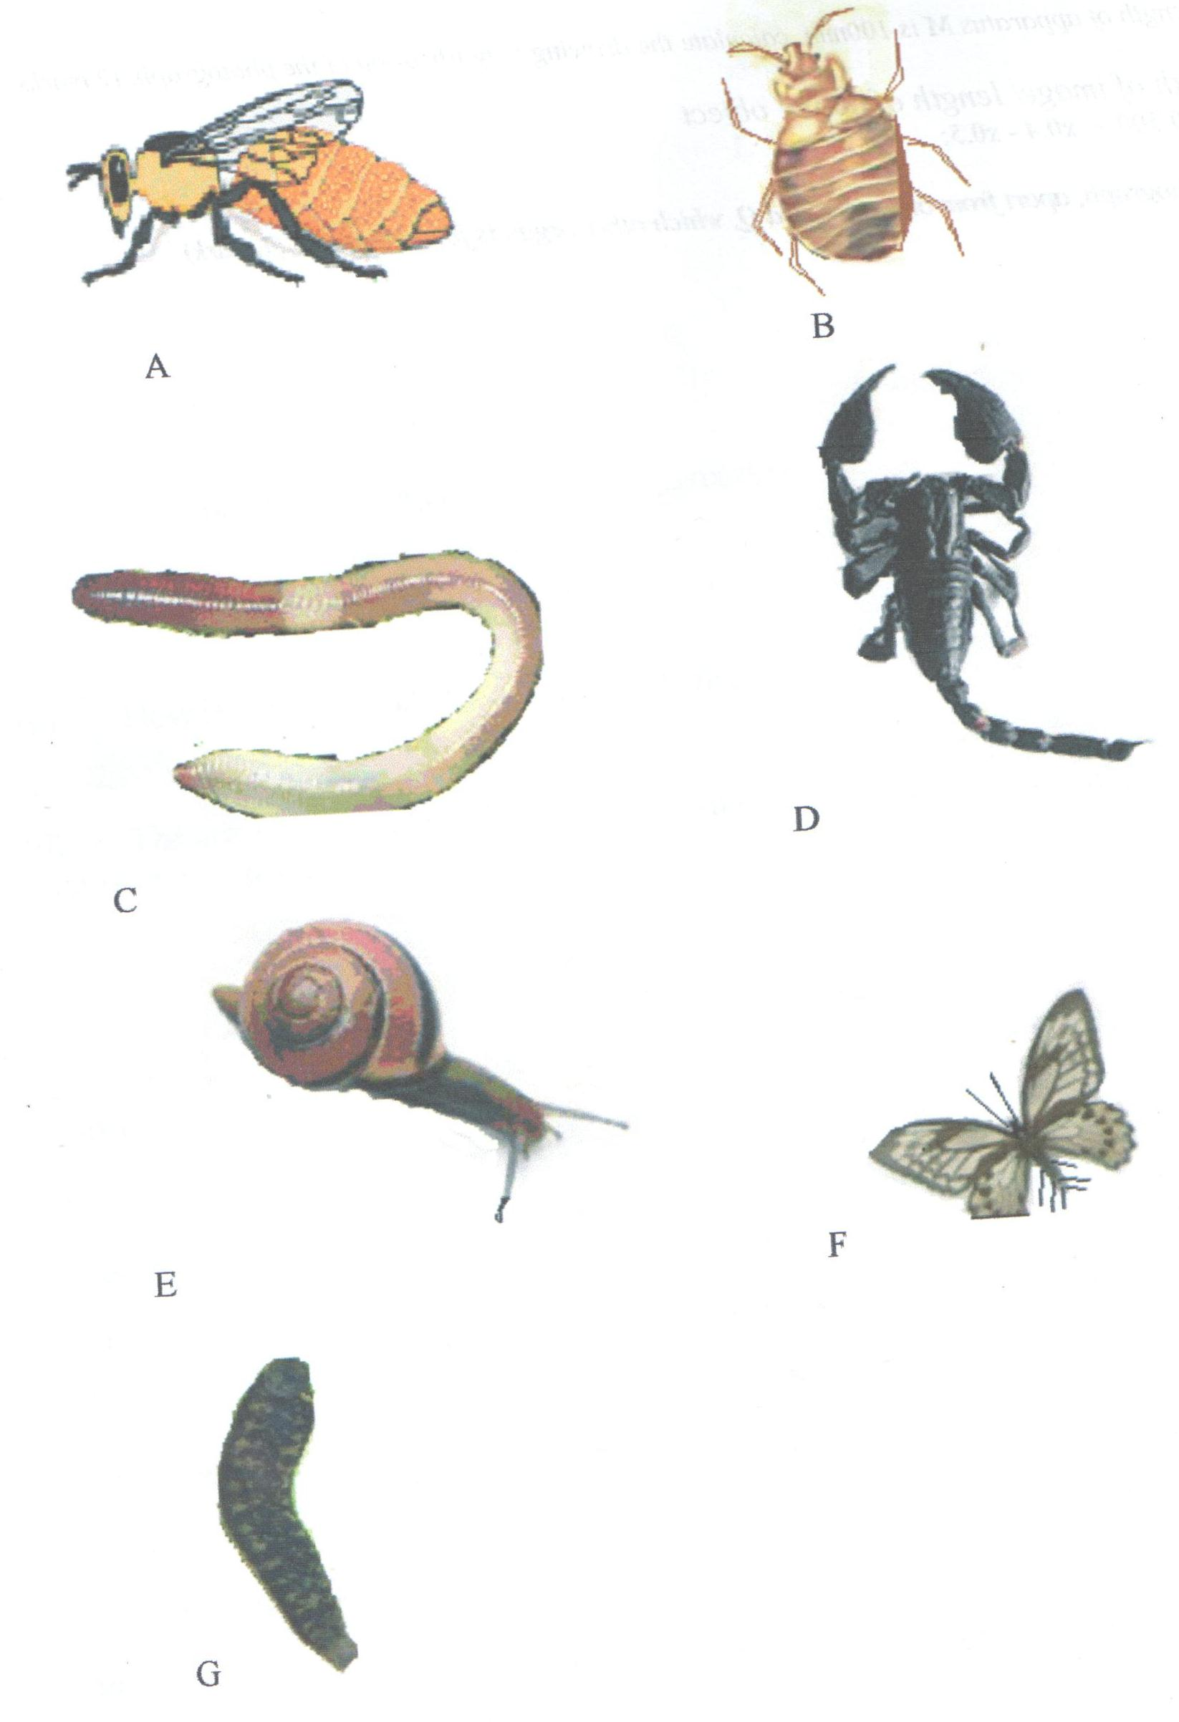

A dichotomous key shown below can be used to identify them
- a) Jointed legs present ------------------------------------- go to 2
b) Jointed legs absent -------------------------------------- go to 6

- a) Three pairs of legs -------------------------------------- go to 3
b) More than three pairs of legs -------------------------- go to 5

- a) Wings present ------------------------------------------- go to 4
b) Wings absent -------------------------------------------- Bedbug

- a) Two pairs of wings ------------------------------------- Batesian butterfly
b) One pair of wings --------------------------------------- Apis mellifera

- a) Antennae present ---------------------------------------- Crab
b) Antennae absent ----------------------------------------- Scorpion

- a) Shell present --------------------------------------------- Snail
b) Shell absent ---------------------------------------------- go to 7

- a) Prominent clitellum ------------------------------------- Earthworm
b) No clitellum visible ------------------------------------- Leech

a) Use the dichotomous key to identify each of the animal specimens provided.
In each case show the sequence of steps that you followed to arrive at the identity of each specimen. (7 marks)
Specimen | Steps followed | Identity
A
B
C
D
E
F
G

b) i) Name the class to which specimen D belongs. (1 mark)
___________________________________________________________________________________
ii) Name two observable features used to classify specimen D in (b) (i) above. (2 marks)
___________________________________________________________________________________ ___________________________________________________________________________________
c) i) Name the type of skeleton found in organism A. (1 mark)
___________________________________________________________________________________
ii) Name one function of the skeleton found in c(i) above. (1 mark)
___________________________________________________________________________________
d) State two economic importance of specimen A in an ecosystem. (2 marks)
_________________________________________________________________________________________________________________________________________________________________________________________________________________________________________________________

- Figure 1.1 below shows the lower surface of a dicotyledonous leaf.
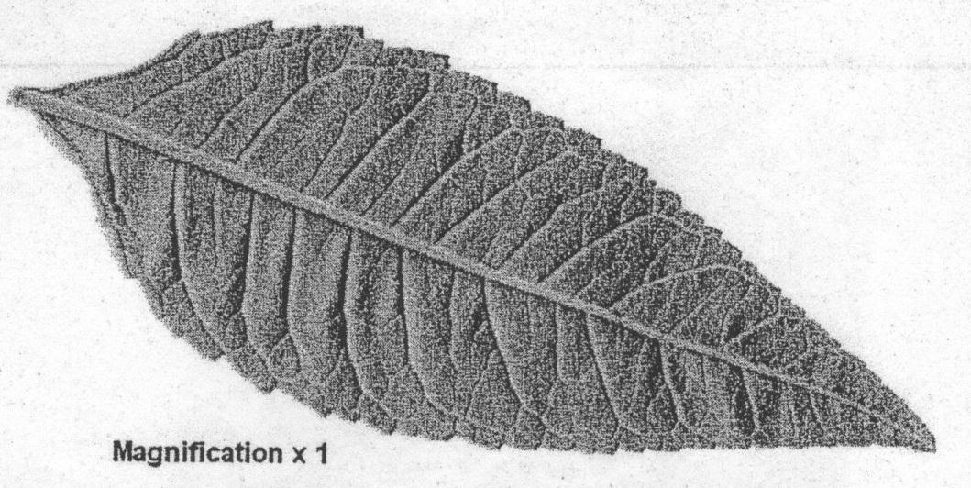
- Make a labelled drawing of the leaf.
Your drawing should be of the same size as that shown in the figure 1.1 (6 marks)

- Figure 1.2 below shows part of the lower surface of the leaf in figure 1.1 as seen under a light microscope.
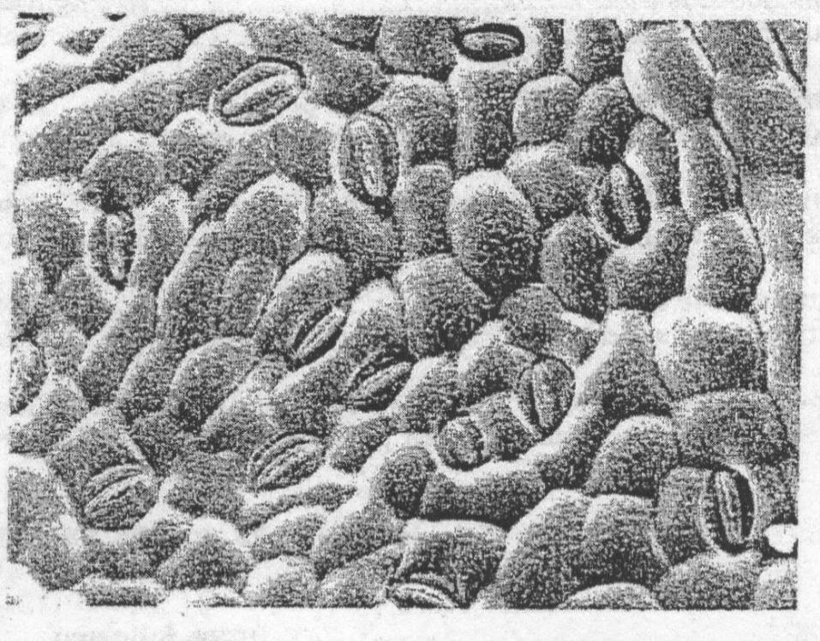
- On the figure 1.2, label using lines two different types of cells. (2 marks)

- On the figure 1.2 put a circle around two of the cells where chloroplasts are normally present. (2 marks)

- Suggest how you could determine the number of stomata present on one surface of a whole leaf.
(4 marks)
__________________________________________________________________________________________________________________________________________________________________________________________________________________________________________________________________________________________________________________________________________________________________________________________________________________________________________________________________________________________________________________

