NAME ____________________________________ INDEX NO. _______________
SCHOOL ____________________________________ SIGNATURE _______________
DATE _______________

232/2
PHYSICS
PAPER 2
(THEORY)
JULY, 2017
TIME: 2 HOURS

232/2
PHYSICS
PAPER 2
(THEORY)
TIME: 2 HOURS

INSTRUCTIONS TO CANDIDATES
- Write your name and index number in the spaces provided above.
- Sign and write the date of examination in the spaces provided above.
- This paper consists of two sections, section A and B.
- Answer all the questions in section A and B in the spaces provided.
- Working of numerical questions must be clearly shown.
- Marks may be given for correct working even if the answer is wrong.
- Mathematical tables and electronic calculators may be used.
- This paper consists of 12 printed pages
- Candidates should check to ensure that all pages are printed as indicated and no questions are missing.
- Where necessary take: - g = 10N/kg
- Plank’s constant, h = 6.63 × 10⁻³⁴ J.S
- Speed of light, C = 3.0 × 10⁸ ms⁻¹

FOR EXAMINER’S USE ONLY
Section | Question | Maximum score | Candidate’s score
A | 1−13 | 25
B | 14 | 11
 | 15 | 09
 | 16 | 14
 | 17 | 11
 | 18 | 10
 | Total | 80

SECTION A (25 MARKS)
Answer ALL the questions in this section in the spaces provided.
- An object 10cm tall is placed 20cm infront of a diverging lens of focal length 15cm.
Determine the nature, position and magnification of the image by calculation. (3 marks)

- Explain why the image formed in a pinhole camera gets blurred when the hole is enlarged. (1 mark)
_________________________________________________________________________________________________________________________________________________________________________________________________________________________________________________________
- Figure 1 shows a cell of e.m.f 2.5V connected in series with a resistor R and a switch S.
Voltmeter, V₁ and V₂ are connected across the cell and the resistor respectively.
Figure 1
- State the reading of V₁with S open. (1 mark)

- With S closed, V₁ reads 1.6V. State the reading of V₂. (1 mark)

- Figure 2 shows the image of an object formed by reflection in a converging mirror.
C is the centre of curvature of the mirror.
Figure 2
Complete the diagram to show:
- How incident rays are reflected to form the image. (2 marks)

- The object position. (1 mark)

- The equation below represents a nuclear reaction in which two deuterium nuclei fuse to form helium and X.
${}_{1}^{2}H+ {}_{1}^{2}H {}_{2}^{4}{He}+ {}_{b}^{a}X$
- Determine the values of a and b. (1 mark)

- Identify X. (1 mark)

- Figure 3 shows a simple transformer connected to a 24v a.c source and an a.c voltmeter.
Figure 3
By counting the number of turns in each coil, determine the reading on the voltmeter. (2 marks)

- In domestic wiring systems lamps in the lighting circuit are required to be in parallel and not in series. Sate two reasons for this requirement. (2 marks)
_________________________________________________________________________________________________________________________________________________________________________________________________________________________________________________________
- Figure 4 shows a narrow beam of x-rays passing between two metal plates in air.
The plates are connected in series with a switch, a cell and a milliameter.
Figure 4
It is observed that when the switch is closed a current flows in the milliameter.
Explain this observation. (2 marks)
____________________________________________________________________________________________________________________________________________________________________________________________________________________________________________________________________________________________________________________________________________
- The anode of an x-ray tube becomes hot when the tube is in use. State the reason for this. (1 mark)
______________________________________________________________________________________________________________________________________________________________________

- Draw a ray diagram to show how a ray of light may be totally internally reflected two times in an isosceles right-angled glass prism. (Assume that the critical angle of glass is 42ºC.) (2 marks)

- Given that the velocity of sound in air is 330ms⁻¹.
Calculate the wavelength of sound produced by a turning fork rated 0.44 kHz. (2 marks)

- Figure 5 below shows two bar magnets and soft iron ring placed between the magnets.

Figure 5
Complete the diagram to show the magnetic field pattern through the soft iron ring. (1 mark)

- Determine the power of a lens whose focal length is 40cm. (2 marks)

SECTION B (55 MARKS)
Answer ALL questions in this section in the spaces provided.
- a) Explain how a negatively charged electroscope gets discharged when the cap is touched with a finger using a simple diagram. (2 marks)
____________________________________________________________________________________________________________________________________________________________________________________________________________________________________________________________________________________________________________________________________________
b) Figure 6 shows capacitors A and B connected in series with a battery of e.m.f 4V.
B
A
Figure 6
6μF
3μF
4V
Determine:
- The effective capacitance of the circuit. (3 marks)

- The quantity of charge in capacitor A. (3 marks)

- The quantity of charge in capacitor B. (1 mark)

c) Figure 7 shows an isolated positive point charge Q.
Figure 7
On the figure, sketch the electric field pattern around the charge. (2 marks)
- a) Figure 8 below shows a cathode ray tube in which a beam of electrons is cast on the screen.
Figure 8
- State how the electrons are produced in the tube. (1 mark)
______________________________________________________________________________________________________________________________________________________________________
- State how the electron beam is detected. (1 mark)
______________________________________________________________________________________________________________________________________________________________________
- State the reason for having a variable potential difference (p.d) at the:
- grid (1 mark)
______________________________________________________________________________________________________________________________________________________________________
- anodes (1 mark)
______________________________________________________________________________________________________________________________________________________________________
b) Figure 9 below shows the wave form of a signal applied at the y-plates of an oscilloscope whose time base is switched to the scale of 20 milliseconds per centimeter.
Figure 9 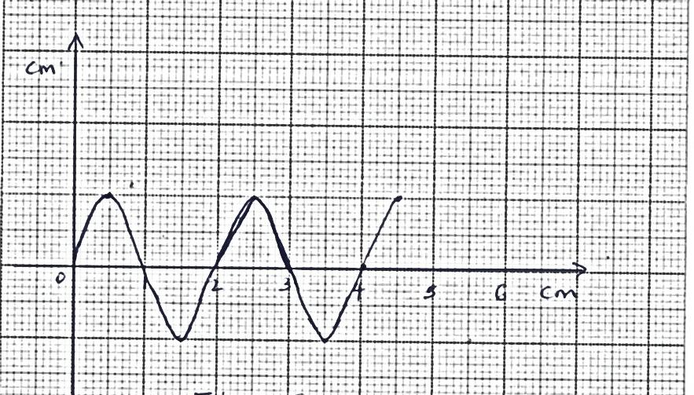
4

6

5

3
2
1
cm
cm

Determine:
- The period of the signal. (2 marks)

- The frequency of the signal. (3 marks)

- An X-ray tube requires an anode potential of 10⁵V and a current of 0.02A to operate.
Determine:
- The number of electrons hitting the target per second. (3 marks)

- The velocity with which the electrons hit the target.
(e = 1.6 × 10⁻¹⁹c, Me = 9.0 × 10⁻³¹kg) (2 marks)

- In an experiment to investigate the relationship between energy of radiation and stopping potential, the results were shown in a graph below. (Velocity of light = 3 x 10⁸ ms⁻¹ and e = 1.6 x 10⁻¹⁹c).
y
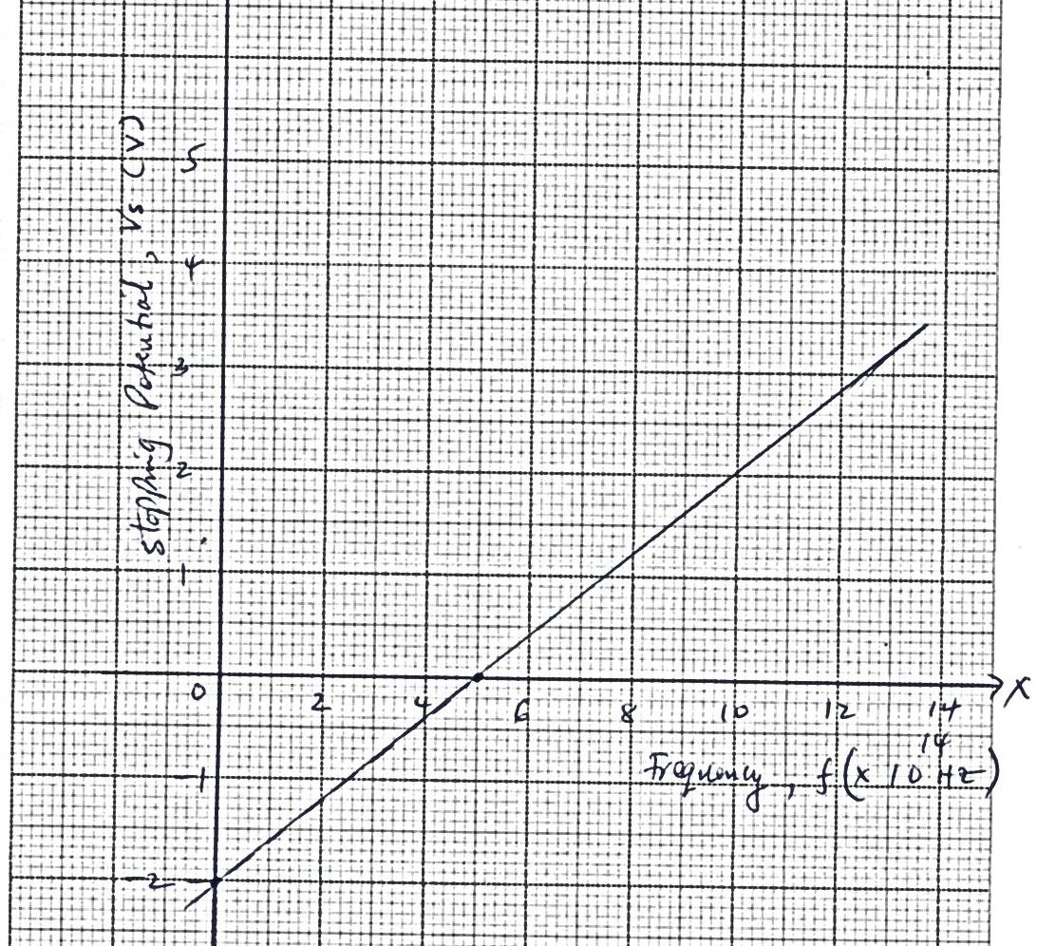
14
12
10
8
6
4
2
−1
−2
4
3
2
1
0
5

Frequency, f (× 10¹⁴Hz)
Stopping potential, Vs (V)
x
From the graph determine:
- The threshold frequency. (1 mark)

- The threshold wavelength. (2 marks)

- Planck’s constant. (3 marks)

- The work function. (3 marks)

- a) A ray of light is incident on a plane mirror as shown in figure 9 below.
Figure 9
What is the angle of reflection? (1 mark)

b) The mirror is then rotated clockwise through 20º. Determine:
i) The angle through which the reflected ray is turned. (2 marks)

ii) The angle between the incident ray and new reflected ray. (2 marks)

c) Explain two ways in which power loss is reduced in transmission of mains electricity. (2 marks)
_________________________________________________________________________________________________________________________________________________________________________________________________________________________________________________________
d) The diagram below shows resistors connected in a circuit diagram.
4Ω
2Ω
3Ω
- Determine the effective resistance of the above circuit. (2 marks)

- Determine the ammeter reading. (2 marks)

- a) The figure 10 shows two coils A and B placed close to each other.
A is connected to a steady D.C supply and a switch, B is connected to a sensitive galvanometer.
- The switch is now closed. State the observation made on the galvanometer. (1 mark)
______________________________________________________________________________________________________________________________________________________________________
- State what would be observed if the switch is then opened. (1 mark)
______________________________________________________________________________________________________________________________________________________________________
b) Define the term electromotive force (e.m.f) of a cell. (1 mark)
______________________________________________________________________________________________________________________________________________________________________
c) The graph in figure 11 shows how the voltage, v, varies with the current, I for a filament lamp.
y
Figure 11 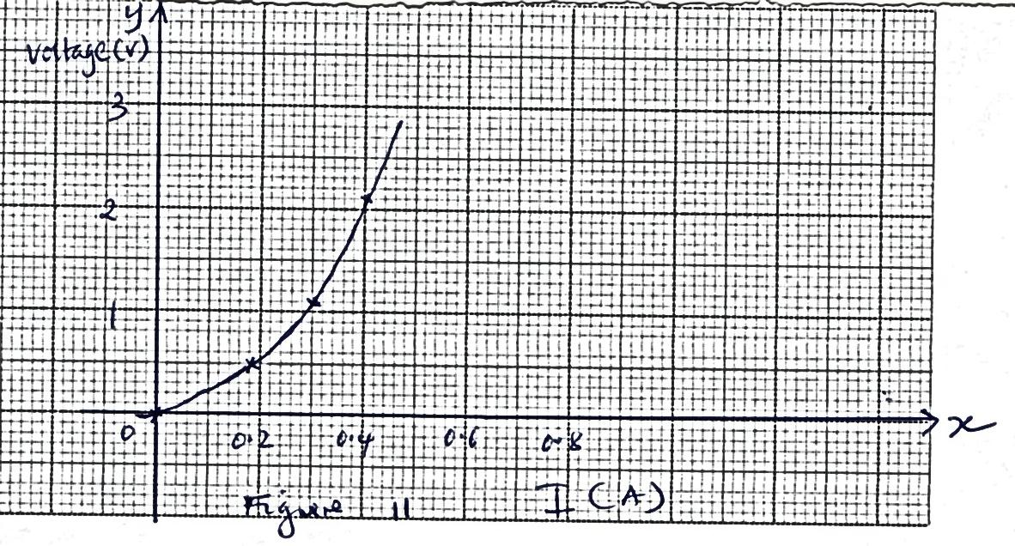
0.8
0.6
0.4
0.2
3
2
1
0

Voltage (V)
x
I (A)

- From the graph, determine the resistance of the lamp when a current of 0.4A flows. (2 marks)

- State with a reason whether the device is ohmic or non-ohmic. (1 mark)
______________________________________________________________________________________________________________________________________________________________________
d) Figure12 shows the variation of voltage against current.
Given that E = V + Ir
Find from the graph,
- The e.m.f, E of the cell. (1 mark)

- The internal resistance, r, of the cell. (3 marks)

