NAME ____________________________________ INDEX NO. _______________
SCHOOL ____________________________________ SIGNATURE _______________
DATE _______________

443/1
AGRICULTURE
PAPER 1
July, 2017
TIME: 2 HOURS

443/1
AGRICULTURE
PAPER 1
TIME: 2 HOURS

INSTRUCTIONS TO CANDIDATES
- Write your name and index number in the spaces provided above.
- Sign and write the date of the examination in the spaces provided above.
- This paper consists of three sections: A, B and C.
- Answer all the questions in section A and B and any two questions from section C.
- All answers must be written in the spaces provided in this booklet.
- This paper consists of 12 printed pages.
- Candidates should check the question paper to ascertain that all pages are printed as indicated and that no questions are missing

For OFFICIAL use only
SECTION | QUESTIONS | MAXIMUM SCORE | CANDIDATES SCORE
A | 1 − 17 | 30
B | 18 − 21 | 20
C |  | 20
 |  | 20
 | TOTAL SCORE | 90

SECTION A (30 MARKS)
Answer ALL questions in this section.
1. Give four methods of applying fertilizers to crops. (2 marks)
____________________________________________________________________________________________________________________________________________________________________________________________________________________________________________________________________________________________________________________________________________
2. State four beneficial biotic factors that influence agriculture. (2 marks)
____________________________________________________________________________________________________________________________________________________________________________________________________________________________________________________________________________________________________________________________________________
3. Give four branches of Agriculture. (2 marks)
____________________________________________________________________________________________________________________________________________________________________________________________________________________________________________________________________________________________________________________________________________
4. State four advantages of co-operative land tenure system. (2 marks)
____________________________________________________________________________________________________________________________________________________________________________________________________________________________________________________________________________________________________________________________________________
5. State four benefits of organic mulch in crop production. (2 marks)
____________________________________________________________________________________________________________________________________________________________________________________________________________________________________________________________________________________________________________________________________________
6. State four conditions under which shifting cultivation is practiced. (2 marks)
____________________________________________________________________________________________________________________________________________________________________________________________________________________________________________________________________________________________________________________________________________
7. Give four effects of mass wasting. (2 marks)
____________________________________________________________________________________________________________________________________________________________________________________________________________________________________________________________________________________________________________________________________________
8. Give four factors that affect the rooting of cuttings. (2 marks)
____________________________________________________________________________________________________________________________________________________________________________________________________________________________________________________________________________________________________________________________________________
9. Name four details that are included in a farm marketing record. (2 marks)
____________________________________________________________________________________________________________________________________________________________________________________________________________________________________________________________________________________________________________________________________________
10. Give four examples of product-product relationships in the management of agricultural enterprises.
(2 marks)
____________________________________________________________________________________________________________________________________________________________________________________________________________________________________________________________________________________________________________________________________________
11. State three entries that are made in a journal. (1½ marks)
_________________________________________________________________________________________________________________________________________________________________________________________________________________________________________________________
12. Give two reasons for cutting back pyrethrum. (1 mark)
___________________________________________________________________________________
___________________________________________________________________________________
13. State three parameters used to indicate national development. (1½ mark)
____________________________________________________________________________________________________________________________________________________________________________________________________________________________________________________________________________________________________________________________________________
14. State four symptoms of viral diseases in crops. (2 marks)
____________________________________________________________________________________________________________________________________________________________________________________________________________________________________________________________________________________________________________________________________________

15. Give four reasons for draining land as part of land reclamation. (2 marks)
____________________________________________________________________________________________________________________________________________________________________________________________________________________________________________________________________________________________________________________________________________
16. State two reasons for topping a pasture. (1 mark)
______________________________________________________________________________________________________________________________________________________________________
17. State two advantages of metal pipes over plastic pipes in piping water in the farm. (1 mark)
_________________________________________________________________________________________________________________________________________________________________________________________________________________________________________________________

SECTION A (30 MARKS)
Answer ALL questions in this section.
18. Study the following weeds and answer questions that follow.
J
K
a) Give the identity of weeds J and K. (2 marks)
J ________________________________________________
K ________________________________________________
b) What makes weed K difficult to control? (1 mark)
___________________________________________________________________________________
c) Give the economic importance of weed J. (1 mark)
___________________________________________________________________________________
d) State one reason that makes weeds excellently adapted to various environments. (1 mark)
___________________________________________________________________________________
19. Study the diagram below of a method of compost making and answer the questions that follow.
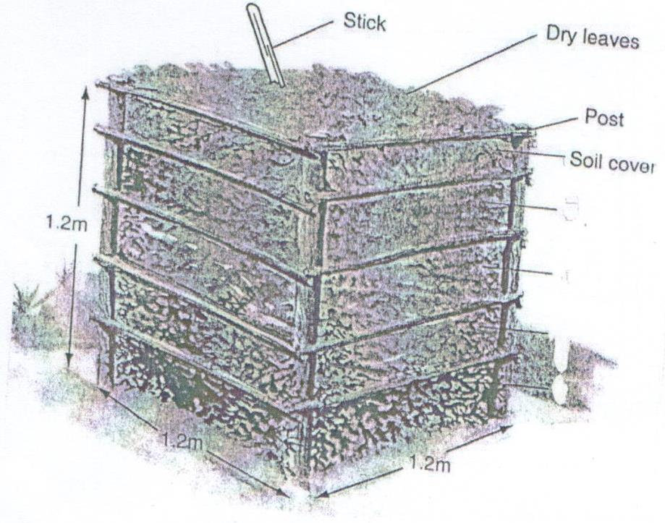
a) Identify the methods of compost making. (1 mark)
___________________________________________________________________________________

b) State four factors to consider when siting the structure. (2 marks)
____________________________________________________________________________________________________________________________________________________________________________________________________________________________________________________________________________________________________________________________________________
c) What is the function of the following materials in preparation of compost manure?
i) Top soil (1 mark)
______________________________________________________________________________________________________________________________________________________________________
ii) Wood ash (1 mark)
______________________________________________________________________________________________________________________________________________________________________
20. Two maize pests are shown in the diagram below. Study them and answer questions that follow.
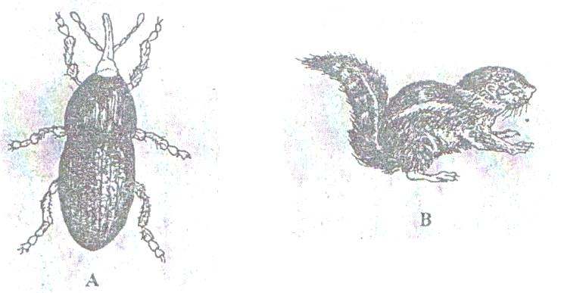
B
A
a) Identify the pests in the diagram labeled A and B. (1 mark)
A ______________________________________
B ______________________________________
b) At what stage of maize production does each pest damage the crop? (2 marks)
A ______________________________________
B ______________________________________
c) Give one way of controlling each of the pests in the field. (2 marks)
_________________________________________________________________________________________________________________________________________________________________________________________________________________________________________________________

21. The diagram below represents a vegetative material used to prepare a certain crop.
Study them and answer the questions that follow.
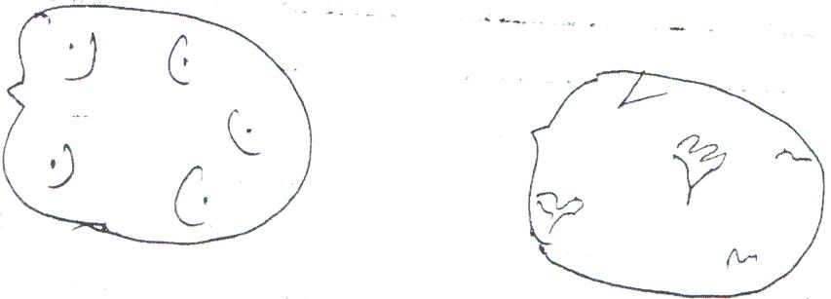
i) Give the name of the material illustrated above. (1 mark)
___________________________________________________________________________________
ii) Give the name of the preparation done on the material to make it ready for planting. (1 mark)
___________________________________________________________________________________
iii) State three advantages of carrying out the practice in (ii) above before planting. (3 marks)
_________________________________________________________________________________________________________________________________________________________________________________________________________________________________________________________

SECTION C (40 MARKS)
Answer ANY TWO questions from this section in the spaces provided
22. a) Describe the growing of dry bean seeds under the following subheadings.
- Selection and preparation of planting materials (3 marks)
- Planting (4 marks)
- Weeding (3 marks)
b) Describe the environmental conditions that may lead to low crop yields. (10 marks)

23. a) Explain six factors considered in designing a crop rotation programme. (6 marks)
b) Explain the factors that influence the type of irrigation to be used in a farm. (8 marks)
c) Explain six post-harvest practiced carried out on production of maize. (6 marks)

24. a) Explain five advantages of budgeting in farming. (10 marks)
b) Explain five various types of risks and uncertainties. (5 marks)
c) Describe the importance of pruning perennial crops. (5 marks)

______________________________________________________________________________________________________________________________________________________________________________________________________________________________________________________________________________________________________________________________________________________________________________________________________________________________________________________________________________________________________________________________________________________________________________________________________________________________________________________________________________________________________________________________________________________________________________________________________________________________________________________________________________________________________________________________________________________________________________________________________________________________________________________________________________________________________________________________________________________________________________________________________________________________________________________________________________________________________________________________________________________________________________________________________________________________________________________________________________________________________________________________________________________________________________________________________________________________________________________________________________________________________________________________________________________________________________________________________________________________________________________________________________________________________________________________________________________________________________________________________________________________________________________________________________________________________________________________________________________________________________________________________________________________________________________________________________________________________________________________________________________________________________________________________________________________________________________________________________________________________________________________________________________________________________________________________________________________________________________________________________________________________________________________________________________________________________________________________________________________________________________________________________________________________________________________________________________________________________________________________________________________________________________________________________________________________________________________________________________________________________________________________________________________________________________________________________________________________________________________________________________________________________________________________________________________________________________________________________________________________________________________________________________________________________________________________________________________________________________________________________________________________________________________________________________________________________________________________________________________________________________________________________________________________________________________________________________________________________________________________________________________________________________________________________________________________________________________________________________________________________________________________________________________________________________________________________________________________________________________________________________________________________________________________________________________________________________________________________________________________________________________________________________________________________________________________________________________________________________________________________________________________________________________________________________________________________________________________________________________________________________________________________________________________________________________________________________________________________________________________________________________________________________________________________________________________________________________________________________________________________________________________________________________________________________________________________________________________________________________________________________________________________________________________________________________________________________________________________________________________________________________________________________________________________________________________________________________________________________________________________________________________________________________________________________________________________________________________________________________________________________________________________________________________________________________________________________________________________________________________________________________________________________________________________________________________________________________________________________________________________________________________________________________________________________________________________________________________________________________________________________________________________________________________________________________________________________________________________________________________________________________________________________________________________________________________________________________________________________________________________________________________________________________________________________________________________________________________________________________________________________________________________________________________________________________________________________________________________________________________________________________________________________________________________________________________________________________________________________________________________________________________________________________________________________________________________________________________________________________________________________________________________________________________________________________________________________________________________________________________________________________________________________________________________________________________________________________________________________________________________________________________________________________________________________________________________________________________________________________________________________________________________________________________________________________________________________________________________________________________________________________________________________________________________________________________________________________________________________________________________________________________________________________________________________________________________________________________________________________________________________________________________________________________________________________________________________________________________________________________________________________________________________________________________________________________________________________________________________________________________________________________________________________________________________________________________________________________________________________________________________________________________________________________________________________________________________________________________________________________________________________________________________________________________________________________________________________________________________________________________________________________________________________________________________________________________________________________________________________________________________________________________________________________________________________________________________________________________________________________________________________________________________________________________________________________________________________________________________________________________________________________________________________________________________________________________________________________________________________________________________________________________________________________________________________________________________________________________________________________________________________________________________________________________________________________________________________________________________________________________________________________________________________________________________________________________________________________________________________________________________________________________________________________________________________________________________________________________________________________________________________________________________________________________________________________________________________________________________________________________________________________________________________________________________________________________________________________________________________________________________________________________________________________________________________________________________________________________________________________________________________________________________________________________________________________________________________________________________________________________________________________________________________________________________________________________________________________________________________________________________________________________________________________________________________________________________________________________________________________________________________________________________________________________________________________________________________________________________________________________________________________________________________________________________________________________________________________________________________________________________________________________________________________________________________________________________________________________________________________________________________________________________________________________________________________________________________________________________________________________________________________________________________________________________________________________________________________________________________________________________________________________________________________________________________________________________________________________________________________________________________________________________________________________________________________________________________________________________________________________________________________________________________________________________________________________________________________________________________________________________________________________________________________________________________________________________________________________________________________________________________________________________________________________________________________________________________________________________________________________________________________________________________________________________________________________________________________________________________________________________________________________________________________________________________________________________________________________________________________________________________________________________________________________________________________________________________________________________________________________
___________________________________________________________________________________________________________________________________________________________________________________________________________________________________________________________________________________________________________________________________________________________________________________________________________________________________________________
___________________________________________________________________________________________________________________________________________________________________________________________________________________________________________________________________________________________________________________________________________________________________________________________________________________________________________________
___________________________________________________________________________________________________________________________________________________________________________________________________________________________________________________________________________________________________________________________________________________________________________________________________________________________________________________
___________________________________________________________________________________________________________________________________________________________________________________________________________________________________________________________________________________________________________________________________________________________________________________________________________________________________________________
__________________________________________________________________________________________________________________________________________________________________________________________________________________________________________________________________________________________________________________________________________________________________________________________________________________________________________________________________________________________________________________________________________________________________________________________________________________________________________________________________________________________________________________________________________________________________________________________________________________________________________________________________________________________________________________________________________________________________________________________________________________________________________________________________________________________________________________________________________________________________________________________________________________________________________________________________

