NAME ____________________________________ INDEX NO. _______________
SCHOOL ____________________________________ SIGNATURE _______________
DATE _______________

443/2
AGRICULTURE
PAPER 2
July, 2017
TIME: 2 HOURS

443/2
AGRICULTURE
PAPER 2
TIME: 2 HOURS

INSTRUCTIONS TO CANDIDATES
- Write your name and index number in the spaces provided above.
- Sign and write the date of the examination in the spaces provided above.
- This paper consists of three sections: A, B and C.
- Answer all the questions in section A and B and any two questions from section C.
- All answers must be written in the spaces provided in this booklet.
- This paper consists of 12 printed pages.
- Candidates should check the question paper to ascertain that all pages are printed as indicated and that no questions are missing

For OFFICIAL use only
SECTION | QUESTIONS | MAXIMUM SCORE | CANDIDATES SCORE
A | 1 − 18 | 30
B | 19 − 22 | 20
C |  | 20
 |  | 20
 | TOTAL SCORE | 90

SECTION A (30 MARKS)
Answer all the questions in this section in the spaces provided.
1. Give three factors that affect the quality of honey. (1½ marks)
_________________________________________________________________________________________________________________________________________________________________________________________________________________________________________________________
2. State three conditions that make a cow to withhold milk during milking. (1½ marks)
_________________________________________________________________________________________________________________________________________________________________________________________________________________________________________________________
3. State four signs of furrowing observed in pigs. (2 marks)
____________________________________________________________________________________________________________________________________________________________________________________________________________________________________________________________________________________________________________________________________________
4. Give three factors that may make birds to lay eggs on the floor in a deep litter. (1½ marks)
_________________________________________________________________________________________________________________________________________________________________________________________________________________________________________________________
5. Give three characteristics of clean and high quality milk. (1½ mark)
_________________________________________________________________________________________________________________________________________________________________________________________________________________________________________________________
6. Outline four control measures of round worms. (2 marks)
____________________________________________________________________________________________________________________________________________________________________________________________________________________________________________________________________________________________________________________________________________
7. State four signs of liver fluke infestation in cattle. (2 marks)
____________________________________________________________________________________________________________________________________________________________________________________________________________________________________________________________________________________________________________________________________________

8. Give four reasons of breeding in cattle. (2 marks)
____________________________________________________________________________________________________________________________________________________________________________________________________________________________________________________________________________________________________________________________________________
9. List four methods of preserving fish. (2 marks)
____________________________________________________________________________________________________________________________________________________________________________________________________________________________________________________________________________________________________________________________________________
10. Name two classes of livestock feedstuffs. (1 mark)
______________________________________________________________________________________________________________________________________________________________________
11. Give two roles of ovaries in cows’ reproductive system. (l mark)
______________________________________________________________________________________________________________________________________________________________________
12. Give two reasons for flushing in sheep. (1 mark)
______________________________________________________________________________________________________________________________________________________________________
13. Give four reasons for treating timber used in construction of farm buildings. (2 marks)
____________________________________________________________________________________________________________________________________________________________________________________________________________________________________________________________________________________________________________________________________________
14. State four factors that influence the daily water intake in an animal. (2 marks)
____________________________________________________________________________________________________________________________________________________________________________________________________________________________________________________________________________________________________________________________________________
15. Name two functions of a clutch in the tractors transmission system. (1 mark)
______________________________________________________________________________________________________________________________________________________________________

16. Give four characteristics of a good calf pen. (2 marks)
____________________________________________________________________________________________________________________________________________________________________________________________________________________________________________________________________________________________________________________________________________
17. State four factors that influence the choice of the poultry system of rearing to use. (2 marks)
____________________________________________________________________________________________________________________________________________________________________________________________________________________________________________________________________________________________________________________________________________
18. State four routine management practices carried out on a replacement stock that is a heifer. (2 marks)
____________________________________________________________________________________________________________________________________________________________________________________________________________________________________________________________________________________________________________________________________________

SECTION B (20 MARKS)
Answer ALL questions in this section in the spaces provided.
19. The diagram below is a cross section of part of a cow's udder.
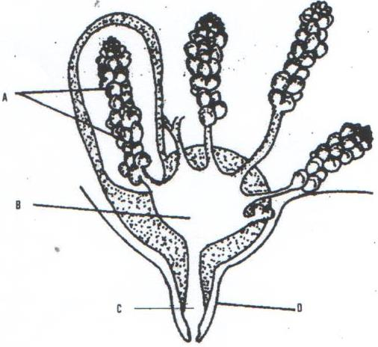
D
C
B
A
a) Name the parts marked A, B, C and D. (2 marks)
A _________________________________________
B _________________________________________
C _________________________________________
D _________________________________________
b) Name two hormones that control milk let down in a dairy cow. (2 marks)
______________________________________________________________________________________________________________________________________________________________________
c) What is a dry cow therapy? (1 mark)
___________________________________________________________________________________ ___________________________________________________________________________________
20. The diagram below shows the head of a chicken having symptoms of a poultry disease.
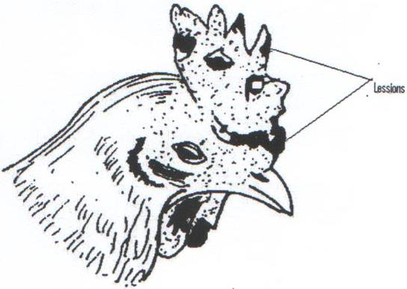
Lessions
a) Identify the disease. (1 mark)
___________________________________________________________________________________
b) Give two reasons why the disease is of economic importance. (2 marks)
______________________________________________________________________________________________________________________________________________________________________

c) Outline two methods of controlling the above disease. (2 marks)
______________________________________________________________________________________________________________________________________________________________________
21. The following diagram shows parts of a roof. Study it carefully and answer the questions that follow.
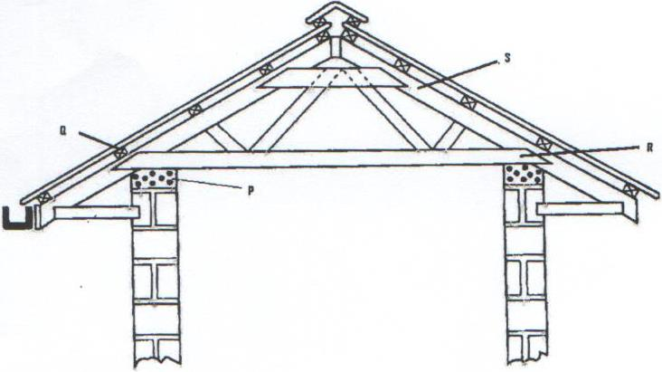
R
S
P
Q
a) Name the parts labeled P, Q, R and S. (2 marks)
P _________________________________________
Q _________________________________________
R _________________________________________
S _________________________________________
b) State the functions of P and Q. (2 marks)
P _______________________________________________________________________________
Q _______________________________________________________________________________
c) Give two chemical preservatives for treating timber before use in the construction of farm structures.
(2 marks)
______________________________________________________________________________________________________________________________________________________________________
22. Below is a diagram of power transmission system of tractor engine.
G
Gear box

Study it and answer the question that follows.
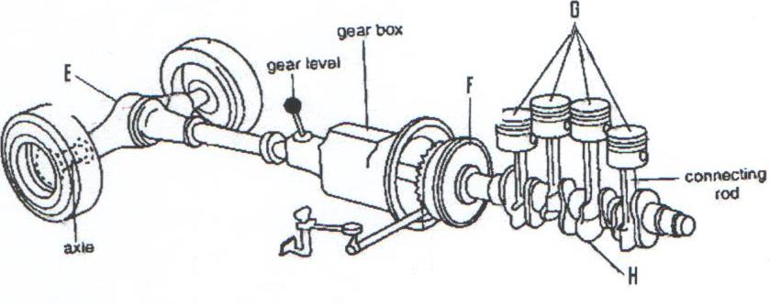
Connecting rod
H
F
Axle
Gear level
E

a) Name the parts labeled E, F, G and H. (2 marks)
E _________________________________________
F _________________________________________
G _________________________________________
H _________________________________________
b) State the functions of E and H. (2 marks)
E _______________________________________________________________________________
H _______________________________________________________________________________

SECTION C (40 MARKS)
Answer ANY TWO questions from this section.
23. a) Describe five pre-disposing factors of livestock diseases. (5 marks)
b) Describe six mechanical methods of controlling ticks. (6 marks)
c) Describe the factors that affect milk composition of a cow. (9 marks)

24. a) State five advantages of farm mechanization. (5 marks)
b) Explain five advantages of using a mould board plough in seed bed preparation. (5 marks)
c) Describe the use of various materials in construction of a Kenya Top bar hive. (5 marks)
d) Outline the care and maintenance of a tractor water cooling system. (5 marks)

25. a) State four physical characteristics of a dairy cow. (4 marks)
b) State nine factors to consider when selecting livestock for breeding. (9 marks)
c) Describe milk fever in dairy cattle under the following sub-headings.
i) The cause of the disease (1 mark)
ii) Symptoms of the disease (4 marks)
iii) Control measures (2 marks)

______________________________________________________________________________________________________________________________________________________________________________________________________________________________________________________________________________________________________________________________________________________________________________________________________________________________________________________________________________________________________________________________________________________________________________________________________________________________________________________________________________________________________________________________________________________________________________________________________________________________________________________________________________________________________________________________________________________________________________________________________________________________________________________________________________________________________________________________________________________________________________________________________________________________________________________________________________________________________________________________________________________________________________________________________________________________________________________________________________________________________________________________________________________________________________________________________________________________________________________________________________________________________________________________________________________________________________________________________________________________________________________________________________________________________________________________________________________________________________________________________________________________________________________________________________________________________________________________________________________________________________________________________________________________________________________________________________________________________________________________________________________________________________________________________________________________________________________________________________________________________________________________________________________________________________________________________________________________________________________________________________________________________________________________________________________________________________________________________________________________________________________________________________________________________________________________________________________________________________________________________________________________________________________________________________________________________________________________________________________________________________________________________________________________________________________________________________________________________________________________________________________________________________________________________________________________________________________________________________________________________________________________________________________________________________________________________________________________________________________________________________________________________________________________________________________________________________________________________________________________________________________________________________________________________________________________________________________________________________________________________________________________________________________________________________________________________________________________________________________________________________________________________________________________________________________________________________________________________________________________________________________________________________________________________________________________________________________________________________________________________________________________________________________________________________________________________________________________________________________________________________________________________________________________________________________________________________________________________________________________________________________________________________________________________________________________________________________________________________________________________________________________________________________________________________________________________________________________________________________________________________________________________________________________________________________________________________________________________________________________________________________________________________________________________________________________________________________________________________________________________________________________________________________________________________________________________________________________________________________________________________________________________________________________________________________________________________________________________________________________________________________________________________________________________________________________________________________________________________________________________________________________________________________________________________________________________________________________________________________________________________________________________________________________________________________________________________________________________________________________________________________________________________________________________________________________________________________________________________________________________________________________________________________________________________________________________________________________________________________________________________________________________________________________________________________________________________________________________________________________________________________________________________________________________________________________________________________________________________________________________________________________________________________________________________________________________________________________________________________________________________________________________________________________________________________________________________________________________________________________________________________________________________________________________________________________________________________________________________________________________________________________________________________________________________________________________________________________________________________________________________________________________________________________________________________________________________________________________________________________________________________________________________________________________________________________________________________________________________________________________________________________________________________________________________________________________________________________________________________________________________________________________________________________________________________________________________________________________________________________________________________________________________________________________________________________________________________________________________________________________________________________________________________________________________________________________________________________________________________________________________________________________________________________________________________________________________________________________________________________________________________________________________________________________________________________________________________________________________________________________________________________________________________________________________________________________________________________________________________________________________________________________________________________________________________________________________________________________________________________________________________________________________________________________________________________________________________________________________________________________________________________________________________________________________________________________________________________________________________________________________________________________________________________________________________________________________________________________________________________________________________________________________________________________________________________________________________________________________________________________________________________________________________________________________________________________________________________________________________________________________________________________________________________________________________________________________________________________________________________________________________________________________________________________________________________________________________________________________________________________________________________________________________________________________________________________________________________________________________________________________________________________________________________________________________________________________________________________________________________________________________________________________________________________________________________________________________________________________________________________________________________________________________________________________________________________________________________________________________________________________________________________________________________________________________________________________________________________________________________________________________________________________________________________________________________________________________________________________________________________________________________________________________________________________________________________________________________________________________________________________________________________________________________________________________________________________________________________________________________________________________________________________________________________________________________________________________________________________________________________________________________________________________________________________________________________________________________________________________________________________________________________________________________________________________________________________________________________________________________________________________________________________________________________________________________________________________________________________________________________________________________________________________________________________________________________________________________________________________________________________________________________________________________________________________________________________________________________________________________________________________________________________________________________________________________________________________________________________________________________________________________________________________________________________________________________________________________________________________________________________________________________________________________________________________________________________________________________________________________________________________________________________________________________________________________________________________________________________________________________________________________________________________________________________________________________________________________________________________________________________
___________________________________________________________________________________________________________________________________________________________________________________________________________________________________________________________________________________________________________________________________________________________________________________________________________________________________________________
___________________________________________________________________________________________________________________________________________________________________________________________________________________________________________________________________________________________________________________________________________________________________________________________________________________________________________________
___________________________________________________________________________________________________________________________________________________________________________________________________________________________________________________________________________________________________________________________________________________________________________________________________________________________________________________
___________________________________________________________________________________________________________________________________________________________________________________________________________________________________________________________________________________________________________________________________________________________________________________________________________________________________________________
____________________________________________________________________________________________________________________________________________________________________________________________________________________________________________________________________________________________________________________________________________________________
___________________________________________________________________________________________________________________________________________________________________________________________________________________________________________________________________________________________________________________________________________________________________________________________________________________________________________________
____________________________________________________________________________________________________________________________________________________________________________________________________________________________________________________________________________________________________________________________________________________________
_______________________________________________________________________________________

