NAME ____________________________________ INDEX NO. _______________
SCHOOL ____________________________________ SIGNATURE _______________
DATE _______________

312/2
GEOGRAPHY
PAPER 2
July, 2017
TIME: 2 HOURS 45 MINUTES

312/2
GEOGRAPHY
PAPER 2
TIME: 2 HOURS 45 MINUTES

INSTRUCTIONS TO CANDIDATES
- This paper has two sections, A and B.
- Answer all the questions in section A.
- Answer question 6 and any other two questions from section B.
- All answers must be written in the answer booklet provided.
- This paper consists of 4 printed pages.
- Candidates should check the question paper to ascertain that all pages are printed as indicated and that no questions are missing
- Candidate should answer the questions in English.

SECTION A (25 MARKS)
Answer ALL the questions in this section
1. a) Name any two underground mining methods. (2 marks)
b) State any three negative effects of mining on the environment. (3 marks)

2. a) List down three human factors that favour wildlife conservation. (3 marks)
b) State two advantages of domestic tourism in Kenya. (2 marks)

3. a) What are floods? (2 marks)
b) Name three rivers in Kenya which cause large scale flooding. (3 marks)

4. a) Define the following terms;
i) Fertility rate (1 mark)
ii) Mortality rate (1 mark)
b) State three types of information that may be derived from an age-sex pyramid. (3 marks)

5. Use the map of East Africa below to answer the questions that follow.
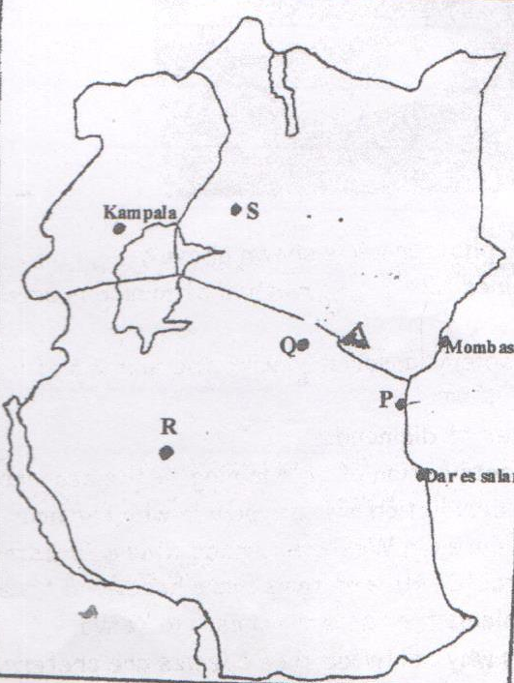
Dar es salam
Mombasa
Kampala
S
R
Q
P

a) Name the towns marked P, Q and R. (3 marks)
b) State two major functions of the town marked S. (2 marks)

SECTION B (75 MARKS)
Answer question 6 and any other two questions from this section
6. The table below shows the value of export crops from Kenya in the year 1995.
Use it to answer the questions below.
Crop / Year | 1995
Maize | 224,000,000
Coffee | 168,000,000
Tea | 320,000,000
Horticultural | 190,000,000
TOTAL | 902,000,000

a) i) Draw a divided rectangle measuring 15cm to represent the above data. (9 marks)
ii) State three advantages of using divided rectangles to represent geographical data. (3 marks)
b) State four physical conditions that favour coffee growing in Kenya highlands. (4 marks)
c) Describe the processing of coffee from harvesting to marketing. (6 marks)
d) List three ways in which planted coffee is taken care by farmers. (3 marks)

7. Use the map of Kenya below to answer question 7. a) i), ii) and iii).
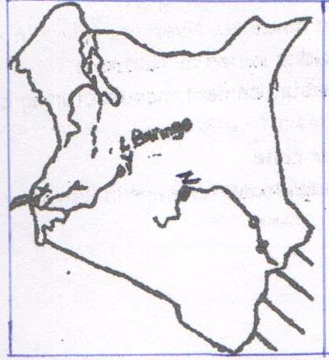
L. Baringo
Y
X
Z

a) i) Identify the irrigation schemes marked X, Y and Z and in each case the main crop grown. (6 marks)
ii) Explain four factors that led to the location of irrigation scheme Y. (8 marks)
iii) State four problems that are experienced in the irrigation marked Z. (4 marks)
b) What is a polder? (2 marks)
c) Give five benefits of the Zuyder Zee project. (5 marks)

8. a) i) Name two types of fishing grounds in Kenya. (2 marks)
ii) Give two types of fishing methods. (2 marks)
iii) Give four reasons why marine fishing industry in east Africa is not well developed. (4 marks)
b) Explain four ways in which marine fisheries are being conserved in Kenya. (8 marks)
c) Use the map of North America below to answer questions (i) and (ii).
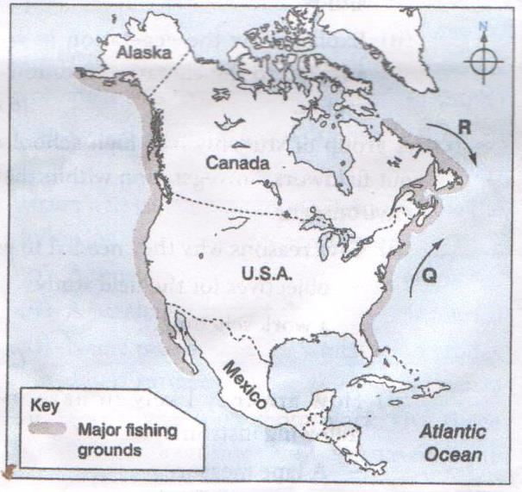
i) Name one method of fishing used in the shaded area. (1 mark)
ii) Name ocean currents marked Q and R. (2 marks)
d) Explain why major fishing grounds of the world are located in the temperate latitudes
of the northern hemisphere. (6 marks)

9. a) Distinguish between manufacturing and tertiary industries. (2 marks)
b) i) Name four agricultural food processing industries in Kenya. (4 marks)
ii) Explain four factors that influenced the location of the iron and steel industries in
the Ruhr region of Germany. (8 marks)
c) Give five reasons why the government of Kenya encourages the establishment of Jua
Kali industries. (5 marks)
d) You intend to carry out a field study in a coffee factor near your school.
i) State three reasons why you would visit the area of study in advance. (3 marks)
ii) You have prepared a working schedule for your study.
State three items you would include in your schedule. (3 marks)

10. a) Draw an outline map of Kenya. (2 marks)
b) On the map indicate the following forests. (3 marks)
i) Kakamega forest
ii) Mt. Kenya forest
iii) Arabuko sokoke forest
c) i) Name three natural causes of forest depletion. (3 marks)
ii) Describe four problems facing forests in Kenya. (8 marks)
d) i) State three factors favouring production of soft wood forests in Canada. (3 marks)
ii) Explain three reasons why the Kenyan government should conserve her forests. (6 marks)

