NAME…………………………………………………………………………………INDEX No………………
CLASS………………………….

AGRICULTURE
443/2
PAPER 1
2 HOURS
PRE-MOCK
TRIAL 6

FORM FOUR
2018
Kenya Certificate of Secondary Education (K.C.S.E)

AGRICULTURE
443/2
PAPER 1
2 HOURS

INSTRUCTIONS TO CANDIDATES
- Write your name and index number at the top of the space given
- This paper has three sections
- Answers all question in section A and B and any 2 from section C
- Answer your questions in the spaces provided.

SECTION A (30MK)
ANSWER ALL QUSTIONS
- Name the dairy cattle breed that provide milk with the highest butter fat content ( ½ mark)

- State the name given to young ones of each of the following animals. (1 ½ marks)
- Rabbit

- Goat

- Pig

- Name the hormones that control milk let down (1mark)

- Name the most appropriate tool used in the following operations
- Cutting identification marks on ears of an animal ( ½ mark)

- Removal of gases which cause bloat in ruminants ( ½ mk)

- Trimming hedges and shrubs ( ½ mark)

- Give three reasons why ewes disown lambs (1 ½ mark)

- List four disadvantages of live fences (2mark)

- Name four light breeds of poultry (2marks)

- State the functions of the following parts of an ox-drawn plough
- Landside ( ½ mark)

- Land wheel ( ½ mark)

- Share ( ½ mark)

- Distinguish between randling and ringing as used in animal production (1mark)

- State 2 causes of bloat in ruminants animals (1mark)

- Diffreciate quarantine and isolation as used in livestock health. (1mark)

- Name three sources of water in animal’s body (1 ½ mark)

- Name any four water fish reared in farm ponds today (2marks)

- Give a fictional difference between a shoves and a spade (1marks)

- State the functions of a ring spanner (1mk)

- Give four methods of harnessing tractor power (2marks)

- (a)Give two maintaince practices of a milking equipment (1mark)

(b)Give two condition that may make a dairy cow withhold milk during milking (1mark)

- List four advantages of embryo transplant as used in livestock production (2marks)

- Give four ways in which famers can control cannibalism in poultry farming (2marks)

- Give four chacteristics of succulent roughages (2marks)

SECTION B
(ANSWER ALL QUESTIONS IN THE SPACES PROVIDED)
- Below are two diagrams of youth chick m and n showing deficiency of certain nutrient
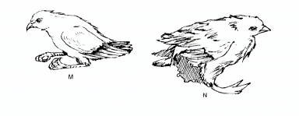
- Identify the nutrient the two chicks are lacking (1mark)
M
N
- State two sources of nutrient chick N is lacking (2mark)

- State the condition chick N is suffering from (1mark)

- Other than the condition shown in chick B above give other symptoms of the deficiency (2mark)

- Study the illustration of the farm structure below and answer the questions that follow:
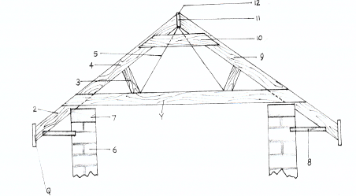 F
- Identify the parts labeled 5, 7, 9 and 10 (2marks)
5
7
9
10
- State one reason why it’s important to have structure labeled F at the edge of the rooting material.

- The diagram below is a cross section of part of cow’s udder.
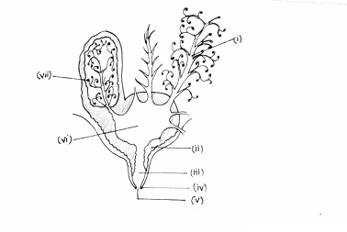
- Label the part’s numbered III, IV, VI, AND VII (2marks)
III
IV
VI
VII
- What is milk let down (1mark)

- Give two characteristic of clean and high quality milk (2marks)

- The diagram below illustrate a disc plough study it carefully and answer the question that follow.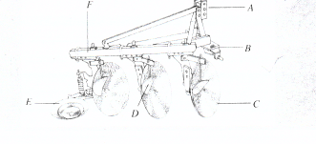
- Label the parts marked A,B and D. (3marks)
A
B
D

- Give the functions the parts marked C and F (2marks)

- State one reason why animals should be watered before dipping (1mark)

SECTION C
- Discuss milk fever under the following sub-heading
- Animals affected (1mark)

- Symptoms of attack (7marks)

- Discuss African swine fever under the following sub- heading
- Animal affected (1mark)

- Causal organism (1mark)

- Symptoms (6marks)

- A.Describe various care and maintenance of a tractor battery (6marks)

B. Outline the expected causes of the following faults of ignitions system of a tractor
- Sudden stopping (2marks)

- Continuous Engine running (3marks)

C) Discuss advantages of battery cage system in poutry rearing (9marks)

- A. Discuss digestion of food in poutry from crop to gizzard (10marks)

B. Give any 4 Harmful effects of Keds in livestock. (4marks)

C. Describe functions of the following parts of plunge dip
- Jump (2marks)

- Drainage race (2marks)

- Roof (2marks)

