NAME………………………………………………………………………………………………………………..INDEX No………………..
CLASS………………………………………

231/2
BIOLOGY
PAPER 2
Time: 2hrs.
PRE-MOCK
TRIAL 6

FORM FOUR
2018
Kenya Certificate of Secondary Education (K.C.S.E)

231/2
BIOLOGY
PAPER 2
Time: 2hrs.
PRE-MOCK

SECTION A(40 MARKS)
Answer all the questions in the spaces provided
1. The diagram below shows the base sequence of a part of a nucleic acid strand. Observe it and answer the questions that follow.
CAAUGCACA
(a) State whether it is a DNA or RNA strand. Give a reason for your answer. (2marks)

(b) Apart from the reason you have given in (a) above write two other differences between DNA and RNA strands. (2marks)

C) Write a
(i) Complementary DNA strand to the one above (1mark)

(ii) Complementary RNA strand to the one above (1mark)

2(a) Name the substance which accumulates in muscles when respiration occurs in the absence of oxygen. (1mark)

(b) The equation below represents a process that occurs in plants at certain times.
C₆H₁₂O₆ 2C ₂H₅ OH + CO ₂ + Energy

(i) Name the process (1mark)

(iii) State two differences that would be observed if the same process occurred in animal tissues under similar conditions. (2marks)

c) Where does respiration take place in a cell (1mark)

3(a) A light microscope is an important apparatus in a laboratory. State two precautions which should be taken when storing the light microscope. (2marks)

(b) State functions of the following parts on a microscope.
(i) Fine adjustment knob (1mk)

(ii) Condenser (1mark)

(c) Briefly explain why one should NEVER use the coarse adjustment knob to focus specimens under high power objective lens. (2marks)

4(a) Explain the significance of the following in photosynthesis. (3marks)
(i) Light;

(ii) Carbon IV oxide;

(iii) Chlorophyll;

(b) Name one appropriate food substance for each of the following enzymes. (2marks)
(i) Ptyalin
(ii) Pepsin
(c) State the cause and two symptoms of Beriberi (1mark)
Cause ______________________________________

Symptoms (2marks)
(i)

(ii)

5 In maize the gene four purple colours is dominant to the gene for white colour. A pure breeding maize plant with purple grains was crossed with a heterozygous plant
(a) Using letter G to represent the gene for purple colour, work out the genotypic ratio of the offspring.
(5marks)

(ii) State the phenotype of the offspring (1mark)

(b) What is hybrid vigour? (1mark)

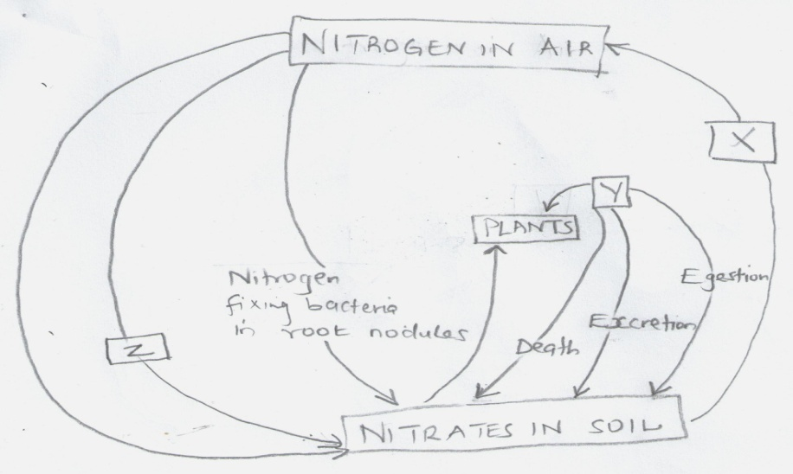
6 The chart below represents a simplified nitrogen cycle

(a) What is represented by x,y and z? (3marks)
X
Y
Z

(b) Name two species of nitrogen fixing bacteria. (2marks)

7 Explain the following terms
(a) organic evolution (1mark)

(b) Special creation (1mark)

(c) Adaptive radiation (1mark)

SECTION B (40 MARKS)
Answer question 8(compulsory) in the spaces provided and either question 9 0r
8 The table below shows how the quantities of sweat and urine vary with external temperature.
External temperature ºC | Urine cm³/h | Sweat cm³/h
0  5  10  15  20  25  30  35 | 100  90  80  70  60  50  40  30 | 5  6  10  20  30  60  120  200

(a) Plot the quantities of urine and sweat produced against the external temperature. (6mks)

(b) At what temperature are the amount of sweat and urine produced equal. (1mk)

(c) What happens to the amount of sweat produced as the temperature rise? Explain the observation
(3marks)

(d) Explain the observation made on the amount of urine produced as the temperature increases.
(3marks)

(e)i Which hormone is responsible for the reabsorption of water from the glomerular filtrate from the kidney
tubules. (1mark)

(ii) Which gland is responsible for secreting the hormone you have named in (i) above. (1mark)

f) How is the skin adapted for temperature regulation. (5marks)

9(a) State three ways in which a respiratory surface is adapted to its function. (3marks)

(b) Name three sites of gaseous exchange in frogs. (2marks)

(c) Describe the mechanism of gaseous exchange in a mammal. (14 marks)

10 Explain how structural features in terrestrial plants affect their rate of transpiration. (20 marks)

