NAME……………………………………………………………INDEX No………….…
CLASS………………………….

231/3
BIOLOGY
PAPER 3
PRACTICAL
TIME: 1³/₄HRS
PRE-MOCK
TRIAL 6

FORM FOUR
2018
Kenya Certificate of Secondary Education (K.C.S.E)

231/3
BIOLOGY
PAPER 3
PRACTICAL
TIME: 1³/₄HRS
PRE-MOCK

1. You are provided with a specimen labelled J.
(a) With reasons identify the organ of a plant represented by J. (1mark)
Reasons (2marks)

(b) Using observable features only identify the class to which J belongs.
Class (1mark)

Observable features. (1mark)

(c) In a previous experiment the lower epidermis and the upper epidermis were peel off, the number of stomata was determined using a microscope at high power objective. The results obtained are recorded in the table below.

Arrange number of stomata in the field of view
Lower epidemis | Upper epidermis
30 | 13

(1) Account for the average number of stomata on the upper and lower side of specimen J.
Upper epidermis. (3marks)

Lower epidermis. (3marks)

2 You are provided with photographs of:
Specimen SI – mango fruit
Specimen T1 – Garden pen pod U
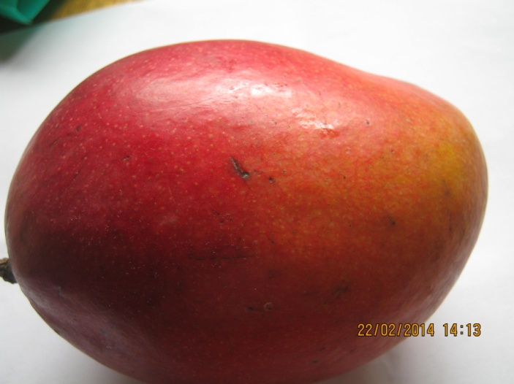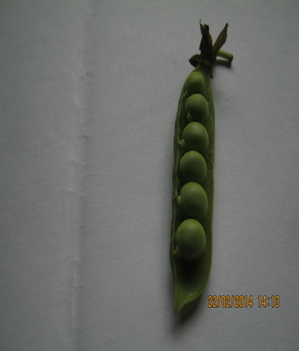
v
w
X
S1 TI
(a) Specimen SI was cut longitudinally. The photograph below shows one half
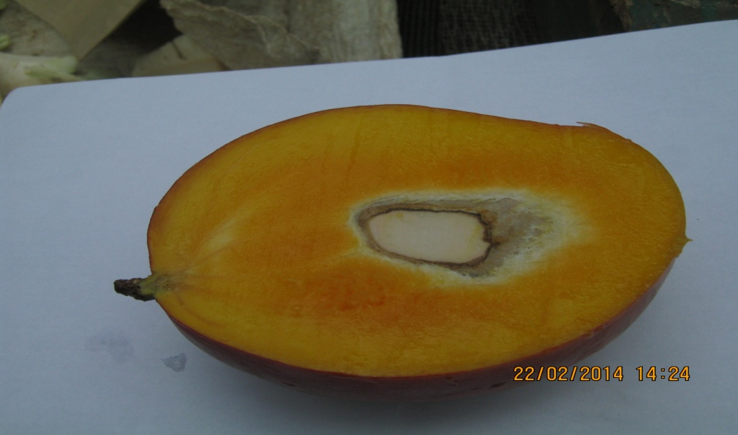
C
d
c
a
b
S1
(i) Name the parts labelled a,b,c,d and e (5marks)
a-
b
c-
d-
e
Study the photographs of specimen T₁ and name the parts labelled u,v,w,x ,y and z (4marks)
labeled
u-
v-
w-
x-
y-
z-

(iii) Identify the type of presentation in each fruit. (2marks)
S₁
T₁
(b) Using observable features identify the method of dispersal for each fruit and in each care give reasons for your answer.
S₁
Method of dispersal (1mark)

Reasons (3marks)

T₁
Method of dispersal (1mark)
Reasons (2marks)

(c) Name the type of fruits represented by
S₁ (1mark)

T₁ (1mark)

(d) What is the importance of fruit and seed dispersal. (3marks)

Q3 You are provided with solution S
(a) Using the reagents provided to carry out the appropriate food tests and complete the table below. (8marks)
Food substance | Procedure | Observation | Conclusion

