NAME:……………………………………………………… INDEX NO:…………………………
SCHOOL:………………………………………………….. DATE:……………………………….
SIGN:………………………………..

231/1
BIOLOGY
PAPER I
(THEORY)
JUNE 2018
TIME: 2 HOURS

MOI HIGH SCHOOL - KABARAK
KASSU JET EVALUATION – 2018
Kenya Certificate of Secondary Education (K.C.S.E)

INSTRUCTIONS TO CANDIDATES

(a) Write your name and Index number in the spaces provided.
(b) Answer ALL questions in the spaces provided.
(c) Candidates check the question paper to ascertain that all the papers are printed

FOR EXAMINERS USE ONLY.

QUESTIONS | MAXIMUM SCORE | CANDIDATES SCORE
1 – 30 | 80

This paper consists of 9 printed pages. Candidates should check the question paper to ensure that all pages are printed as indicated and that no questions are missing.

1. Name two components of blood that are absent in the tissue fluid. (2mks)
……………………………………………………………………………………………………..
……………………………………………………………………………………………………..
2. The following is a drawing of a cell structure.
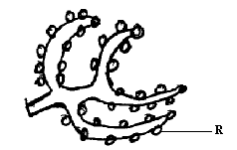

i) Identify the cell structure. (1 mark)

…………………………………………………………………………………………………….. ……………………………………………………………………………………………………..

ii) Give the function of the part labelled R. (1 mark)
……………………………………………………………………………………………………..
……………………………………………………………………………………………………..
3. (a) Name the association between leguminous plant and rhizobium bacteria. (1mk)
……………………………………………………………………………………………………..
……………………………………………………………………………………………………..
(b) State the population estimation method of grasshoppers in your school compound. (1mk)
……………………………………………………………………………………………………..
……………………………………………………………………………………………………..
4. State the function of the following apparatus.
(a) A sweep net. (1mk)
……………………………………………………………………………………………………..
……………………………………………………………………………………………………..
(b) A bait trap. (1mk).
……………………………………………………………………………………………………..
……………………………………………………………………………………………………..

5. The diagram below shows a certain eye defect.

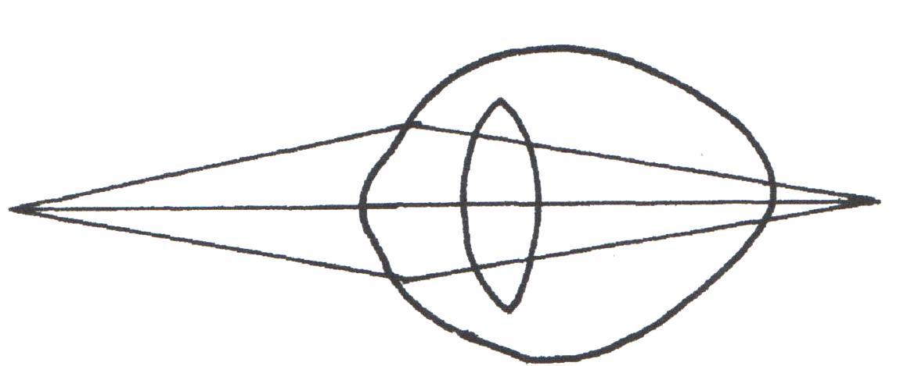

- State the defect. (1mk)
……………………………………………………………………………………………………..
……………………………………………………………………………………………………..

- On the diagram illustrate how the defect can be corrected. (2mks)
…………………………………………………………………………………………………
……………………………………………………………………………………………………

(c) State one advantage of having two eyes in human beings. (1 mk)
……………………………………………………………………………………………………..
……………………………………………………………………………………………………..
6. The diagram below represents the mammalian vertebra.
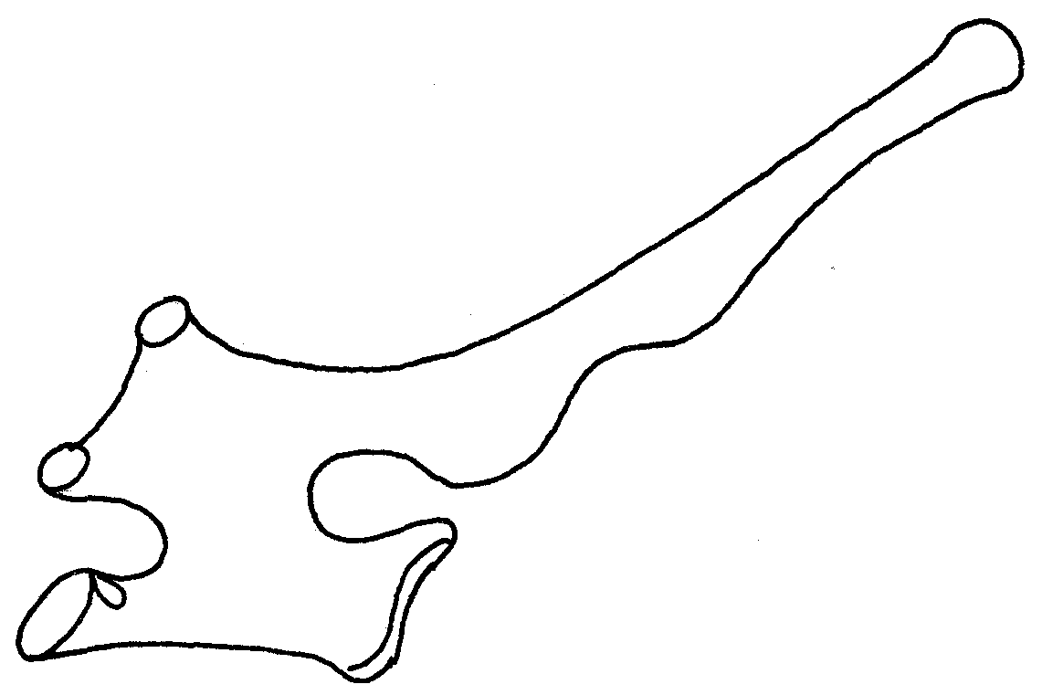
(a) Identify the vertebra represented above. (1mk)
……………………………………………………………………………………………………..
……………………………………………………………………………………………………..
(b) Give a reason for your answer. (1mk)
……………………………………………………………………………………………………..

7. The diagram below represents one of the specialized cells found in the human body.
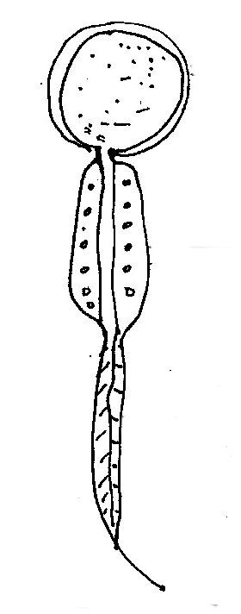
K

L

M

(a) Identify the cell. (1mk)

……………………………………………………………………………………………………..
(b) Name the parts labeled. K and L. (2mks)

K……………………………………………………………………………………………………..

L……………………………………………………………………………………………………..

(c) What is the function of part labeled M? (1mks) ………………………………………………………………………………………………………
8. State three theories that explain the mechanism of opening and closing of stomata. (3 mks)
……………………………………………………………………………………………………..
…………………………………………………………………………………………………….. ……………………………………………………………………………………………………..
9. Describe how human skin reacts to sudden cold when one takes a cold shower in the morning.
(2 mks) ……………………………………………………………………………………………………..
……………………………………………………………………………………………………..
……………………………………………………………………………………………………..
10. A student visiting a game park observed that an adult elephant flapping its ears twice as much as
its calf in order to cool its body when it is hot. Explain. (2mks)
……………………………………………………………………………………………………..
……………………………………………………………………………………………………..
……………………………………………………………………………………………………..
……………………………………………………………………………………………………..
11. Name any three divisions in the kingdom plantae. (3mks)
……………………………………………………………………………………………………..
……………………………………………………………………………………………………..
12. (a) Distinguish between the terms transpiration and Guttation. (1 mks)
……………………………………………………………………………………………………..
……………………………………………………………………………………………………..

(b) State the structures through which each of the process named in (a) above occurs. (2mks)
……………………………………………………………………………………………………..
……………………………………………………………………………………………………..
……………………………………………………………………………………………………..
13. Study the diagram below of a neurone in human being.

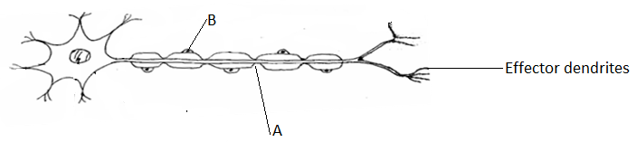
(a) Identify the type of neurone. (1mk)
……………………………………………………………………………………………………..
……………………………………………………………………………………………………..
(b) Name the parts labeled. A and B. ( 2 mks)

A……………………………………………………………………………………………………..
B……………………………………………………………………………………………………
(c) On the diagram indicate the direction of movement of a nerve impulse along the neurone (1 mk )

……………………………………………………………………………………………………..
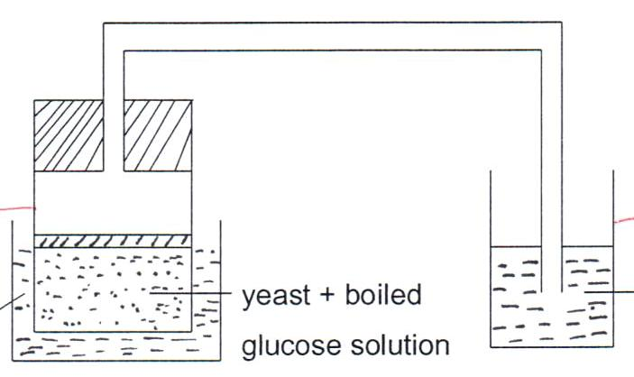
14. The diagram below illustrates an experiment to demonstrate the gas produced during fermentation.

Test Tube B
Test Tube
A
Lime Water
Water bath
37⁰C

After one hour the following observations were made:

- Gas bubbles appear in both tubes.
- White precipitate formed in lime water.

- Account for the above observations. (3mks)
……………………………………………………………………………………………………..
..……………………………………………………………………………………………………..
……………………………………………………………………………………………………..
……………………………………………………………………………………………………..

- Explain how you can set a control for the experiment. (1mk)
….………………………………………………………………………………………………..
……………………………………………………………………………………………………..

15. (a) State the part of the brain that controls breathing movements in man. (1mk)
……………………………………………………………………………………………………..
…………………………………………………………………………………………………….. (ii) Maintenance of body posture and balance. (1 mk)
……………………………………………………………………………………………………..
……………………………………………………………………………………………………..
(b) State two survival values of tactic responses. (2mk) …………………………………………………………………………………………………..
……………………………………………………………………………………………………..
16. State the function of the following structures found in a mammalian ear. ( 3 mks) (a) Cochlea.
………………………………………………………………………………………………………
……………………………………………………………………………………………………….
(b) Eustachian Tube.
……………………………………………………………………………………………………….
………………………………………………………………………………………………………
(c) Semi-circular canals.
……………………………………………………………………………………………………….
………………………………………………………………………………………………………
17. The diagram below shows a seed of a certain plant.
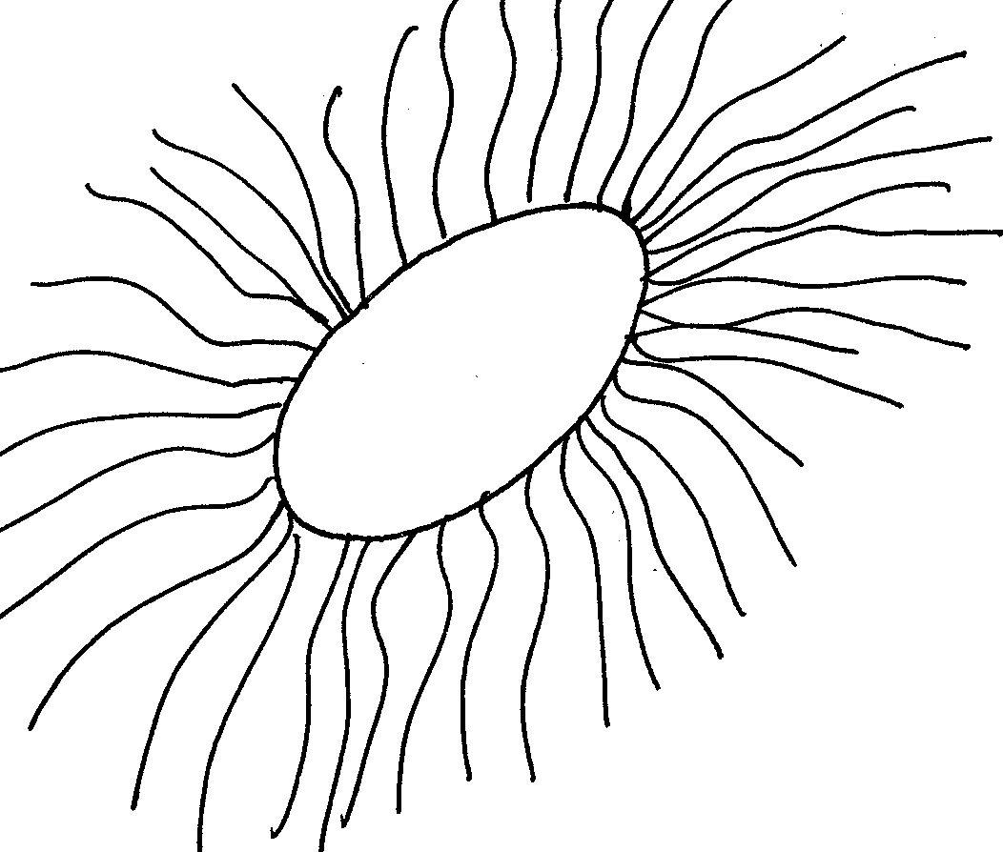

(a) Name the likely agent of dispersal. (1mk)
……………………………………………………………………………………………………..
(b) Give a reason for your answer. (1mk)
……………………………………………………………………………………………………..

18. Name two classes of the phylum Arthropoda that have cephalothorax. (2mks)
……………………………………………………………………………………………………..
……………………………………………………………………………………………………..
19. (a) Name the source of hydrochloric acid in the mammalian stomach. (1mk)
……………………………………………………………………………………………………..
(b) Study the diagram of the mammalian tooth below and answer the questions that follow.
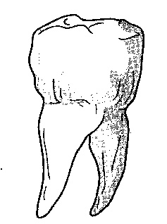

.

- Identify the tooth. ( 1mk)

……………………………………………………………………………………………………..
……………………………………………………………………………………………………..

- Give a reason for your answer in (a) above. (1mk)
……………………………………………………………………………………………………….
……………………………………………………………………………………………………….

- State one adaptation of the tooth to its function. (1 mk)
……………………………………………………………………………………………………..

20. Name one condition caused by gene mutation. (1 mks)
……………………………………………………………………………………………………..
……………………………………………………………………………………………………..

21. Differentiate between intracellular and extracellular enzymes, giving an example in each case. (3mks)
……………………………………………………………………………………………………..
……………………………………………………………………………………………………..
……………………………………………………………………………………………………...
22. During a practical lesson to estimate the size of a cell a student observed and sketched the diagram below. Using information from the sketch, calculate the length of one cell in micrometers given the field of view was 8mm in width. (3 mk)
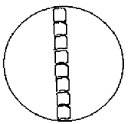
……………………………………………………………………………………………………..
……………………………………………………………………………………………………..
……………………………………………………………………………………………………..
23. If pepsinogen and trypsinogen were produced in their active forms, what would be their effect on the alimentary canal? (1mk)
……………………………………………………………………………………………………..
……………………………………………………………………………………………………..
24. State the stage in meiosis where the following take place.
(a) Disappearing of nucleolus. (1mk)
……………………………………………………………………………………………………..
(b) Formation of new spindle fibres. (1mk)
……………………………………………………………………………………………………..
(c) Formation of separate cells each with haploid number of chromosomes. (1mk)
……………………………………………………………………………………………………..
25. State the function of the following structures. (3mks)
i. Seminiferous tubule.
……………………………………………………………………………………………………..
…………………………………………………………………………………………………..…
iii. Prostate gland.
……………………………………………………………………………………………………..
……………………………………………………………………………………………………..
ii. Epididymis.
…………………………………………………………………………………………………..………………………………………………………………………………………………………..
26. (a) What is meant by organic evolution. (1mk)
……………………………………………………………………………………………………..

(b) State two limitations in use of fossil records in retracting the evolutionary history
of all modern day organisms. (2 mks)
……………………………………………………………………………………………………..
……………………………………………………………………………………………………..
……………………………………………………………………………………………………..
27. State two ways in which knowledge of genetics has been applied by humans. ( 2 mk)

……………………………………………………………………………………………………..
……………………………………………………………………………………………………..
……………………………………………………………………………………………………..
28. State two advantages of metamorphosis to the life of insects. (2mks)
……………………………………………………………………………………………………..
……………………………………………………………………………………………………..
……………………………………………………………………………………………………..
29. State two types of immunity. (2 mk)
……………………………………………………………………………………………………
……………………………………………………………………………………………………
30. Give three features that make mammalian alveoli adapted to gaseous exchange. (3 mks)
……………………………………………………………………………………………………..
……………………………………………………………………………………………………..
……………………………………………………………………………………………………..
THE LAST PAGE

