KASSU JET EXAM

451/2 - COMPUTER STUDIES - Paper 2
(PRACTICAL)
JUNE. 2018 - 2 ¹/2 hours

Instructions to candidates
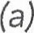Write your name, class and admission number at the top right hand corner of each of the papers provided for printing.
- Write your name, class and admission number on the CD/Removable storage medium provided.
- Write the name and version of the software used for each question attempted in the printouts used.
- Answer all the questions.
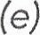 All questions carry equal marks.
- Passwords should not be used while saving files.
- All files must be transferred to the CD/Removable storage medium.
- Make printouts of your answers on the papers provided for printing. Arrange your printouts and tie/staple them together.
- Hand in all the printouts and the CD/Removable storage medium used.
- This paper consists of 5 printed pages.
- Candidates should check the question paper to ascertain that all the pages are printed as indicated and that no questions are missing.
- Candidates should answer the questions in English.

- (a) (i) Create a folder. The name of the folder should be the last three digits of your index number. (1 Mark)
(ii)The table below shows extract books stored in Kassu School Library System
Student  ID | Book  ID | Student  Name | Gender | Class | Book  Name | Purchase Price | Publisher Name | Publisher  ID | Book Shelf Number
104 | 11-01 | Leshan | F | 3P | Enemy | 480 | Topex | Pu-1 | 12
106 | 11-02 | Losim | M | 3R | Arrow | 600 | Apex | Pu-2 | 13
120 | 12-01 | Taabu | F | 3R | Spear | 560 | Sky | Pu-3 | 16
189 | 12-02 | Amina | F | 3P | Enemy | 480 | Topex | Pu-1 | 12
199 | 13-01 | Mapenzi | F | 3S | Arrow | 600 | Apex | Pu-2 | 13
200 | 11-01 | Krop | M | 3P | Spear | 560 | Sky | Pu-3 | 16
210 | 11-02 | Kasuku | M | 3W | Enemy | 480 | Topex | Pu-1 | 12
222 | 12-01 | Karema | M | 3S | Arrow | 600 | Apex | Pu-2 | 13
234 | 13-01 | Bahati | F | 3P | Spear | 560 | Sky | Pu-3 | 16
244 | 13-02 | Amina | F | 3W | Spear | 560 | Sky | Pu-3 | 16
256 | 11-02 | Kemboi | M | 3W | Cloud | 720 | Romeo | Pu-4 | 20
270 | 13-02 | Atieno | F | 3W | Beta | 800 | Romeo | Pu-4 | 22
Table 1
(iii) Using a database application package, create a database file named Kassu Lib _2018.
(1 Mark)
(iv) Create three tables, one to store student details, book details and publisher detail. Name the tables as ‘Student_Table and Book_Table and Publisher_Table. (3 Marks)
(v) Assign an appropriate primary key to each table. (2 Marks)
(vi)Create a relationship between the three tables. (2 Marks)
(b)(i)Create data entry form for each table. (2 Marks)
(ii)Use the forms to enter the respective the data in table 1 above. (10 Marks)
(c) Modify the books table so as to capture the date the book was borrowed and returned for each student as shown below. (3 Marks)
Student  ID | Date borrowed | Date returned
104 | 03/03/2018 | 12/03/2018
106 | 13/03/2018 | 18/03/2018
120 | 23/03/2018 | 21/03/2018
189 | 18/03/2018 | 29/03/2018
199 | 15/03/2018 | 27/03/2018
200 | 10/03/2018 | 29/03/2018
210 | 11/03/2018 | 19/03/2018
222 | 12/03/2018 | 21/03/2018
234 | 09/03/2018 | 26/03/2018
244 | 03/03/2018 | 13/03/2018
256 | 09/03/2018 | 13/03/2018
270 | 17/03/2018 | 23/03/2018

- (i) Create a query named B_Query to display student, books, purchase price, publisher, gender, class and record whose student whose name start with letter ”K”. (4 Marks)
(ii) Create a query named Overdue_Query to display BookID, student names, gender, class books borrowered , publisher, and their respective prices. List of overdue books showing their respective overdue days. A book is termed overdue if a stuent stays with it for more than 14 days without returning. (8 Marks)
- Compute total cost of overdue books.
- Sort the records in descending order overdue days.
- Create a report named S_Report to display BookID, student name, book category, purchase price, publlisher name, class, and books shelf number. (7 Marks)
- The records in the report should be grouped by class.
- Show the number of students per class.
- Title the report “Kassu School Library Management System”.
(g) Generate a bar chart to show all students and their respective numberof days the book was borrowed. (2 Marks
Print the following: (3 Marks
- Table : Student, Book and Publisher.
- Queries : B_Query, Overdue
- Report: S_Report

2. The manager of Regent Book Supplies provided his business card shown below for reproduction.
Front

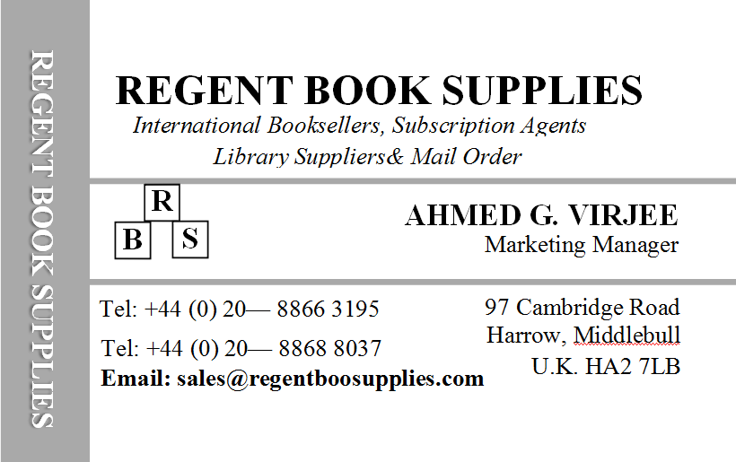

Back
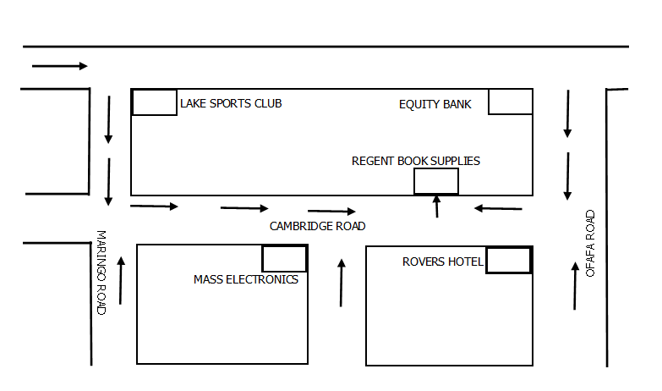

- Using a desktop publisher, create for him the job cards as they appear with the following additional specifications; (20 Marks)
Font type: - Front: Times new Romans, Back: Tahoma
Font size: - 14, 10 & 8 (front) and 4 (Back) respectively
Margins: - 5cm /0.197 1nches
- Group the elements of each side of the card (4 Marks)
- Rename the publication pages FRONT and BACK respectively (4 Marks)
- Save your publication Draft job card (3 Marks)
- Open a new publication and set it to have A4 paper size (3 Marks)
- Copy the front and the back sides of the card from your Draft job card publication to your new publication and make 6 copies of each on their respective pages (5 Marks)
- Arrange and align the card parts (2 columns and 3 rows) such that the front part is in line with the back part for uniform trimming without wastage (5 Marks)
- save it as final job card (2 Marks)
- print a back to back copy of the final job card (4 Marks)

