NAME: ……………………………………. INDEX NUMBER: ……………………………….
SCHOOL: ………………………………… CANDIDATES SIGNATURE: …………………..
DATE: ……………………………………………..
451/2
COMPUTER STUDIES
PRACTICAL
PAPER 2
2¹/₂Hours
PRE-MOCK
TRIAL 6

FORM FOUR
2018
Kenya Certificate of Secondary Education (K.C.S.E)

451/2
COMPUTER STUDIES
PRACTICAL
Paper 2
Time: 2¹/₂ Hours

INSTRUCTIONS TO CANDIDATES

- Indicate your name and index number at the top right of each printout.
- Write your name and index number on the storage medium provided.
- Write the name and version of the software used for each question attempted in the answer sheet.
- Passwords should not be used while saving in the storage medium.
- Answer all the questions.
- All questions carry equal marks
- All answers must be saved in your storage medium
- Make a printout of the answers on the answer sheets provided.
- Hand all the printouts and the storage medium.

This paper consists of 1Printed pages.
Candidates should check the question paper to ensure that all the
Papers are printed as indicated and no questions are missing.
1. Word processor
(a) Type the text below as it is into a word processing software (20 marks)

The corporate world has its own range of stress designed to play havoc with the psyche of
an employee coping with ambiguous instructions, difficulties in co-ordination amongst various department, communication gaps, alienation and the constant conflicts that occurs between the employee’s and the corporate norms or objectives are just a few of these. Many employees, with creative potential, exhibit a total lack of motivation and resign themselves to a boring routine, because of external compulsion. As they enter the corporate scene, many compromise their creative needs. They were compelled to hide their true selves-behind their corporate masks and follow the script written by their seniors and bosses.
Stress is created in the mind and this is where all attention is to be focused. Stress is not everybody’
(First) Delicacy
(Second) Anxiety
(Third) Insomnia
(Forth) Irritability
(Fifty) Depression
(Sixth) Blood pressure and other cardiovascular complications.

STRESS CAUSING FACTORS
EXTERNAL STRESS CAUSING FACTORS
Highest Stress Rating | High stress Rating | Moderate stress rating | Low stress rating
Death of partner | Reconciliation with a partner | Family Arguments | Change of school
Divorce or separation | Retirement | Large mortgage bond | Holidays
Prison Sentence | Pregnancy | Difficulties with  in-laws | Change of contacts with relatives
INTERNAL STRESS CAUSING FACTORS
- Avoidance – avoidance conflicts
- Approach Approach conflicts
- Approach Avoidance conflicts
- Personality
- Guilt
- temperaments

- Copy the first and justify the whole document, and at the centre insert the footnote
“Borabu Evaluation Test” (5 marks)

(c) Space the whole document into 1.5 spacing in1b) above (5 marks)

(d) Create the object below using the drawing toolbar (20marks)
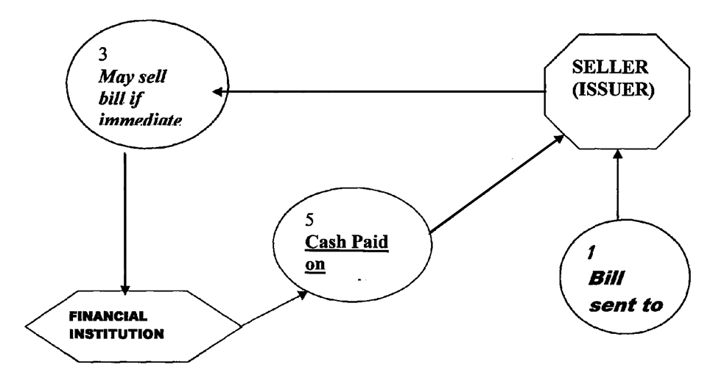
2. The information given below is on Item code, supplier and units of order for a supply- chain department.

- Table x (item code table) contains four fields representing Item ID, Name of the item, the retail price of a unit of the item, and the number of units of the item in store respectively. The primary key of an item is its Item ID

- Table y( Supplier Table) contains five fields representing Supplier code, name of the supplier, the supplier contact address, city and mobile telephone number respectively. The primary key is the supplier code.

- Table z (Units ordered Table) contains seven fields representing, units ordered ID, Item ID, Supplier Code, the wholesale price of a unit of the product ordered from the supplier, the number of units of the product, the date the product was ordered and the date the ordered product was received respectively. The primary key is the
Unit Ordered ID.
Table x (Item Code Table)
1  2  3  4  5  6  7  8  9  10 | Baking powder  Kimbo 2kg  Cowboy  Salt  Sweets  Blanket  Shoes  Plastic bags  Sugar  Umbrella | 150  240  130  85  750  950  2999  458  100  399 | 450  180  65  152  452  235  568  542  865  120

Table y (supplier Table)
501  502  503  504  505  506 | Jonase  Kriarie  Jailing  Kush  Delmonte  Tegemea | 65238  5623  58794  4875  7598  54878 | Kisii  Nakuru  Malindi  Narok  Thika  Kisii | 0733586845  0725683654  0734857423  0723864203  0723589541  0733648752
Table z (units ordered table)
5001  5003  5006  5010  5009  5005  5007 | 1  5  3  9  5  2  7 | 503  505  501  502  503  502  505 | 32  14  18  42  23  13  25 | 30  56  23  18  36  24  52 | 6/7/05  5/08/06  6/08/06  02/03/05  03/04/07  05/07/07  05/09/08 | 28/07/05  23/09/07  25/07/05  27/07/07  30/09/08
(a) Use the information to create a database named A: Obama DB and enter the data in
tables x,y,z. (30 marks)

(b) (i) create the relationships between the tables. And save query as borabu 1 (4 marks)
(ii) Using table Z creates a query of the supplier code, item ID, product order date,
extract all records whose item ID is greater than 6 save borabu 2 (7 marks)

(c) Create a form to allow the entering of the item code details and add an appropriate form title. Save as borabu item details. (4mks)

(d) Print the three tables x, y, z,, Borabu 2 and borabu item detail (5mks)

END

