**NAME………………………………………INDEX NUMBER…………………………….…**

**DATE………………………………**

**121/2**

**MATHEMATICS**

**PAPER 2**

**TIME: 2½ HOURS**

**PRE-MOCK**

**TRIAL 6**

**FORM FOUR**

**2018**

***Kenya Certificate of Secondary Education (K.C.S.E)***

**MATHEMATICS**

**PAPER 2**

**TIME: 2½ HRS.**

**INSTRUCTION TO CANDIDATE’S:**

1. *Write your* ***name****,* ***index number*** *and* ***school*** *in the spaces provided above.*
2. *Write the* ***date*** *of examination in spaces provided.*
3. *This paper consists of* ***two*** *Sections; Section* ***I*** *and Section* ***II****.*
4. *Answer* ***ALL*** *the questions in Section* ***I*** *and any* ***five*** *questions from Section* ***II****.*
5. *All answers and working must be written on the question paper in the spaces provided* ***below*** *each question.*
6. *Show all the steps in your calculation, giving your answer at each stage in the spacesprovided*

***below*** *each question.*

1. *Marks may be given for correct working even if the answer is wrong.*
2. *Non-programmable silent electronic calculators and KNEC Mathematical tables* ***may be****used,*

*except where stated otherwise.*

1. *Candidates should check the question paper to ascertain that all the pages are printed as indicated and that no questions are missing.*
2. ***Candidates should answer the questions in English.***

**FOR EXAMINER’S USE ONLY:**

**SECTION I**

|  |  |  |  |  |  |  |  |  |  |  |  |  |  |  |  |  |
| --- | --- | --- | --- | --- | --- | --- | --- | --- | --- | --- | --- | --- | --- | --- | --- | --- |
| 1 | 2 | 3 | 4 | 5 | 6 | 7 | 8 | 9 | 10 | 11 | 12 | 13 | 14 | 15 | 16 | TOTAL |
|  |  |  |  |  |  |  |  |  |  |  |  |  |  |  |  |  |

**SECTION II**

|  |  |  |  |  |  |  |  |  |
| --- | --- | --- | --- | --- | --- | --- | --- | --- |
| 17 | 18 | 19 | 20 | 21 | 22 | 23 | 24 | TOTAL |
|  |  |  |  |  |  |  |  |  |

|  |
| --- |
| GRAND TOTAL |
|  |

**SECTION I: (50 MARKS)**

*Answer all the question in this section in the spaces provided:*

1. Use logarithm tables to evaluate (4marks)

58.32 x (0.9823)2

3

693.5

1. Given that is a perfect square, find K. (3 marks)
2. Make **t** the subject of the formula

(3marks)

3 3h (t - h)

t

x =

1. (a) Expand (1 – 2***x***)6 in ascending powers of ***x*** upto ***x*3.** (2marks)

(b) Hence evaluate (1.02)6 to 4 d.p. (2marks)

1. Peter and Tom working together can complete a piece of work in 6 days. Peter working alone can complete the work in 15days. Both worked for 4 days then Peter fell sick, find the time taken by Tom to complete the remaining work. (3marks)
2. A point P divides AB in the ratio 7:-5 where A(2,-3,4) and B(-4,7,-2) Find the coordinates of P (2marks)
3. It has been found that the annual rate of increase in the population of people infected by H.I.V. in a certain country is 4%. How long will the infected population take to double its self. Give answer to the nearest year? (3marks)

\

1. Two circles of radii 3cm and 8cm have their centers 13cm apart. Calculate the length of the common direct tangent. (2marks)
2. Y varies partly as x and partly as z. If y = 2 when x = 3 and z = 4, and y = 1 when x = 2 and z = 3. Find y when x = 5 and z = 2. (3marks)
3. What is the smallest number of terms that can be added so that the sum of

1 + 4 + 16 + 64 ……………. Is more than 25,000 (3marks)

1. Two blends of Tea costing Kshs.120 and Kshs. 150 per kilogram were mixed and the mixture sold at shs. 171.60. Which was a profit of 30% at what ratio were they mixed. (3marks)
2. In the figure below, BT is a tangent to the circle at B. AXCT and BXD are straight lines

AX = 6cm, CT = 8cm, BX = 4.8 cm and XD = 5cm.



Find the length of

1. XC (2marks)
2. BT (2marks)
3. If



Find the values of a and b where b are rational numbers (3marks )

1. The radius of a spherical ball is measured as 7cm,correct to the nearest centimeter. Determine to 2 decimal places, the percentage error in calculating the surface area of the ball. (4 marks)
2. Determine the amplitude and the period for the graph of $y=\sin{{\left[\frac{x}{2}-90\right]}^{0}}$ (3marks)
3. The transformation represented by the matrix

M = 0 1 maps a triangle **ABC** onto another triangle **A1 B1 C1** of area 36cm2.

3 1

Find the area of triangle **ABC** (3marks)

1. The table below represents marks scored in maths

|  |  |  |  |  |  |  |  |
| --- | --- | --- | --- | --- | --- | --- | --- |
| Marks | 10-19 | 20-29 | 30-39 | 40-49 | 50-59 | 60-69 | 70-79 |
| No. of students | 2 | 6 | 7 | 13 | 6 | 4 | 2 |

Use the above frequency table to calculate

i) Mean (3marks)

ii) Standard deviation (4marks)

iii) Upper quartile (3marks)

1. A matrix 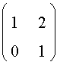 represent the transformation T, triangle ABC where A(1,1) B(5,1) and C(2,4) is transformed by T.

a) i) Find the image A1B1C1 of ABC under T. (2marks)

ii) Draw A1B1C1 and ABC (2marks)

iii) Describe the transformation T (1mark)

b) Draw A2B2C2 image A1B1C1 under enlargement centre (0,0) scale factor -1/2  (2 marks)

c) Find a single matrix that would A2B2C2 onto ABC. (3 marks)

1. The probability that a volleyball team wins a game is 3/5. If the team plays three games using a tree diagram find the probability that they

i) Win only two games (3marks)

ii) Loose at least one game (2marks)

b) Unfair die with six faces numbered 1 to 6 is tossed. The probability of a number appears on top is proportional to the number. Find the probability of

i) Number 4 showing on top (3marks)

ii) Prime number showing on top (2marks)

1. The figure below represents a square based pyramid with equilateral triangles AB=5cm



Calculate the

a) Height of the triangular faces (2mark)

b) Length of AC (1mark)

c) Angle between VA and ABCD (2marks)

d) Angle between VAD and ABCD (2marks)

e) Angle between VAB and VBC (3marks)

1. Two variables x and y are related by the formula y = kax where a and k are constants. The values of x and y are given in the table below.

|  |  |  |  |  |  |  |  |
| --- | --- | --- | --- | --- | --- | --- | --- |
| x | 2 | 0 | 7 | 12 | 4 | 9 | 5 |
| y | 286 | 256 | 385 | 525 | 316 | 437 | 339 |

1. By drawing a suitable straight line graph, find the values of k and a

(b) Establish the relationship between x and y.

1. marks)
2. In the figure below C is a point on AB such that  and D is the mid-point of OA. OC and BD intersect at X Given that 

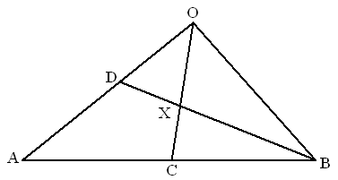

1. **Write** down in terms of  and  the vectors.
2.  (1mark)
3.  (2marks)
4.  (1mark)
5. If = h., express  in terms of, and h (1mark)
6. If  = k, find h and k (4marks)
7. Hence express  in terms of  and  only. (1mark)
8. The fig shows two intersecting circles with centres A and Band radii 7cm and 10.5cm respectively. The distance between AB = 14 and AM:MB = 3:4.

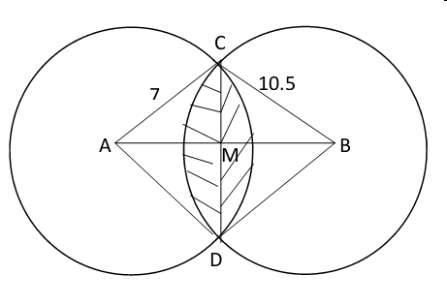

Calculate to four significant fig the;

1. Size of angle CAD (2marks)
2. Size of angle CBD (2marks)
3. Area of shaded region (use p = 3.142). (6marks)
4. a) Complete the table below for the graph of y = Cos (4x – 60) for O<x <180. (2marks)

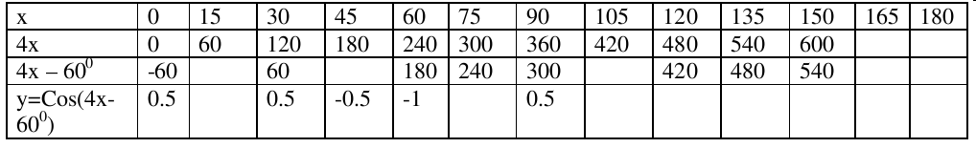

b) Using the scale of 1cm to represent 150 on the x - axis and 4cm to represent 1 unit on they-axis, draw the graph of y = Cos (4x – 60) for O<x <180. (3marks)

c) Use your graph to solve the equations.

(i) 1 + Cos (4x – 60) = 1 (1mark)

(ii) 5 Cos ( 4x – 60)=1 (2marks)

d) State the period and the phase angle of the graph. (2marks)