Name:………………………………………………………………………………… Adm. No. …………………….
Class: …………………………
Signature:…………………….
232/2
PHYSICS Date: …………………………..
JUNE 2018
TIME: 2 HRS

KASSU J O I N T E X A M I N A T I O N - 2018
Kenya Certificate to Secondary Education
PHYSICS PAPER 2

Instructions

- Write your name, admission number, class, signature and date of examination in the spaces provided at the top of the page.
- This paper consists of two sections A and B.
- Answer all the questions in the two sections in the spaces provided after each question.
- Electronic calculators and mathematical tables may be used.
- All numerical answers should be expressed in decimal notations.

FOR EXAMINER’S USE ONLY

SECTION | QUESTION | MAXIMUM  MARKS | CANDIDATE’S SCORE
A | 1 – 12 | 25
B | 13 | 10
B | 14 | 10
B | 15 | 11
B | 16 | 8
B | 17 | 8
B | 18 | 9
 | TOTAL | 80

SECTION A (45 MARKS)
This paper consists of 15 printed pages. Candidates are advised to check and to make sure all pages are printed.
1. Determine the number of images formed when an object is placed between two plane mirrors inclined at an angle of 20⁰ to each other. (1 mark)

2. State and explain what will be observed when a wire is connected between a positively charged electroscope and uncharged electroscope. (2 marks)

3. Figure shows an electrical circuit including two switches S₁ and S₂ and three identical lamps L₁, L₂, L₃.

S₁
S₂

L₂
L₂

L₁
L₃
- Compare the brightness of L₁ and L₂ when switch S₁ is closed. (1 mark)

- State what will be observed when all the switches are closed (1 mark)

4. (a) The figure below shows a horse shoe electromagnet. Determine the polarity
at the ends A and B. (1 mark)

B

A

(b) Two steel needles are placed at the poles A and B state and explain what happens to the needles. (2 marks)

5. An object 5cm tall is placed 20cm in front of a concave mirror of focal length 15cm. Using a ray diagram and the grid below, determine the distance of the image from the object. (2 marks)
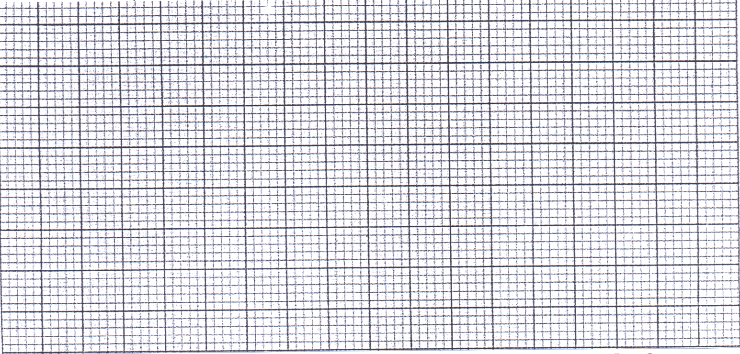

6. Figure shows a transverse wave travelling along the x-axis
y(cm)
2
A
x(cm)
0 2 4 6 8 10 12 14
-2

If the time taken by the wave to move from O to A is 0.13 seconds determine the;
- Frequency of the wave. (1 mark)

- Speed of the wave. (2 marks)

7. (i) An optical fibre provides an efficient way of transmitting light energy. State
and explain the property of light behind its functioning. (2 marks)

(ii) State the advantage of optical fibre over ordinary cables. (1 mark)

8. The graph below shows how the terminal voltage V of a certain battery varies with the current I being drawn from the battery

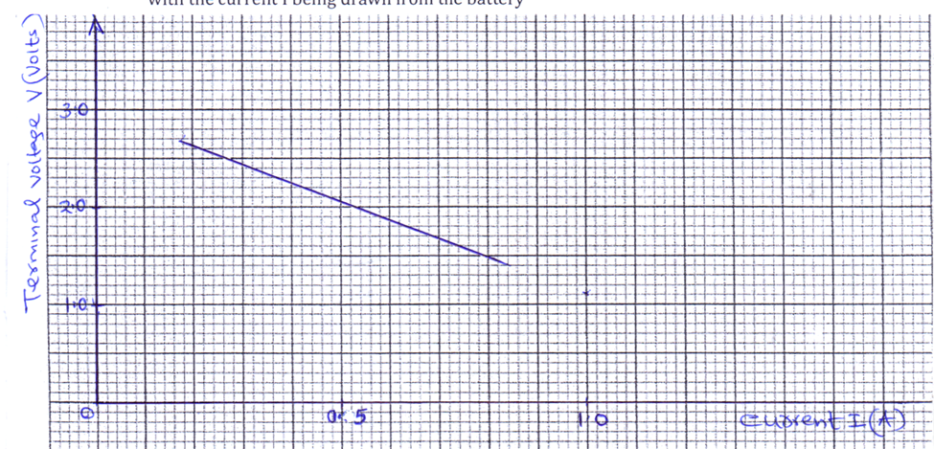
Given that E = I (R+r)
From the graph determine the
I. internal resistance r of the battery. (2 marks)

II. e.m.f E of the battery. (1 mark)

9. Arrange the following radiation in the order of their increasing energy given the radiations below and their wavelengths. (1 mark)

Type of radiation | Yellow light | Gamma rays | Radio waves | Micro wave
Wave length (m) | 3.0 x 10⁻⁷ | 3 x 10⁻¹⁴ | 300 | 3 x 10⁻³

10. State Lenz’s law. (1 mark)

11. A consumer has the following appliances operating in his house for the time
indicated in a day.
- Two 60W, 250V bulbs for 30minutes
- One 1000W, 250V fridge for 10hours
- One 3KW, 250V heater for 2 hours

Calculate:

(a) total power used in kwh in 30 days assuming that power consumption per day is the same. (2 marks)

(b) cost of electricity consumed in 30 days if 1 unit cost sh.1.50 (1 mark)

12. The diagram below shows water ripples generated in a ripple tank moving from deep to shallow end.
Shallow
Deep

Sketch on the same diagram the refracted waves. (1 mark)

SECTION B (55 MARKS)
13. (a) Figure shows an experimental set up consisting of a mounted lens L, a screen
S, a meter rule and a candle.
candle
L

S

Metre rule

- Describe how the setup may be used to determine the focal length f of the lens. (5 marks)

- State the reason why the setup would not work if the lens was replaced with a diverging lens. (1 mark)

(b) (i) A real object of height 1 cm placed 5cm from a converging lens forms
a virtual image 10cm from the lens (i) determine the focal length of the lens. (2 marks)

(ii) On the grid provided draw to scale the ray diagram for the setup to show how the image is formed. (2 marks)

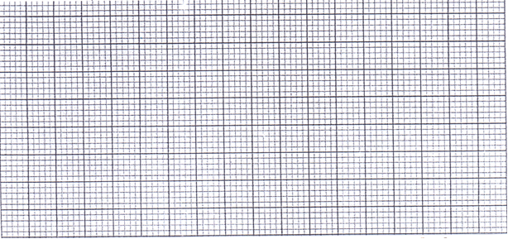
14. (a) State one factor that affects the capacitance of a parallel plate capacitor.
(1 mark)

(b) The figure below shows three capacitors C_{1,} C₂ and C₃ connected in parallel to a battery V.

C₃

C₂

C₁

Show that the effective capacitance C_{T} is given by C_{T} = C₁ +C₂+C₃ (2 marks)

(c) The figure below shows a circuit for charging a capacitor
S

mA

V

R
C

(i) State what is observed on the following when the switch S is closed
I. the milliammeter (1 mark)

II. the voltmeter (1 mark)

(ii) Explain how the capacitor works. (2 marks)

- State the purpose of the resistor R. (1 mark)

- Sketch the graph of voltage V (y-axis) against time t when the switch is closed. (2 marks)

15. (a) State two factors that affect photo electric effects. (2 marks)

(b) Define the following terms. (2 marks)
(i) work function (Wo)

(ii) threshold frequency (ƒ_{o})

(c) Light beam was radiated onto a metal surface in an experiment and the
results obtained were used to plot a graph of stopping potential Vs against frequency f of the radiation as shown
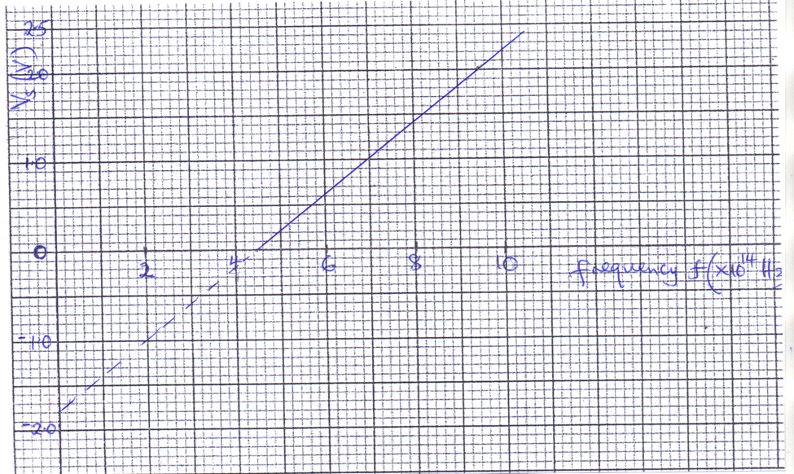

From the graph determine:-
- the threshold wavelength λ_{o} (2 marks)

- Planck’s constant h given that
hf = hf_{o} + eV_{s} e = 1.6 x 10⁻¹⁹c
c = 3.0 x 10⁸m/s (2 marks)

- work function Wo (in eV) (2 marks)

- Draw on the same axis a graph for a metal of lower work function. (1 mark)
16. (a) With the time base switched off the trace shown below was observed in a
C.R.O. State the nature of the p.d applied and state to which plate it was applied. (1 mark)

(b) With the time base switched on the trace shown below was observed in a C.R.O. State the nature of the p.d applied and state to which plate it was applied. (2 marks)

(c) How can a radiographer increase the;
(i) intensity (1 mark)

(ii) energy of x-rays produced by an x-ray tube. (1 mark)

(d) Calculate wavelength of x-rays whose energy is 9.5eV given that
c = 3.0 x 10⁸m/s, h = 6.63 x 10⁻³⁴JS and 1eV = 1.6 x 10⁻¹⁹J. (3 marks)

17. (a) The diagram below shows a junction diode. Complete the diagram to show
how the diode can be connected in a reverse bias mode. (1 mark)

(b) Explain how an n-type semi-conductor is formed. (1 mark)

(c) (i) Define half-life of a radioactive material. (1 mark)

(ii) Figure below shows a graph of variation of the number of atoms of a certain radioactive material with time.
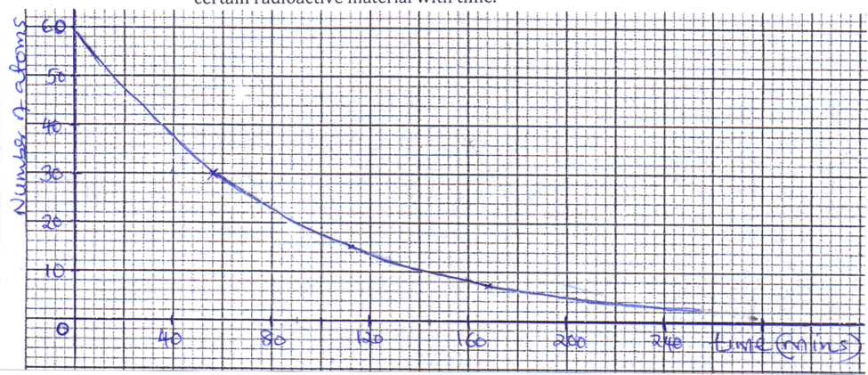

Determine the half-life of the material. (1 mark)

(iii) Cobalt -60 is a radioactive isotope of half-life 5.25years. What fraction
of the original atoms in a sample will have decayed after 21 years?
(3 marks)

18. (a) Distinguish between transverse waves and longitudinal waves. (1 mark)

(b) A ship in an ocean sends out an ultra sound whose echo is received after 3 seconds. If the wavelength of the ultra sound in water is 7.5cm and the frequency of the transmitter is 20 KHz; determine the depth of the ocean. (3 marks)

(c) Figure shows water waves of different wavelengths incident on identical
apertures A and B.

A
B

Complete the diagrams to show the patterns of the waves beyond the aperture in each case. (2 marks)

(d) Figure shows two speakers S₁ and S₂ which produce sound of the same frequency they are placed equidistant from a line AB and a line PQ (PQ is perpendicular to line AB.
S₁
A
P
Q

S₂
B

- A student walking from A to B hears alternating loud and soft sounds. Explain why at some points the sound heard is loud. (2 marks)

- State the nature of the sound the student hears if he walks along line PQ. (1 mark)

