NAME:……………………………………………………………..…………INDEX NO:……………

SCHOOL:………………………………………….…………………………………………………….

232 / 2
PHYSICS
PAPER 2
2 HOURS
PRE-MOCK
TRIAL 6
FORM FOUR
2018
Kenya Certificate of Secondary Education (K.C.S.E)

232 / 2
PHYSICS
PAPER 2
2HOURS

INSTRUCTIONS TO CANDIDATES
- Write your name and index number in the spaces provided above.
- This paper consists of two sections, A and B.
- Answer all the questions in the spaces provided
- All working must be clearly shown
- Mathematical tables and Electronic calculators may be used.

For Examiners Use Only

Section | Question | Maximum Score | Candidates’ Score
A | 1 – 14 | 25
B | 15  16  17  18  19 | 14  13  9  10  9
 | Total Score | 80

SECTION A (25 MARKS)
Answer all questions in this section
- A ray of light makes an angle of 20⁰ with a plane mirror as shown in figure 1 below. The mirror is then rotated through an angle of 10⁰ about the point O in a clockwise direction.
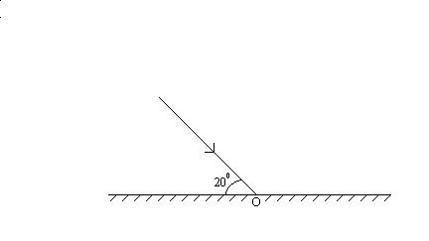
Figure 1
Determine the new angle of reflection. (2mks)

- Figure 2 represents a long horizontal insulated wire XY connected in an electric circuit. The circle represents where a plotting compass is placed on the wire.
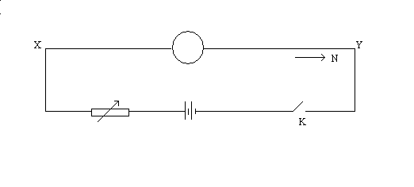
Figure 2
    - In the circle put an arrow to show the direction the N pole of the compass will deflect when switch k. is closed. (2mks)

    - State two changes which can be made in the circuit to increase the deflection. (2mks)
…………………………………………………………………………………………………………………………………………………………………………………………………………
- State one advantage of alkaline battery over lead acid battery. (1mk)
…………………………………………………………………………………………………………………………………………………………………………………………………………

- Water waves are observed as they pass a fixed point at a rate of 15 crests per minute. If the speed of the waves is 1.5m/s, determine the wavelength. (3mks)

- Figure 3 below shows a conductor connected to the dome of a Van der Graaff.
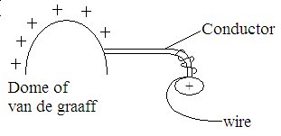
Figure 3

Explain the observation that would be made when a candle flame is brought very close to the wire. (2mks)
……………………………………………………………………………………………………
……………………………………………………………………………………………………………
- A man sees ‘steam’ start to come from a factory whistle and 3 seconds later he hears the sound. If the velocity of sound in air is 360m/s, calculate the distance from the man to the whistle.
(3mks)

- A circuit consists of a battery, a metal wire, ammeter and a switch connected in series. The switch is closed and the ammeter reading noted. The metal wire is now heated.
    - State the observations made on the ammeter reading. (1mk)
……………………………………………………………………………………………
    - Give one observation for the above observation made. (1mk)
……………………………………………………………………………………………
- State Shell’s law of refraction of light. (1mk)
……………………………………………………………………………………………………………
- State the reason why tungsten is a suitable material for the filament of an electric bulb. (1mk)
……………………………………………………………………………………………………………
- Arrange the following in order of increasing wavelength: Visible light, x- ray, ultra violet radiation and radio waves. (1mk)
……………………………………………………………………………………………………………
- State one similarity between the water waves on a ripple tank and sound waves in air. (1mk)
……………………………………………………………………………………………………………
- Give a reason why attraction in magnetism is not regarded as a reliable method of testing for polarity. (1mk)
……………………………………………………………………………………………………………
- An object is placed 10cm from a converging lens of focal length 15cm. Calculate the position of the image. (3mks)

- State one advantage of connecting lamps in parallel over series connection in a house. (1mk)
…………………………………………………………………………………………………………………………………………………………………………………………………………

SECTION B (55 MARKS)
Answer All questions in this section in the spaces provided.
- (a) Figure 4 below shows an X – ray tube
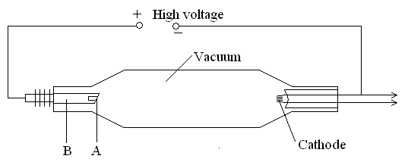
Figure 4
    - Label the parts A and B. (2mks)
A…………………………………………………………………………
B…………………………………………………………………………
    - Suggest with a reason the material used for A. (2mks)
…………………………………………………………………………………………… ……………………………………………………………………………………………
    - State the reason why the X –ray tube is evacuated. (1mk)
…………………………………………………………………………………………… ……………………………………………………………………………………………
    - For the X – ray tube how would the following be controlled;
- The intensity (1mk)
…………………………………………………………………………………………… ……………………………………………………………………………………………
- Quality of X- rays (1mk)
…………………………………………………………………………………………… ……………………………………………………………………………………………
- The exposure to patients (1mk)
…………………………………………………………………………………………… ……………………………………………………………………………………………
(b) (i) A potential difference of 50KV is applied across an X-ray tube. Given that the charge of
an electron e = 1.6 x 10⁻¹⁹coulombs and the mass of an electron $M_{e} = 9\text{.}1 × {\text{10}}^{−\text{31}}\text{kg}\text{.}$ Calculate the kinetic energy of the electrons. (3mks)

- If 12% of the electron energy is converted into X-ray, determine the minimum wavelength of the emitted X –ray given planks constant h = 6.63 x 10⁻³⁴ (3mks)

- (a) State two factors that affect the photoelectric effect. (2mks)
…………………………………………………………………………………………… ……………………………………………………………………………………………

(b) A student carried out an experiment to determine the Plank’s constant and the work
function of a metal surface, she obtained the following results.

Kinetic energy $\text{ke} × {\text{10}}^{−\text{20}}J$ | 4.00 | 10.40 | 16.50 | 22.72 | 29.28 | 35.84
Frequency ${\text{10}}^{\text{14}}\text{Hz}$ | 4 | 5 | 6 | 7 | 8 | 9
      - On the grid provided, plot a graph of ke. Against frequency. (5mks)

      - Given that $\text{hf} = w_{o} + \text{ke}$, determine the Plank’s constant. (4mks)

      - Work function of the surface. (2mks)

- (a) Distinguish between self induction and mutual induction. (2mks)
…………………………………………………………………………………………… ……………………………………………………………………………………………
(b) State the Lenz’s law of electromagnetic induction. (1mk)
(c) State the difference between a step-up transformer and an induction coil. (1mk)

……………………………………………………………………………………………

(d) Figure 5 below shows a diagram of a bicycle dynamo. The wheel A is connected by an
axle to a permanent cylindrical magnet and is rotated by the bicycle tyre.
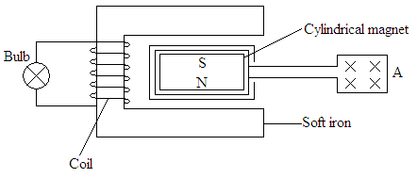
Figure 5
      - Explain why the bulb lights. (2mks)
…………………………………………………………………………………………… ……………………………………………………………………………………………
      - If you were riding the bicycle, what would you do to make the bulb light more brightly? (2mks)
……………………………………………………………………………………………

      - On the axes provided, sketch the graph of induced e.m.f with time (1mk)

Induced
e.m.f

Time t

- (a) Define the term intrinsic semiconductor. (1mk)
……………………………………………………………………………………………………………
(b) Explain how a p – type semiconductor is formed. (2mks)
…………………………………………………………………………………………………………………………………………………………………………………………………………
……………………………………………………………………………………………………

(c) Using the components symbols shown below, sketch a circuit diagram for forward bias
diode
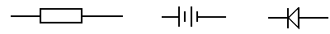

(d) Figure 6 below shows a circuit of a special type of a cathode ray tube.
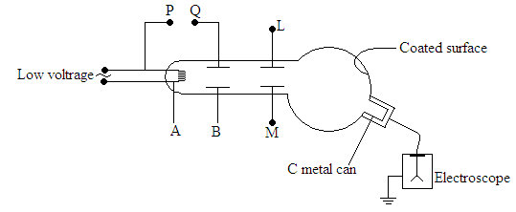
Figure 6
      - Name the parts labelled A and B. (2mks)
A ……………………………………………………………………………….
B ……………………………………………………………………………….

C is a metal can mounted inside the side tube and is connected externally to a negatively charged electroscope with its casing earthed. The p.d. across the metal plates L and M was then adjusted so that the cathode rays were deflected into the can and electroscope leaf rose steadily.
      - Why did the leaf rise steadily? (1mk)
…………………………………………………………………………………………… ……………………………………………………………………………………………

      - What does the result in (ii) above tell you about the charge of cathode rays. (1mk)
…………………………………………………………………………………………… ……………………………………………………………………………………………

      - State two other properties of cathode rays not mentioned above. (2mks)
…………………………………………………………………………………………… ……………………………………………………………………………………………
- (a) Figure 7 below shows the deflection from a radioactive isotope by an electric field.
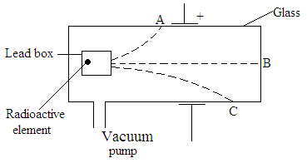
Figure 7

      - Define the term isotope. (1mk)
…………………………………………………………………………………………… ……………………………………………………………………………………………

      - Identify the radiations A,B, and C (3mks)
A ………………………………………………………………………………..
B ………………………………………………………………………………..
C ………………………………………………………………………………..

(b) Give one use of a radioactive isotope in medicine. (1mks)
…………………………………………………………………………………………… ……………………………………………………………………………………………

(c) Radium ${}_{\text{88}}^{\text{226}}{}\text{Ra}$ disintegrates into a new stable element lead ${}_{\text{82}}^{\text{206}}{}\text{Pb}$ how many alpha and Beta particles are emitted (2mks)

(d) A 32g sample of radioactive substance was reduced to 2g in 96 days. What is the half life
of the substance. (2mks)

