Name………………………………………………… Index No. …………………….

School ………………………………………………...

232 / 3
PHYSICS
PAPER 3
TIME: 2 ½ hours
PRE-MOCK
TRIAL 6
FORM FOUR
2018
Kenya Certificate of Secondary Education (K.C.S.E)

232 / 3
PHYSICS
PAPER 3
TIME: 2 ½ hours

INSTRUCTIONS TO CANDIDATES
- Answer ALL the questions in this spaces provided in the question paper.
- You are supposed to spend 15 minutes of the 2 ½ hours allowed in this paper reaching the whole paper carefully before commencing your work.
- Marks are given for clear records of observation actually made, their suitability, accuracy and the use made of them.
- Candidates are advised to record their observation as soon as they are made.
- Mathematical tables and electronic calculations may be used.

For Examiners Use Only.

Questions 1
 | d i | d v | e (i) | e(ii) | e(iii) | e(iv)  Total
Maximum Score | 1 | 7 | 5 | 3 | 2 | 2
Candidates Score

Question 2
 | a(ii) | b(i) | b(ii) | b(iii) | b(iv) | c(i) | c(ii)  Total
Maximum Score | 5 | 5 | 4 | 1 | 1 | 1 | 3
Candidates Score

Grand Total

This paper consists of 12 printed pages.
Candidates should check the question paper to ensure that all pages are printed as indicated
and no questions are missing

1. You are provided with the following apparatus
- One spiral with a pointer
- One stand, two bosses and 2 clamps
- One half- metre rule
- One metre rule
- A piece of cotton thread
- A brick or some other heavy objects
- One 100g mass

Proceed as follows
- Set the apparatus as shown in fig 1 below
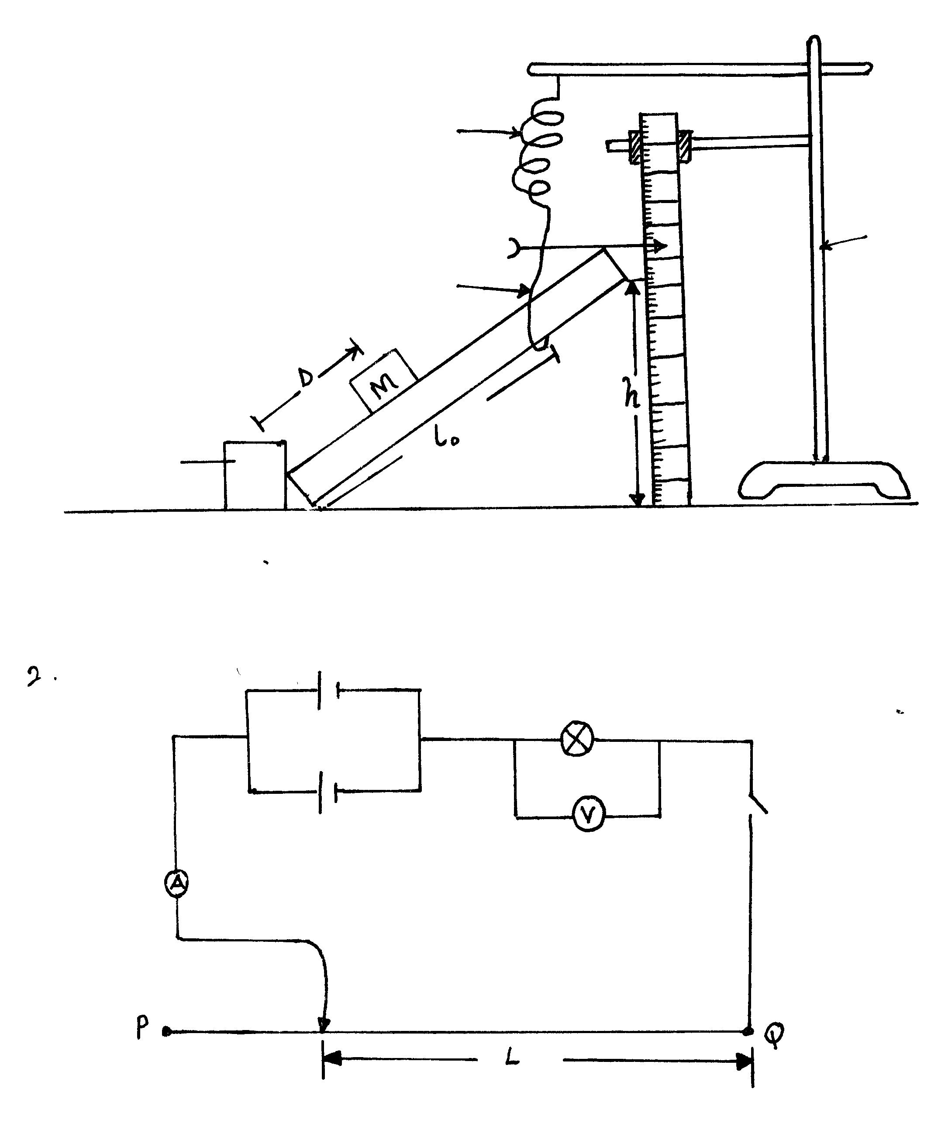
Spiral spring
Thread
Retort stand
Brick
d
Fig. 1
- Suspend the spring with its pointer against a mm scale as shown
- Place one end of the metre rule against a brick and suspend the other end or the spring using a piece of thread. Adjust the thread so that the height (h) above the table is 30cm.
- (i) Measure and record the distance L₀ in meters between the end of the rule pressing against the brick and the point of suspension of the metre rule

L₀ = ………………………………………………. m (1mk)

ii) Note and record the position of the pointer reading in the table below for d= 0 (the pointer reading when there is no mass placed on metre rule )
iii) Place the mass M at a difference d= 20cm from the brick. Read and record the new position of the pointer reading.

iv) Find the extension x of the spring and enter your value in the table below.
Distance d (cm) | 0 | 20 | 30 | 40 | 50 | 60 | 70
Pointer reading (cm)
Extension x (cm)
v) Repeat parts (iii) to (iv) above for the other values of d shown in the table above.(7mks)
e) (i) Plot a graph of extension X (y axis) against d (5mks)

(ii) Determine the slopes s of your graphs. (3mks)
…………………………………………………………………………………………………………………………………………………………………………………………………………
…………………………………………………………………………………………………………………………………………………………………………………………………………
…………………………………………………………………………………………………………………………………………………………………………………………………………
…………………………………………………………………………………………………………………………………………………………………………………………………………
(iii) Determine the value of constant K from. (2mks)

K = 0.98
S x L₀
…………………………………………………………………………………………………………………………………………………………………………………………………………
……………………………………………………………………………………………………………………………………………………………………………………………………………………………………………………………………………………………………………………………………………………………………………………………………………………

(iv) Use the graph to determine the pointer reaching when d = 35 cm. (2mks)
…………………………………………………………………………………………………………………………………………………………………………………………………………
…………………………………………………………………………………………………………………………………………………………………………………………………………

2. You are provided with the following
- Two dry cells
- A nichrome wire 1 m long labelled P Q
- Ten connecting wires one of length 70cm having a jockey.
- A micrometer screw gauge
- A torch bulb
- An ammeter
- Voltmeter
- Switch

Proceed as follows
a (i) Set up the circuit below.
Bulb
Switch
Voltmeter
Jockey
Ammeter
ii) With the jockey at P i.e L = 100 note and record the Voltmeter and ammeter reading
Voltmeter reading V = V
Ammeter reaching I = A (1mk)
Repeat the reading for L = 80, 60, 40, and 20 and enter your results in the table.
L (cm) | 100 | 80 | 60 | 40 | 20
P.d V (volts)
Current I (amps)
(4mks)
b (i) Plot the graph of p.d V (y axis) against current I (5mks)

(ii) Determine the slope of your graph when V= 0.3 volts (4mks)
…………………………………………………………………………………………………………………………………………………………………………………………………………
…………………………………………………………………………………………………………………………………………………………………………………………………………
…………………………………………………………………………………………………………………………………………………………………………………………………………
…………………………………………………………………………………………………………………………………………………………………………………………………………
…………………………………………………………………………………………………………………………………………………………………………………………………………
(iii) What physical quantity does the slope in (ii) represent? (1mk)
……………………………………………………………………………………………………………………………………………………………………………………………………………………………………………………………………………………………………………………………………………………………………………………………………………………
(iv) What happens to this physical quantity named in (iii) above as the current increases. ( 1mk)
…………………………………………………………………………………………………………………………………………………………………………………………………………
c) (i) using the micrometer screw gauge measure the diameter of this wire;
d = ______________ m (1mk)

(ii) Calculate the quantity P where
P = πVd² take π = 3.142.
4 I L
And state the units of P. (3mks)
…………………………………………………………………………………………………………………………………………………………………………………………………………
…………………………………………………………………………………………………………………………………………………………………………………………………………
…………………………………………………………………………………………………………………………………………………………………………………………………………
…………………………………………………………………………………………………………………………………………………………………………………………………………
…………………………………………………………………………………………………………………………………………………………………………………………………………

END

