NAME...........................................................................................INDEX NO.................................../......
CANDIDATE’S SIGNATURE............................................... DATE......................................................
443/1
AGRICULTURE
Paper 1
2 Hours
SET 3
FORM 4

Instructions to candidates
- Write your name and index number in the spaces provided above.
- Sign and write the date of examination in the spaces provided above.
- This consists of three sections: A, B and c.
- Answer all the questions in sections A and B.
- Answer any two questions from section C.
- Answers should be written in the spaces provided.
- This paper consists of 12 printed pages.
- Candidates should check the question paper to ascertain that all the pages are printed as indicated and that no questions are missing.
For Examiner’s Use Only.
Section | Question | Maximum score | Candidate’s Score
A | 1 – 22 | 30
B | 23 – 27 | 20
C |  | 20
 |  | 20
Total Score

SECTION A – (30 Marks)
Answer all the questions in this section in the spaces provided
1. List four branches of livestock farming. (2 marks)
………………………………………………………………………………………………………………………………………………………………………………………………………………………………………………………………………………………………………………………………………………………………………………………………………………………………………………………………………………………………………………………………………………………………………………………………………………………………………………………………
2. Give three reasons why old rather than fresh manure is preferred for application onto crop land.
(1 ½ marks)
………………………………………………………………………………………………………………………………………………………………………………………………………………………………………………………………………………………………………………………………………………………………………………………………………………………………………………………………………………………………………………………………………………………………………………………………………………………………………………………………
3. State three ways in optimum soil temperature enhance crop production. (1 ½ marks)
………………………………………………………………………………………………………………………………………………………………………………………………………………………………………………………………………………………………………………………………………………………………………………………………………………………………………………………………………………………………………………………………………………………………………………………………………………………………………………………………
4. Give two aspects of light which influence agricultural. (1 mark)
………………………………………………………………………………………………………………………………………………………………………………………………………………………………………………………………………………………………………………………………
5. Give three reasons for rolling a seedbed as a tertiary operation. (1 ½ marks)
………………………………………………………………………………………………………………………………………………………………………………………………………………………………………………………………………………………………………………………………………………………………………………………………………………………………………………………………………………………………………………………………………………………………………………………………………………………………………………………………
6. State three types of water sources in the farm. (1 ½ marks) ………………………………………………………………………………………………………………………………………………………………………………………………………………………………………………………………………………………………………………………………………………………………………………………………………………………………………………………………………………………………………………………………………………………………………………………………………………………………………………………………
7. Give the difference between permanent goods inventory and consumable goods inventory.
(1 mark)
…………………………………………………………………………………………………………………………………………………………………………………………………………………………………………………………………………………………………………………………………………………………………………………………………………………………………………
8. Name two methods of soil sampling. (1 mark)
…………………………………………………………………………………………………………………………………………………………………………………………………………………………………………………………………………………………………………………………………………………………………………………………………………………………………………
9. Give two ways in which soil PH influences soil fertility (1mark)
…………………………………………………………………………………………………………………………………………………………………………………………………………………………………………………………………………………………………………………………………………………………………………………………………………………………………………
10. Differentiate terms chiting and seed inoculation as used in crop production. (1 mark)
…………………………………………………………………………………………………………………………………………………………………………………………………………………………………………………………………………………………………………………………………………………………………………………………………………………………………………
11. What is the meaning of germination percentage? (1 mark)
…………………………………………………………………………………………………………………………………………………………………………………………………………………………………………………………………………………………………………………………………………………………………………………………………………………………………………
12. Give four characteristics of certified seeds (2 marks)
……………………………………………………………………………………………………………………………………………………………………………………………………………………………………………………………………………………………………………………………………………………………………………………………………………………………………………………………………………………………………………………………………………………
13. State the importance of a grass ley in a rotation program. (¹/₂ mark)
………………………………………………………………………………………………………………………………………………………………………………………………………………………………………………………………………………………………………………………………
14. State three factors which encourage successful grafting. (1 ½ marks)
…………………………………………………………………………………………………………………………………………………………………………………………………………………………………………………………………………………………………………………………………………………………………………………………………………………………………………
15. What is the effect on organic manure in carrot production? (1 mark)
………………………………………………………………………………………………………………………………………………………………………………………………………………………………………………………………………………………………………………………………
16. State three physical measures of soil and water conservation. (1 ½ marks)
……………………………………………………………………………………………………………………………………………………………………………………………………………………………………………………………………………………………………………………………………………………………………………………………………………………………………………………………………………………………………………………………………………………
17. State four varieties of dry beans. (2 marks)
………………………………………………………………………………………………………………………………………………………………………………………………………………………………………………………………………………………………………………………………………………………………………………………………………………………………………………………………………………………………………………………………………………………………………………………………………………………………………………………………
18. State four effects of late defoliation in pastures. (2 marks)
……………………………………………………………………………………………………………………………………………………………………………………………………………………………………………………………………………………………………………………………………………………………………………………………………………………………………………………………………………………………………………………………………………………
19. Give two tree shrubs which may be used as folder crops. (1 ½ marks)
……………………………………………………………………………………………………………………………………………………………………………………………………………………………………………………………………………………………………………………………………………………………………………………………………………………………………………………………………………………………………………………………………………………
20. State three kinds of individual tenure system. (1 ½ marks)
…………………………………………………………………………………………………………………………………………………………………………………………………………………………………………………………………………………………………………………………………………………………………………………………………………………………………………
21. Differentiate gross domestic product and Gross national products. (1 mark)
…………………………………………………………………………………………………………………………………………………………………………………………………………………………………………………………………………………………………………………………………………………………………………………………………………………………………………
22. Give the meaning of the following terms in agricultural economics; (1 mark)
i) Liquid capital
………………………………………………………………………………………………………………………………………………………………………………………………………………………………………………………………………………………………………………………………
ii) Fixed capital
…………………………………………………………………………………………………………………………………………………………………………………………………………………………………………………………………………………………………………………………………………………………………………………………………………………………………………
SECTION B – (20 Marks)
Answer all the questions in this section in the spaces provided.
23. A livestock farmer in Kirinyaga can rear dairy cattle, beef cattle or sheep. If the farmer undertakes each of the enterprises at a time, he is likely to get returns as follows:
Dairy cattle Kshs.70, 000
Beef cattle Kshs.65, 000
Sheep farming Kshs.75, 000
- From the information given which enterprise the farmer should choose? (¹/₂ mark)
…………………………………………………………………………………………………………………………………………………………………………………………………………………………………………………………………………………………………………………………………………………………………………………………………………………………………………
………………………………………………………………………………………………………….
b) Give a reason for your answer in (a) above. (1mark)
…………………………………………………………………………………………………………………………………………………………………………………………………………………………………………………………………………………………………………………………………………………………………………………………………………………………………………
(c) What is the opportunity cost of undertaking the enterprise chosen in (a) above? (1 mark)
…………………………………………………………………………………………………………………………………………………………………………………………………………………………………………………………………………………………………………………………………………………………………………………………………………………………………………
24. a) What is soil PH? (1 mark)
………………………………………………………………………………………………………………………………………………………………………………………………………………………………………………………………………………………………………………………………
b) The diagram below is a PH scale. Study it and answer the questions that follow

1 2 3 4 5 6 7 8 9 10 11 12 13 14
K L
i) What PH do the arrows K and L represent? (1 mark)
…………………………………………………………………………………………………………………………………………………………………………………………………………………………………………………………………………………………………………………………………………………………………………………………………………………………………………
ii) State the PH range where most beneficial soil organisms are active. (1 mark)
………………………………………………………………………………………………………………………………………………………………………………………………………………………………………………………………………………………………………………………………
…………………………………………………………………………………………………………
iii) Give the soil PH in which nematodes are prevalent. (1 mark)
………………………………………………………………………………………………………………………………………………………………………………………………………………………………………………………………………………………………………………………………
25. Diagrams EF and G blow shows the panicles of three sorghum varieties growing side by side
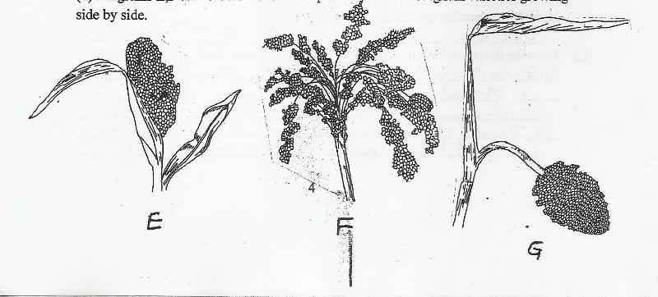

i) Which one of the three varieties of sorghum is last likely to be damaged by the birds. (1 mark)
………………………………………………………………………………………………………………………………………………………………………………………………………………………………………………………………………………………………………………………………
ii) Give a reason for you answer in (i) above (1 mark)
………………………………………………………………………………………………………………………………………………………………………………………………………………………………………………………………………………………………………………………………
(iii) State two other methods apart from using the above variety that are used to control birds in a
field of sorghum (2 marks)
……………………………………………………………………………………………………………………………………………………………………………………………………………………………………………………………………………………………………………………………………………………………………………………………………………………………………
……
26. The diagram below illustrates a field management practice carried out on a fruit crop.
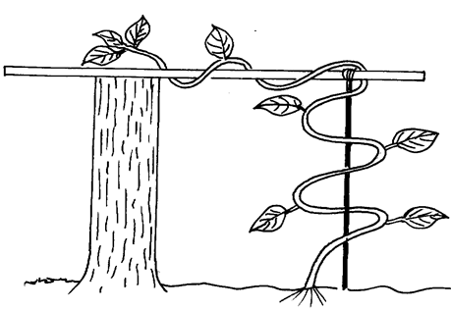
a) Identify the practice illustrated above. (1 mark)
…………………………………………………………………………………………………………………………………………………………………………………………………………………………………………………………………………………………………………………………………………………………………………………………………………………………………………
b) Give two reasons for carrying out the practice illustrated in the above diagram. (2 marks)
…………………………………………………………………………………………………………………………………………………………………………………………………………………………………………………………………………………………………………………………………………………………………………………………………………………………………………
27. Below are diagrams showing how to place the cuttings in the sleeves.
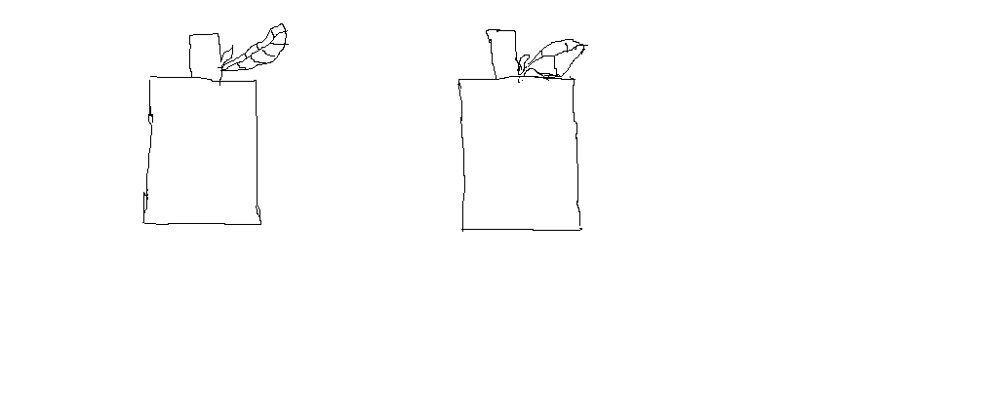
i) State the cutting which has been planted correctly between C₂ and C₁. ( ½ mark) ……………………………………………………………………………………………………………………………………………………………………………………………………………………

ii) Give a reason for the answer given in (a) above. ( 1 mark)
…………………………………………………………………………………………………………………………………………………………………………………………………………………………………………………………………………………………………………………………………………………………………………………………………………………………………………
b) The stem cuttings should be obtained from the middle part of the shoot. Give a reason why it is
not advisable to use the bottom and the top. (2 marks)
…………………………………………………………………………………………………………………………………………………………………………………………………………………………………………………………………………………………………………………………………………………………………………………………………………………………………………
c) State three advantages of raising stem cuttings in polythene sleeve. (3 marks)
…………………………………………………………………………………………………………………………………………………………………………………………………………………………………………………………………………………………………………………………………………………………………………………………………………………………………………
SECTION C: (40 marks)
Answer two questions from this section
28. a) Explain ten factors to consider when selecting a farm enterprise. (10 marks)
b) Describe five human factors which influence agricultural production. (5 marks)
c) Describe the precautions to be taken when harvesting cotton. (5 marks)
29. a) Describe the procedure a farmer should use during transplanting seedling. (10 marks)
b) Describe five functions of a farm manager as a factor of production. (10 marks)
30. a) Explain ten farming practices which help to conserve soil in a farm. (10 marks)
b) Explain ten cultural methods of disease control in crops. (10 marks)

…………………………………………………………………………………………………………………………………………………………………………………………………………………………………………………………………………………………………………………………………………………………………………………………………………………………………………
…………………………………………………………………………………………………………………………………………………………………………………………………………………………………………………………………………………………………………………………………………………………………………………………………………………………………………
……………………………………………………………………………………………………………………………………………………………………………………………………………………………………………………………………………………………………………………………………………………………………………………………………………………………………………………………………………………………………………………………………………………………………………………………………………………………………………………………………………………………………………………………………………………………………………………………………………………………………………………………………………………
…………………………………………………………………………………………………………………………………………………………………………………………………………………………………………………………………………………………………………………………………………………………………………………………………………………………………………
…………………………………………………………………………………………………………………………………………………………………………………………………………………………………………………………………………………………………………………………………………………………………………………………………………………………………………
…………………………………………………………………………………………………………………………………………………………………………………………………………………………………………………………………………………………………………………………………………………………………………………………………………………………………………
…………………………………………………………………………………………………………………………………………………………………………………………………………………………………………………………………………………………………………………………………………………………………………………………………………………………………………
…………………………………………………………………………………………………………………………………………………………………………………………………………………………………………………………………………………………………………………………………………………………………………………………………………………………………………
…………………………………………………………………………………………………………………………………………………………………………………………………………………………………………………………………………………………………………………………………………………………………………………………………………………………………………
…………………………………………………………………………………………………………………………………………………………………………………………………………………………………………………………………………………………………………………………………………………………………………………………………………………………………………
…………………………………………………………………………………………………………………………………………………………………………………………………………………………………………………………………………………………………………………………………………………………………………………………………………………………………………
…………………………………………………………………………………………………………………………………………………………………………………………………………………………………………………………………………………………………………………………………………………………………………………………………………………………………………
…………………………………………………………………………………………………………………………………………………………………………………………………………………………………………………………………………………………………………………………………………………………………………………………………………………………………………

