Name...........................................................................................Index No.................................../......
Candidate’s Signature............................................... Date......................................................
443/1
AGRICULTURE
2 Hours
FORM 4

Instructions to candidates
- Write your name and index number in the spaces provided above.
- Sign and write the date of examination in the spaces provided above.
- This consists of three sections: A, B and c.
- Answer all the questions in sections A and B.
- Answer any two questions from section C.
- Answers should be written in the spaces provided.
- This paper consists of 12 printed pages.
- Candidates should check the question paper to ascertain that all the pages are printed as indicated and that no questions are missing.
For Examiner’s Use Only.
Section | Question | Maximum score | Candidate’s Score
A | 1 – 19 | 30
B | 20 – 23 | 20
C |  | 20
 |  | 20
Total Score

SECTION A – (30 Marks)
Answer all the questions in this section in the spaces provided.
- State two ways through which agriculture contribute to directly to development of industries.
(1 mark)
………………………………………………………………………………………………………………………………………………………………………………………………………………………………………………………………………………………………………………………………
…………………………………………………………………………………………………………
2. State two effects of soil organisms which benefit crop growth. (1 mark)
………………………………………………………………………………………………………………………………………………………………………………………………………………………………………………………………………………………………………………………………
…………………………………………………………………………………………………………
3. Name two processes of rock wearing. (1 mark)
………………………………………………………………………………………………………………………………………………………………………………………………………………………………………………………………………………………………………………………………
4. Give four activities involved in land preparation. (2 marks)
………………………………………………………………………………………………………………………………………………………………………………………………………………………………………………………………………………………………………………………………
…………………………………………………………………………………………………………
……………………………………………………………………………………………………………………………………………………………………………………………………………………
5. Give two types of water pumps. (1 mark)
………………………………………………………………………………………………………………………………………………………………………………………………………………………………………………………………………………………………………………………………
…………………………………………………………………………………………………………
6. Give two symptoms of potassium deficiencies in maize. (1 mark)
………………………………………………………………………………………………………………………………………………………………………………………………………………………………………………………………………………………………………………………………
…………………………………………………………………………………………………………
7. Give four variable costs in the production of maize. (2 marks) ………………………………………………………………………………………………………………………………………………………………………………………………………………………………………………………………………………………………………………………………
…………………………………………………………………………………………………………
……………………………………………………………………………………………………………………………………………………………………………………………………………………
8. State four factors that determine the stage at which a grain crop is ready for harvesting. (2 marks)
………………………………………………………………………………………………………………………………………………………………………………………………………………………………………………………………………………………………………………………………
…………………………………………………………………………………………………………
………………………………………………………………………………………………………………………………………………………………………………………………………………………………………………………………………………………………………………………………
…………………………………………………………………………………………………………
9. Give four reasons for earthing up in crop production. (2 marks)
………………………………………………………………………………………………………………………………………………………………………………………………………………………………………………………………………………………………………………………………
…………………………………………………………………………………………………………
………………………………………………………………………………………………………………………………………………………………………………………………………………………………………………………………………………………………………………………………
…………………………………………………………………………………………………………
10. State four advantages of applying lime as a measure of improving soil condition. (2 marks)
………………………………………………………………………………………………………………………………………………………………………………………………………………………………………………………………………………………………………………………………
…………………………………………………………………………………………………………
………………………………………………………………………………………………………………………………………………………………………………………………………………………………………………………………………………………………………………………………
…………………………………………………………………………………………………………
11. Name two forms of gulley erosion. (1mark)
………………………………………………………………………………………………………………………………………………………………………………………………………………………………………………………………………………………………………………………………
…………………………………………………………………………………………………………
12. State any three any three stages of land adjudication. (1½marks)
………………………………………………………………………………………………………………………………………………………………………………………………………………………………………………………………………………………………………………………………
…………………………………………………………………………………………………………
13. State four precautions a maize farmer would take to minimize risks in the production.
(2 marks)
………………………………………………………………………………………………………………………………………………………………………………………………………………………………………………………………………………………………………………………………
…………………………………………………………………………………………………………
………………………………………………………………………………………………………………………………………………………………………………………………………………………………………………………………………………………………………………………………
…………………………………………………………………………………………………………
14. Give four sources of agricultural credit to a farmer. (2 marks)
………………………………………………………………………………………………………………………………………………………………………………………………………………………………………………………………………………………………………………………………
…………………………………………………………………………………………………………
………………………………………………………………………………………………………………………………………………………………………………………………………………………………………………………………………………………………………………………………
15. Differentiate the term partial budget and complete budget. (1 mark)
………………………………………………………………………………………………………………………………………………………………………………………………………………………………………………………………………………………………………………………………
…………………………………………………………………………………………………………
16. a) Define the term market (1 mark)
………………………………………………………………………………………………………………………………………………………………………………………………………………………………………………………………………………………………………………………………
…………………………………………………………………………………………………………
b) List two types of market in agricultural economics. (1mark)
………………………………………………………………………………………………………………………………………………………………………………………………………………………………………………………………………………………………………………………………
…………………………………………………………………………………………………………
17. State four examples of leguminous fodder crops. (2 marks)
………………………………………………………………………………………………………………………………………………………………………………………………………………………………………………………………………………………………………………………………
…………………………………………………………………………………………………………
18. State three ways in which labour peak constraints can be overcome in the farm. (1 ½ marks)
………………………………………………………………………………………………………………………………………………………………………………………………………………………………………………………………………………………………………………………………
…………………………………………………………………………………………………………
19. How are the following conditions prevented in carrot production? (2 marks)
i) Forking-avoid organic manure during planting
………………………………………………………………………………………………………………………………………………………………………………………………………………………………………………………………………………………………………………………………
…………………………………………………………………………………………………………
ii) Greening of carrots tuber- earthing up tuber.
………………………………………………………………………………………………………………………………………………………………………………………………………………………………………………………………………………………………………………………………
…………………………………………………………………………………………………………
SECTION B – (20 Marks)
Answer all the questions in this section in the spaces provided.
20. The diagram below labeled G, H, J and K shows different stages of cotton fruit.
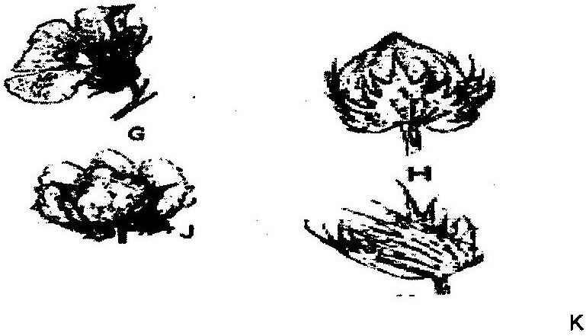

i) Rearrange the label G, H, J, and K to show the correct sequence in which the cotton fruit
develops. (1 mark)
………………………………………………………………………………………………………………………………………………………………………………………………………………………………………………………………………………………………………………………………
…………………………………………………………………………………………………………
ii) What would be the effect of attack by cotton boll worms atthe stage labeled K? (1 mark)
………………………………………………………………………………………………………………………………………………………………………………………………………………………………………………………………………………………………………………………………
…………………………………………………………………………………………………………
iii) State two conditions that should be observed when harvesting toensure that cotton picked is of
high quality. (2 marks)
………………………………………………………………………………………………………………………………………………………………………………………………………………………………………………………………………………………………………………………………
…………………………………………………………………………………………………………
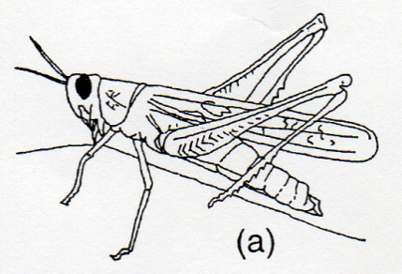
21. The illustration below are crop pests. Study them and answer the questions that follow.
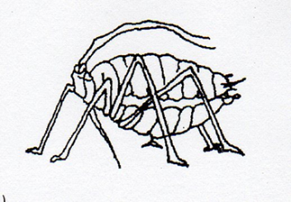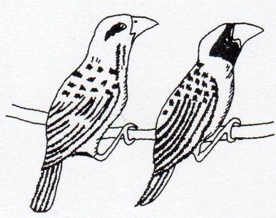
(b) (c)
i) Identify each of the pest labeled as (a),(b) and (c) ( 2 marks)
(a)
(b)
(c)
ii) State two types of damage caused by pest (c) in the crops infested. (2 marks)
………………………………………………………………………………………………………………………………………………………………………………………………………………………………………………………………………………………………………………………………
…………………………………………………………………………………………………………
22. The diagram below shows two types of weeds A , B ,C and D. Study and answer the questions that follow.
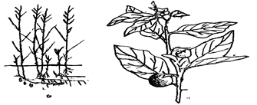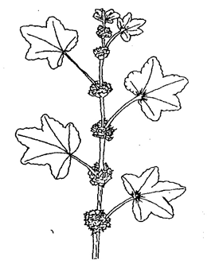
A B C D
a ) i) Identify the above weeds. (2 marks)
A………………………………………………………………………
B…………………………………………………………………………
C…………………………………………………………………………
D………………………………………………………………………
ii) Why is it difficulty to control the weed in diagram A (1 mark)
………………………………………………………………………………………………………………………………………………………………………………………………………………………………………………………………………………………………………………………………
iii) State one harmful effect of B. (1 mark)
……………………………………………………………………………………………………………………………………………………………………………………………………………………
b) i) Why is it difficult to control weed C in the crop of cereals? (1 mark)
………………………………………………………………………………………………………………………………………………………………………………………………………………………………………………………………………………………………………………………………
ii) State one negative effect of weed C in a field of cereal crops. (1 mark )
………………………………………………………………………………………………………………………………………………………………………………………………………………………………………………………………………………………………………………………………
…………………………………………………………………………………………………………
c) State one harmful of effect of weed D in a crop of cotton. (1 mark)
………………………………………………………………………………………………………………………………………………………………………………………………………………………………………………………………………………………………………………………………
23. The diagrams labeled F and G below represent physical measures in conservation soil and water. Study them carefully and answer the questions that follow.
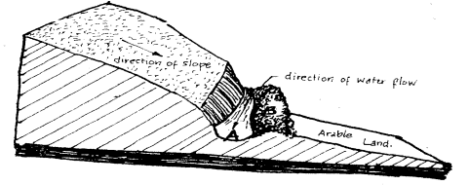
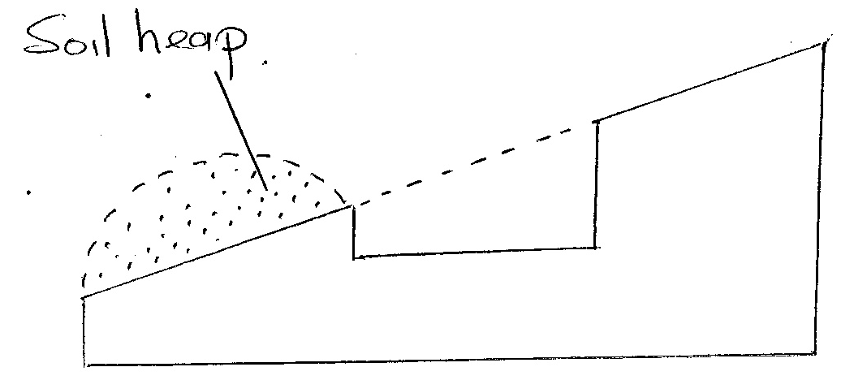

F G
a) Identify the illustration F and G above. (2 marks) F-
G-.
b) Why is it that the embankment of F should not be cultivated with crops. (1 mark) ………………………………………………………………………………………………………………………………………………………………………………………………………………………………………………………………………………………………………………………………

d) Name two other physical measures a part from F and G that can be used to conserve water. (2marks)
………………………………………………………………………………………………………………………………………………………………………………………………………………………………………………………………………………………………………………………………

SECTION C: (40 marks)
Answer two questions from this section
24. (a) Describe four components of well-developed soil profile. (8 marks)
(b) Describe the disadvantages of herding in livestock production. (5 marks)
(c) Explain how a maize farmer may overcome risks and uncertainties in a farming business.
(7 marks)
25. (a) Describe field production of Napier elephant grass under the following sub-headings.
(i) Seedbed preparation (5 marks)
(ii) Planting (5 marks)
(iii) Fertilizer application (3 marks)
(iv) Weed control (3 marks)
(v) Utilization (4 marks)
(b) State and explain five factors to consider when siting a nursery bed. (10 marks)
26. (a) The following accounts information is from Mrs. Mangs’s farm for the year ended 31 – 12 – 2010.
Opening valuation Ksh. 6,0007/=
Paid wages Ksh. 5000/=
Bought equipment worth Ksh. 8,000/=
Bought pig feeds worth Ksh. 4,000/=
Sold mature pigs worth Ksh. 7,000/=
Bought drugs worth Ksh. 3,200/=
Sold maize worth Ksh. 3,000/=
Closing valuation Ksh. 4,000/=
- Using the information above, prepare a profit and loss account for Mrs. Mangu’s farm. ( 2 ½ marks)
- From the calculations in (i) above, state whether Mrs. Mangu made a profit or a loss.
(¹/₂ mark)
(b) Describe four advantages of mulching in crop production. (4 marks)
(c) Explain three farming practices which may lead to soil erosion. (3 marks)
………………………………………………………………………………………………………………………………………………………………………………………………………………………………………………………………………………………………………………………………
…………………………………………………………………………………………………………
………………………………………………………………………………………………………………………………………………………………………………………………………………………………………………………………………………………………………………………………
…………………………………………………………………………………………………………
………………………………………………………………………………………………………………………………………………………………………………………………………………………………………………………………………………………………………………………………
…………………………………………………………………………………………………………
………………………………………………………………………………………………………………………………………………………………………………………………………………………………………………………………………………………………………………………………
…………………………………………………………………………………………………………
………………………………………………………………………………………………………………………………………………………………………………………………………………………………………………………………………………………………………………………………
…………………………………………………………………………………………………………
………………………………………………………………………………………………………………………………………………………………………………………………………………………………………………………………………………………………………………………………
…………………………………………………………………………………………………………
………………………………………………………………………………………………………………………………………………………………………………………………………………………………………………………………………………………………………………………………
…………………………………………………………………………………………………………
………………………………………………………………………………………………………………………………………………………………………………………………………………………………………………………………………………………………………………………………
…………………………………………………………………………………………………………
………………………………………………………………………………………………………………………………………………………………………………………………………………………………………………………………………………………………………………………………
…………………………………………………………………………………………………………
………………………………………………………………………………………………………………………………………………………………………………………………………………………………………………………………………………………………………………………………
…………………………………………………………………………………………………………
………………………………………………………………………………………………………………………………………………………………………………………………………………………………………………………………………………………………………………………………
…………………………………………………………………………………………………………
………………………………………………………………………………………………………………………………………………………………………………………………………………………………………………………………………………………………………………………………
…………………………………………………………………………………………………………

