NAME………………………………ADMNO.……………SIGNATURE………………..DATE………….
AGRICULTURE
PAPER 2
444/2
TIME 2 HOURS

INSTRUCTIONS TO CANDIDATES:
- Write your name and index number in the spaces provided above.
- Sign and write the date of examination in the spaces provided above.
- This paper consists of THREE Sections A, B and C.
- Answer all questions in Section A and B.
- Answer two questions in Section C in the spaces provided.

FOR EXAMINER’S USE ONLY

Section | Question | Maximum  Score | Candidate’s  Score
A | 1 - 13 | 30
B | 14 - 20 | 20
C | 21 - 23 | 20
 |  | 20
Total Score |  | 90

SECTION A (30 MARKS)
Answer all questions in this section
1. Differentiate the following terms
i) A ram and a ewe. (1 mark)
………………………………………………………………………………………………………………………
………………………………………………………………………………………………………………………
……………………………………………………………………………………………………………………….
………………………………………………………………………………………………………………………
……………………………………………………………………………………………………………………….
ii) Quarantine and prophylaxis (1 mark)
………………………………………………………………………………………………………………………
………………………………………………………………………………………………………………………
……………………………………………………………………………………………………………………….
………………………………………………………………………………………………………………………
……………………………………………………………………………………………………………………….
iii)Mortality rate and incubation period. (1 mark)
………………………………………………………………………………………………………………………
………………………………………………………………………………………………………………………
……………………………………………………………………………………………………………………….
………………………………………………………………………………………………………………………
……………………………………………………………………………………………………………………….

2.Give two reasons for steaming up in dairy cattle management (1 mark)
………………………………………………………………………………………………………………………
………………………………………………………………………………………………………………………
……………………………………………………………………………………………………………………….
………………………………………………………………………………………………………………………
……………………………………………………………………………………………………………………….
3.State the parturition period of the following animals kept in the farm. (2 marks)
Cow- …………………………………………………………………
Goat-………………………………………………………………….
Rabbit-………………………………………………………………..
Sow-…………………………………………………………………..
4. a)State three reasons for castrating a billy goat. (1 ½ marks)
………………………………………………………………………………………………………………………
………………………………………………………………………………………………………………………
……………………………………………………………………………………………………………………….
………………………………………………………………………………………………………………………
……………………………………………………………………………………………………………………….
b)State two methods of carbonization in cocks. (1 mark)
………………………………………………………………………………………………………………………
………………………………………………………………………………………………………………………
……………………………………………………………………………………………………………………….
………………………………………………………………………………………………………………………
5. a)State four signs of infestation by external parasites in livestock? (2marks)
………………………………………………………………………………………………………………………
………………………………………………………………………………………………………………………
……………………………………………………………………………………………………………………….
………………………………………………………………………………………………………………………
……………………………………………………………………………………………………………………….
b) Name four insect parasites in livestock. (2 marks)
………………………………………………………………………………………………………………………
………………………………………………………………………………………………………………………
……………………………………………………………………………………………………………………….
………………………………………………………………………………………………………………………
……………………………………………………………………………………………………………………….
c) Name four vector borne diseases in livestock. (2 marks)
………………………………………………………………………………………………………………………
………………………………………………………………………………………………………………………
……………………………………………………………………………………………………………………….
………………………………………………………………………………………………………………………
……………………………………………………………………………………………………………………….
6. Give two qualities of creep feed that makes it suitable for piglets. (2 marks)
………………………………………………………………………………………………………………………
………………………………………………………………………………………………………………………
……………………………………………………………………………………………………………………….
………………………………………………………………………………………………………………………
7.State two main types of roughages for livestock. (1 mark)
………………………………………………………………………………………………………………………
………………………………………………………………………………………………………………………
……………………………………………………………………………………………………………………….
………………………………………………………………………………………………………………………
……………………………………………………………………………………………………………………….
8 .Mention two ways in which the gizzard is adapted to its function. (1 mark)
………………………………………………………………………………………………………………………
………………………………………………………………………………………………………………………
……………………………………………………………………………………………………………………….
9. State the functions of the following parts of a fish pond. (3 marks)
Spillway- Spillway-
………………………………………………………………………………………………………………………
………………………………………………………………………………………………………………………
Out let-
………………………………………………………………………………………………………………………
………………………………………………………………………………………………………………………
Inlet – allows water in the fish pond
………………………………………………………………………………………………………………………
………………………………………………………………………………………………………………………
Out let-
………………………………………………………………………………………………………………………
………………………………………………………………………………………………………………………
10.A student from Pavement academy saw a brown cow with a white patch on the face, on the legs part below the knees, below the tail switch and flank. Identify the breed of the cow. (1 mark)
………………………………………………………………………………………………………………………
………………………………………………………………………………………………………………………
11. State four structural requirements of a deep litter. (2marks)
………………………………………………………………………………………………………………………
………………………………………………………………………………………………………………………
………………………………………………………………………………………………………………………
………………………………………………………………………………………………………………………
………………………………………………………………………………………………………………………
12. a)State four symptoms of anthrax infection in the carcass of a cow. (2 marks)
………………………………………………………………………………………………………………………
………………………………………………………………………………………………………………………
………………………………………………………………………………………………………………………
………………………………………………………………………………………………………………………
………………………………………………………………………………………………………………………
b) What is meant by providing a feedstuff ad libitum. (1 mark)
………………………………………………………………………………………………………………………
………………………………………………………………………………………………………………………
c) Factors that enable ruminants to break down fibrous feed material. (1½ marks)
………………………………………………………………………………………………………………………
………………………………………………………………………………………………………………………
………………………………………………………………………………………………………………………
13.Give two reasons for treating timber to be used in construction of farm buildings (1 mark)
………………………………………………………………………………………………………………………
………………………………………………………………………………………………………………………
………………………………………………………………………………………………………………………
………………………………………………………………………………………………………………………
SECTION B (20 MARKS)
Answer all the questions from this section in the spaces provided.

14.A farmer is required to prepare 100 kg of ration of 30% digestible crude protein ( DCP) from simsim seed cake containing 50% DCP and maize meal 10% DCP. Using Pearson’s square method calculate the amount of simsim and maize the farmer requires. (4marks)
………………………………………………………………………………………………………………………
………………………………………………………………………………………………………………………
………………………………………………………………………………………………………………………
………………………………………………………………………………………………………………………
………………………………………………………………………………………………………………………
………………………………………………………………………………………………………………………
15.The diagram below illustrates a hoof of a sheep. Study it carefully and answer the questions that follow

- Name the routine management practice that should be carried out on the hoof illustrated above. (1 mark)
………………………………………………………………………………………………………………………
………………………………………………………………………………………………………………………
(b) State two reasons for carrying out the management practice in (a) above. (2 marks)
………………………………………………………………………………………………………………………
………………………………………………………………………………………………………………………
………………………………………………………………………………………………………………………
………………………………………………………………………………………………………………………
16.The photographs below are workshop tools. Study them and answer the questions that follow.

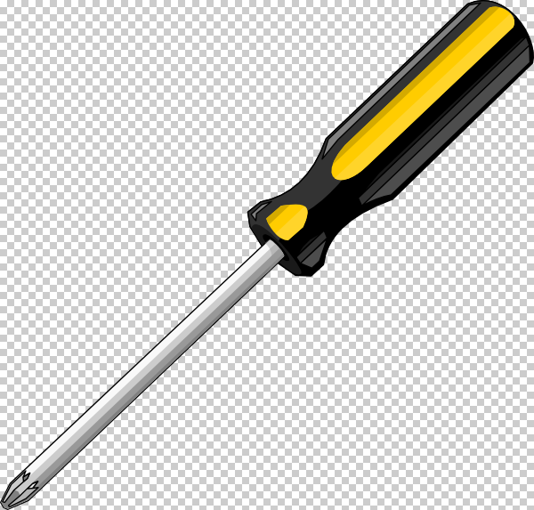
L M

- Identify the tools Land M (1 mark)
L………………………………………………………………..
M…………………………………………………………………..

ii) Give the functional difference between the following tools labeled Land M. (2 marks)
………………………………………………………………………………………………………………………
………………………………………………………………………………………………………………………
………………………………………………………………………………………………………………………
………………………………………………………………………………………………………………………
………………………………………………………………………………………………………………………
………………………………………………………………………………………………………………………
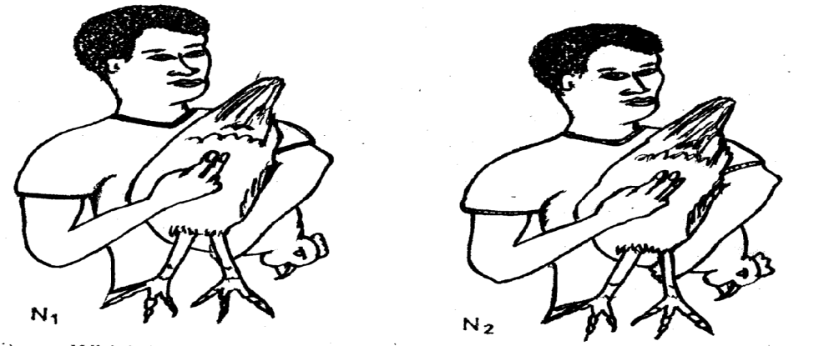
17. DiagramsN1 and N2 below show the fingers fitted between pelvic bones as a practice used in examining layers during culling

- Which layer would be culled (1 mark)
………………………………………………………………………………………………………………………
ii) Give two other characteristics that can be examined when culling. (1 mark)
………………………………………………………………………………………………………………………
………………………………………………………………………………………………………………………
………………………………………………………………………………………………………………………
………………………………………………………………………………………………………………………
18. The illustration below shows a male reproductive system in cattle. Study it and answer the questions that follow.
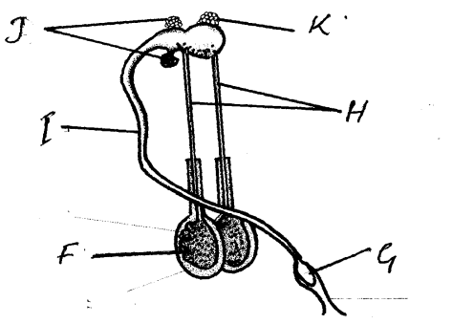

- Identify the parts labeled I, J, K and G (2marks)
I………………………………………………………………………….
J …………………………………………………………………………
K………………………………………………………………………..
G………………………………………………………………………….
- Give the functions of the parts labeled F and H
………………………………………………………………………………………………………………………
………………………………………………………………………………………………………………………
………………………………………………………………………………………………………………………
………………………………………………………………………………………………………………………
19.The photographs labeled D and E are pig breeds. Study them and answer the questions that follow.

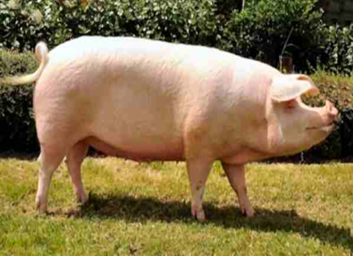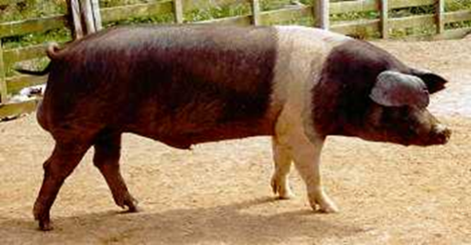 G
D E
- Identify the breeds D and E (1 mark)
D-…………………………………………………………..
E- ………………………………………………………..
- Name the part labeled G on the diagram E (1 mark)
………………………………………………………………………………………………………………………
………………………………………………………………………………………………………………………
c) State the main product got from breed D (1 mark)
………………………………………………………………………………………………………………………
………………………………………………………………………………………………………………………
20. The diagram below represents roof of a building.
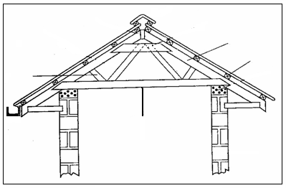
A
D
C
B

(i) Identify the parts labeled A, B, C. (3marks)
A ……………………………………………………..
B……………………………………………………..
C………………………………………………….. ….
ii) State four factors considered when sitting farm buildings and structures. (2marks)
………………………………………………………………………………………………………………………
………………………………………………………………………………………………………………………
………………………………………………………………………………………………………………………
……………………………………………………………………………………………………………………….
SECTION C (40 marks)
Answer TWO questions from this section.
- a) i) Precautions to be observed during transportation of fingerings. (5 marks)
(ii) Procedure of stocking fingerlings (5 marks)
b)Describe the factors a farmer should consider when selecting a heifer for breeding. (6 marks)
c)Explain the functions of workers bees in a bee colony. (4marks)
22. a) Describe the process of egg formation in the reproduction system of hen. (10 marks)
b) Describe the management of piglets from birth to weaning. (10 marks)
23. a) Explain five reasons as to why it is important of keeping livestock healthy. (5 marks)
b) Procedure of harvesting honey. (5 marks)
c) Explain functions of any five parts of a zero grazing unit in dairy farming. (10 marks)
………………………………………………………………………………………………………………………
………………………………………………………………………………………………………………………
………………………………………………………………………………………………………………………
………………………………………………………………………………………………………………………
………………………………………………………………………………………………………………………
………………………………………………………………………………………………………………………
………………………………………………………………………………………………………………………
………………………………………………………………………………………………………………………
………………………………………………………………………………………………………………………
………………………………………………………………………………………………………………………
………………………………………………………………………………………………………………………
………………………………………………………………………………………………………………………
………………………………………………………………………………………………………………………
………………………………………………………………………………………………………………………
………………………………………………………………………………………………………………………
………………………………………………………………………………………………………………………
………………………………………………………………………………………………………………………
………………………………………………………………………………………………………………………
………………………………………………………………………………………………………………………
………………………………………………………………………………………………………………………
………………………………………………………………………………………………………………………
………………………………………………………………………………………………………………………
………………………………………………………………………………………………………………………
………………………………………………………………………………………………………………………
………………………………………………………………………………………………………………………
………………………………………………………………………………………………………………………
………………………………………………………………………………………………………………………
………………………………………………………………………………………………………………………
………………………………………………………………………………………………………………………
………………………………………………………………………………………………………………………
………………………………………………………………………………………………………………………
………………………………………………………………………………………………………………………
………………………………………………………………………………………………………………………
………………………………………………………………………………………………………………………
………………………………………………………………………………………………………………………
………………………………………………………………………………………………………………………
………………………………………………………………………………………………………………………
………………………………………………………………………………………………………………………
………………………………………………………………………………………………………………………
………………………………………………………………………………………………………………………
………………………………………………………………………………………………………………………
………………………………………………………………………………………………………………………
………………………………………………………………………………………………………………………
………………………………………………………………………………………………………………………
………………………………………………………………………………………………………………………
………………………………………………………………………………………………………………………
………………………………………………………………………………………………………………………
………………………………………………………………………………………………………………………
………………………………………………………………………………………………………………………
………………………………………………………………………………………………………………………
………………………………………………………………………………………………………………………
………………………………………………………………………………………………………………………
………………………………………………………………………………………………………………………
………………………………………………………………………………………………………………………
………………………………………………………………………………………………………………………
………………………………………………………………………………………………………………………
………………………………………………………………………………………………………………………
………………………………………………………………………………………………………………………
………………………………………………………………………………………………………………………
………………………………………………………………………………………………………………………
………………………………………………………………………………………………………………………
………………………………………………………………………………………………………………………
………………………………………………………………………………………………………………………
………………………………………………………………………………………………………………………
………………………………………………………………………………………………………………………
………………………………………………………………………………………………………………………
………………………………………………………………………………………………………………………
………………………………………………………………………………………………………………………
………………………………………………………………………………………………………………………
………………………………………………………………………………………………………………………
………………………………………………………………………………………………………………………
………………………………………………………………………………………………………………………

