NAME………………………………………………………………………………………CLASS……………INDEX NO.………….. CANDIDATES SIGNATURE………………………………… DATE……………………………………………………………..
AGRICULTURE
PAPER 2
444/2
TIME 2 HOURS
FORM 4

INSTRUCTIONS TO CANDIDATES:
- Write your name and index number in the spaces provided above.
- Sign and write the date of examination in the spaces provided above.
- This paper consists of THREE Sections A, B and C.
- Answer all questions in Section A and B.
- Answer two questions in Section C in the spaces provided.

FOR EXAMINER’S USE ONLY

Section | Question | Maximum  Score | Candidate’s  Score
A | 1 - 22 | 30
B | 23 - 26 | 20
C | 27 - 29 | 20
 |  | 20
Total Score |  | 90

SECTION A (30 MARKS)
Answer all questions in this section.
1. Name two methods of identification of livestock that do cause pain to the animal. (1 mark)
………………………………………………………………………………………………………………………………………………………………………………………………………………………………………………………………………………………………………………………………
2. Mention two ways in which the gizzard is adapted to its function. (1 mark)
………………………………………………………………………………………………………………………………………………………………………………………………………………………………………………………………………………………………………………………………
…………………………………………………………………………………………………………
3. Name four main dairy breeds of goats reared in Kenya. ( 2 marks)
………………………………………………………………………………………………………………………………………………………………………………………………………………………………………………………………………………………………………………………………
…………………………………………………………………………………………………………
4. Name four farm implements taken to obtain power from the power take off shaft. (PTO) of a tractor. (2 marks)
………………………………………………………………………………………………………………………………………………………………………………………………………………………………………………………………………………………………………………………………
…………………………………………………………………………………………………………
5. State three reasons for castrating a billy goat. (1 ½ marks)
………………………………………………………………………………………………………………………………………………………………………………………………………………………………………………………………………………………………………………………………
…………………………………………………………………………………………………………
…………………………………………………………………………………………………………

6. State four desirable qualities of whole milk. (2 marks)
………………………………………………………………………………………………………………………………………………………………………………………………………………………………………………………………………………………………………………………………
…………………………………………………………………………………………………………
7. Differentiate the following terms as used in livestock management;
Mothering ability and prolificacy (1 mark)
………………………………………………………………………………………………………………………………………………………………………………………………………………………………………………………………………………………………………………………………
…………………………………………………………………………………………………………
Flushing and steaming up (1 mark)
………………………………………………………………………………………………………………………………………………………………………………………………………………………………………………………………………………………………………………………………
…………………………………………………………………………………………………………
8. State the function of the following parts of a moldboard plough. (2 marks)
Shear
Landside
9. Give one main reason for withering lucerne (Medicagosative) before feeding to livestock.
(¹/₂mark)
……………………………………………………………………………………………………………………………………………………………………………………………………………………
10. Give four disadvantages of natural mating in a dairy cow. (1 ½ marks)
………………………………………………………………………………………………………………………………………………………………………………………………………………………………………………………………………………………………………………………………
…………………………………………………………………………………………………………
11. State four qualities of a good honey. (1 ½ marks)
………………………………………………………………………………………………………………………………………………………………………………………………………………………………………………………………………………………………………………………………
…………………………………………………………………………………………………………
…………………………………………………………………………………………………………
12. Name two examples of the harvesting machines commonly used the farm. (1 mark)
………………………………………………………………………………………………………………………………………………………………………………………………………………………………………………………………………………………………………………………………
13. Give two disadvantages of using thatch as a roofing material. (1 mark)
………………………………………………………………………………………………………………………………………………………………………………………………………………………………………………………………………………………………………………………………
…………………………………………………………………………………………………………
14. Give three reasons of spreading a polythene paper ( PVC) on the slab of a permanent. ( 1 ½ marks)
………………………………………………………………………………………………………………………………………………………………………………………………………………………………………………………………………………………………………………………………
…………………………………………………………………………………………………………
15. State two functions of a footbath in a plunge cattle dip. (1 mark)
………………………………………………………………………………………………………………………………………………………………………………………………………………………………………………………………………………………………………………………………
16. State three reasons for debeaking birds in poultry . (1 ½ marks)
………………………………………………………………………………………………………………………………………………………………………………………………………………………………………………………………………………………………………………………………
…………………………………………………………………………………………………………
17. Give four reasons for raising rabbits hatch above the general level. (1 mark)
………………………………………………………………………………………………………………………………………………………………………………………………………………………………………………………………………………………………………………………………
…………………………………………………………………………………………………………
18. State the use of a stir up pump. (½ mark)
………………………………………………………………………………………………………………………………………………………………………………………………………………………………………………………………………………………………………………………………
19. List two additives in livestock nutrition. (1 mark)
………………………………………………………………………………………………………………………………………………………………………………………………………………………………………………………………………………………………………………………………
…………………………………………………………………………………………………………
20. State the function of the guard rails in a farrowing pen. (1 mark)
………………………………………………………………………………………………………………………………………………………………………………………………………………………………………………………………………………………………………………………………
…………………………………………………………………………………………………………
21. State two reasons why air is undesirable in the process of making silage.
………………………………………………………………………………………………………………………………………………………………………………………………………………………………………………………………………………………………………………………………
…………………………………………………………………………………………………………
22. Give four reasons for culling a breeding boar. (2 marks)
………………………………………………………………………………………………………………………………………………………………………………………………………………………………………………………………………………………………………………………………
…………………………………………………………………………………………………………
SECTION B (20 MARKS)
Answer all the questions from this section in the spaces provided.
23. Study the diagram of a biogas plant below and answer the questions that follow.
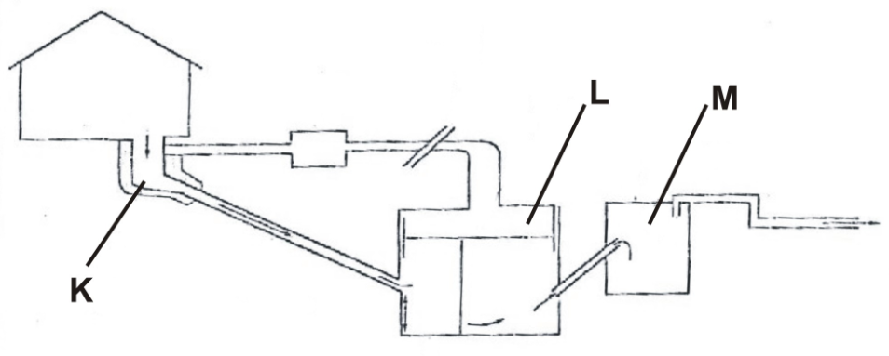

(a) Name the main component of biogas that is trapped in the part labeled L. (1 mark)
………………………………………………………………………………………………………………………………………………………………………………………………………………………………………………………………………………………………………………………………………………
(b) Give the name and use of the materials deposited in the part labeled M (1 mark)
………………………………………………………………………………………………………………………………………………………………………………………………………………………………………………………………………………………………………………………………………………
........................................................................................................................................................................
(c) State three uses of biogas on the farm (3 marks)
………………………………………………………………………………………………………………………………………………………………………………………………………………………………………………………………………………………………………………………………………………………………………………………………………………………………………………………………

24. The diagram below shows some management practices done in farm animals study it and answer
the questions that follow.
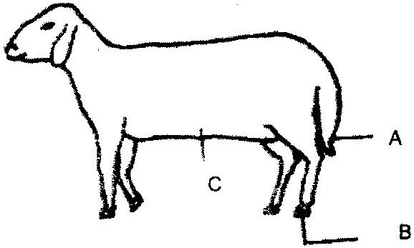

- (i) What operation is usually carried out on the part labeled A during a sheep’s early stages
of life? (1 mark)
………………………………………………………………………………………………………………………………………………………………………………………………………………………………………………………………………………………………………………………………
…………………………………………………………………………………………………………
(ii) Why is it necessary to carry out the operation in (i) above? (1 mark)
………………………………………………………………………………………………………………………………………………………………………………………………………………………………………………………………………………………………………………………………
…………………………………………………………………………………………………………
(iii) At what stage of sheep should the operation in (i) above be carried out? (1 mark)
……………………………………………………………………………………………………………………………………………………………………………………………………………………
(iv) Give two methods of carrying out the operation in (i) above. (1 mark)
………………………………………………………………………………………………………………………………………………………………………………………………………………………………………………………………………………………………………………………………
(b) (i) Which operation is usually carried out on part labeled B. (1 mark)
………………………………………………………………………………………………………………………………………………………………………………………………………………………………………………………………………………………………………………………………
(ii) What problem would occur if the operation in (bi)) above is not carried out? (1mark)
………………………………………………………………………………………………………………………………………………………………………………………………………………………………………………………………………………………………………………………………
(c) What practice is done on the ram in the part labeled C to control breeding . (1 mark)
……………………………………………………………………………………………………………………………………………………………………………………………………………………
25. The diagram below shows a type of a farm gate. Study the diagram and answer the questions that
follow.
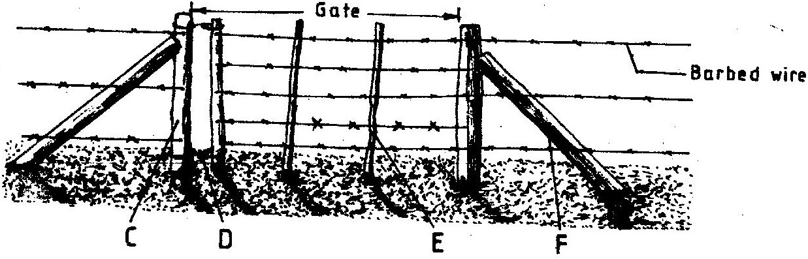

(a) Identify the type of gate shown (1 mark)
…………………………………………………………………………………………………………………………………………………………………………………………………………………… (b) Name the parts labeled C, D and E. (3 marks)
C

D

E
(c) (i) State one function of the part labeled F. (1 mark)

………………………………………………………………………………………………………………………………………………………………………………………………………………………………………………………………………………………………………………………………
…………………………………………………………………………………………………………
(ii) State two functions of the gate illustrated above. (2 marks)
………………………………………………………………………………………………………………………………………………………………………………………………………………………………………………………………………………………………………………………………
…………………………………………………………………………………………………………
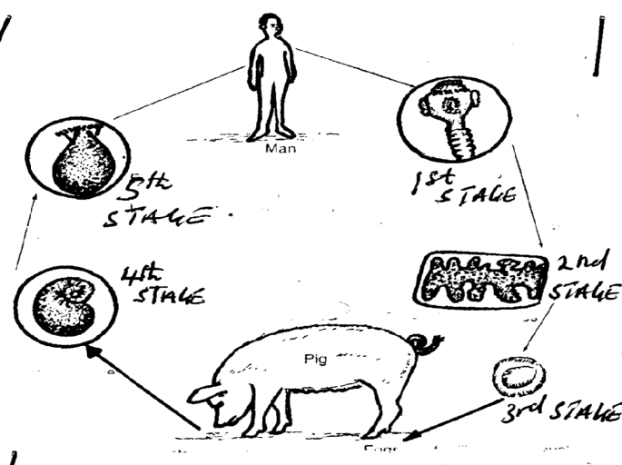
26. The illustration below shows a life cycle of an internal parasite.

(a) Identify the parasite (¹/₂ mark)
…………………………………………………………………………………………………………
(b) Give one forms in which the parasite is found in livestock. (¹/₂ mark)
…………………………………………………………………………………………………………
(c) Name the intermediate host of the above parasite. (½ mark)
…………………………………………………………………………………………………………
(d) State one way through which the above parasite can be passed to man. (1 mark)
………………………………………………………………………………………………………………………………………………………………………………………………………………………………………………………………………………………………………………………………

SECTION C (40 marks).
Answer two TWO questions from this section.
27. (a) Describe the procedure of wool shearing in sheep. (10marks)
(b) Stating the practices explain ten appropriate methods of handling livestock (10 marks)
28. (a) Explain five factors that influence the choice of building materials. (5 marks)
(b) Describe the Procedure of bull castration using burdizzor. (5 marks)
(c) Describe ten management practices carried out on cattle during parturition. (10 marks)
29. Describe the rearing of one day old chicks from the day they arrive on the farm to the point of
laying. (20 marks)
………………………………………………………………………………………………………………………………………………………………………………………………………………………………………………………………………………………………………………………………
…………………………………………………………………………………………………………
………………………………………………………………………………………………………………………………………………………………………………………………………………………………………………………………………………………………………………………………
…………………………………………………………………………………………………………
………………………………………………………………………………………………………………………………………………………………………………………………………………………………………………………………………………………………………………………………
…………………………………………………………………………………………………………
………………………………………………………………………………………………………………………………………………………………………………………………………………………………………………………………………………………………………………………………
…………………………………………………………………………………………………………
………………………………………………………………………………………………………………………………………………………………………………………………………………………………………………………………………………………………………………………………
…………………………………………………………………………………………………………
………………………………………………………………………………………………………………………………………………………………………………………………………………………………………………………………………………………………………………………………
…………………………………………………………………………………………………………
………………………………………………………………………………………………………………………………………………………………………………………………………………………………………………………………………………………………………………………………
…………………………………………………………………………………………………………
………………………………………………………………………………………………………………………………………………………………………………………………………………………………………………………………………………………………………………………………
…………………………………………………………………………………………………………
………………………………………………………………………………………………………………………………………………………………………………………………………………………………………………………………………………………………………………………………
…………………………………………………………………………………………………………
………………………………………………………………………………………………………………………………………………………………………………………………………………………………………………………………………………………………………………………………
…………………………………………………………………………………………………………
………………………………………………………………………………………………………………………………………………………………………………………………………………………………………………………………………………………………………………………………
…………………………………………………………………………………………………………
………………………………………………………………………………………………………………………………………………………………………………………………………………………………………………………………………………………………………………………………
…………………………………………………………………………………………………………
………………………………………………………………………………………………………………………………………………………………………………………………………………………………………………………………………………………………………………………………
…………………………………………………………………………………………………………
………………………………………………………………………………………………………………………………………………………………………………………………………………………………………………………………………………………………………………………………
…………………………………………………………………………………………………………
………………………………………………………………………………………………………………………………………………………………………………………………………………………………………………………………………………………………………………………………
…………………………………………………………………………………………………………
………………………………………………………………………………………………………………………………………………………………………………………………………………………………………………………………………………………………………………………………
…………………………………………………………………………………………………………
………………………………………………………………………………………………………………………………………………………………………………………………………………………………………………………………………………………………………………………………
…………………………………………………………………………………………………………
………………………………………………………………………………………………………………………………………………………………………………………………………………………………………………………………………………………………………………………………
…………………………………………………………………………………………………………
………………………………………………………………………………………………………………………………………………………………………………………………………………………………………………………………………………………………………………………………
…………………………………………………………………………………………………………

