NAME ____________________________________ INDEX NO. _______________
SCHOOL ____________________________________ SIGNATURE _______________
DATE _______________

231/1
BIOLOGY
(THEORY)

PAPER 1

TIME: 2 HOURS

FORM 4

INSTRUCTIONS TO CANDIDATES
- Write your name, school and admission number in the spaces provided above.
- Sign and write date of examination in the spaces provided above.
- Answer all the questions in the spaces provided.
- Additional pages must not be inserted.
- Candidates may be penalized for false information and even wrong spellings of technical terms.
- This paper consists of 8 printed pages.
- Candidates should check to ensure that all pages are printed as indicated and no questions are missing.

FOR OFFICIAL USE ONLY

Question | Maximum score | Candidate’s score
1 − 27 | 80

1. Explain the meaning of the following branches of biology.
a) Cytology (1mark)
___________________________________________________________________________________
b) Mycology (1mark)
___________________________________________________________________________________
2. State three reasons why it’s necessary to classify living organisms. (3marks)
____________________________________________________________________________________________________________________________________________________________________________________________________________________________________________________________________________________________________________________________________________
3. The diagram below represents a neuron.
D
A
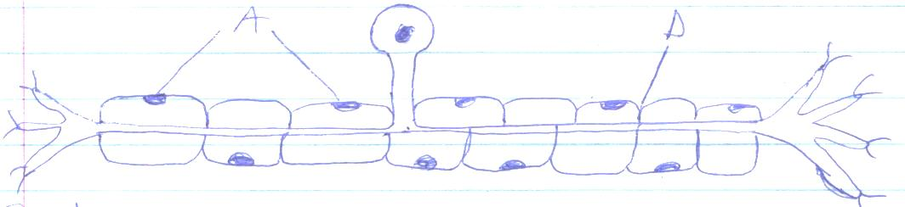
- i) Identify the neuron. (1mark)
___________________________________________________________________________________
ii) Give a reason. (1mark) ______________________________________________________________________________________________________________________________________________________________________
b) Identify the parts labeled A and D. (2marks)
A ________________________________________________________________________________
D _________________________________________________________________________________
c) State the function of neuron. (1mark) ______________________________________________________________________________________________________________________________________________________________________
4. A form one student trying to determine the size of onion cells observed the following on a microscopes field of view.

If the student observed 2 cells across the field of view calculate the length of one cell in micrometers (3marks)

5. The diagram below represents a certain organism collected by a student on his way to school
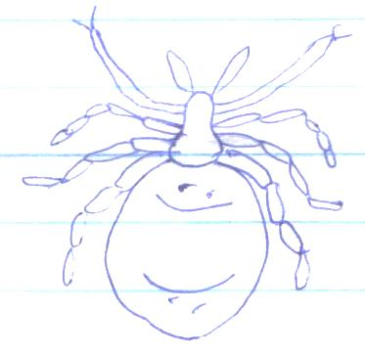
a) State the class to which the organism belongs (1mark)
___________________________________________________________________________________
- Give two reasons for your answer 5(a) above (2mark)
_________________________________________________________________________________________________________________________________________________________________________________________________________________________________________________________
6. What is meant by the following terms as used in ecology?
i) Biomass (1mark)
______________________________________________________________________________________________________________________________________________________________________
ii) Ecosystem (1mark)
______________________________________________________________________________________________________________________________________________________________________
7. The diagram below represents a synapse
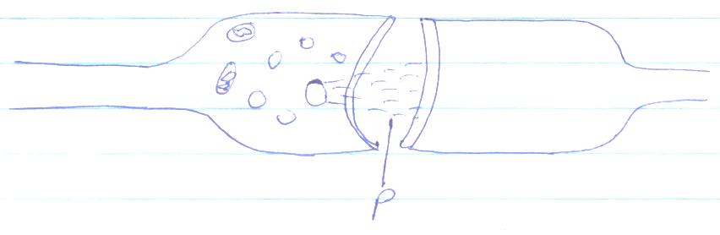
P
a) Indicate the direction of the impulse on the diagram (1mark)
b) State two significances of a synapse in the body (2mark s)
_________________________________________________________________________________________________________________________________________________________________________________________________________________________________________________________
8. Name a tissue whose cells are thickened with
a) Cellulose and pectin (1mark)
___________________________________________________________________________________
b) Lignin (1mark)
___________________________________________________________________________________
9. The diagram below shows the structure of an organelle
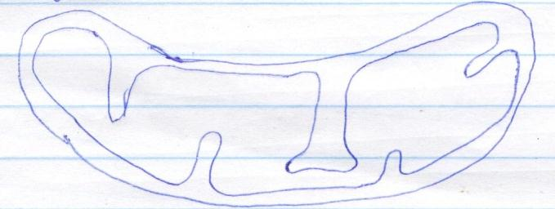
a) State the function of the organelle (1mark)
______________________________________________________________________________________________________________________________________________________________________
b) State one adaptation of the above organelle to its function (1mark)
______________________________________________________________________________________________________________________________________________________________________
- Give the function of the following cell organelles
- Lysosomes (1mark)
______________________________________________________________________________________________________________________________________________________________________
- Golgi bodies (1mark)
______________________________________________________________________________________________________________________________________________________________________
10. The diagram below represents across section of a certain plant
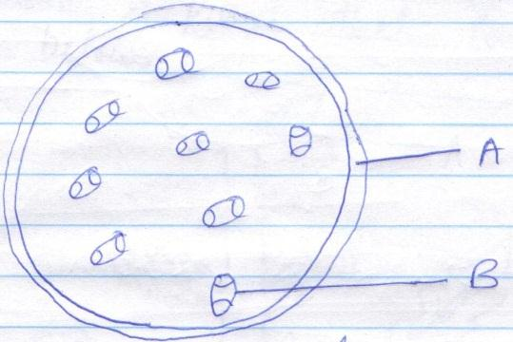
B
A
- Name the parts labeled A and B (2marks)
A _________________________________________________________________________________
B _________________________________________________________________________________
b) i) State the class to which the plant above belongs (1mark)
___________________________________________________________________________________
ii) Give a reason (1mark)
______________________________________________________________________________________________________________________________________________________________________

11. During research on different types of plants students found a plant that looked like the one shown below
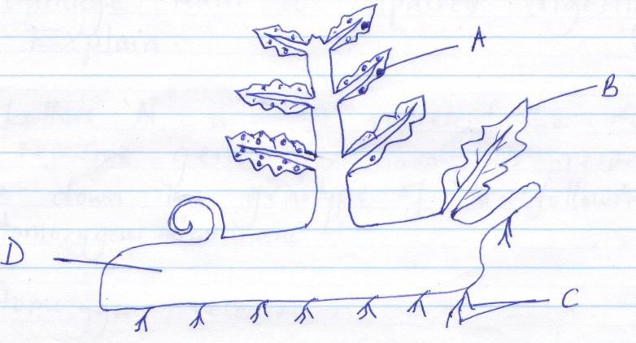
D
C
B
A
a) Identify the plant. (1mark)
______________________________________________________________________________________________________________________________________________________________________
- Name the parts labeled A, B, C and D. (4marks)
A _________________________________________________________________________________
B _________________________________________________________________________________
C _________________________________________________________________________________
D _________________________________________________________________________________
c) State the division to which the plant belongs. (1mark)
___________________________________________________________________________________
12. Why do you think we experience more discomfort in hot humid weather than we do in hot dry weather (3marks)
_______________________________________________________________________________________________________________________________________________________________________________________________________________________________________________________________________________________________________________________________________________________________________________________________________________________________
13. Explain why a water logged soil does not support plant growth. (3marks)
_______________________________________________________________________________________________________________________________________________________________________________________________________________________________________________________________________________________________________________________________________________________________________________________________________________________________
14. Name the carbohydrate that is.
- Found in abundance in mammalian blood. (1mark)
___________________________________________________________________________________
b) Stored in a mammalian liver. (1mark)
___________________________________________________________________________________
15. Liver damage leads to impaired digestion of fats. Explain. (2marks)
_________________________________________________________________________________________________________________________________________________________________________________________________________________________________________________________
16. The letters ‘N’ and n represents the dominant and recessive genes for hemophilia respectively.
Write down the genotype of the following (3marks)
- Homozygous dominant________________________________________________________________
- Homozygous recessive________________________________________________________________
- Heterozygote________________________________________________________________________
17. Give three adaptations of human male gamete to its functions. (3marks)
____________________________________________________________________________________________________________________________________________________________________________________________________________________________________________________________________________________________________________________________________________
18. The diagram below represents a longitudinal section of a bean study it and answer the questions that follow:
A
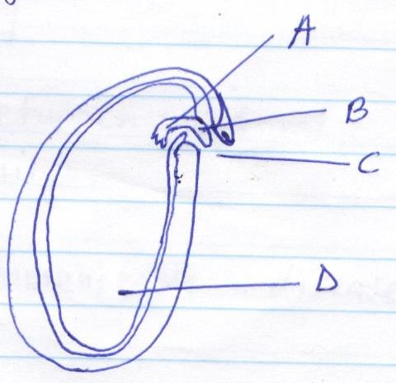
D
C
B
a) Identify the parts labeled A to D. (2marks)
A _________________________________________________________________________________
B _________________________________________________________________________________
C _________________________________________________________________________________
D _________________________________________________________________________________
b) Give the role of the plant labeled D. (1mark) ______________________________________________________________________________________________________________________________________________________________________
c) What type of germination would the seed shown above undergo? (1mark)
______________________________________________________________________________________________________________________________________________________________________

19. a) A person who is blood group AB has an advantage over a person who is blood group O. Explain.
(2marks) _________________________________________________________________________________________________________________________________________________________________________________________________________________________________________________________
b) Give two reasons for screening blood before transfusion. (2marks)
_________________________________________________________________________________________________________________________________________________________________________________________________________________________________________________________
20. a) Define immunity. (1mark) ______________________________________________________________________________________________________________________________________________________________________
b) Distinguish between natural immunity and acquired immunity. (1mark) _________________________________________________________________________________________________________________________________________________________________________________________________________________________________________________________
c) Identify one immunisable disease in Kenya. (1mark)
___________________________________________________________________________________
21. State the causative agent of;
i) Cholera (1mark) ___________________________________________________________________________________
ii) Amoebic dysentery. (1mark) ___________________________________________________________________________________
22. Explain why it difficult to calculate the respiratory quotient (RQ) in plants. (2marks) _________________________________________________________________________________________________________________________________________________________________________________________________________________________________________________________
23. The diagram below represents a stage in the development of human foetus.
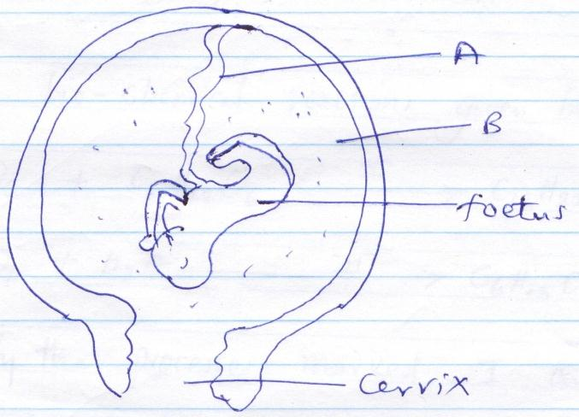
Cervix
Foetus
B
A
a) State one function of each of the structures labeled A and B. (2marks)
A _________________________________________________________________________________
_________________________________________________________________________________
B _________________________________________________________________________________
_________________________________________________________________________________
b) Apart from the size of the foetus what else from diagram illustrates that birth was going to occur in the near future.
______________________________________________________________________________________________________________________________________________________________________
24. Give the reasons why Lamar’s theory on natural selection in organic evolution was discarde. (2marks) ____________________________________________________________________________________________________________________________________________________________________________________________________________________________________________________________________________________________________________________________________________
25. Explain why the following process is essential in living organism.
- Reproduction (1mark)
______________________________________________________________________________________________________________________________________________________________________
- Excretion (1mark)
______________________________________________________________________________________________________________________________________________________________________
26. Explain why there are only a few days in each menstrual cycle when fertilization can occur. (2marks) _________________________________________________________________________________________________________________________________________________________________________________________________________________________________________________________
27. Study the bio-chemical reactions given below.
I
C₆ H₁₂ O₆ + C₆ H₁₂ O₆ C₁₂ H₂₂ O_{n} + H₂O
II
C₁₂ H₂₂ O₁₁ + H₂O C₆ H₁₂ O₆ + C₆ H₁₂ O₆
- Identify the process marked I and II (2marks)
I _________________________________________________________________________________
II _________________________________________________________________________________
b) Explain how the process marked II can be carried out in a laboratory. (1mark)
_________________________________________________________________________________________________________________________________________________________________________________________________________________________________________________________

