Name …………………………………………………. ADM NO………………\…………
Candidate’s signature ……………………….. Date ……………………………………………

231/1
BIOLOGY
PAPER 1
(THEORY)
2 HOURS
FORM 4

Instruction to candidates
- Write your name and index number in the spaces provided above.
- Sign and write the date of examination in the spaces provided above.
- Answer all the questions in the spaces provided.
- Candidates should check the question paper to ascertain that all the pages are printed as indicated and that no questions are missing.

- Name two nutrients that are absorbed without being digested by enzymes in humans. (2mks)
...............................................................................................................................................................................................................................................................................................
- a) Describe the condition known as varicose veins (2mks)
...............................................................................................................................................................................................................................................................................................................................................................................................................................................
................................................................................................................................................
................................................................................................................................................
b)What is the role of blood platelets in the blood clotting process? (2mks)

...............................................................................................................................................................................................................................................................................................................................................................................................................................................
3. Name the organelle that is involved in each of the following: (2mks)
a) Manufacturing of lipids.
................................................................................................................................................................................................................................................................................................
b)Formation of lysosomes.
................................................................................................................................................
................................................................................................................................................
- a) Give two differences in the products of anaerobic respiration between plants and animals. (2mks)
………………………………………………………………………………………………………………………………………………………………………………………………………………………………………………………………………………………………………………………………………………………………………………………………………………………………

b) Name the site of anaerobic respiration in a cell. (1mks)
...............................................................................................................................................................................................................................................................................................
5. The diagram below represents a certain plant.

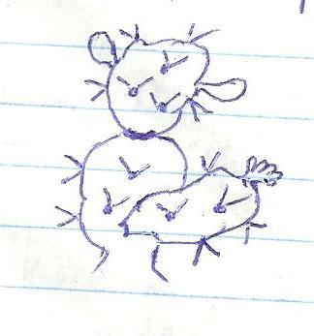

- What is the likely habitat for the plant? (1mk)

.................................................................................................................................................
- Give two reasons for your answer in (a) above. (2mks)
...........................................................................................................................................................
...........................................................................................................................................................
6. a) (i) What is meant by vestigial structures? (1mk)
...........................................................................................................................................................
...........................................................................................................................................................
.......................................................................................................................................................
(ii) Give an example of a vestigial structure in human (1mk)
...........................................................................................................................................................
...........................................................................................................................................................
.......................................................................................................................................................
- Explain why certain drugs become ineffective in curing disease after many years of use. (2mks)
...........................................................................................................................................................
...............................................................................................................................................................................................................................................................................................................................................
7. a) Name the part of a light microscope used to bring an image of a specimen into a sharp focus. (1mk)
...........................................................................................................................................................
..........................................................................................................................................................
- Why is it recommended to keep the stage of a microscope dry? (1mk)
...........................................................................................................................................................
...........................................................................................................................................................
.......................................................................................................................................................
8. State three external differences between diplopoda and chilopoda. (3mks)
...........................................................................................................................................................
...........................................................................................................................................................
.......................................................................................................................................................
...........................................................................................................................................................
...........................................................................................................................................................
.......................................................................................................................................................
9. State three factors that affect the rate of diffusion. (3mks)
………………………………………………………………………………………………………………………………………………………………………………………………………………………………………………………………………………………………………………………………………………………………………………………………………………………………………………………………………………………………………………………………………………………………………………………………………………………………………………

10. The diagram below represents a bone obtained from a mammal.
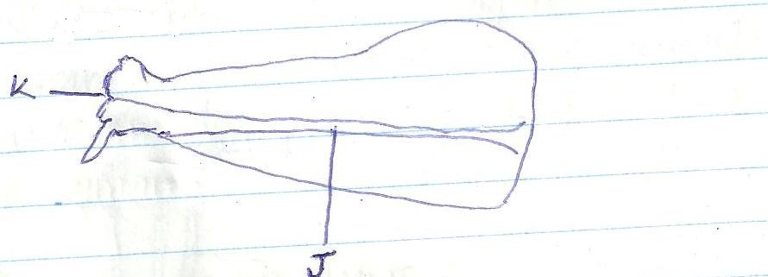
- Name the bone. (1mk)
…………………………………………………………………………………………………
- Name the:
- Bone which articulates with the bone named in (a) above at the cavity labeled K. (1mk)
…………………………………………………………………………………………………
- Joint formed by the two bones. (1mk)
………………………………………………………………………………………………………
- State the function of the part labeled J. (1mk)
……………………………………………………………………………………………………………………………………………………………………………………………………………………………………………………………………………………………………………………
11. a) A part from the lungs, name two gaseous exchange surface in a frog. (2mks)
……………………………………………………………………………………………………………………………………………………………………………………………………………………………………………………………………………………………………………………………………………………………………………………………………………………………
b)Write an equation that summarizes the process of aerobic respiration. (1mk)
………………………………………………………………………………………………………………………………………………………………………………………………………………………………………………………………………………………………………………………

12. The diagram below illustrates the structure of a bread mould.
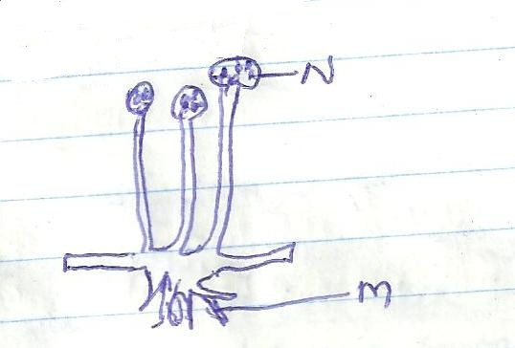

- Name the structure labeled N. (1mk)
………………………………………………………………………………………………………
- State the functions of the structure labeled K. (2MKS)
………………………………………………………………………………………………………………………………………………………………………………………………………………………………………………………………………………………
13. What is meant by the following terms?
a) Habitat: (1mk)
……………………………………………………………………………………………………………………………………………………………………………………………………………………………………………………………………………………………………………………
b) Ecosystem; (1mk)
……………………………………………………………………………………………………………………………………………………………………………………………………………………………………………………………………………………………………………………
14. State one economic importance of each of the following plant excretory products. (3mks)
a) Tannin
………………………………………………………………………………………………………………………………………………………………………………………………………………………………………………………………………………………………………………………

b)Quinine
…………………………………………………………………………………………………………………………………………………………………………………………………………………………………………………………………………
- Caffein
………………………………………………………………………………………………………………………………………………………………………………………………………………………………………………………………………………

15. In an investigation, a student extracted three pieces of pawpaw cylinders using a cork bovver. The cylinders were cut back to 50mm length and placed in a beaker containing a solution. The results after 40 min were shown in the table below
Feature | Results
Average length of cylinders(mm) | 56mm
Stiffness of cylinders | stiff

- Account for the results in the table above. (3mks)
………………………………………………………………………………………………………………………………………………………………………………………………………………………………………………………………………………………………………………………………………………………………………………………………………………………………………………………………………………………………………………………………………………………………………………………………………………………………………………………………………………………………………………………………………………………………………………………………………………………………………….
- What would be the control experiment for the investigation? (2mks)
………………………………………………………………………………………………………………………………………………………………………………………………………………………………………………………………………………………………………………………
16. How does nutrition as a characteristic of living organisms differ in plants and animals? (2mks)
………………………………………………………………………………………………………………………………………………………………………………………………………………………………………………………………………………………………………………………………………………………………………………………………………………………………………………………………………………………………………………………………………………………………………………………………………………………………………………………………………
17. The number of stomata on the lower and upper surface of two leaves from plant species X and Y were counted under the field of view of a light microscope. The results were as shown in the table below.

Leaf | Upper Surface | Lower Surface
X | 4 | 12
Y | 20 | 23

- Which of the two leaves would be expected to have a lower rate of transpiration? (1mk)
………………………………………………………………………………………………………………………………………………………………………………………………………………………………………………………………………………………………………………………
- Give a reason for your answer in (a) above (1mk)
………………………………………………………………………………………………………………………………………………………………………………………………………………………………………………………………………………………………………………………………………………………………………………………………
18. State the changes that occur in arterioles in the human skin during thermoregulation. (2mks)
…………………………………………………………………………………………………………………………………………………………………………………………………………………………………………………………………………………………………………………………………………………………………………………………………………………………………………………………………………………………………………………………………………………………………………………………………………………………………………………………………………………………………………………………………………………………………………………………………………………………………………..
19. State two advantages of internal fertilization in humans. (2mks)
……………………………………………………………………………………………………………………………………………………………………………………………………………………………………………………………………………………………………………………………………………………………………………………………………………………………………………………………………………………………………………………………………………………………………………………………………………………………………

20. a) What is meant by the following terms:
(i) Hybrid Vigour; (1mk)
……………………………………………………………………………………………………………………………………………………………………………………………………………………………………………………………………………………………………………………………………
(ii) Polyploid? (1mk)
………………………………………………………………………………………………………………………………………………………………………………………………………………………………………………………………
- State two causes of chromosomal mutations (2mks)
………………………………………………………………………………………………………………………………………………………………………………………………………………………………………………………………………………………………………………………………………………………………………………………………………………………………………………………………………………………………
21. What is the functions of the following structures in human reproductive organs?
a) Fallopian tubes. (1mk)
………………………………………………………………………………………………………………………………………………………………………………………………………………………………………………………………………………………………………………………
b) Epididymis (1mk)
……………………………………………………………………………………………………………………………………………………………………………………………………………………………………………………………………………………………………………………
c) Scrotal sac. (1mk)
……………………………………………………………………………………………………………………………………………………………………………………………………………………………………………………………………………………………………………………

22. State the differences in content of oxygen and carbon (iv) oxide in the air that enters and leaves the human lungs. (2mks)
……………………………………………………………………………………………………………………………………………………………………………………………………………………………………………………………………………………………………………………………………………………………………………………………………………………………………………………………………………………………………………………………………………………………………………………………………………………………………………………………………………………………………………………………………………
23. State three factors that contribute to the deceleration phase in the population curve of an organism. (3mks)
………………………………………………………………………………………………………………………………………………………………………………………………………………………………………………………………………………………………………………………………………………………………………………………………………………………………
24. Name two kidney diseases. (2mks)
………………………………………………………………………………………………………………………………………………………………………………………………………………………………………………………………………………………………………………………
25. The diagram below represents a transverse section of an ovary from a certain flower.
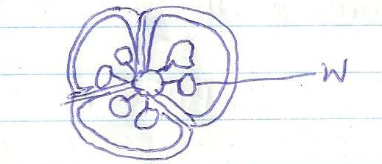

- (i) Name the structure labeled W. (1mk)
………………………………………………………………………………………………………
- Name the type of placentation illustrated in this diagram. (1mk)
………………………………………………………………………………………………………

26. a) What is meant by the term non-disjunction? (1mk)
……………………………………………………………………………………………………………………………………………………………………………………………………………………………………………………………………………………………………………………
- Give an example of a genetic disorder caused by:
- Non-disjunction. (1mk)
………………………………………………………………………………………………………………………………………………………………………………………………………………
- Gene mutation. (1mk)
………………………………………………………………………………………………………………………………………………………………………………………………………………………………………………………………………………………………

27. State how the rough endoplasmic reticulum is adapted to its function. (2mks)
……………………………………………………………………………………………………………………………………………………………………………………………………………………………………………………………………………………………………………………………………………………………………………………………………………………………………………………………………………………………………………………………………
28. a) What is a tropic response? (1mk)
………………………………………………………………………………………………………………………………………………………………………………………………………………………………………………………………………………………………………………………………………………………………………………………………………………………………
b) State three ways by which auxins regulate growth in seedlings. (3mks)
………………………………………………………………………………………………………………………………………………………………………………………………………………………………………………………………………………………………………………………………………………………………………………………………………………………………………………………………………………………………………………………………………

29. What is meant by the term apical dominance? (3mks)
………………………………………………………………………………………………………………………………………………………………………………………………………………………………………………………………………………………………………………………………………………………………………………………………………………………………………………………………………………………………………………………………………

