Name:…………………………………………......................Index No…….....……………… Signature……………….................. Date: ……………......
FORM 4

231/1 (THEORY)
BIOLOGY PAPER 1
TIME: 2 HOURS

- Write your Name and Index Number in the spaces provided above.
- Sign and write the date of examination in the spaces provided above.
- This paper consists of TWO sections: A and B.
- Answer ALL the questions in section A in the spaces provided after each question
- In Section B, answer question 6 (compulsory) in the spaces provided and either question 7 or 8 in the spaces provided after question 8.
- Answers must be written in English only.

For Examiner’s Use Only
Questions | Maximum score | Candidate’s score
1-24 | 80

This paper consists of 10 printed pages. Candidates should check the question paper to ensure that all the pages are printed as indicated and no question is missing.

- Name one characteristic feature of organisms that enables them to survive in a new environment. (1 mark)
…………………………………………………………………………………………………
- (a) A student caught an organism and observed that it had the following characteristic features:
Body divided into two body parts; eight legs;
- To which class does the organism belong? (1 mark)
………………………………………………………………………………………………
- State another characteristic feature the members belonging to this class are likely to have. (1 mark)
…………………………………………………………………………………………….
- Name the phylum whose members posses a notochord. (1 mark)
………………………………………………………………………………………………
- Which organelles will be abundant in :
- Skeletal muscles. (1 mark)
…………………………………………………………………………………………………
- Palisade cells. (1 mark)
…………………………………………………………………………………………………..
- (a) What are lipids? (1 mark)
………………………………………………………………………………………………
- State three properties of lipids. (3 marks)
- …………………………………………………………………………………………….
- …………………………………………………………………………………………….
- ……………………………………………………………………………………………

- (a)Why do organisms reproduce? (1 marks)
………………………………………………………………………………………………
- Give differences between plants and animals in respect to gaseous exchange. (1 marks)
……………………………………………………………………………………………..
- In a certain experiment, the following observation was made:
When red blood cell was placed in a certain solution, the solution exerted more osmotic pressure leading to the cell losing water molecules to become crenated/ shrunk.
- What type of solution was the cell placed in respect to the cell’s cytoplasm? (1 mark)
……………………………………………………………………………………………..
- By which physiological process did the cell lose water molecules? (1 mark)
…………………………………………………………………………………………….
- Name two water-borne parasitic diseases that are characterised by severe diarrhoea. (2 marks)
……………………………………………………………………………………………………………………………………………………………………………………………………
- Study the flow diagram below.
☼
CO₂
U
CH₂O
2H₂O
Dark stage
V
W
Light stage

Name the substance U, V and W. (3 marks)
U:…………………………………………………………………………………………
V:……………………………………………………………………………………………
W:…………………………………………………………………………………………..
- (a) State the deficiency diseases of each of the following vitamins. (3 marks)
- B₁ ………………………………………………………………………………………….
- B₂ ………………………………………………………………………………………….
- B₆ …………………………………………………………………………………………
- What is the role of roughage in a diet? (1 mark)
……………………………………………………………………………………………
- The flow chart below shows the digestion of sucrose in mammalian ileum.
Sucrose

X
Y

Name the products X and Y. (2 marks)
X: …………………………………………………………………………………………..
Y: …………………………………………………………………………………………
- List down three adaptations of the preys against being predated upon by predators. (3 marks)
………………………………………………………………………………………………………………………………………………………………………………………………………………………………………………………………………………………………………
- How does temperature affect the rate of photosynthesis? (3 marks)
……………………………………………………………………………………………………………………………………………………………………………………………………………………………………………………………………………………………………….
- Name three biological ways by which atmospheric nitrogen is availed for plant use.
(3 marks)
………………………………………………………………………………………………………………………………………………………………………………………………………………………………………………………………………………………………………
- The diagram below represents the structure of a nephron. Study it and answer the questions that follow.

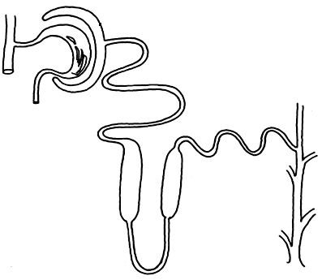
B
C
C
X

- State the roles of the part labelled B and C. (2 marks)
B: …………………………………………………………………………………………...
C: …………………………………………………………………………………………...
- Which hormone is involved in the function of the part labelled D? (1 mark)
………………………………………………………………………………………………
- Name the part labelled X. (1 mark)
………………………………………………………………………………………………

- A microscope with an eye piece of X10 was used to magnify a cell 400 times. What power of the objective lens was used? Show your working. (3 marks)

- (a) What are variations? (1 mark)
……………………………………………………………………………………………...
(b)List down three types of chromosomal mutations related to the structure of chromosomes.
(1 mark)
………………………………………………………………………………………………………………………………………………………………………………………………………………………………………………………………………………………………

- (a) Identify the type of placentation shown by the fruit shown below: (1 mark)
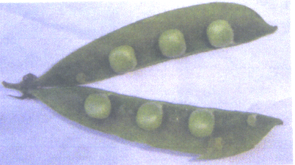
………………………………………………………………………………………………
- How is the fruit adapted to its mode of dispersal of seeds? (1 mark)
………………………………………………………………………………………………
- The diagram below represents a cell at one stage of the cell division.
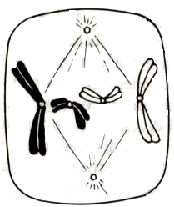
J
- Identify the stage. (1 mark)
………………………………………………………………………………………………
- (i) Is the cell of a plant or an animal? (1 mark)
……………………………………………………………………………………………..
- Give a reason for your answer in (b)(ii) above. (1 mark)
…………………………………………………………………………………………….
- Name the economic importance of the three products of respiration which occurs in plants in absence of oxygen. (3 marks)
………………………………………………………………………………………………………………………………………………………………………………………………………………………………………………………………………………………………………
- Name two gaseous exchange structures in terrestrial plants. (2 marks)
……………………………………………………………………………………………………………………………………………………………………………………………………
- (a) State the functions of each of the following parts of mammalian eye:
- Cornea (1 mark)
………………………………………………………………………………………………

- Fovea centralis (1mark)
………………………………………………………………………………………………
- State how the shortsightedness is corrected. (1mark)
………………………………………………………………………………………………

- Name two areas of study of Biology you would acquire appropriate knowledge to enable you to solve the problem of water Hyacinth in Lake Victoria. (2 marks)
…………………………………………………………………………………………………………………………………………………………………………………………………….
- State the functions of each of the following specialised cells in plants:
- male gamete nucleus. (1 mark)
………………………………………………………………………………………………
- endodermal cell. (1 mark)
………………………………………………………………………………………………
- Differentiate between the following pairs of terms:
- Guttation and transpiration. (1 mark)
……………………………………………………………………………………………..
- Morphology and anatomy. (1 mark)
……………………………………………………………………………………………..
- List down three effects of gibberellins in plant growth and development. (3 marks)
………………………………………………………………………………………………………………………………………………………………………………………………………………………………………………………………………………………………………

- (a) Name the type of seed germination shown below: (1 mark)
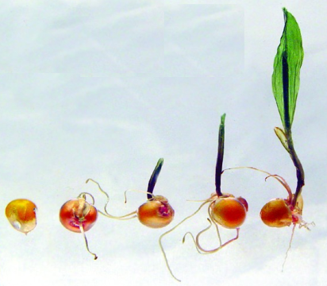
…………………………………………………………………………………………
- Explain how the germination occurs. (3 marks)
………………………………………………………………………………………………………………………………………………………………………………………………………………………………………………………………………………………………
- List down three differences between bryophytes and spermatophytes. (3 marks)
……………………………………………………………………………………………………………………………………………………………………………………………………
- (a) What are gene mutations? (1 mark)
……………………………………………………………………………………………
- State two genetic disorders which are as a result of gene mutation. (2 marks)
………………………………………………………………………………………………………………………………………………………………………………………………
- State the roles of the following parts of mammalian heart. (2 marks)
- Sino-atrio node (SAN).
…………………………………………………………………………………………….
- Tricuspid valve.
………….. ………………………………………………………………………………..
- State three effects of soil pH in distribution of organisms in a given ecosystem. (3marks)
………………………………………………………………………………………………………………………………………………………………………………………………………………………………………………………………………………………………………

