NAME:…………………………………………………………………………………… ADM. NO…………………………..…..…..
SCHOOL:……………………………………………………SIGNATURE………………………………DATE…………….…………
231/1
BIOLOGY
(Theory)
TIME: 2HOURS

FORM 4

INSTRUCTIONS TO CANDIDATES
- Write your name and Adm. number in the spaces
provided.
- Answer ALL the questions in the spaces provided,

FOR EXAMINERS USE ONLY
Question | Maximum score | Candidates score
1-34 | 80

Candidates should check the question paper to ensure that all the pages are printed as indicated and no questions are missing.

- In mitosis in animals chromatids failed to separate and moved to the opposite poles
i) Name the organelle that the cell was lacking. (1 mark)
…………………………………………………………………………………………..
ii) State one function of the named organelle. (1 mark)
…………………………………………………………………………………………..
- Study the part of the mammalian skeleton represented by the diagram below.
- Name the bone (l mark)
……………………………………….
- Which bone articulates with the
above bone at point V? (l mark)
……………………………………….
- Name the type of joint formed at point Y. (l mark)
..................................................................
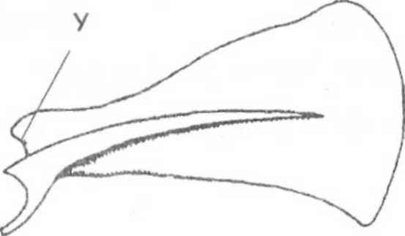

- List down two functions of placenta in mammals. (2 marks)
……………………………………………………………………………………….........................
……………………………………………………………………………………….........................
.............................................................................................................................................................
- Explain why food is stored in an insoluble form in the cells of living things. (2 marks)
………………………………………………………………………………………….....................
…………………………………………………………………………………………....................
............................................................................................................................................................
- State two homeostatic functions of the liver. (l mark)
………………………………………………………………………………………................
………………………………………………………………………………………...............
...................................................................................................................................................
- State how the tracheoles of insect are adapted to their functions. (2 marks)
……………………………………………………………………………………….....................
………………………………………………………………………………………......................
- The diagram below shows a mature fruit from a dicotyledonous plant.
- To what a group of fruits does the specimen belong?
(l mark)

………………………………………………………

- Name the method of dispersal of fruit (l mark)

………………………………………………………..

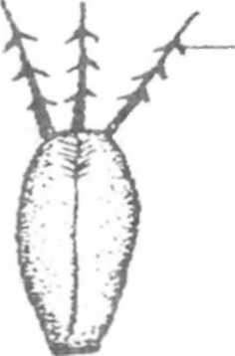
Hook
- State the functions of each of the following parts of microscope.
a) Diaphragm (1 Mark)
………………………………………………………………………………………………….........
.............................................................................................................................................................
b) Eye piece lens. (1 Mark)
………………………………………………………………………………………………...........
...........................................................................................................................................................
- Enzyme + substrate Enzyme + products.
From the above equations name two properties of enzymes shown. (2 marks)
…………………………………………………………………………………………………......
……………………………………………………………………………………………..............
..........................................................................................................................................................
- Explain why plants shed of their leaves. (2 marks)
…………………………………………………………………………………………………......
…………………………………………………………………………………………….............
........................................................................................................................................................

- A form one student trying to estimate the size of an onion cell observed the following on the microscope field of view.
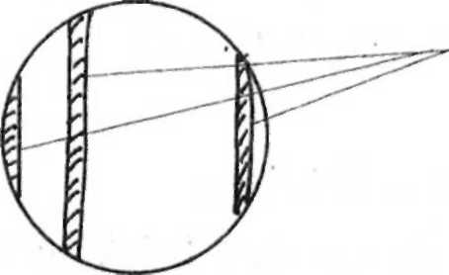
He counted 20 cells across the field of view. Calculate the size of one cell in micrometres
Millimetres
(2 marks)
………………………………………………………………………………………………………………………………………………………………………………………………………………………………………………………………………………………………………
- Name two organisms that form the biological environment of malaria parasite. (2 Marks)
……………………………………………………………………………………………………………………………………………………………………………………………………
- Name the organelle that performs each of the following functions in a cell. (2 Marks)
a) Break down worn out organelles.
………………………………………………………………………………………….........
- Transport proteins
…………………………………………………………………………………………….
- An organism with an exoskeleton, segment body, two pairs of legs per segment, a pair of eyes and a pair of short antenae belongs to the class? (l mark)
…………………………………………………………………………………………………
15. Explain the following
a) When transplanting a seedling, it's advisable to remove some of the leaves.
……………………………………………………………………………………………………………………………………………………………………………………………………
b) There are generally fewer stomata's on the upper surface of a terrestrial leaf than on the lower surface. (l mark)
………………………………………………………………………………………………..
16. Name the carbohydrate that is
- Found in abundance in mammalian blood. (l mark)
……………………………………………………………………………………………….
- Stored in the mammalian liver. (l mark)
………………………………………………………………………………………………..
17. Explain why
a) Red blood cells burst when placed in distilled water while plant cells remain intact.
(2 marks)
…………………………………………………………………………………………………
…………………………………………………………………………………………………
- Fresh water protozoa like amoeba do not burst when placed in distilled water. (2 Marks)
………………………………………………………………………………………………..
- Stored in potato tuber
………………………………………………………………………………………………..
18. a) The equation below represents oxidation of certain food substrate.
C₅₇ H₁₀₄ O₆ + 80O₂ 57CO₂+ 52H₂O + Energy
i) Calculate the respiratory quotient.
…………………………………………………………………………………………………
…………………………………………………………………………………………………
ii) Which type of food substrate is being oxidised?
…………………………………………………………………………………………………
b) Explain the meaning of the term oxygen debt. (1 Mark)
…………………………………………………………………………………………………
19. Define Apical Dominance. (1 Mark)
…………………………………………………………………………………………………
20. State 3 characteristics of skeletal muscles. (3 Marks)
………………………………………………………………………………………………………………………………………………………………………………………………………………………………………………………………………………………………………
21. A person was found to pass out large volumes of dilute urine frequently
- Which disease was the person suffering from? (l mark)
…………………………………………………………………………………………………
ii) Name the hormone the person was deficient. (l mark)
…………………………………………………………………………………………………
22. The diagram below represents a mature bread mould (Rhizopus)

a) Name the kingdom to which bread mould belongs (l mark)
…………………………………………………
b) Name the structures A and B (2 marks)
…………………………………………………
…………………………...................................
c) State the role of the part labelled C. (l Mark)
……………………………………………………………………………
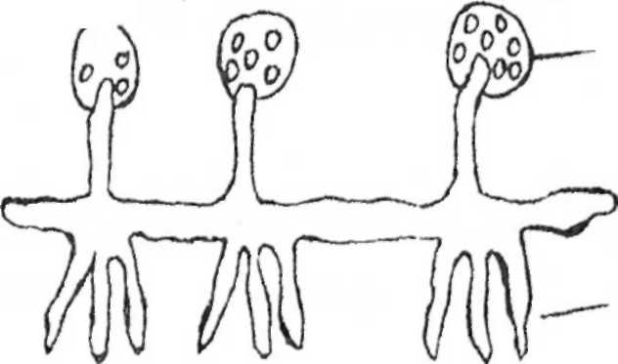
0

23. Explain the meaning of the following terms in human reproduction.
a) Implantation (l mark)
…………………………………………………………………………………………………..
b) Gestation period (l mark)
…………………………………………………………………………………………………..
24. Distinguish between genotype and phenotype
………………………………………………………………………………………………….
25. Give two advantages homoiotherms have over poikilotherms. (2 marks)
……………………………………………………………………………………………………………………………………………………………………………………………………
26. Distinguish between hypogeal and epigeal germination. (2 marks)
……………………………………………………………………………………………………………………………………………………………………………………………………
27. State one weakness of Lamarckian theory of evolution. (2 marks)
……………………………………………………………………………………………………………………………………………………………………………………………………
28. The diagram below represents a neurone.
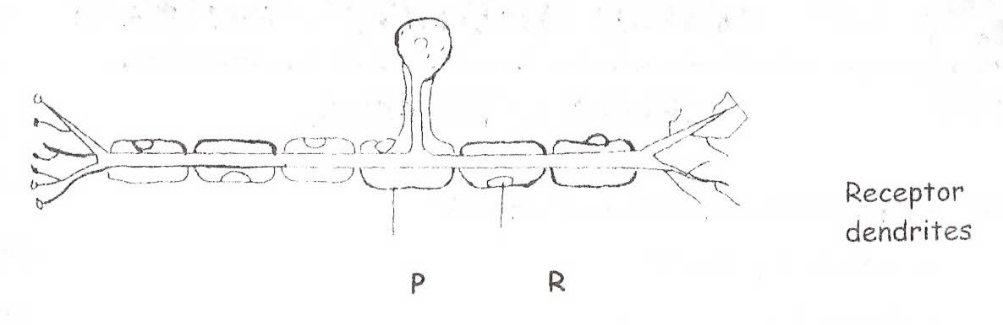

- Name the neurone represented. (2 marks)
…………………………………………………………………………………………………
- What is the function of the part labelled P and R. (2 marks)
………………………………………………………………………………………………....
…………………………………………………………………………………………………
c) Using an arrow, indicate the direction of the impulse on the diagram. (l mark)
…………………………………………………………………………………………………
29. Name two structures of gaseous exchange in plant. (2 marks)
…………………………………………………………………………………………………
…………………………………………………………………………………………………
30. State two roles of water during the process of germination. (2 marks)
……………………………………………………………………………………………………………………………………………………………………………………………………
31. Give three structural differences between arteries and veins. (3 marks)
………………………………………………………………………………………………………………………………………………………………………………………………………………………………………………………………………………………………………
32. An experiment was set up to investigate the effect of light on a growing maize seedling. The seedling was covered with a darkened box with only one opening. After one week, it appeared as follows.
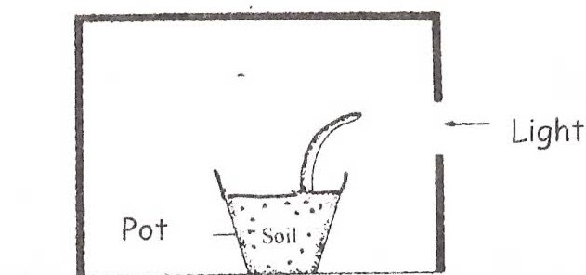

Darkened room
a) Name the type of response shown by the seeding (l mark)
…………………………………………………………………………………………………..
b) Explain how the response named in (a) above occurs. (3 marks)
………………………………………………………………………………………………………
………………………………………………………………………………………………………
………………………………………………………………………………………........................
33. a) Define photosynthesis (2 marks)
………………………………………………………………………………………………………
……………………………………………………………………………………………...............
b) Name two products formed during the light stage of photosynthesis. (2 marks)
………………………………………………………………………………………………………
……………………………………………………………………………………………...............
34. Identify two ways through which HIV / Aids virus can be transmitted. (2 marks)
………………………………………………………………………………………………………
……………………………………………………………………………………………................

