Name………………………………………………………. ADM No……….. Class…………

Candidates Signature…………… Date…………………………….

231/2
BIOLOGY
Paper 2
(THEORY)
TIME 2 HOURS

FORM 4
Kenya certificate of secondary education (K.C.S.E)

INSTRUCTIONS TO CANDIDATES

- Write your name and Index Number in the spaces provided above.
- Sign and write date of examination in the spaces provided above.
- This paper consists of Two sections A and B.
- Answer ALL questions in section A in the spaces provided.
- In section B answer question 6(compulsory) and either question or 8 in the spaces provided after question 8.

FOR EXAMINERS USE ONLY
Questions | questions | Maximum score | Candidates score
A | 1 | 8
 | 2 | 8
 | 3 | 8
 | 4 | 8
 | 5 | 8
B | 6 | 20
 | 7 | 20
 | 8 | 20
Total score |  | 80

This paper consists of 12 printed pages
Candidates should check the question paper to ensure that all the
Papers are printed as indicated and no questions are missing

- The diagram below represents a human foetus in the uterus
A
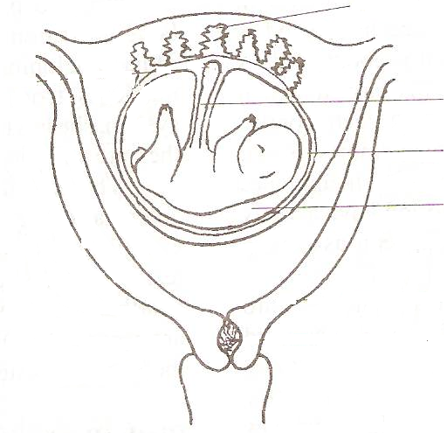
A

B
B

C
E
E

- Name the part labeled C (1 mark)
………………………………………………………………………………………………………………………………………………………………………………………………………………
(b) Name the types of blood vessels found in the structures labeled B giving their functions
(2 marks)
………………………………………………………………………………………………….........
………………………………………………………………………………………………………………………………………………………………………………………………………………………………………………………………………………………………………………………
(c) Give three features that enable the structure labeled A carry out its functions (3 marks)
…………………………………………………………………………………………………........ ……………………………………………………………………………………………………...
…………………………………………………………………………………………………......................................................................................................................................................................
(d) Name the structure labeled E giving its role (2 marks)
…………………………………………………………………………………………………........ ……………………………………………………………………………………………………...
………………………………………………………………………………………………….......

- The diagram below represents the structure of a nephron. Study it and answer the questions that follow.
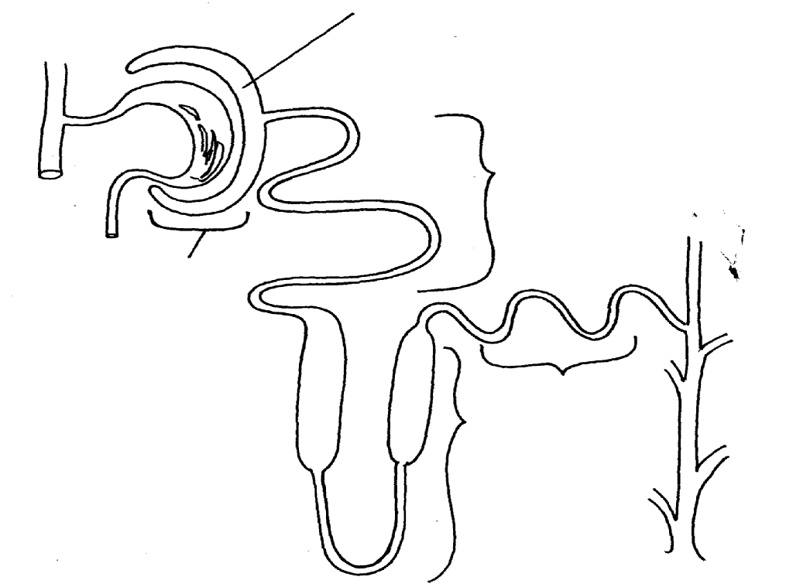
X
B
A
C
D
C

- (i) State the physiological process by which solutes are selectively re-absorbed back into
blood stream at the part labelled B. (1 mark)
………………………………………………………………………………………………………
(ii) How is the part labeled B adapted to carry out the physiological process named in 2 (a) (i)
above. (1 mark)
………………………………………………………………………………………………………………………………………………………………………………………………………………
b) In which part of the kidney is the part labelled A abundantly found. (1mark)
………………………………………………………………………………………………………
c) On the diagram above, indicate the direction of flow of blood using arrows at the part labelled C. (1mark) ………………………………………………………………………………………………………
……………………………………………………………………………………………………..
e) State the functions carried out by the following hormones in the functioning of the nephrone.
(i) Aldosterone. (1mark) ………………………………………………………………………………………………………………………………………………………………………………………………………………………………………………………………………………………………………………………
(ii) Anti diuretic hormone. (1mark) ………………………………………………………………………………………………………………………………………………………………………………………………………………………………....................................................................................................................................
- Below is a set up that was used to investigate a certain process in plants

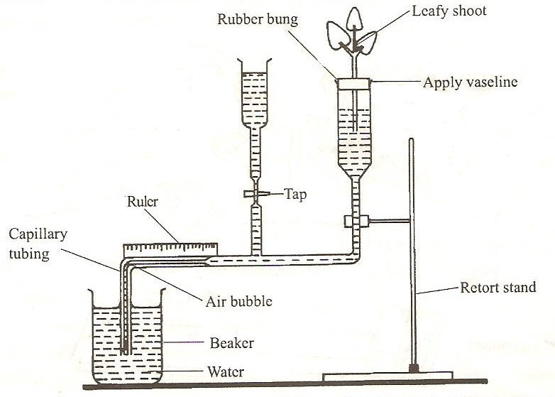

(a) State the process that was being investigated (1 mark)
………………………………………………………………………………………………………
……………………………………………………………………………………………………..
(b )(i) Give two precautions that should be taken when preparing the experiment (2 marks)
…………………………………………………………………………………………………………………………………………………………………………………………….......................................................................................................................................................................................................................................................................................................................................................
(ii) State a reason for each precautions stated in b(i) above (2 marks)
……………………………………………………………………………………………………..
……………………………………………………………………………………………………... …..…………………………………………………………………………………………………
(c) List three structural factors that affect the process under investigation (3 marks)
…………………………………………………………………………………………………........ ……………………………………………………………………………………………………...
……………………………………………………………………………………………………

4. The figure below shows a germinating seedling.
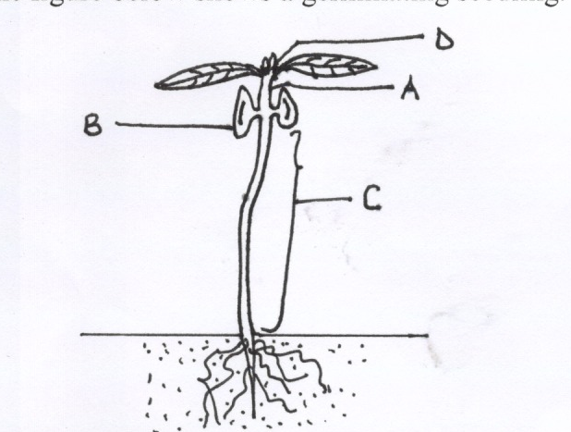

a) On the diagram, label the parts labeled A to D. (2 marks)
…………………..……………………………………………………………………………………………………………………………………………………………………………………………………………………………………………………………………………………………………………
b) State two functions of the part labeled B. (2marks) ……………………………………………………………………………………………………………………………………………………………………………………………………………………………………………………………………………………………………………………………….
c) Name the type of germination shown by the diagram. (1mark.) …………………………………………………………………………………………………………… ……………………………………………………………………………………………………………
d) Explain two functions carried out by water during the process of germination. (2marks) …………………………………………………………………………………………………………… ……………………………………………………………………………………………………………
e) Give a reason why the radical emerges first during germination. (lmark) …………………………………………………………………………………………………………… ……………………………………………………………………………………………………………
- The figure below shows a structure found in the small intestine

(i)Identify the structure (1mark)
………………………………………………………………………………………………………………………………………………………………………………………………………………
(ii) Name and state one function of each of the structures labeled A-C (6 marks)

Structure | Name | Function
A

B

C

(b) What is the importance of structure labeled D (1mark)
…………………………………………………………………………………………………........ ……………………………………………………………………………………………………...
………………………………………………………………………………………………….....

SECTION B.
Question 6 is compulsory.
Choose either question 7 or 8 and answer in space after question 8

- Experiments were set up separately to investigate the rate if growth of paramecium and amoeba. The results are shown in the table below.
Population number
day | paramecium | Amoeba
0 | 85 | 75
1 | 95 | 80
2 | 140 | 125
3 | 250 | 260
4 | 510 | 400
5 | 525 | 325
6 | 530 | 125

- ot graphs showing the rate of population growth against the number of days on the same axis (6mks)

b) During which days was the population increase in paramecium and amoeba.
(i) Lowest…………………………………………… …………………………………….. (1mark)

(ii) Highest..;…………………………. ……………………. …………………………… (1mark)
(c ) Account for the shape of the graph of
(i) Paramecium at day (6 marks)
1 and 2 ……………………………………………………………………………………………………………………………………………………………………………………………………………………………………………………………………………………………………………………………………………………………………………………………………………………………………………………………………………………………………………………………………….

3 and 4
………………………………………………………………………………………………………………………………………………………………………………………………………………………………………………………………………………………………………………………
……………………………………………………………………………………………………...
5 and 6
………………………………………………………………………………………………………………………………………………………………………………………………………………………………………………………………………………………………………………………………………………………………………………………………………………………………
(ii) Amoeba at day (2 marks)
5 and 6
……………………………………………………………………………………………………… ……………………………………………………………………………………………………………………………………………………………………………………………………………………………………………………………………………………………………………………………………………………………………………………………………………………………….
(d) Suppose both paramecium and amoeba were put in the same medium, suggest the results that would have been obtained giving reasons (4marks)
………………………………………………………………………………………………………………………………………………………………………………………………………………………………………………………………………………………………………………………………………………………………………………………………………………………………………………………………………………………………………………………………………………………………………………………………………………………………………………
7. Describe how human male reproductive system is adapted to its functions (20 marks)
8 Discus how the various seeds and fruits are adapted to their mode of dispersal (20 marks)
………………………………………………………………………………………………………………………………………………………………………………………………………………………………………………………………………………………………………………………………
……………………………………………………………………………………………………………………………………………………………………………………………………………………………………………………………………………………………………………………………….
……………………………………………………………………………………………………………………………………………………………………………………………………………………………………………………………………………………………………………………………….
………………………………………………………………………………………………………………………………………………………………………………………………………………………………………………………………………………………………………………………………
……………………………………………………………………………………………………………………………………………………………………………………………………………………………………………………………………………………………………………………………….
……………………………………………………………………………………………………………………………………………………………………………………………………………………………………………………………………………………………………………………………….
………………………………………………………………………………………………………………………………………………………………………………………………………………………………………………………………………………………………………………………………
……………………………………………………………………………………………………………………………………………………………………………………………………………………………………………………………………………………………………………………………….
……………………………………………………………………………………………………………………………………………………………………………………………………………………………………………………………………………………………………………………………….
………………………………………………………………………………………………………………………………………………………………………………………………………………………………………………………………………………………………………………………………………………………………………………………………………………………………………………………………………………………………………………………………………………………………………………………………………………………………………………………………………………………………………………………………………………………………………………………………………………………………………………………………………………………………………………………………………………………………………………………………………………………………………………………………………………………………………………………………………………………………………………………………………………………………………………………………………………………………………………………………………………………………………………………………………………………………………………………………………………………………………………………………………………………………………………………………………………………………………………………………………………………………………………………………………………………………………………………………………………………………………………………………………………………………………………………………………………………………………………………………………………………………………………………………………………………………………………………………………………………………………………………………………………………………………………………………………………………………………………………………………………………………………………………………………………………………………………………………………………………………………………………………………………………………………………………………………………………………………………………………………………………………………………………………………………………………………………………………………………………………………………………………………………
……………………………………………………………………………………………………………………………………………………………………………………………………………………………………………………………………………………………………………………………….
………………………………………………………………………………………………………………………………………………………………………………………………………………………………………………………………………………………………………………………………
……………………………………………………………………………………………………………………………………………………………………………………………………………………………………………………………………………………………………………………………….
……………………………………………………………………………………………………………………………………………………………………………………………………………………………………………………………………………………………………………………………….………………………………………………………………………………………………………………………………………………………………………………………………………………………………………………………………………………………………………………………………
……………………………………………………………………………………………………………………………………………………………………………………………………………………………………………………………………………………………………………………………….
……………………………………………………………………………………………………………………………………………………………………………………………………………………………………………………………………………………………………………………………….
…………………………………………………………………………………………………………………………………………………………………………………………………………………………………………………………………………………………………………………………………………………………………………………………………………………………………………………………………………………………………………………………………………………………………………………………………………………………………………………………………………………………………………………………………………………………………………………………………………………………………………………………………………………………………………………………………………………………………………………………………………………………………………………………………………………………………………………………………………………………………………………………………………………………………………………………………………………………………………………………………………………………………………………………………………………………………………………………………………………………………………………………………………………………………………………………………………………………………………………………………………………………………………………………………………………………………………………………………………………………………………………………………………………………………………………………………………………………………………………………………………………………………………………………………………………………………………………………………………………………………………………………………………………………………………………………………………………………………………………………………………………………………………………………………………………………………………………………………………………………………………………………………………………………………………………………………………………………………………………………………………………………………………………………………………………………………………………………………………………………………………………………………………………………………………………………………………………………………………………………………………………………………………………………………………………………………………………………………………………………………………………………………………….
………………………………………………………………………………………………………………………………………………………………………………………………………………………………………………………………………………………………………………………………
……………………………………………………………………………………………………………………………………………………………………………………………………………………………………………………………………………………………………………………………….
……………………………………………………………………………………………………………………………………………………………………………………………………………………………………………………………………………………………………………………………….
………………………………………………………………………………………………………………………………………………………………………………………………………………………………………………………………………………………………………………………………
……………………………………………………………………………………………………………………………………………………………………………………………………………………………………………………………………………………………………………………………….
……………………………………………………………………………………………………………………………………………………………………………………………………………………………………………………………………………………………………………………………….
………………………………………………………………………………………………………………………………………………………………………………………………………………………………………………………………………………………………………………………………………………………………………………………………………………………………………………………………………………………………………………………………………………………………………………………………………………………………………………………………………………………………………………………………………………………………………………………………………………………………………………………………………………………………………………………………………………………………………………………………………………………………………………………………………………………………………………………………………………………………………………………………………………………………………………………………………………………………………………………………

