Name …………………………………………………. Index number ………………\…………
Candidate’s signature ……………………….. Date ……………………………………………

231/2
BIOLOGY
PAPER 2
(THEORY)
2 HOURS

FORM 4

Instruction to candidates
- Write your name and index number in the spaces provided above.
- Sign and write the date of examination in the spaces provided above.
- This paper consist of two sections; A and B.
- Answer all the questions in section A in the spaces provided.
- In section B answer question 6 (compulsory) and either question 7 or 8 in the spaces provided after question 8.
- This paper consist of 12 printed pages
- Candidates should check the question paper to ascertain that all the pages are printed as indicated and that no questions are missing.
For Examiner’s Use Only
Section | Questions | Maximum score | Candidate’s score
A | 1 | 12
 | 2 | 8
 | 3 | 8
 | 4 | 10
 | 5 | 11
B | 6 | 20
 | 7 | 20
 | 8 | 20
 | Total Score | 80

SECTION A (40 marks)
Answer all the questions in this section.
- The diagram below shows how gaseous exchange occurs across the gills of fish.

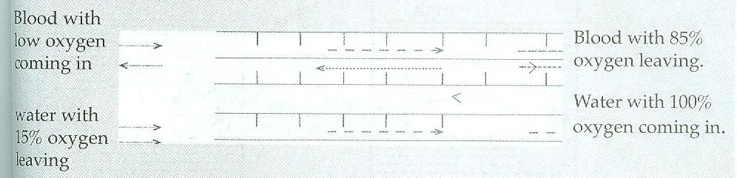

- From the diagram above, water and blood flow in opposite direction.
- Give the term used to describe this type of flow ( 1 mark)
…………………………………………………………………………………..

- Explain the significance of this type of flow. (2 marks)
………………………………………………………………………………………………………………………………………………………………………………………………………………………………………………………
- Name two organs in human beings that display the flow system named in (a) (i) above. (2mks)
……………………………………………………………………………………………………………………………………………………………………………………………………………………………………………………
- Explain why the gills of a fish are:
- Highly vascularised. (1 mark)
……………………………………………………………………………………………………………………………………………………………………
- Thin walled. (1 mark)
…………………………………………………………………………………………………………………………………………………………………..
- Moist. (1 mark)
……………………………………………………………………………………………………………………………………………………………………

- How are the gill rakers adapted to perform their functions? (1 mark)
……………………………………………………………………………………………………………………………………………………………………………………………………………………………………………………………………………..
- Explain how the tracheole system in insects is adapted for gaseous exchange.
(3 marks)
…………………………………………………………………………………………………………………………………………………………………………………………………………………………………………………………………………………………………………………………………………………………………………

- The figure below shows a stem of a plant growing round a tree trunk. Study it and answer the questions that follow.

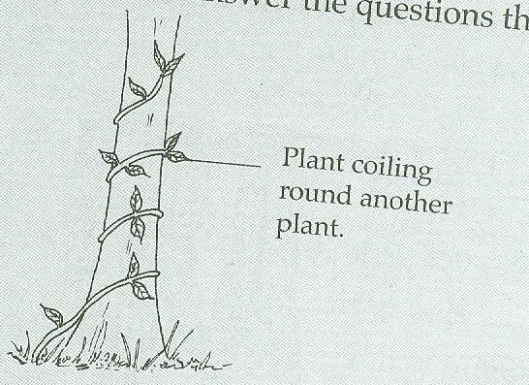

- What is the name of the response which causes such a twisted growth? (1 mark)
……………………………………………………………………………………………………………………………………………………………………………………………

- Explain how the twisting growth occurs. (3 marks)
………………………………………………………………………………………………………………………………………………………………………………………………………………………………………………………………………………………………………………………………………………………………………………………

- Explain the adaptations of the leaves if the plant is autotrophic. (4 marks)
……………………………………………………………………………………………………………………………………………………………………………………………………………………………………………………………………………………………………………………………………………………………………………………………………………………………….……………………………………………………………..

- (a) What is meant by the term sex – linkage? (2 marks)
………………………………………………………………………………………………………………………………………………………………………………………………………………………………………………………………………………………….....

(b) name two sex – linked traits in humans. (2 Marks)
………………………………………………………………………………………………………………………………………………………………………………………………………………………………………………………………………………………….

(c) In Drosophila melanogaster, the inheritance of eye colour is sex – linked. The gene for Red eye is dominant. A cross was made between a homozygous Red-eyed female and a white – eyed male. Work out the phenotypic ratio of F1 generation. (Use R to represent the gene for red eyes). (4 marks)
………………………………………………………………………………………………………………………………………………………………………………………………………………………………………………………………………………………………………………………………………………………………………………………………………………………………………………………………………………………………………………………………………………………………………………………………………………………………………………………………………………………………………………………………………………………………………………………………………………………………………………………………………………………………

- A student set up an experiment to investigate a certain process. Study it and answer the questions that follow. The cubes are of the same size an shape.

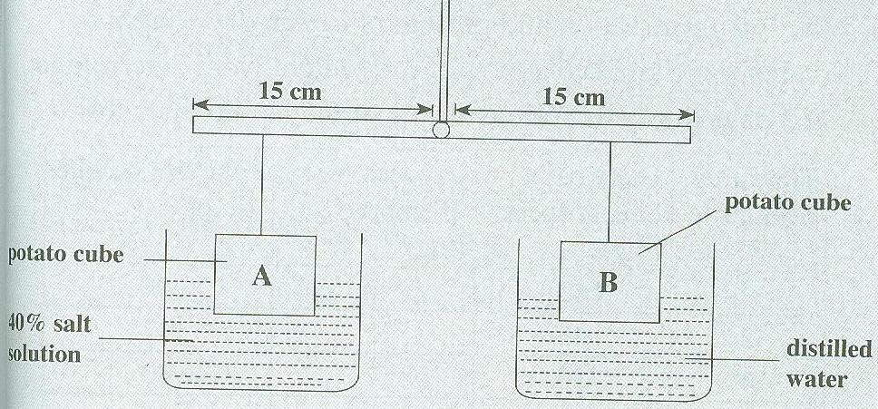

- Name the process being investigated. (1 mark)
…………………………………………………………………………………………..

- State 2 roles played by the process named in (a) above in plants (2 marks)
………….…………………………………………………………………………………………………………………………………………………..………………………………………………………………………………………………………………..…

- What observations would be made after 40 minutes? (3 marks)
………………………………………………………………………………………………………………………………………………………………………………………………………………………………………………...………………………………………………………………………………………………………………………
- Account for your observation. (3 marks)
………..……………………………………………………………………………………………………………………………………………………………………………………………………………………………………………………………………………………………………………..………………………………………………..

- Suggest a control for this experiment. (1 mark)
………………………………………………………………………………………….

- (a) Give the difference between the following structures in wind and insect pollinated flowers.
- Anthers (2 marks)
……….……………………………………………………………………………………………………………………………………………………………………………………………………………………………………………….

- Pollen grain (2 marks) ……………………………………………………………………………………………………………………………………………………………………………………………………………………………………………………...

- Stigma (2marks)

………………………………………………………………………………………………………………………………………………………………………………………………………………………………………………………
(b) State the necessity for cross pollination. (2 marks)
………………………………………………………………………………………………………………………………………………………………………………………………………………………………………………………………………………………………………………………
- Briefly explain how a seed is formed after the fertilization of ovule. (3 marks)
…………………………………………………………………………………………………………………………………………………………………………………………………………………………………………………………………………………………………………………………………………………………………………………………………………………………………………,……………………………….…………………..

SECTION B (40 Marks)

Answer question 6 (compulsory), and either question 7 or 8.

- During germination and growth of cereal, dry weight of endosperm, embryo and total dry weight were determined at 2 days intervals and results recorded as shown below.

Time after planting (days) | Dry weight of endosperm(mg) | Dry weight of embryo (mg) | Total dry weight (mg)
0 | 43 | 2 | 45
2 | 40 | 2 | 42
4 | 33 | 7 | 40
6 | 20 | 17 | 37
8 | 10 | 25 | 35
10 | 6 | 33 | 39

- Using same axes, draw graphs of dry weight of endosperm, embryo and total dry weight against time. (7 marks)

- What was the total dry weight on 5th day? (1 mark)
…………………………………………………………………………………………..

- Account for the:
- Decrease in dry weight of endosperm from day 0 to 10. (2 marks)
………………………………………………………………………………………………………………………………………………………………………………………………………………………………………………………

- Increase in dry weight of embryo from day 0 to 10th day. (2 marks)
………………………………………………………………………………………………………………………………………………………………………………………………………………………………………………………

- Decrease in total dry weight from day 0 to 8. (1 mark)
………………………………………………………………………………………………………………………………………………………………….

- Increase in total dry weight after the 8th day. (1 mark)
………..…………………………………………………………………………………………………………………………………………………………….

- State two factors within the seed and two outside the seed that causes dormancy.
- Within the seed (2 marks)
………………………………………………………………………………………………………………………………………………………………………………………………………………………………………………………

- Outside the seed (2 marks)
………………………………………………………………………………………………………………………………………………………………………………………………………………………………………….…………

- What is the characteristics of meristematic cells? (2 marks)
………..………………………………………………………………………………………………………………………………………………………………………………………………………………………………………………………………………

- How is the mammalian eye adapted to its function? (20 marks)

- How is the mammalian intestine adapted to its functions? (20 marks)
…………………………………………………………………………………………………………………………………………………………………………………………………………………………………………………………………………………………………………………………………………………………………………………………………………………………………………………………………………………………………………………………………………………………………………………………………………………………………………………………………………………………………………………………………………………………………………………………………………………………………………………………………………………………………………………………………………………………………………………………………………………………………………………………………………………………………………………………………………………………………………………………………………………………………………………………………………………………………………………………………………………………………………………………………………………………………………………………………………………………………………………………………………………………………………………………………………………………………………………………………………………………………………………………………………………………………………………………………………………………………………………………………………………………………………………………………………………………………………………………………………………………………………………………………………………………………………………………………………………………………………………………………………………………………………………………………………………………………………………………………………………………………………………………………………………………………………………………………………………………………………………………………………………………………………………………………………………………………………………………………………………………………………………………………………………………………………………………………………………………………………………………………………………………………………………………………………………………………………………………………………………………………………………………………………………………………………………………………………………………………………………………………………………………………………………………………………………………………………………………………………………………………………………………………………………………………………………………………………………………………………………………………………………………………………………………………………………………………………………………………………………………………………………………………………………………………………………………………………………………………………………………………………………………………………………………………………………………………………………………………………………………………………………………………………………………………………………………………………………………………………………………………………………………………………………………………………………………………………………………………………………………………………………………………………………………………………………………………………………………………………………………………………………………………………………………………………………………………………………………………………………………………………………………………………………………………………………………………………………………………………………………………………………………………………………………………………………………………………………………………………………………………………………………….......................................................................................................................................................................................................................................................................................................................................................................................................................................................................................................................................................................................................................................................................................................................................................................................................................................................................................................................................................................................................................................................................................................................................................................

