Name: …………………………………………................................ Index No…….....…… Signature……………….................. Date: ……………........
FORM 4

231/2 (THEORY)
BIOLOGY PAPER 2

TIME: 2 HOURS

- Write your Name and Index Number in the spaces provided above.
- Sign and write the date of examination in the spaces provided above.
- This paper consists of TWO sections: A and B.
- Answer ALL the questions in section A in the spaces provided after each question
- In Section B, answer question 6 (compulsory) in the spaces provided and either question 7 or 8 in the spaces provided after question 8.
- Answers must be written in English only.

For Examiner’s Use Only

SECTION | Question | Maximum score | Candidate’s score
A | 1 | 8
A | 2 | 8
A | 3 | 8
A | 4 | 8
A | 5 | 8
B | 6 | 20
B | 7 | 20
B | 8 | 20
TOTAL SCORE |  | 80

This paper consists of 9 printed pages. Candidates should check the question paper to ensure that all the pages are printed as indicated and no question is missing.

SECTION A (40 MARKS)

Answer all the question in the spaces provided

- Two herbivore mammalian species were introduced into an ecosystem at the same time and in equal numbers. The graph below represents their populations during the first seven years. Study the graph and answer the questions that follow:
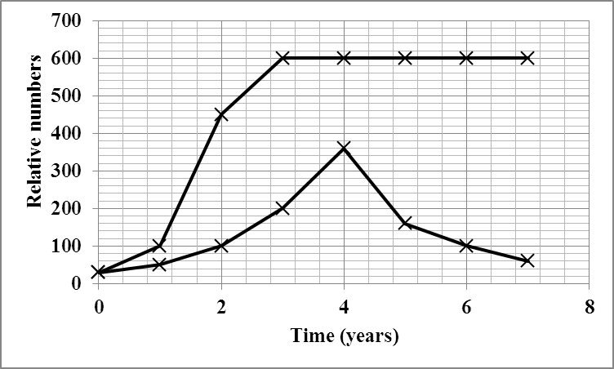
Species B
Species A
- (i) Which species has better competition ability? (1mark)
………………………………………………………………………………………………
- Give a reason for your answer in (a)(i) above. (1 mark)
………………………………………………………………………………………………
- Account for the shape of the curve of species A between:
- one year and three years. (2 marks)
……………………………………………………………………………………………………………………………………………………………………………………………………………………………………………………………………………………………………….

- three years and seven years. (2 marks)
…………………………………………………………………………………………………………………………………………………………………………………………………………………………………………………………………………………………………….
- Name the type of interaction that exists between the tow species of Paramecia in the ecosystem. (1 mark)
………………………………………………………………………………………………
- Why is it that gazelles and buffaloes do occupy same ecosystem? (1 mark)
………………………………………………………………………………………………
- In an experiment using Snapdragon plants, pure bred white-flowered plants were crossed with pure bred red-flowered plants. Their seeds were then sown. The F₁ offspring that developed from them all produced pink flowers.
- Work out the genotypes for the F₁ offspring using “R” to represent dominant gene for red colour and “r” to represent recessive gene for white colour. (4 marks)

- If the pink flowered plants were selfed, state the phenotypic ratio and genotypic ratio of F₂ offspring. (2 marks)
……………………………………………………………………………………………………………………………………………………………………………………………..
- Explain why there are no red or white flowered plants in F₁ offspring. (2 marks)
……………………………………………………………………………………………..
- The diagram below is of a part of human skeleton.
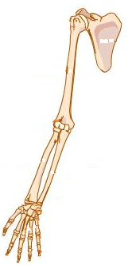
S
R
T
- Name the bones labelled R and T. (2 marks) R: ……………………………………………………………………………………….
T: ……………………………………………………………………………………….
- Name the type of joint at the proximal end of bone R, which is labelled S. (1 mark)
………………………………………………………………………………………….
- State three adaptations of the bone labelled T to its function. (3 marks)
………………………………………………………………………………………………………………………………………………………………………………………………………………………………………………………………………………………………
- (i) Name the type of design exhibited by this part of the skeleton which is common to all vertebrates. (1 mark)
……………………………………………………………………………………………
(ii) Of what significance is the design you have named in (d)(i) above to evolution?
(1 mark)
…………………………………………………………………………………………….
- (a) State three structural differences between an artery and a vein of a mammal. (3 marks)
………………………………………………………………………………………………………………………………………………………………………………………………………………………………………………………………………………………………
- How are the capillary suited to their function? (2 marks)
……………………………………………………………………………………………………………………………………………………………………………………………………………………………………………………………………………………………..
- (i) What is blood transfusion? (1 mark)
………………………………………………………………………………………………………………………………………………………………………………………………
- A person whose blood group is A died shortly after receiving blood from a person of blood group B. Explain the cause of death. (2 marks)
……………………………………………………………………………………………………………………………………………………………………………………………..

- The diagram below represents the gaseous exchange system of an Amphibian.

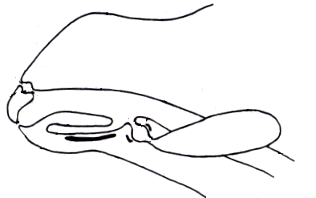
N
K
M
L
- Identify the parts labelled K and N (2 marks)
K: …………………………………………………………………………….….…………
N: …………………………………………………………………………………..……….
- Give the functions of the parts L and M. (2 marks)
L: …………………………………………………………………………………………..
M: ………………………………………………………………………………………….
- When the structure is labeled M used by the organism for gaseous exchange? (1 mark)
………………………………………………………………………………………..……..
- State three structural adaptations of the part labeled M that facilitates the animal’s gaseous exchange. (3 marks)
………………………………………………………………………………………………………………………………………………………………………………………………………………………………………………………………………………………………………………………………………………………………………………………………

SECTION B (40 MARKS)
- In an experiment, a man drank one litre of water and the volume of urine produced was measured and recorded at an interval of one hour after drinking the water. On the second day, the man repeated the experiment but this time he drank one litre of 0.9% sodium chloride solution. The results are as shown in the table below:
Time (hours) | Volume of urine produced (cm³) on drinking
Time (hours) | Water | 0.9 % sodium chloride solution
0  1  2  3  4  5  6  7 | 80  50  350  540  30  100  50  70 | 30  30  40  35  60  40  80  100
- On the same axes, plot graphs of urine produced on drinking water and 0.9 % sodium chloride solution against time. (8 marks)

- From the graph, determine the volume of urine produced by the man two and a half hours after drinking water. (1 mark)
…………………………………………………………………………………………..
- Account for the production of urine produced by the man when he drank the litre of 0.9 % sodium chloride solution. (3 marks)
…………………………………………………………………………………………………………………………………………………………………………………………………………………………………………………………………………………………………………………………………………………………………………………………………………………………………………………………………….
- What is diabetes insipidus? (2 marks)
……………………………………………………………………………………………………………………………………………………………………………………
- Explain why treatment of diabetes mellitus is via injection and not through taking insulin tablets orally. (2 marks)
…………………………………………………………………………………………………………………………………………………………………………………….
- (a) Differentiate between nervous system and endocrine system. (4 marks)
- Describe how hormones regulate the menstrual cycle in human being. (16 marks)
- (a) What are xerophytes? (2 marks)
- Describe the ways by which terrestrial plants are adapted to living in arid and semi- arid ecosystems. (16 marks)

........................................................................................................................................................................................................................................................................................................................................................................................................................................................................................................................................................................................................................................................................................................................................................................................................................................................................................................................................................................ ........................................................................................................................................................................................................................................................................................................................ ........................................................................................................................................................................................................................................................................................................................................................................................................................................................................................................................................................................................................................................................................................................................................................................................................................................................................................................................................................................
............................................................................................................................................................ ....................................................................................................................................................................................................................................................................................................................................................................................................................................................................................................................................................................................................................................................................................................................................................................................................................................................................................................................................................................................................................................................................................................................................

