NAME:…………………………………………………………………………………… ADM. NO…………………………..…..…..
SCHOOL:……………………………………………………………SIGNATURE…………………………DATE…………….…………

231/2
BIOLOGY
PAPER 2
TIME: 2HOURS
FORM 4

INSTRUCTIONS TO CANDIDATES
This paper consists of two sections A and B
Answer all the questions in section A in the spaces provided
In section B, answer question (6) compulsory and either 7 or 8 in the space provided after question 8.
SECTION | QUESTION | MAXIMUM SCORE | CANDIDATE SCORE
A | 1 | 08
 | 2 | 08
 | 3 | 08
 | 4 | 08
 | 5 | 08
B | 6 | 20
 | 7 | 20
 | 8 | 30
 | TOTAL | 80

Candidates should check the question paper to ensure that all the pages are printed as indicated and no questions are missing.

- The formation of urine in the mammal takes place in stages in the kidney. Describe the main
process that occur in the following sections of the nephron.
- (i) Proximal convoluted tubule. (1 mark)
……………………………………………………………………………………………………………………………………………………………………………………………………………………
…………………………………………………………………………………………………………
(ii) Loop of Henle. (1 mark)
……………………………………………………………………………………………………………………………………………………………………………………………………………………
…………………………………………………………………………………………………………
(iii) Distal convoluted tubule. (1 mark)
……………………………………………………………………………………………………………………………………………………………………………………………………………………
…………………………………………………………………………………………………………
- Name the gland and state the function of the hormones involved in urine production.
(i) Aldosterone (ii) Antidiuretic hormone
Gland ………………………………..(1 mark) Gland ………………………………… (1 mark)
- A girl who was learning to swim accidentally drinks a lot of sea water. Explain the effect this would have on his kidneys. (2 marks)
……………………………………………………………………………………………………………………………………………………………………………………………………………………
……………………………………………………………………………………………………………………………………………………………………………………………………………………
- Catalase is an enzyme present in all living tissues in both plants and animals. It breaks down toxic hydrogen peroxide produced during cellular metabolism into less toxic water and oxygen is evidenced by effervescence.
In an experiment 10 ml of hydrogen peroxide was put in different boiling tubes into which different specimen were put. The table below summarizes part of the results. Carefully analyze the table and answer the questions that follow.

 | The specimen | Observation
A | Fresh liver | A lot of bubbling almost violent
B | Boiled liver | No bubbling
C | Fresh muscle tissue | Vigorous bubbling less than tube A
D | Dry bean seed | Very slow bubbling
E | Soaked bean seed | Vigorous bubbling done intensity of tube C
F | 1 cm3 potato cube | Moderate bubbling
G | 1 cm3 mashed potato | Vigorous bubbling since intensity as in tube E

- Compare & account for the rate of bubbling between
(i) Tube A and tube B. (2 marks)
………………………………………………………………………………………………………………………………………………………………………………………………………………………………………………………………………………………………………………………………
(ii) Tube A and C (2 marks) ……………………………………………………………………………………………………………………………………………………………………………………………………………………………………………………………………………………………………………………………
(iii) Tube D and tube E (2 marks)
………………………………………………………………………………………………………………………………………………………………………………………………………………………………………………………………………………………………………………………………
(iv) Tube F and G (1 mark
…………………………………………………………………………………………………………………………………………………………………………………………………………………………………………………………………………………………………………………………
- Write the equation for the reaction that produces the bubbling. (1 mark)
…………………………………………………………………………………………………………
- Suggest why hydrogen peroxide should not accumulate in living cells. (1 mark)
……………………………………………………………………………………………………………………………………………………………………………………………………………………
- The diagram below shows the life cycle of a butterfly.
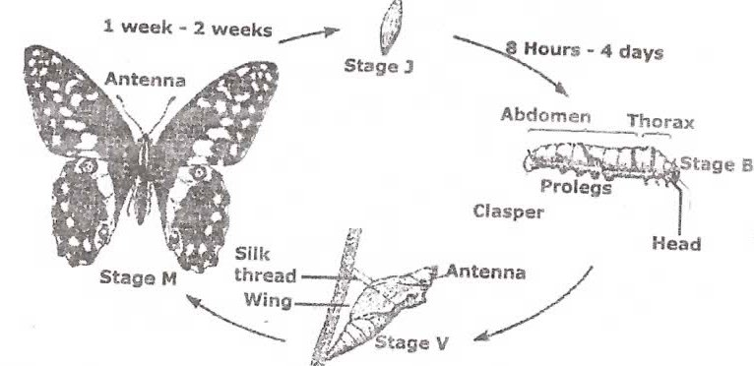

- (i) Name the type of life cycle shown above. (1 mark)
…………………………………………………………………………………………………………
(ii) Give a reason for your answer. (1 mark)
……………………………………………………………………………………………………………………………………………………………………………………………………………………
- Suggest the importance of such type of life cycle. (1 mark)
……………………………………………………………………………………………………………………………………………………………………………………………………………………
- Using letter symbols list the various stages in the sequence they occur. (1 mark)
……………………………………………………………………………………………………………………………………………………………………………………………………………………
- Of the stages labelled name
(i) The resting (1 mark)
…………………………………………………………………………………………………………
…………………………………………………………………………………………………………
(ii) The feeding stage (1 mark)
…………………………………………………………………………………………………………
…………………………………………………………………………………………………………
- What is the importance of stage B and V (2 marks)
……………………………………………………………………………………………………………………………………………………………………………………………………………………
- (i) Colour blindness is rare in women. However when a woman has normal colour vision but is a carrier for this trait marries a colour blind man, a colour blind daughter may be born to them. Show how this is possible. (4 marks)

(ii) Give two examples of disorders caused by mutant gene located in the chromosomes. (2 marks)
…………………………………………………………………………………………………………..………………………………………………………………………………………………………..
(iii) What do you understand by the term linked genes (2 marks) ……………………………………………………………………………………………………………………………………………………………………………………………………………….
- The figure below shows the distribution of some endocrine glands in human body. Name the glands A to E, a hormone that each produces and effects. (5 marks)

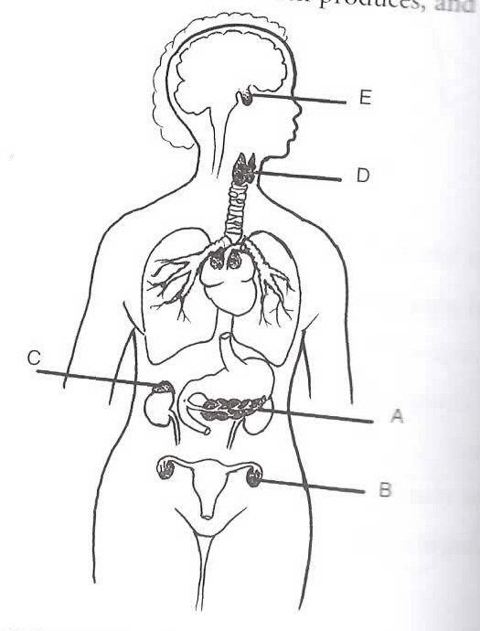

(i)
Name Hormone Effect
A ……………………… (½) ………………….. (½ mk) ……………………. (½ mark)
B ……………………… (½) ………………….. (½ mk) ……………………. (½ mark)
C……………………… (½) ………………….. (½ mk) ……………………. (½ mark)
D ……………………… (½) ………………….. (½ mk) ……………………. (½ mark)
(ii) Explain why pituitary gland is referred to as the master gland. (2 marks) …………………………………………………………………………………………………………………………………………………………………………………………………………………………………………………………………………………………………………………………..
SECTION B
Answer question 6 and either 7 or 8
- Some students used a model to demonstrate the effect of sweating on human body temperature. Two boiling tubes A and B were filled with hot water. The surface of tube A was continually wiped with a piece of cotton wool soaked in methylated spirit. The temperature of water in the tubes was taken at the start of the experiment and then at 5 minutes interval. The results obtained are as shown in the table below.
Time (in minutes) | Temperature (oC) in tubes
 | A | B
0 | 80 | 80
5 | 54 | 67
10 | 40 | 59
15 | 29 | 52
20 | 21 | 47
25 | 18 | 46

- On the same axis plot graphs of temperature of water in the tubes against time. (7 marks)
- At what rate was the water cooling in tube A? (2 marks)
……………………………………………………………………………………………………………………………………………………………………………………………………………………
- Why was tube B included in the set up? (1 mark)
……………………………………………………………………………………………………………………………………………………………………………………………………………………
- Account for the rate of cooling in tube A (3 marks)
……………………………………………………………………………………………………………………………………………………………………………………………………………………
- State two processes of heat loss in tube B. (2 marks)
……………………………………………………………………………………………………………………………………………………………………………………………………………………
- What would be the expected results if tube B was insulated? (1 mark)
………………………………………………………………………………………………………..
- What would the insulation be compare to in
(i) birds ? (1 mark)
…………………………………………………………………………………………………………
(ii) mammals? (1 mark)
………………………………………………………………………………………………………..
- Name the structures in the human body that detect
(i) external temperature changes (1 mark)
………………………………………………………………………………………………………..
(ii) internal temperature changes (1 mark)
………………………………………………………………………………………………………..
- Give the adaptation of plant and animal cell to its function. (20 marks)
- (a) Explain why plants lack elaborate excretory organs like those found in animals. (3 marks)
(b) Name five methods of excretion in plants. (5 marks)
(c) State any six excretory products in plant and give their economic uses. (12 marks)
…………………………………………………………………………………………………………
……………………………………………………………………………………………………………………………………………………………………………………………………………………
……………………………………………………………………………………………………………………………………………………………………………………………………………………
…………………………………………………………………………………………………………
……………………………………………………………………………………………………………………………………………………………………………………………………………………
……………………………………………………………………………………………………………………………………………………………………………………………………………………
…………………………………………………………………………………………………………
……………………………………………………………………………………………………………………………………………………………………………………………………………………
……………………………………………………………………………………………………………………………………………………………………………………………………………………
…………………………………………………………………………………………………………
……………………………………………………………………………………………………………………………………………………………………………………………………………………
……………………………………………………………………………………………………………………………………………………………………………………………………………………
…………………………………………………………………………………………………………
……………………………………………………………………………………………………………………………………………………………………………………………………………………
……………………………………………………………………………………………………………………………………………………………………………………………………………………
…………………………………………………………………………………………………………
……………………………………………………………………………………………………………………………………………………………………………………………………………………
……………………………………………………………………………………………………………………………………………………………………………………………………………………
…………………………………………………………………………………………………………
……………………………………………………………………………………………………………………………………………………………………………………………………………………

