NAME ____________________________________ INDEX NO. _______________
SCHOOL ____________________________________ SIGNATURE _______________
DATE _______________

231/2
BIOLOGY
(THEORY)

PAPER 2

TIME: 2 HOURS

FORM 4

INSTRUCTIONS TO CANDIDATES
- Write your name, school and index number in the spaces provided above.
- Write the date of examination and sign in the spaces provided above.
- Answer ALL the questions in section A by filling in the spaces provided.
- In section B, answer question 6 (compulsory question) and any other one question from the remaining two questions. (i.e. 7 or 8) in the spaces provided after question 8.
- Candidates may be penalized for false information and even wrong spellings of technical terms.
- This paper consists of 10 printed pages.
- Candidates should check to ensure that all pages are printed as indicated and no questions are missing.
FOR OFFICIAL USE ONLY
Section | Question | Maximum score | Candidate’s score
A | 1 | 8
 | 2 | 8
 | 3 | 8
 | 4 | 8
 | 5 | 8
B | 6 | 20
 | 7 | 20
 | 8 | 20
 | Total Score | 80

SECTION A (40 MARKS)
Answer ALL questions
1. A pure breed red flowered plants was crossed with a pure breed white flowered plant. The F1 generate had all pink flowers. When F1 were selfed 1600 plants were obtained in F2 generation
a) Identify the type of dominance (1mark)
___________________________________________________________________________________
b) Give a reason for your answer (1mark)
______________________________________________________________________________________________________________________________________________________________________
c) i) Using letter R to represent the gene for red color and W for the white colour work out the possible genotypes for F2 generation. (4marks)

ii) Work out the answer of plants in F2 with
Pink flower (1mark)

Red flowers (1mark)

2. Study the food web below and use it to answer the questions that follow
a) Identify the tropical level occupied by the hawks. (1mark)
______________________________________________________________________________________________________________________________________________________________________
b) Write down any two food chains from the food web that ends with:
i) Quaternary consumer (2marks)
______________________________________________________________________________________________________________________________________________________________________
ii) Tertiary consumer (1mark)
______________________________________________________________________________________________________________________________________________________________________
c) Suggest three short term effects on the ecosystem if all the snakes died (3marks)
____________________________________________________________________________________________________________________________________________________________________________________________________________________________________________________________________________________________________________________________________________
d) Which organism has the highest number of predators (1mark)
___________________________________________________________________________________

3. The diagram below shows how blood glucose in mammalian body is regulated.

a) Name the feedback represented by 2 (1marks)
___________________________________________________________________________________
b) Explain what happens during corrective mechanism P (3marks) ____________________________________________________________________________________________________________________________________________________________________________________________________________________________________________________________________________________________________________________________________________
c) i) Name two organism involved in corrective mechanism P and Q (2 marks)
_________________________________________________________________________________________________________________________________________________________________________________________________________________________________________________________
ii) Why would glucose level be maintained constant (1marks)
______________________________________________________________________________________________________________________________________________________________________
d) What is osmoregulation? (1 mark)
______________________________________________________________________________________________________________________________________________________________________

4. In a fish pond the number of fish was estimated by use of the following information.
First captured =50
Second captured =90
Marked recaptured =25
a) Identify the method suggested above (1mark)
___________________________________________________________________________________
b) Name two other sampling methods used in estimating populations (2marks)
_________________________________________________________________________________________________________________________________________________________________________________________________________________________________________________________
c) Calculate the total number of fish in the pond (2marks)

d) Give three assumptions of the above method (3marks)
____________________________________________________________________________________________________________________________________________________________________________________________________________________________________________________________________________________________________________________________________________

5. a) The diagram below represents bones and muscles in human arm
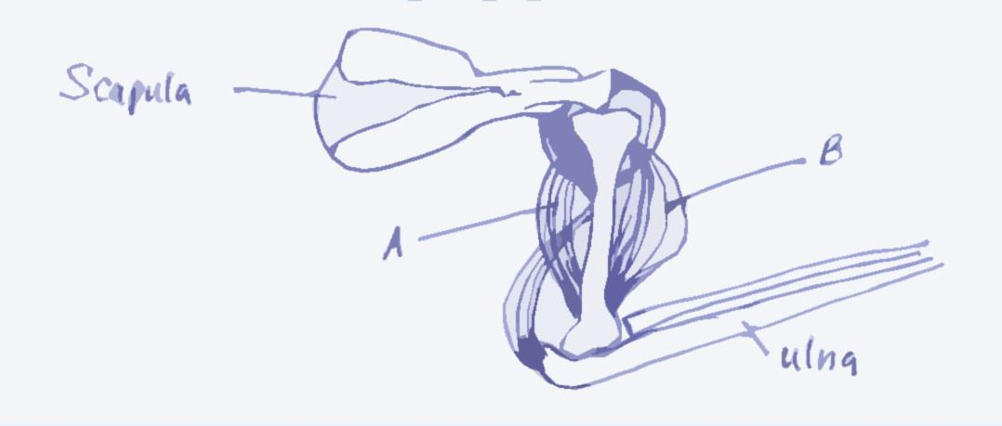
Scapula
Ulna
B
A
- Give two differences between the type of muscles labeled A and B above and the type of muscles found in the blood vessel (2mark )
____________________________________________________________________________________________________________________________________________________________________________________________________________________________________________________________________________________________________________________________________________
ii) Explain how the muscles labeled A and B above bring about stretching of the arm (2marks) _________________________________________________________________________________________________________________________________________________________________________________________________________________________________________________________
b) Below is diagram of above coiled sacrum
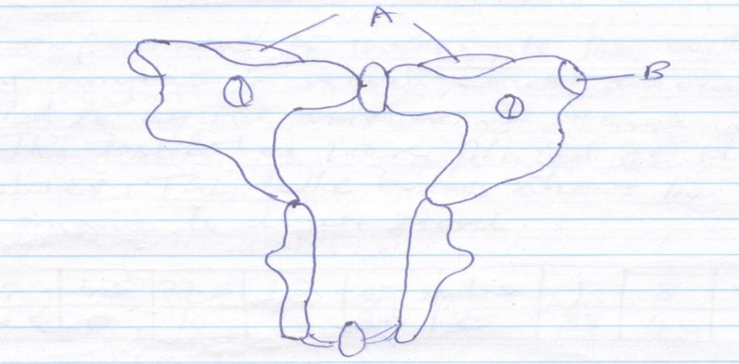
A
B
- State the disgusting feature of sacrum (1mark)
______________________________________________________________________________________________________________________________________________________________________
- What is the function of sacrum in the body (1mark)
______________________________________________________________________________________________________________________________________________________________________
- How is sacrum adapted to its function (2marks)
_________________________________________________________________________________________________________________________________________________________________________________________________________________________________________________________

SECTION B (40 MARKS)
Answer question 6 (compulsory and either question 7 or 8 in the provided after question 8.
6. In an experiment to investigate the action of salivary amylase in starch, equal amount of amylase was added to equal amount of starch in in different tubes. The test tubes were placed at different temperatures. The table below shows the time taken for the enzyme to digest starch.
Time (min) | 45 | 27.5 | 15 | 05 | 1.5 | 1 | 8 | 35
Temperature ⁰c | 0 | 10 | 20 | 30 | 35 | 38 | 40 | 45

- On the grid provided, plot a graph of time in minutes against temperature. (5marks)

b) What is the optimum temperature of the enzyme (1mark)
___________________________________________________________________________________
c) Account for the time taken to digest starch at
- 5⁰C (2marks)
____________________________________________________________________________________________________________________________________________________________________________________________________________________________________________________________________________________________________________________________________________
- 45⁰C (2marks)
____________________________________________________________________________________________________________________________________________________________________________________________________________________________________________________________________________________________________________________________________________
d) Other than temperature name two other factors that influence the rate of enzyme action. (2marks)
_________________________________________________________________________________________________________________________________________________________________________________________________________________________________________________________
e) What is the rate of enzyme action at 15⁰C? Work out using the graph drawn. (3marks)
_______________________________________________________________________________________________________________________________________________________________________________________________________________________________________________________________________________________________________________________________________________________________________________________________________________________________
f) Salivary amylase continues to digest starch to maltose in the bolus from the mouth down the esophagus but stops in the stomach. Explain. (2marks)
____________________________________________________________________________________________________________________________________________________________________________________________________________________________________________________________________________________________________________________________________________
g) Name the secretions received in the duodenum from the pan crease to facilitate the process of digestion (1mark)
___________________________________________________________________________________

h) During a scientific research on a rat hydrochloric acid was carefully introduced in the pancreatic duct to mix with the secretion before it was received in the duodenum it was discovered that no digestion took place in the duodenum. Explain . (2marks)
____________________________________________________________________________________________________________________________________________________________________________________________________________________________________________________________________________________________________________________________________________

7. a) Describe the adaptations of the human ear to its function (10marks)
b) Describe the following evidence of organic evolution
- Comparative anatomy (6marks)
- Geographical distribution (4marks)

8. a) Define pollution (2marks)
b) Describe water pollution under the following:
i) Causes (6marks)
ii) Effects of pollutants on plants and animals (6marks)
iii) Methods of controlling pollution (6marks)
______________________________________________________________________________________________________________________________________________________________________________
______________________________________________________________________________________________________________________________________________________________________________
______________________________________________________________________________________________________________________________________________________________________________
______________________________________________________________________________________________________________________________________________________________________________
______________________________________________________________________________________________________________________________________________________________________________
______________________________________________________________________________________________________________________________________________________________________________
______________________________________________________________________________________________________________________________________________________________________________
______________________________________________________________________________________________________________________________________________________________________________
_______________________________________________________________________________________
______________________________________________________________________________________________________________________________________________________________________________
______________________________________________________________________________________________________________________________________________________________________________
______________________________________________________________________________________________________________________________________________________________________________
______________________________________________________________________________________________________________________________________________________________________________
______________________________________________________________________________________________________________________________________________________________________________
______________________________________________________________________________________________________________________________________________________________________________
______________________________________________________________________________________________________________________________________________________________________________
______________________________________________________________________________________________________________________________________________________________________________
______________________________________________________________________________________________________________________________________________________________________________
______________________________________________________________________________________________________________________________________________________________________________
______________________________________________________________________________________________________________________________________________________________________________
______________________________________________________________________________________________________________________________________________________________________________
______________________________________________________________________________________________________________________________________________________________________________
______________________________________________________________________________________________________________________________________________________________________________
______________________________________________________________________________________________________________________________________________________________________________
______________________________________________________________________________________________________________________________________________________________________________
______________________________________________________________________________________________________________________________________________________________________________
_______________________________________________________________________________________

