Name………………………………………………… ADM No. …………………….

School ………………………………………………... Date……. …………………….

Sign……. …………………….

231/3
BIOLOGY
PAPER 3
PRACTICAL
Time: 1 ¾ Hours

FORM 4
Kenya certificate of secondary education (K.C.S.E)

INSTRUCTIONS TO CANDIDATES

- Write your name and index number in the spaces provided
- Sign and write the date of examination in the spaces provided above.
- Answer all questions in the spaces provided in the question paper.
- You are required to spend the first 15 minutes of 1 ¾ hours allowed for this paper reading the whole paper before commencing your work.
- Answers MUST be written on the spaces provided after each question.
- Candidates may be penalized for recording irrelevant information and incorrect spelling especially of technical terms.
FOR EXAMINERS USE ONLY

QUESTION | Max Score | Candidate Score
1 | 12
2 | 15
3 | 13
TOTAL SCORE | 40

- a). You are provided with a sample of food labeled P in solution form. Using the
reagents provided, carry out tests on the food sample to identify the type of food
substances present. (6 marks)
Food substance | Procedure | Observation | Conclusion

b). Suggest the regions of the human digestive system where the foods tested are
digested. (2 marks)
.................................................................................................................................................................................................................................................................................................................................................................................................................................................................................................................................................................................................................................................................................................................................................................................................................
c).State enzyme involved in the digestion of the foods tested. (2 marks)
.......................................................................................................................................................................................................................................................................................................................................................................................................................................................................................
d). Name the deficiency diseases of each of the food tested. (2 marks)
..........................................................................................................................................................................................................................................................................................................................
…………………………………………………………………………………………………………………

2. Below are photographs of specimens obtained from plants. Examine the photographs

R
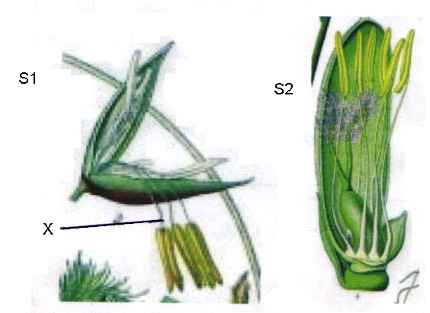

- For each of the specimens, name the mode of pollination and the features that adapt the specimen to the mode of pollination.
Specimen R
-Mode of pollination (1mark)
......................................................................................................................................................................
-Adaptive features. (2marks)
i)............................................................................................................................................................................................................................................................................................................................................
ii)...........................................................................................................................................................................................................................................................................................................................................
Specimen S1
-Mode of pollination (1mark)
......................................................................................................................................................................
-Adaptive features (2marks)
i).............................................................................................................................................................................................................................................................................................................................................
ii)............................................................................................................................................................................................................................................................................................................................................
b) Label any four parts on specimen R (4 marks)
c). Name the structure labeled X on specimen S1. (1 mark)
...........................................................................................................................................................................................................................................................................................................................................................
d).Using observable features, only state two differences between R and S. (2marks)
.............................................................................................................................................................................. ….......................................................................................................................................................................... ...........................................................................................................................................................................................................................................................................................................................................................
e).With a reason, name the class of the spermatophyta to which specimen R belongs. (2marks)
Class..........................................................................................................................................................................
Reason..........................................................................................................................................................................................................................................................................................................................................................

3.You are provided with seven, photographs of plans specimen. They are labelled specimen D₁D₂D₃ D₄,D₅ D₆ and D₇
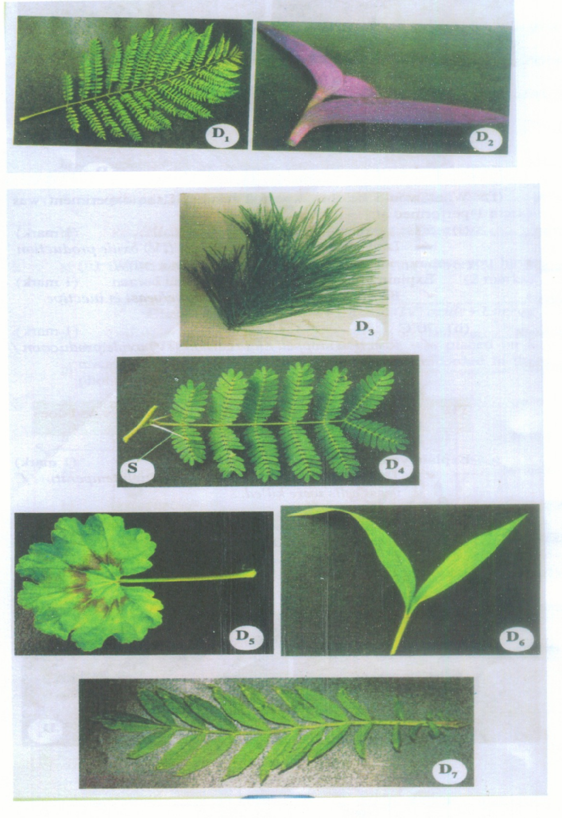

Key.
1. a) Leaves needle like ……………………………………………………………..go to 2
b) Leaves broad ………………………………………………………………….. go to3
2. a) Leaves arranged in clusters on stem………………………………………….. Pinnacea
b) Leaves not arranged in clusters on stem ……………………………………..Araucariaceac
3. a) Leaves compound…………………………………………………………….. go to 4
b) Leaves simple………………………………………………………………… go to 7
4. a) Leaflets pointed at the end …………………………………………………….go to 5
b) Leaflets rounded at the end……………………………………………………go to 6
5. a) Leaflets attached to many small stalks that join the main one ……………….Mimosaceae
b) Leaflets attached to one stalk …………………………………………………Rosaceae
6. a) Leaflets attached to many small stalks that join the main one………………. Bignonaceae
b) Leaflets attached to one stalk …………………………………………………Compositae
7. a) Leaves green ………………………………………………………………….go to 8
b) Leaves purple ……………………………………………………………….. go to 9
8. a) Leaves parallel veined ………………………………………………………..Graminae
b) Leaves net veined ……………………………………………………………. Geranaceae
9. a) Leaves parallel veined ……………………………………………………Commelinaceae
b) Leaves net veined ………………………………………………………….Euphorbiaceae

a) Use the dichotomous key to identify the taxonomic group specimensD₁D₃ and D₅ photographs provided. ___________________ ______ {6 marks}
Specimen | Steps followed | Identity
D₁

D₃

D₆

b) (i) Suggest the likely natural habitat for specimen D₄. {l mark}
............................................................................................................................................................. .............................................................................................................................................................

(ii) Explain one observable feature that adapts specimens D₄ to the habitat you have mentioned in
(b) (i) above. (2marks)

............................................................................................................................................................. .............................................................................................................................................................
. ............................................................................................................................................................ . ............................................................................................................................................................

iii) What is the importance of the structure marked S in specimen D₄? {l mark}

............................................................................................................................................................. .............................................................................................................................................................
c) (i) If the stem of specimen D₂ was squeezed strongly, state the expected
observations. {l mark}
............................................................................................................................................................. .............................................................................................................................................................

(ii) From your observation in c (i) above, suggest how specimen D₂ is adapted to its habitat. (2marks)
............................................................................................................................................................. .............................................................................................................................................................
END

