NAME ____________________________________ INDEX NO. _______________
SCHOOL ____________________________________ SIGNATURE _______________
DATE _______________

231/3
BIOLOGY
Paper 3
(PRACTICAL)
TIME: 1¾ HOURS

FORM 4

INSTRUCTIONS TO CANDIDATES
- Write your name, school and index number in the spaces provided above.
- Write the date of examination and sign in the spaces provided above.
- You are required to spend the first 15 minutes of the 1¾ allowed for this paper reading the whole paper carefully before commencing your work.
- Answer all the questions in spaces provided.
- Additional pages must not be inserted.
- Candidates may be penalized for recording irrelevant information and for incorrect spellings especially of technical terms.
- This paper consists of 6 printed pages.
- Candidates should check to ensure that all pages are printed as indicated and no questions are missing.

FOR OFFICIAL USE ONLY
QUESTION | MAXIMUM SCORE | CANDIDATE’S SCORE
1 | 10
2 | 16
3 | 14
TOTAL SCORE | 40

- You are provided with substances labelled M, N, Q, X, Y and Z. Q is a food substance, while M is 10% sodium hydroxide, N is 1% copper (II) sulphate, X is dilute hydrochloric acid, Y is dilute sodium hydrogen carbonate and Z is Benedict’s solution.
Carry out food tests to determine the food substances present in Q. (10 marks)
Food substance | Procedure | Observations | Conclusion
- You are provided with specimen labelled M and N, examine them.
- Identify the specimens and in each case give two reasons for your answer.
- Specimen M (1 mark)
___________________________________________________________________________________
Reasons (2 marks)
_________________________________________________________________________________________________________________________________________________________________________________________________________________________________________________________
- Specimen N (1 mark)
___________________________________________________________________________________
Reasons (2 marks)
_________________________________________________________________________________________________________________________________________________________________________________________________________________________________________________________

- State three ways in which specimen N is adapted to its functions. (3 marks)
_________________________________________________________________________________________________________________________________________________________________________________________________________________________________________________________

- State four differences between specimen M and N. (4 marks)
N | M

- Draw and label the anterior view of the specimen N. (3 marks)

- Below are photographs labelled I, II, III, IV, VI and VII of fruits obtained from different plants.
Examine them and answer the questions that follow.

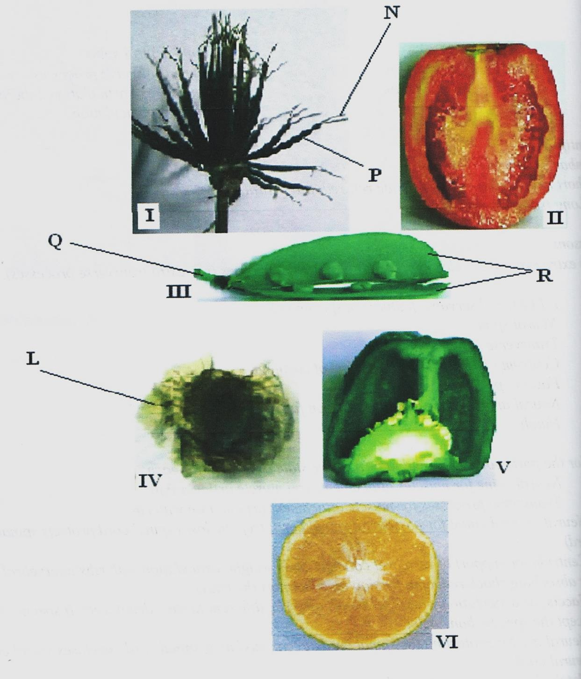
- With reasons determine the modes of dispersal for the fruits labelled I, III and IV. (6 marks)
I
Mode of dispersal _______________________________________________________________
Reasons _______________________________________________________________
_______________________________________________________________
III
Mode of dispersal _______________________________________________________________
Reasons _______________________________________________________________
_______________________________________________________________

IV
Mode of dispersal _______________________________________________________________
Reasons _______________________________________________________________
_______________________________________________________________

- State the type of placentation in III, V and VI. (3 marks)
III ____________________________________________________________________________
V ____________________________________________________________________________
VI ____________________________________________________________________________

- Name the parts labelled: (3 marks)
N ____________________________________________________________________________
P ____________________________________________________________________________
Q ____________________________________________________________________________

- What is the function of the part labelled L? (1 mark)
______________________________________________________________________________________________________________________________________________________________________

- How is the part labelled R adapted to its function? (1 mark)
______________________________________________________________________________________________________________________________________________________________________

