Name: ………………………………………….................... Index No………………………. Signature: …………………….. Date: ……………………………
FORM 4

231/3
Biology Practical
1 ¾ hours

INTRUCTIONS TO CANDIDATES
- Write your Name and Index Number in the spaces provided above.
- Sign and write the date of examination in the spaces provided above.
- Answer all the questions in this paper.
- You are supposed to spend the first 15 minutes of the 1 ¾ hours allowed for this paper reading the whole paper carefully before commencing your work.
- Answers must be written in the spaces provided on the question paper.
- Additional pages must not be inserted.
- Candidates may be penalized for recording irrelevant information and for incorrect spelling especially of technical terms.
- Answers must be written in English only.
For Examiner’s use only
Question | Maximum score | Candidate’s  score
1 | 15
2 | 11
3 | 14
Total | 40

This paper consists of 7 printed pages. Candidates should check the question paper to ensure that all the pages are printed as indicated and no question is missing.

- You are provided with provided with solution L, starch solution and sodium chloride in two different concentrations 0.1 % and 14 %.
Place 3 ml of starch solution in test tubes labelled 1, 2 and 3.
Add 3 drops of 0.1 % sodium chloride to the test tube labelled 3.
Add 3 ml of solution L to each of the test tubes labelled 2 and 3.
- Place drops of the contents from each of the test tubes 1, 2, and 3 on a white tile. To each drop, add iodine solution. Record your results in the table below: (3 marks)
Test tube | Observations at the start of experiment (a) | Observations at the end of experiment (b)
1

2
3

- Place the test tubes in water bath maintained at 37 º C. Allow to stand for 30 minutes.
Place a drop of the contents from each test tube on a white tile. To each drop add iodine solution. Record your observations in the table above. (3 marks)
- Add equal amounts of Benedict’s solution to the test tubes 2 and 3. Heat the mixtures to boil. Record your observations. (2 marks)
………………………………………………………………………………………………………………………………………………………………………………………………………………………………………………………………………………………………

- Why was the test tube labelled 1 included in the experiment? (1 mark)
………………………………………………………………………………………………
- Account for the results in the test tube 1, 2 and 3 at the end of the experiment. (4 marks)
……………………………………………………………………………………………………………………………………………………………………………………………………………………………………………………………………………………………………………………………………………………………………………………………………………………………………………………………………………………………………………………………………………………………………………………………….
- Suggest the identity of solution L. (1 mark)
………………………………………………………………………………………………
- Why were the test tubes placed in water bath maintained at 37 º C? (1 mark)
……………………………………………………………………………………………..
- You are provided with photographs labelled S and T.
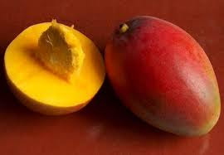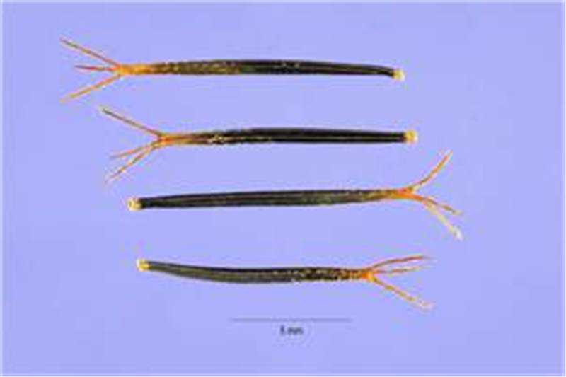
S
T

- With reason, identify the type of fruit each specimen belongs.
- Specimen S: (1 mark)
………………………………………………………………………………………………
Reason: (1 mark)
………………………………………………………………………………………………
- Specimen T: (1 mark)
……………………………………………………………………………………………… Reason: (1 mark)
………………………………………………………………………………………………
- State three differences between specimens S and T. (3 marks)
………………………………………………………………………………………………………………………………………………………………………………………………………………………………………………………………………………………………………………………………………………………………………………………………
- With reasons, state the mode of dispersal of each specimen:
- Specimen S: (1 mark)
………………………………………………………………………………………………
Reason: (1 mark)
………………………………………………………………………………………………
- Specimen T: (1 mark)
……………………………………………………………………………………………… Reason: (1 mark)
………………………………………………………………………………………………

- You are provided with photographs of specimens labelled P, Q, R, S and T. Examine them carefully.
P
Q
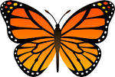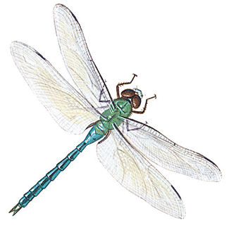
R
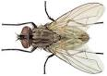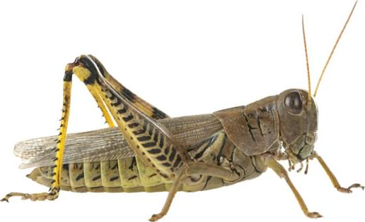
S
T
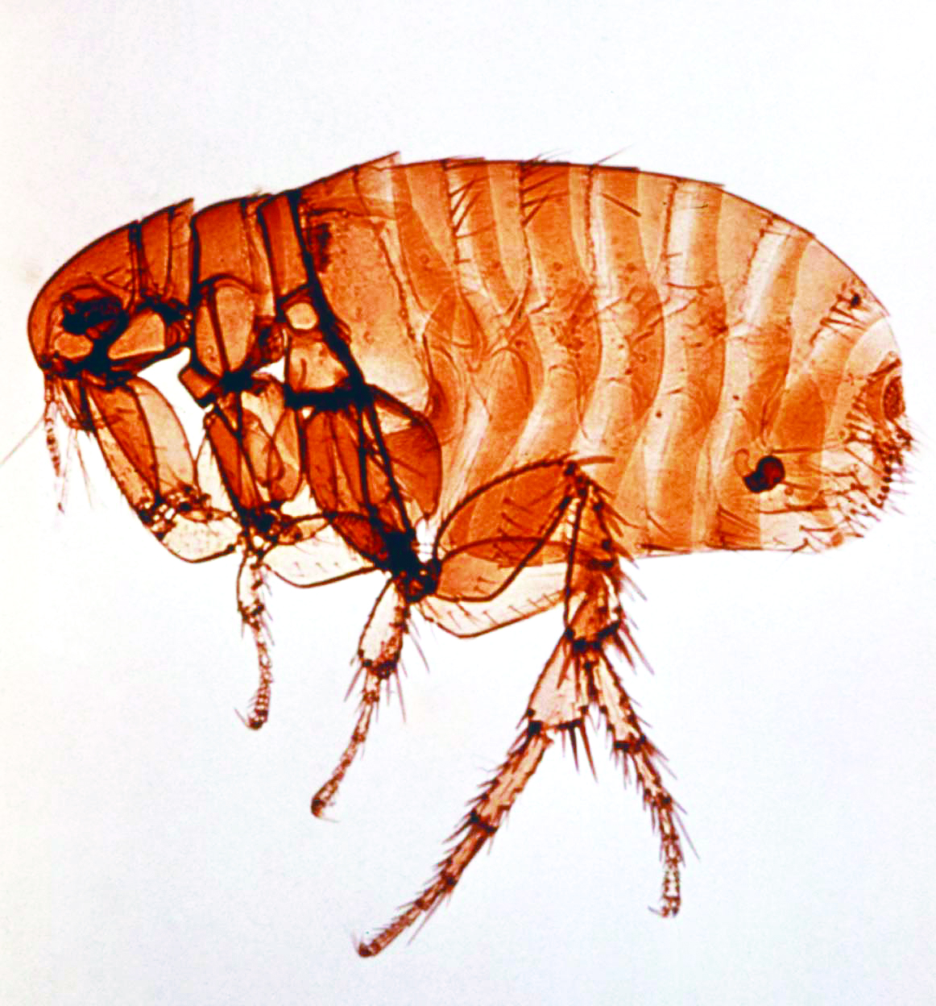

(a) Use the dichotomous key provided below to answer the questions that follow
1 a Wings present……………………………………………….Go to 2
b Wings absent………………………………………………..Go to 7
2 a One pair of wings…………………………………………...Housefly
b Two pairs of wings …………………………………….......Go to 3
3 a Wings membranous ………………………………………..Go to 4
b Hind wings only membranous……………………………....Go to 6
4 a Long and thin abdomen…………………………………......Dragon fly
b Medium sized abdomen…………………………………......Go to 5
5 a Wings peckled….....................................................................Butterfly
b Wings not peckled …………………………………………..Bee
6 a Forewings shell-like……………………………………........Beetle
b Fore wings hand……………………….………………........Grasshopper
7 a Body laterally flattened…..……………………………........Louse
b Body horizontally flattened…………………..………..........Flea

- Use the dichotomous key provided to identify each of the specimens. (5 marks)
Specimen Steps followed Identity
P …………………….. ……………………
Q …………………….. ……………………
R …………………….. ……………………
S …………………….. …………………….
T …………………….. …………………….

- (i) State the class to which the specimens belong. (1mark)

…………………………………………………………………………………………………………

(ii) Give a reason for your answer in (b)(i) above. (1mark)
…………………………………………...………………………………………………………………
……………………………………………...……………………………………………………………
- Give two observable similarities and three observable differences between specimens S and T.
- Observable similarities. (2marks)
…………………………………………..………………………………………………………………
………………………………………………………………….……………………………………….
- Observable differences. (3 marks)
........................................................................................................................................................................................................................................................................................................................................................................................................................................................................................................
(d)(i) Identify the type of habitat specimen S is likely to be found living. (1mark)
…………………………………………..………………………………………………………………
(ii) Give a reason for your answer in (d) (i) above. (1mark)
………………………………………………………………….………………………………………
…………………………………………..………………………………………………………………
………………………………………………………………….………………………………………

