FORM 4

565/1
BUSINESS STUDIES
PAPER 1
TIME: 2½ HOURS

Name: _______________________________________ Adm No.: _____________________
Candidate’s Signature: __________
Date: __________________________

INSTURCTIONS TO CANDIDATES

- Write your name and adm. no in the spaces provided above.
- Sign and write the date of examination in the spaces provided above.
- Answer ALL the questions.
- All answers should be written in the spaces provided in this booklet.
- This paper consists of 6 printed pages
- Candidates should check the question paper to ascertain that all the pages are printed as indicated and that no questions are missing.
- Candidates should answer all the questions in English

FOR EXAMINER’S USE ONLY

Question | 1 | 2 | 3 | 4 | 5 | 6 | 7 | 8 | 9 | 10 | 11 | 12 | 13 | 14
Candidate’s score

Question | 15 | 16 | 17 | 18 | 19 | 20 | 21 | 22 | 23 | 24 | 25
Candidate’s score

TOTAL MARKS

- Define the following terms as used in Business Studies. (4 mks)
- Economics………………………………………………………………………………
………………………………………………………………………………………….
- Entrepreneurship………………………………………………………………………..
…………………………………………………………………………………………..
- Opportunity cost………………………………………………………………………...
…………………………………………………………………………………………..
- Scale of preference……………………………………………………………………...
…………………………………………………………………………………………..

- Highlight four reasons why food is an important basic need. (4 mks)

- ………………………………………………………………………………………….
- …………………………………………………………………………………………..
- …………………………………………………………………………………………..
- …………………………………………………………………………………………..

- Outline four importance of a warehouse to a consumer. (4 mks)

- ………………………………………………………………………………………….
- …………………………………………………………………………………………..
- …………………………………………………………………………………………..
- …………………………………………………………………………………………..

- Outline four requirements for one to start a limited liability company as one of the forms of business units. (4 mks)

- ………………………………………………………………………………………….
- …………………………………………………………………………………………..
- …………………………………………………………………………………………..
- …………………………………………………………………………………………..

- Highlight four factors a firm must take into account when deciding on the product(s) to produce.

- ………………………………………………………………………………………….
- …………………………………………………………………………………………..
- …………………………………………………………………………………………..
- …………………………………………………………………………………………..

- Highlight four ways in which entrepreneurs can observe ethics in the management of their business. (4 mks)

- ………………………………………………………………………………………….
- …………………………………………………………………………………………..
- …………………………………………………………………………………………..
- …………………………………………………………………………………………..

- The following information was extracted from the books of Dawida business enterprise for the year ended 30th June 2000.

Capital as at 30th June, 2000 640,000
Capital as at 1st July 1999 420,000
Drawing for the year 180,000
Net profit for the year 140,000

Determine the additional capital during the year. (4 mks)

- Highlight four ways through which one can convey verbal communication. (4 mks)

- ………………………………………………………………………………………….
- …………………………………………………………………………………………..
- …………………………………………………………………………………………..
- …………………………………………………………………………………………..
- Below is a demand and supply curve.
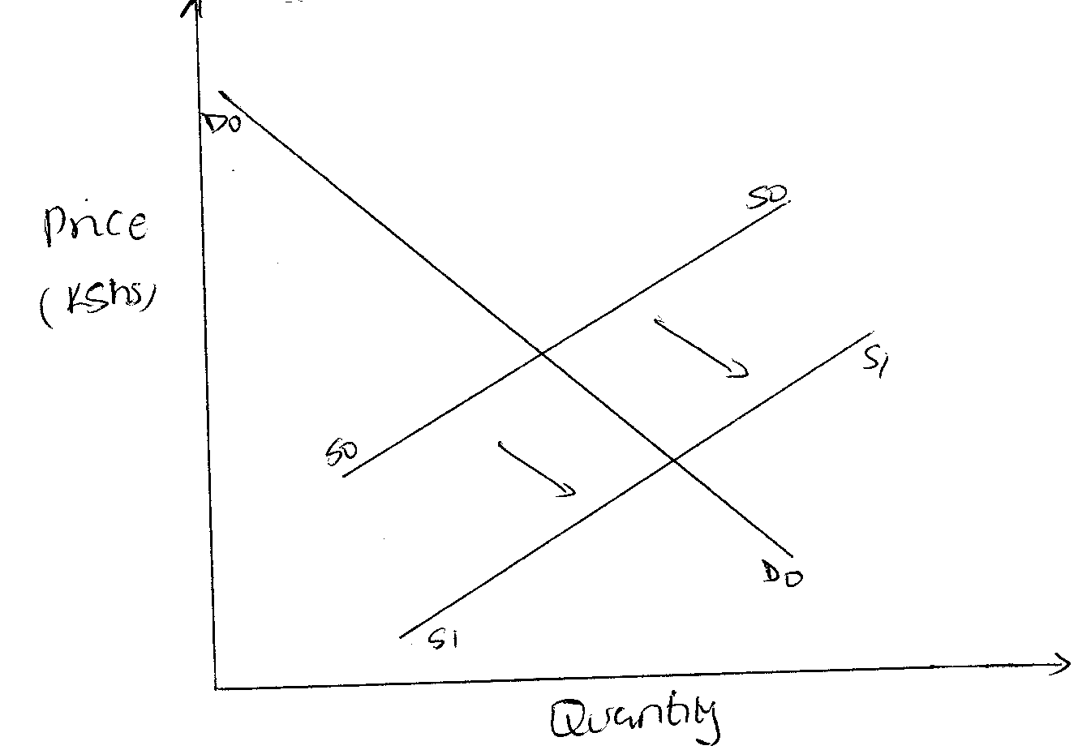

Highlight the factors that may have led to the above behavior. (4 mks)

- ………………………………………………………………………………………….
- …………………………………………………………………………………………..
- …………………………………………………………………………………………..
- …………………………………………………………………………………………..

- Outline four circumstances under which a trader can issue a credit note to a customer.
(4 mks)

- ………………………………………………………………………………………….
- …………………………………………………………………………………………..
- …………………………………………………………………………………………..
- …………………………………………………………………………………………..

- Give the difference between: (4 mks)
- Double and co-insurance
………………………………………………………………………………………………
………………………………………………………………………………………………
………………………………………………………………………………………………
- Premiums and surrender value
………………………………………………………………………………………………
………………………………………………………………………………………………
………………………………………………………………………………………………

- Highlight four advantages of indirect tax. (4 mks)

- ………………………………………………………………………………………….
- …………………………………………………………………………………………..
- …………………………………………………………………………………………..
- …………………………………………………………………………………………..

- Highlight four ways in which a legal-political environment can impact negatively on entrepreneurs. (4 mks)

- ………………………………………………………………………………………….
- …………………………………………………………………………………………..
- …………………………………………………………………………………………..
- …………………………………………………………………………………………..

- Highlight four duties of commercial attaches in trade promotion. (4 mks)

- ………………………………………………………………………………………….
- …………………………………………………………………………………………..
- …………………………………………………………………………………………..
- …………………………………………………………………………………………..

- Identify the book of original entry in which the following transactions can be recorded.
(4 mks)

Transaction | Book of Original Entry
Paid salaries by cheque
returned goods to a supplier
Sold goods on credit
Bought delivery van on credit

- Outline three leakages in a circular flow of income. (3 mks)

- ………………………………………………………………………………………….
- …………………………………………………………………………………………..
- …………………………………………………………………………………………..

- Outline four advantages of using celebrities in product promotion. (4 mks)

- ………………………………………………………………………………………….
- …………………………………………………………………………………………..
- …………………………………………………………………………………………..
- …………………………………………………………………………………………..
- Distinguish between the following terms of sale as used in international trade. (4 mks)

- Free on rail (FOR)
………………………………………………………………………………………….
………………………………………………………………………………………….
- Free on board (FOB)
…………………………………………………………………………………………..
………………………………………………………………………………………….
- In Bond
…………………………………………………………………………………………..
………………………………………………………………………………………….
- On nearest offer (ONO)
…………………………………………………………………………………………..
………………………………………………………………………………………….
- Kenya is planning to extend her pipeline transport. State four advantages of pipeline transport to the country. (4 mks)

- ………………………………………………………………………………………….
- …………………………………………………………………………………………..
- …………………………………………………………………………………………..
- …………………………………………………………………………………………..

- Outline four emerging issues in office management. (4 mks)

- ………………………………………………………………………………………….
- …………………………………………………………………………………………..
- …………………………………………………………………………………………..
- …………………………………………………………………………………………..

- Kiburu carried out the following transactions during the month of February 2015.

February 1: Started business by depositing sh 220,000 in business bank account
7: Bought goods on credit from Miyogo Sh 72,000
8: Paid rent by cheque Sh 20,000
16: Sold goods to Kamula on credit Sh 50,000.

Required: Post the above transaction in the relevant ledge accounts.

- Highlight four features of perfect competition market. (4 mks)

- ………………………………………………………………………………………….
- …………………………………………………………………………………………..
- …………………………………………………………………………………………..
- …………………………………………………………………………………………..

- Mention whether the following transactions have an increase, decrease or no effect on the assts, capital and liabilities of a business. (4 mks)

 | Transaction | Assets | Capital | Liabilities
(a) | Bought premises on credit
(b) | Took stock of goods and donated to a local dispensary
(c) | Withdrew money from bank for office use
(d) | Sold furniture receiving cash

- The following information relates to Liston traders for the period ended 31st March 2012.
Opening stock Sh 40,000
Sales Sh 100,000
Closing stock 25% on cost of sales
Mark-up 25%

By clearly calculating gross profit and purchases, prepare a trading account
- Gross profit (1 mk)
- Purchases for the year (2 mks)

