Name………………………………………………………. Index No…………………/…….
Candidates Signature………………
Date ………………………………..

233/1
CHEMISTRY
Paper 1
2 Hours

Kenya certificate of secondary education (K.C.S.E)

Instructions to candidates
(a)Write your name and index number in the spaces provided above.
(b) Sign and write the date of examination in the spaces provided above
(c) Answer ALL the questions in the spaces provided in the question paper
- KNEC Mathematical tables and electronic calculators may be used for calculations
- All working MUST be clearly shown where necessary
- This paper consists of 13 printed pages
- Candidates should check the question paper to ascertain that all the pages are printed as indicated and that no questions are missing
- Candidates should answer the questions in English

For examiner’s only

question | maximum score | candidates score
1-29 | 80

1. In the industrial preparation of oxygen, state:
(a) How dust particles are removed from air. (1 mark)

…………………………………………………………………………………………………….
(b) Why carbon (IV) oxide is removed before the mixture is cooled to – 25⁰C (1 mark)

…………………………………………………………………………………………………
…………………………………………………………………………………………………
2. A form four student accidentally mixed Sodium Carbonate and Calcium Carbonate. Describe
how he would obtain a dry sample of Sodium Carbonate from the mixture. (3 marks)
………………………………………………………………………………………………………………………………………………………………………………………………………………………………………………………………………………………………………………………
3. The set up below was used to prepare dry hydrogen gas. Study it and answer the questions that follow.
Cardboard
Hydrochloric
acid
Zinc granules
Liquid Y

(i) Identify a mistake in the set up (1 mark)

…………………………………………………………………………………………………
(ii) Write an equation for the reaction for the reaction that produces hydrogen gas (1 mark)

…………………………………………………………………………………………………
(iii) State the chemical test for hydrogen (1 mark)

…………………………………………………………………………………………………..

4. The following is a part of Uranium decay series
238
U
92
234
Th
90
234
Pa
91
Z
X
A
Step I
Step II
Step III

(i) Which particles are emitted in step I and II (1 mark)

……………………………………………………………………………………………………
(ii) If a beta particle is emitted in step III, find Z and A (1 mark)

………………………………………………………………………………………………………

(iii) State one environmental effect of radioisotopes. (1 mark)
…………………………………………………………………………………………………
5. The standard electrode potentials for the elements chlorine and magnesium
Cl_{2(aq)} + 2ē 2Cl⁻_{(aq),} E = + 1.36V
Mg + 2ē Mg_{(s),} E = - 2.36V
i) Which one of the two elements will act as an oxidizing agent?Explain your choice(2 marks)

………………………………………………………………………………………………………………………………………………………………………………………………………………
(ii).Calculate the electromotive force of a cell whose overall reaction is
Cl_{2(aq)} + Mg(_{g)} Mg Cl_{2(aq)} (1 mark)
………………………………………………………………………………………………………………………………………………………………………………………………………………
6. Describe how a solid sample of Lead(II) Chloride can be prepared using the following Reagents: Dilute Nitric Acid, Dilute Hydrochloric Acid and Lead Carbonate. (3 marks)
………………………………………………………………………………………………………………………………………………………………………………………………………………
………………………………………………………………………………………………………
7. 50cm³ of Carbon (IV) Oxide diffuses through a porous plate in 15 seconds. Calculate the time taken by 75cm³ of Nitrogen (IV) Oxide to diffuse through the same plate under similar conditions. (C = 12, 0 = 16, N = 14) (2 marks)
……………………………………………………………………………………………………………………………………………………………………………………………………………………………………………………………………………………………………………………
8.(a). Carbon (IV) oxide is bubbled through Calcium hydroxide until there is no further change.
Explain using equations the changes observed. (2 marks)
……………………………………………………………………………………………………….
(b) Explain why diamond is used in cutting of glass and drilling. (1 mark)
………………………………………………………………………………………………
9. Using an energy cycle diagram, calculate the enthalpy change of formation of carbon disulphide. (3 marks)

S_{(s)} + O_{2 (g)} SO_{2 (g)} ΔH = -294 kJmol⁻¹
CS_{2(g)} + 3O_{2 (g)} CO_{2 (g)} + 2SO_{2 (g)} ΔH = -1072 kJmol⁻¹
C_{(s)} + O_{2 (g)} CO_{2 (g)} ΔH = -393 kJmol⁻¹

……………………………………………………………………………………………………………….…………………………………………………………………………………………………………….....................................................................................................
10.A compound G reacts with 2 moles of bromine to form another compound whose structural
formula is.

H Br Br H
| | | |
H- C - C - C - C – H
| | | |
H Br Br H

i) What is the formula and name of compound G (2 marks)

………………………………………………………………………………………………………………………………………………………………………………………………………………
ii) State the observations made when acidified potassium chromate (VI) is added to compound G

(1 mark)
………………………………………………………………………………………………………
11. Study the set-up below and answer the questions that follow
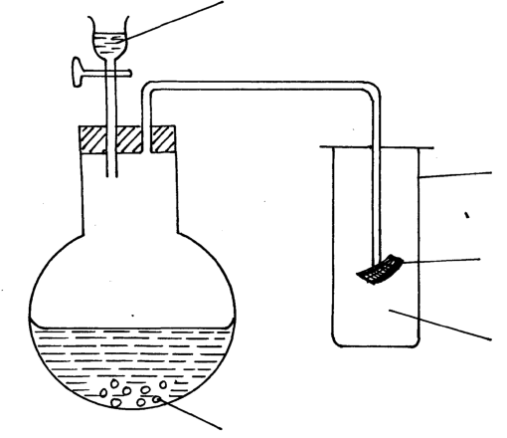
Dilute hydrochloric acid
A gas jar
gas x
Sodium sulphite

Red litmus paper

(a) Identify gas (1 mark)

……………………………………………………………………………………………
(b) Write an equation for the reaction that produces gas x. (1 mark)

…………………………………………………………………………………………………….
(c) What is the effect of the gas x above on the red-litums paper (1 mark)

……………………………………………………………………………………………………...
………………………………………………………………………………………………………
12. The grid below is part of the periodic table. Use it to answer the questions that follow. ( The letters do not represent the actual symbols of elements.)

 |  |  |  |  |  |  | R | S
N | Q |  |  |  |  |  |  | T | U
P

(a) Indicate in the grid the position of an element represented by letter V, whose atomic number
is 14. (1 mark)

(b) Select a letter which represents a monoatomic gas. (1 mark)
………………………………………………………………………………………………….
(c) Write an equation for the reaction between Q and T (1 mark)

………………………………………………………………………………………………………
13. The table below shows the solubility of a substance at various temperatures. Study it and answer the questions that follow.
Temperature (⁰C) | Solubility in g/100g of water
0 | 36
40 | 30
80 | 25
110 | 20

(a) What is the meaning of solubility? (1 mark)

………………………………………………………………………………………………
(b) What is the physical state of the substance? (1 mark)

………………………………………………………………………………………………
(c) State and explain what would happen if a sample of a saturated solution of the substance at 40⁰C was heated to 110⁰C. (1 mark)
………………………………………………………………………………………………
………………………………………………………………………………………………
14. Study the chart below and answer the questions that follow.
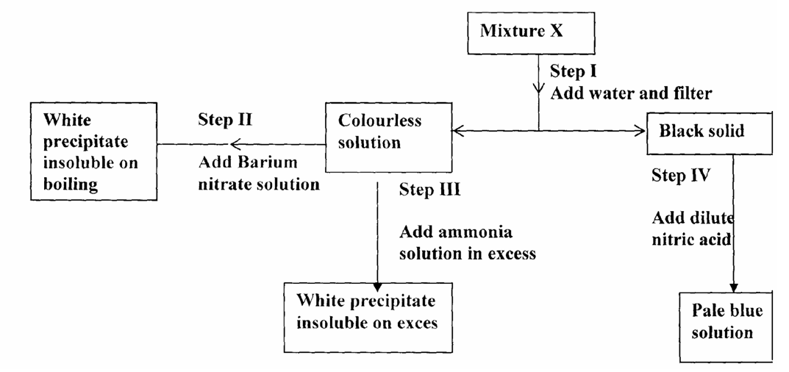
(a) Name:
(i) Cations present in mixture X. (1 mark)
…………………………………………………………………………………
(ii) Anions present in the solution. (1 mark)
…………………………………………………………………………………
(b) Write an equation to show how the white precipitate in step III is formed. (1 mark)
………………………………………………………………………………….
15. Study the diagram below and answer the questions
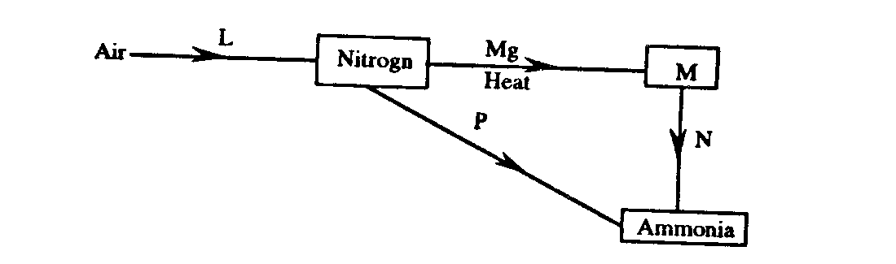
(i) What is the process involved in step L (1 mark)
……………………………………………………………………………………….
(ii) Explain how process N and P can be affected (2 marks)
N………………………………………………………………………………………
…………………………………………………………………………………….
P…………………………………………………………………………………….

16. The scheme below was used to prepare a cleansing agent. Study it and answer the questions that follow.
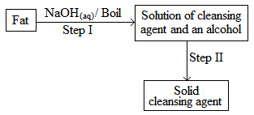
- Given to the type of cleansing agent prepared by the method above? (1 mark)

…………………………………………………………………………………………………..

(ii) Name one chemical substance added in step II (1 mark)

……………………………………………………………………………………………………

(iii) What is the purpose of adding the chemical substance named in c (ii) above? (1 mark)

………………………………………………………………………………………………………

17.The rate of a reaction depends on concentration of reactants, temperature and possibly a catalyst. Apiece of magnesium ribbon was added to 100cm³ of 1M HCl. The hydrogen evolved was collected in a gas syringe and its volume measured every 30 seconds
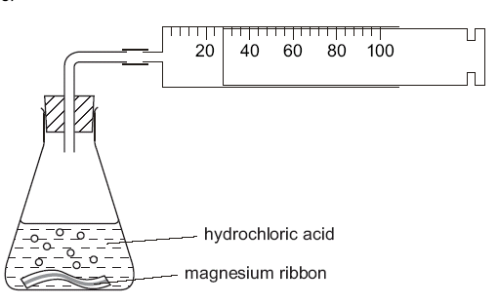

The results were plotted to give a graph shown below
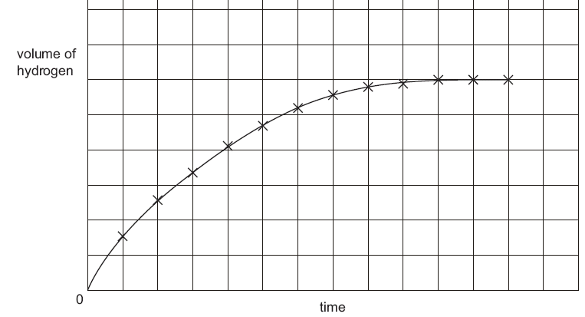
- The experiment was repeated. Two pieces of magnesium ribbon were added to 100cm³ of 1M
HCl . Sketch this graph on the same grid and label it X (1 mark)

(ii) The experiment was repeated using one piece of magnesium ribbon and 100cm³ of 1.0M ethanoic acid. Describe how the shape of the graph would differ from the one given on the grid.
(2 marks)
………………………………………………………………………………………………

……………………………………………………………………………………………..

18. 6g of potassium nitrate solid were added to 120cm³ of water in a plastic beaker. The mixture was stirred gently and the following results were obtained.
Initial temperature = 21.5⁰C
Final temperature = 17.0⁰C
(a) Calculate the enthalpy change for the reaction (density = 1g/cm³, C = 4.2jg⁻¹K⁻¹) (2 marks)
……………………………………………………………………………………………………………………………………………………………………………………………………………..
……………………………………………………………………………………………………..
b) Calculate the molar enthalpy change for the dissolution of potassium nitrate. (2 marks)
(K = 39, N = 14, O = 16)
………………………………………………………………………………………………………………………………………………………………………………………………………………………………………………………………………………………………………………………

19. In the redox reaction below:
2H⁺_{(aq)} + Cr₂0₇²⁻_{(aq)} + 3SO_{2 (aq)} Cr³⁺_{(aq)} + 3SO₄²⁻ +H₂0_{(l)}
Identify the reducing agent, explain your answer. (2 marks)
……………………………………………………………………………………………………………………………………………………………………………………………………
20. Study the set-up below and answer questions that follow.

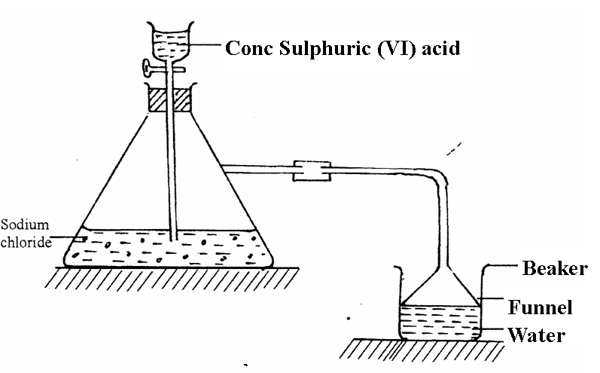

i) Name the gas that is produced when concentrated sulphuric (VI) acid reacts with the
sodium chloride (1 mark)

………………………………………………………………………………………………….

ii)Why is it necessary to use a funnel in the beaker? (1 mark)

………………………………………………………………………………………………………

iii) How does the gas affect the P^{H} of the water in the beaker? (1 mark)

…………………………………………………………………………………………………….

21.The flow chart/diagram below outlines a method of preparing a fertilizer
Salt V
Nitric (V) acid
E
Gas W
Air
Gas U
Air
NH_{3(g)}
Dilute
Salt F
H₂SO₄

i) Identify U and W
U ……………………………………………………………. (¹/₂ mark)
W …………………………………………………………… (¹/₂ mark)
ii) Give the names of salt F and V
F ……………………………………………………………. (¹/₂ mark)
V ……………………………………………………………. (¹/₂ mark)
iii) Write a balanced equation for the formation of salt F (1 mark)
…………………………………………………………………………………….
22. (a) Draw a dot (•) and a cross (x) diagram to show bonding in Cl₂O. (1 mark)

b) Explain why the compound Cl₂O has a very low melting and boiling point. (1 mark)
………………………………………………………………………………………………………………………………………………………………………………………………………………
23. Ethene reacts with oxygen according to the equation.
C₂H₄ _{(g)} + 3O₂ _{(g)} 2 C0₂ _{(g)} + 2H₂O _{(g)}
15.0 cm³ of ethene were mixed with 50cm³ of oxygen and mixture was sparked to complete the reaction. If all the volumes were measured at a pressure of one atmosphere and 25⁰C. Calculate the volume of resulting gaseous mixture. (3 marks)

………………………………………………………………………………………………………………………………………………………………………………………………………………………………………………………………………………………………………………………………………………………………………………………………………………………………
24. The graph below shows the behavior of a fixed mass of a gas at constant temperature.

Pressure
(atmospheres)

Volume (litres)
- What is the relationship between the volume and the pressure of the gas? (1 mark)
……………………………………………………………………………………………………
- 3 litres of oxygen gas at 1atm atmosphere pressure were compressed to 2atm at constant temperature. Calculate the volume occupied by the oxygen gas. (2 marks)
…………………………………………………………………………………………………………………………………………………………………………………………………………………………………………………………………………………………………………………….
25. Temporary water hardness can be removed by boiling
(a) What is hard water. (1 mark)

……………………………………………………………………………………………………....
(b) Write a chemical equation to show how temporary hardness is removed by boiling. (1 mark)

……………………………………………………………………………………………………....
…………………………………………………………………………………………………...
(c) State one advantage of hard water. (1 mark)

……………………………………………………………………………………………………..
Glass wool
Soaked
with water
Boiling tube
Gas K
Zinc powder
26. A student set-up the experiment below to collect gas K. The glass wool was heated before heating the zinc powder.

Heat
Heat

- Why was it necessary to heat the moist glass wool before heating the zinc powder?
(1 mark)
……………………………………………………………………………………………………………….……………………………………………………………………………………
(b) What observation was made in the boiling tube. (1 mark)

……………………………………………………………………………………………………………….……………………………………………………………………………………………
27. During the extraction of lead from its ores one of the main ore used is Galena
Roasting Furnace
Smelting furnance
SO_{2(g))}
Lead
Hot air
Galena
Coke and CaO
Gas P
Slag

(i) Write an equation for the reaction in roasting furnace. (1 mark)

…………………………………………………………………………………………………….
(ii) Name gas P (1 mark)

……………………………………………………………………………………………
(iii) State one use of lead metal. (1 mark)

……………………………………………………………………………………………………...
28. The empirical formula of a compound is CH₂ and it has a molecular mass of 42.
(a) What is the molecular formula of this compound? (1 mark)

................................................................................................................................................
................................................................................................................................................

- Write the general formula of the homologous series to which the compound belongs.
(1 mark)
...............................................................................................................................................
- Draw the structural formula of the third member of this series and give its IUPAC name.
(1 mark)
………………………………………………………………………………………………………

………………………………………………………………………………………………………

SET 9
MARKING SCHEME CHEMISTRY PAPER 233/1
1.(a)By passing through filters/electrostatic precipitators

(b) Carbon (IV) oxide would otherwise solidify and block the pipes

2. Add✓ ½ water to the mixture stir ✓ ½ the mixture for all Sodium Carbonate to dissolve. Filter
✓ ½ the mixture to obtain calcium carbonate as residue and sodium carbonate as filtrate.
Heat ✓ ½ the filtrate to evaporate ✓ ½ excess water and leave it to cool slowly for sodium
carbonate to crystallize ✓ ½ . Finally filter the product and obtain pure crystals of sodium
carbonate.
3. (i) Method of gas collection is wrong,gas is lighter than air
(ii) Zn(s) + 2HCl(aq) ZnCl₂(aq) +H₂(g)
(iii) It burns with a pop sound when ignited
4.(i) I alpha particle 
II beta particle
(ii) Z-234 
A-91 
(iii) –when they pass through human body they destroy body cells leading to cancer
- they can cause mutation
5. i) Chlorine1. It has the highest positive ¹/₂ reduction potential and it will therefore be the most easily reduced ¹/₂ and hence acts as the oxidizing agent. Or magnesium has the highest oxidation potential (+2.36v) and it will therefore act as a reducing agent donating electrons to chlorine which therefore acts as the oxidizing agent.
ii) E^{θ}_{reaction} = E^{θ}_{reduced} - E^{θ}_{oxidised}
E^{θ} = +1.36 ½ – (-2.36) V ¹/₂
= +1.36 + 2.36V
= +3.72V ¹/₂
5. (i) H₂SO₄ + Na₂SO₃(s) Na₂SO₄aq +H₂O(l) + SO₂(g)
2H₂SO₄(aq) + Cu(s) CuSO₄(aq) + 2NaCl(aq) +H₂O(l)
(ii) bleaching property
Bi Tl Pb Bi Pb P
Bi Tl Pb Bi Pb P
I. V – sulphur (IV) oxide
D – sulphuric (IV) acid

II. Ba²⁺_{(aq)} + SO₃²⁻_{(aq)} BaSO_{3 (s)} 
6. Dissolve ( ½) Lead carbonate in dilute Nitric acid ( ½ ) React the mixture with dilute
Hydrochloric acid (1) Filter ( ½ ); to get Lead (II) Chloride ( ½ )
7. 75cm³ of CO₂ takes = second ✓ ½ = 22.5 seconds✓½
Rmm of CO₂ = 12 + 2 x 16 = 44 ✓ ½
Rmm of NO₂ = 14 + 2 x 16 = 46 ✓ ½
= 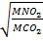
TNO₂ = 22.5 seconds ✓ ½
= 23.006s ✓ ½
8.(a) Ca(OH)₂ _{(aq)} + CO_{2(s)} CaCO_{3(s)} + H₂O_{(l)}✓ ½
Lime water forms white ✓ ½ ppt due to the formation of calcium carbonate but in excess
calcium carbonate forms colourless solution due to the formation of soluble ✓ ½ calcium
hydrogen carbonate.

CaCO_{3(s)} + H₂O_{(l)} + CO₂ _{(g)} Ca(HCO₃)_{2(aq)} (2 mks)
(b).In diamond each carbon atom is bonded to four other carbon atoms ✓ ½ arranged in a regular
tetrahedron shape the whole structure of diamond extends all directions forming a rigid ✓ ½
mass of atoms. (1 mk)

9. From the energy cycle diagram:-
ΔH₃₌?
O_{2(g)}
3O_{2(g)}
ΔH₄ =-1072
ΔH₂
ΔH₁ O_{2(g)}
CO_{2(g)} +2SO₂

C_{(s)} + 2S _{(g) (g)} CS₂

ΔH₁ + ΔH₂ = ΔH₃ + ΔH_{4 ✓} 1
Then
ΔH₃ = ΔH₁ + ΔH₂ – ΔH₄
ΔH₃ = (2 x -294) + -293) – (-1072) ✓ 1

ΔH₃ = -981 + 1072
ΔH₃ = -91kJmol⁻¹ ✓ 1
10. (i) H H H H
| | | |
H- C - C - C - C – H
| | | |
H H H H
(ii) acidified potassium chromate (VI) changes from orange to green✓ 1
11.(a) Sulphur(iv)oxide✓ 1
(b) Na₂SO₃ (s) +2HCl(aq) SO₂(g) + 2NaCl(aq) + H₂O(l) ✓ 1
(c) the red litmus paper is bleached✓ 1
12.(a) 2.8.4 group IV,period 3✓ 1
(b)U✓ 1
(c) Q(s) +T₂(g) QT₂(s) ✓ 1

13.(a)It is the maximum mass of solute that dissolves in 100g of water to form a saturated
solution at aparticular temperature. 
(b) it is agas
(c) the solution becomes more saturated with the gas
14.(a).(i) Cu²⁺ , Al³⁺
(ii) SO₄²⁻
(b) Al3+(aq) + 3OH- Al(OH)3(s) 

15. (i) fractional distillation
(ii) N-add water
P- addition of hydrogen
16.(i) Soap.1mk
(ii) Concentrated NaCl/ Brine/ NaCl_{(l)} 1

(iii) To precipitate out the soap1

17.(i) higher volume of hydrogen produced

(ii) Same volume of gas as before but takes longer time since ethanoic acid is a week acid

18.(a) McT
=120 x 4.2 x 4.5
= +2268J
(b) 6g produces 2268J
101g produces ?
= +38.178kJ/mol
19. SO2- because it has been oxidized/oxidation no of sulphur has increased from +4 to +6
20.(i) Hydrogenchloride
(ii) it prevents sucking back/increases surface area for dissolving
(iii) the p^{H} of the water drops
21.(i)U- Nitrogen(I)oxide 
W- Nitrogen(iv)oxide
(ii) F-ammonium sulphate 
V-ammonium nitrate
(iii)NH₃(g) + H₂SO₄(g) (NH₄)₂SO₄

22. (a)
OR
√ 2mks
xx
xx
xx
●●
xx
x
●
xx
xx
xx
x
x
x
●
Cl
x
x
Cl
Cl
x
●
Cl
●●
xx
●●
xx
xx
xx

(b) It forms a molecular structure with weak vander waals forces that are easily broken √ ½
23. C₂ H_{4 (g)} + 3O_{2(g)} 2CO_{2(g)} + 2H₂O_{(g)}

1 Mol 3 Mol : 2 Mole (¹/₂ mks)
1 Mole: 3 Vol. :2 Vol.
15cm³ :45cm³ :30 cm³
Total residual gas mixture
= 5cm³ of excess oxygen + 30 cm³ of Co₂
Total = 35cm³  (¹/₂ mks)
24.(a) volume is inversely proportional to pressure
(b) P₁V₁ =P₂V₂
3 x 1 =2 x V₂
V₂ =1.5litres
25.(a) it is water that contains dissolved calcium and magnesium ions and does not lather easily
(b) Ca(HCO₃)(aq) CaCO₃(s) +CO₂(g) +H₂O(l) 
(c) –contains calcium ions required for strong teeth
-used for brewing
-used for leather tanning
26.(a) to generate steam that reacts with zinc metal and also drive away air from the apparatus
(b) zinc glows and a yellow solid is seen
27.(i)2PbS(s) +3O₂(g) 2PbO(s) +2SO₂(g)
(ii) Carbon(iv)oxide
(iii) making lead pipes, making lead acid batteries
28.(a) (CH₂)n = 42
(12 + 2)n = 42
14n = 42
n = 3 √ ½
MF = 3(CH₂) C₃H₆ √ ½
(b) CnH₂n √ 1
(c) But-1-ene/ √ ½/ Butene
