NAME:…………………………………………….……CLASS:….…….ADM No.:…………..
SIGNATURE:………………………………… INDEXNO:………………………… DATE………………………………………
233/1
CHEMISTRY
Paper 1
THEORY
2 Hours

SET 2

INSTRUCTIONS TO THE CANDIDATES:-

- Write your Name and Index number in the spaces provided.
- Answer all the questions in the spaces provided.
- Mathematical tables and electronic calculators may be used
- All working MUST be clearly shown where necessary.

For Examiner’s Use Only
Question | Maximum score | Candidate’s score
1 - 30 | 80

- (a) State graham’s law of diffusion. (1 mk)
………………………………………………………………………………………………….
………………………………………………………………………………………………….
(b) 48cm³ of an oxide of Nitrogen diffused through a porous plug in the same time it took
159 cm³ of helium to diffuse through the same plug under similar conditions. What is the molecular mass of the oxide? (He = 4, N = 14) (2 mks)

………………………………………………………………………………………………….
………………………………………………………………………………………………….
………………………………………………………………………………………………….
………………………………………………………………………………………………….
- 3.1 of an organic compound containing Carbon hydrogen and oxygen only produced 4.4g of Carbon (IV) oxide and 2.0g of water on complete combustion.

- Calculate its empirical formular. (2 mk)

………………………………………………………………………………………………….
………………………………………………………………………………………………….
………………………………………………………………………………………………….
………………………………………………………………………………………………….
- Calculate in molecular formula if its formula mass is 62 (1 mk)

………………………………………………………………………………………………….
………………………………………………………………………………………………….
- Sketch the cooling curve of a pure substance and impure substance in the sane axis. (2 mks)

- (a) Define the term solubility. (1 mk)

………………………………………………………………………………………………….
………………………………………………………………………………………………….

(b) The mass of a solution of salt of sodium chloride is 70 grams. This solution has 10 grams
of sodium chloride dissolved in it. The solubility of this salt is 30 grams / 100 grams of water at 25⁰C. 65 grams of sodium chloride salt are added to the solution at 25⁰C. How much sodium chloride will remain undissolved. (2 mks)

………………………………………………………………………………………………….
………………………………………………………………………………………………….
………………………………………………………………………………………………….
………………………………………………………………………………………………….
………………………………………………………………………………………………….
- Study the table for certain properties of substances A, B, C and D.

 | Melting point ⁰c | Solubility in water | Electrical conduct
A | -119⁰c | Soluble | Solution does not conduct
B | 1020⁰c | Soluble | Solution conducts
C | 1740⁰c | Insoluble | Doest not conduct
D | 1600⁰c | Insoluble | Conducts at room temperature

Which of the substances A, B, C and D: (4 mks)
- Is a metal ……………………………………………………………………………….
- Has a simple molecular structure………………………………………………………
- Has a giant ionic structure………………………………………………………………
- Has a giant covalent structure…………………………………………………………..

- The table below gives percentages of a radioactive isotope of Bismuth that remain after decaying at different times.

Time | 0 | 6 | 12 | 22 | 38 | 62 | 100
% of Bismum | 100 | 81 | 65 | 46 | 29 | 12 | 13

- Plot a graph of the percentage of remaining vertical axis against time. (3 mks)

- Use your graph to determine the half life of the Bismuth isotope. (1 mk)

………………………………………………………………………………………………….
- An equilibrium exists between the reaction of chromate ion (cro₄2⁻_{(aq)}) and dichromate ions (Cr₂O₇²⁻)

2cro₄²⁻_{(aq)} + 2H+_{(aq)} $⇋$ cr₂O₇²⁻ + H₂O
Yellow Orange

State and explain observations made when aqueous Hcl is added to the above system at equilibrium. (2 mks)

………………………………………………………………………………………………….
………………………………………………………………………………………………….
………………………………………………………………………………………………….
………………………………………………………………………………………………….
- The table below gives factors which affect the rate of the reaction.

Factor | Effect on rate of reaction | Explanation
Using zinc powder instead of zinc granules | ½ mk | 1 mk
Heating the reaction | ½ mk | 1 mk

Complete the table to show how the factors given affect the rate of reaction and give an explanation for each effect.

- (a) Name two cations making water hard. (1 mk)

………………………………………………………………………………………………….
………………………………………………………………………………………………….
(b) By use of an ionic equation, shows how sodium carbonate makes permanent hard water
soft. (1 mk)

………………………………………………………………………………………………….
………………………………………………………………………………………………….
………………………………………………………………………………………………….
- Describe a chemical test which can be used to differentiate between sodium carbonate and sodium sulphate. (2 mks)

………………………………………………………………………………………………….
………………………………………………………………………………………………….
- Explain the observation using equation mad when two to three drops of aqueous ammonia are added to zinc ions until in excess. (2 mks)

………………………………………………………………………………………………….
………………………………………………………………………………………………….
- A gas of mass 1.8g was found to have a density of 1.12g / litre at 25⁰C and 745 mmHg. Find its molecular weight at r.t.p. molar gas volume = 24 litres and temperature 25⁰C at
760 mmHg. (3 mks)

………………………………………………………………………………………………….
………………………………………………………………………………………………….
………………………………………………………………………………………………….
………………………………………………………………………………………………….
………………………………………………………………………………………………….
………………………………………………………………………………………………….
- Hydrogen burns in air to form steam.

- Write the chemical equation involved in the reaction. (1 mk)

………………………………………………………………………………………………….
………………………………………………………………………………………………….

- Use the bond energies in the following table to calculate ΔH for the reaction. (2 mk)

Bond | Bond energy Kj mol⁻¹
H – H | 436
O = O | 489
O – H | 464

………………………………………………………………………………………………….
………………………………………………………………………………………………….
………………………………………………………………………………………………….
………………………………………………………………………………………………….
- The set up below indicate how hydrogen gas I was passed over heated copper (ii) oxide.

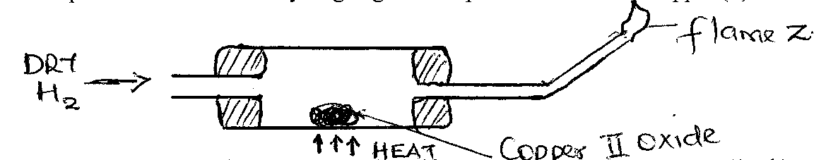
State one mistake in the set up and rectify. (1 mk)

………………………………………………………………………………………………….
………………………………………………………………………………………………….
- Write the chemical equation for the reaction taking place in the combustion table. (1 mk)

………………………………………………………………………………………………….
- Before heating is stopped, a stream of hydrogen gas is passed continuously through the combustion tube until it has cooled explain why. (1 mk)

………………………………………………………………………………………………….
………………………………………………………………………………………………….

- Musau was stung by a wasp while on his way to the market, he felt a lot of pain. How would you treat Musau to relieve him of the pain? (2 mks)

………………………………………………………………………………………………….
………………………………………………………………………………………………….
- (a) Hydrogen Sulphide is a strong reducing agent. Explain the observations made when this
gas is bubbled through a solution of Iron (iii) chloride. (2 mks)

………………………………………………………………………………………………….
………………………………………………………………………………………………….
………………………………………………………………………………………………….
………………………………………………………………………………………………….
(b) Write the chemical equation involved in the reaction. (1 mk)

………………………………………………………………………………………………….
- The formula given represents a position of a polymer.

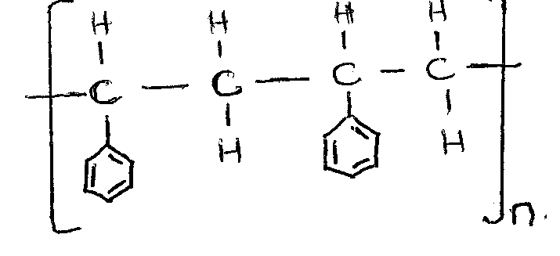

- Give the name of the polymer. (1 mk)

………………………………………………………………………………………………….
- One disadvantage of continued use of this polymer. (1 mk)

………………………………………………………………………………………………….
………………………………………………………………………………………………….
- Describe how the percentage of mass of copper in copper carbonate can be determined. (3 mk)

………………………………………………………………………………………………….
………………………………………………………………………………………………….
………………………………………………………………………………………………….
………………………………………………………………………………………………….
………………………………………………………………………………………………….
- Copper is listed on the periodic table as having a relative atomic mass of 63.55. Reference books indicate two isotopes of copper, with relative masses of 62.93 and 64.93. Find the percent abundance of each isotope (2mks)

………………………………………………………………………………………………….
………………………………………………………………………………………………….
………………………………………………………………………………………………….
………………………………………………………………………………………………….
- A form 4 student of Supamo High school was told to prepare a pure sample of Copper (II) Carbonate salt starting with Copper metal. Describe how the student prepared the salt in the laboratory. (3mks)

………………………………………………………………………………………………….
………………………………………………………………………………………………….
………………………………………………………………………………………………….
………………………………………………………………………………………………….
………………………………………………………………………………………………….
- How many cubic centimeters of hydrogen chloride gas at s.t.p would be required to to precipitate all silver ions from 32cm³ of 0.08M silver nitrate solution? (Molar Gas Volume at s.t.p =24dm³) (3mks)

………………………………………………………………………………………………….
………………………………………………………………………………………………….
………………………………………………………………………………………………….
………………………………………………………………………………………………….
- The following half equations refer to half-cells A and B and their electrode potentials measured at standard states.

A: 2H⁺_{(aq)} + O_{2(g)} +2e⁻ H₂O_{2 (l)} E^{θ} = 0.68V

B: Ag⁺ + e Ag _{(s) +} Ag_{(s)} E⁺ = +0.80V

- Calculate the e.m.f of the cell formed from A and B. (2mks)
………………………………………………………………………………………………….
………………………………………………………………………………………………….
………………………………………………………………………………………………….
………………………………………………………………………………………………….
- Explain why potassium chloride is not suitable salt for the bridge of this cell (1mk)
………………………………………………………………………………………………….
………………………………………………………………………………………………….
- Compound Q was reacted with hydrogen chloride to produce compound R whose structural formula is shown below

CH₃CH₂CH(CH₃)CHClCH₃

- Give the structural formula of Q (1mk)
………………………………………………………………………………………………….
- Which type of reaction takes place in the reaction above? (1mk)
………………………………………………………………………………………………….
- The boiling point of R is slightly higher than that of Q. Explain (1mk)
………………………………………………………………………………………………….
………………………………………………………………………………………………….
- State and explain one effect of sulphur (iv) oxide causes environmental pollution. (2mks)
………………………………………………………………………………………………….
………………………………………………………………………………………………….
………………………………………………………………………………………………….
………………………………………………………………………………………………….
………………………………………………………………………………………………….
- A mixture contains sodium chloride, sugar and camphor. The table below shows the solubility of these solids in different liquids.

Liquid  Solid | Water | Ethanol | Ether
Sodium chloride | Soluble | Insoluble | Insoluble
Camphor | Soluble | Insoluble | Very soluble
Sugar | Soluble | Soluble | Insoluble

Explain how sugar can be obtained from a mixture of sodium chloride, camphor and
sugar. (3 mks)

………………………………………………………………………………………………….
………………………………………………………………………………………………….
………………………………………………………………………………………………….
………………………………………………………………………………………………….
………………………………………………………………………………………………….
………………………………………………………………………………………………….
- The table below gives the first ionization energies of the alkali metals.

Element | 1st ionization energy kJ mol⁻¹
A | 494
B | 418
C | 519

- Define the term ionization energy. (1mk)
………………………………………………………………………………………………….
- Which of the three metals is the least reactive? Give a reason. (2mks)
………………………………………………………………………………………………….
………………………………………………………………………………………………….
………………………………………………………………………………………………….
………………………………………………………………………………………………….
………………………………………………………………………………………………….
- Nitrates of metals A, B, C were heated and the products of the reactions recorded in the table bellow.

Nitrate of metal | Products
A | Metal nitrate and oxygen
B | Free metal, nitrogen (IV) Oxide and oxygen gas
C | Metal oxide, nitrogen (IV) oxide and oxygen gas

- Name two possible identities of metal A. (1mk)

………………………………………………………………………………………………….
………………………………………………………………………………………………….
- Name the two possible identity of metal B (1mk)

………………………………………………………………………………………………….
………………………………………………………………………………………………….

- Calcium nitrate is one of the nitrate which forms the products in C. Using chemical equation show how the products are formed. (1mk)

………………………………………………………………………………………………….
- When magnesium ribbon is burnt in air two possible products are formed and when the products are dissolved in distilled water and warmed slightly, smell of ammonia gas is observed.
- Write the formulae of the product responsible for the production of ammonia. (1 mk)

- Write a balanced chemical equation which occurs when the product is dissolve in distilled water. (1 mk)

- Explain why iron III chloride is fairly soluble in methylbenzene while Magnesium chloride is insoluble. (2 mks)

………………………………………………………………………………………………….
………………………………………………………………………………………………….
………………………………………………………………………………………………….
………………………………………………………………………………………………….
- In the industrial preparation of oxygen, state:
- How dust particles are removed from air. (1 mk)

………………………………………………………………………………………………….
………………………………………………………………………………………………….
- Why CO₂ is removed before the mixture is cooled to -25⁰C. (1 mk)

………………………………………………………………………………………………….
………………………………………………………………………………………………….

