NAME: ……………………………………………. INDEXNO: …………..…… DATE………
SCHOOL: ..……………………………………… SIGNATURE: …………………………

233/1
CHEMISTRY PAPER 1
THEORY
2 HOURS

Kenya Certificate of Secondary Education

INSTRUCTIONS TO CANDIDATES
- Write your name and index number in the spaces provided above.
- Sign and write the date of examination in the spaces provided above.
- Answer all questions in the spaces provided
- Mathematical tables and electronic calculators may be used for calculations
- All working must be clearly shown where necessary
- Answer all the questions in the spaces provided

For Examiner’s Use Only
Questions | Maximum Score | Candidates Score
1-30 | 80

This paper consists of 13 printed pages .Candidates should check the question paper to ensure that all the pages are printed as indicated and no questions are missing

- An aluminum metal is a good conductor and is used for overhead cables. State any two other properties that make Aluminum suitable for this use. (2mks)
………………………………………………………………………………………………………...…..……………………………………………………………………………………………………………………………………………………………………………………………………………………………………………………………………………………………………………………………………………………………………………………..
- Some Sodium chloride was found to be contaminated with Copper (II) oxide. Describe how a sample of Sodium chloride can be separated from the mixture. (3mks)
………………………………………………………………………………………………………..………………………………………………………………………………………………………………………………………………..………………………………………………………………………………………………………………………………………………..………………………………………………………………………………………………………………………………………………………………………………………………………….
- Study the sequence of reactions below and answer the questions that follow. 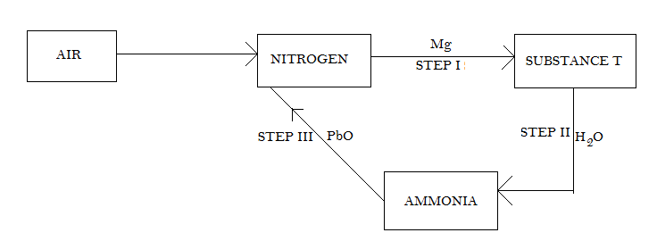
(a) Write the formulae of substance T. (1 mk)
…………………………………………………………………………………………………………………………………………………………………………………………
(b) Write balanced chemical equations for steps II and III.
Step II
…………………………………………………………………………………………………………………………………………………………………………… (1mk)

Step III ………………………………………………………………………………………………………………………………………………………………………. (1mk)

- The table below shows the atomic and ionic radii of some period three elements.
 | Atomic radius (nm) | Ionic radius (nm)
X | 0.186 | 0.175
Y | 0.160 | 0.135
Z | 0.104 | 0.184

From the table, Identify:
(a) Strongest reducing agent. (1mk)
……………………………………………………………………………………………..

(b) The bond between the atoms of X. (1mk)
……………………………………………………………………………………………..

(c) An element whose oxide has a P^{H} of below seven. (1mk)
…………………………………………………………………………………………….

- Sulphur (IV) oxide and Nitrogen (IV) oxide react as shown in the equation below
SO_{2 (g)} + NO_{2 (g)} SO_{3 (g)} + NO _{(g)}
(i) Using oxidation numbers of either sulphur or Nitrogen show that this is a redox reaction. (2mks)
…………………………………………………………………………………………………………………………………………………………………………………………………………………………………………………………………………………………………………………………………………………………………………………..

(ii) Identify the reducing agent. (1mk)
………….………………………………………………..……………………………………

- The table below shows the solubility of salt at various temperatures.

Temperatures (ºC) | Solubility of water  (g / 100g water)
0 | 36
40 | 30
80 | 25
110 | 20

What would happen if a sample of a saturated solution of the salt at 40 ºC is heated to 80 ºC? Explain. (2mks)
…………..……………………………………………………………………………………………………..………………………………………………………………………………………………………………………………………………..………………………………………………………………………………………………………………………………………………………………………………………………………………………………………..

- State two observations that would be made when a piece of Sodium metal is placed in samples of:
- Pentane (1mk)
………………………………………………………………………………………………………..………………………………………………………..………………………………………

- Pentanol (1mk)
…………………………………………………………………………………………………………..………………………………………………………..……………………………………
- Xg of Potassium hydroxide were dissolved in water to make 100cm³ of solution.50cm³ of this solution required 50cm³ of 2M Nitric acid for complete neutralization. Calculate the mass X of Potassium hydroxide. (3mks)
………………………………………………………………………………………………………………………………………………………………………………………………………………………………………………………………………………………………………………………………………………………………………………………………………………………………………………………………………………………………………………………………………………………………………………………………………………………………

- When steam was passed over heated charcoal as shown in the diagram below, Hydrogen and Carbon (II) oxide gases were formed.
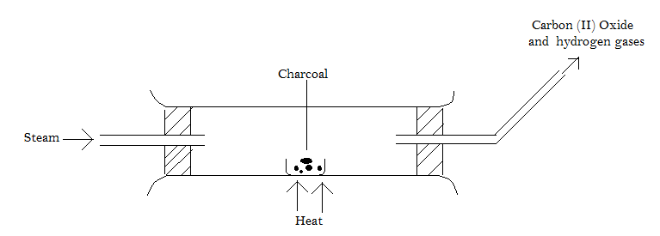
a) Write the equation for the reaction that takes place. (1mk)
……………………………………………………………………………………………………………………………………………………………………………………………………………………………………………………………………………………………………………………………………………………………………………………………………………………

b) Name two uses of Carbon (II) oxide gas which are also uses of Hydrogen gas. (2mks)
………………………………………………………………………………………………………..………………………………………………………………………………………………
- The diffusion of molecules of ammonia and an unknown gas B through air was investigated. The distance covered by the two gases is shown by the apparatus below. A white ring indicated appeared after 4 minutes.
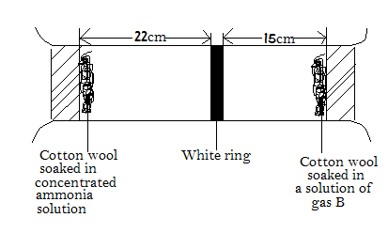

Calculate the molar mass of B. (3mks)
(N = 14, H = 1)
………………………………………………………………………………………………………………………………………………………………………………………………………………………………………………………………………………………………………………………………………………………………………………………………………………………………………………………………………………………………………………………………………………………………………………………………………………………………………………………………………………………………………………………………………………………………………………………………………………………………………..

- But - 2- ene undergoes hydrogenation according to the equation given below.
CH₃CH = CH CH_{3 (g)} + H_{2 (g)} CH₃CH₂CH₂CH_{3 (g)}
a) Name the product formed when but - 2 - ene reacts with Hydrogen gas (1mk)
…………………………………………………………..………………………………………
b) State one industrial use of hydrogenation. (1mk)
…………………………………………………………..………………………………………
- Under certain conditions, Carbon (IV) oxide reacts with water to form Methanol (CH₃OH) and Oxygen as shown below.
2CO_{2 (g)} + 4H₂O _{(l)} 2CH₃OH _{(l)} + 3O_{2 (g)} ∆H = +1452KJ
What would be the effect on the yield of Methanol if the temperature of the reaction mixture is increased? Explain (2mks)
………………………………………………………………………………………………………..……………………………………………..……………………………………………………………………………………………………………..…………………………………………………………………………………………………………………………………….
- Starting with Copper metal, describe how a solid sample of Copper (II) carbonate can be prepared. (3mks)
………………………………………………………………………………………………………..……………………..…………………………………………………………………………………………………..……………………..………………………………………………………..…………………………………………………………………………………………..…………………………………………………………………………………………………………………………………………………………………………………………………………………………………………………………………………………………………………………..

- A radioactive element X decays as shown below.
${}_{84}^{216}X$ ${}_{82}^{208}{Pb}$ + aα + bβ
- Give the atomic number of X. (1mk)
……………………………………………………………………………………………………………………………………………………………………………………
- Determine the values of a and b in the equation. (2mks)
…………………………………………………………………………………………………………………………………………………………………………………………………………………………………………………………………………………………………………………………………………………………………………………………………………………………………………………………………………………………………………………..
- a) Write the electron configuration of Calcium and Beryllium (Calcium atomic number 20 and Beryllium atomic number 4)
Calcium (½mk)
…………………………………………………………..………………………………………
Beryllium (½mk)
…………………………………………………………..………………………………………
b) Why is Calcium more reactive than Beryllium? (2mks)
………………………………………………………………………………………………………..………………………………………………………..………………………………………
- Sulphur atomic number 16 and oxygen atomic number 8 are elements in
group VI of the periodic table. Sulphur is a solid at room temperature while oxygen is a gas at room temperature. Explain why hydrogen sulphide with molecular mass 34 is a gas at room temperature while water with molecular mass 18 is a liquid. (2mks)
……………………………………………………………………………………………………..……………………………………………………………………………………………………………………………………………………………..………………………………………………………………………………………………………………………………………………………………………………………………………………………………………………………………………………………………………………………………………………
- Sulphur exists in two crystalline forms.
a) Name one crystalline form of Sulphur. (1mk)
…………………………………………………………..………………………………………

b) State two uses of Sulphur. (2mks)
………………………………………………………………………………………………………..………………………………………………………..………………………………………………………………………………………………………………………………………….
- When 94.5g of hydrated Barium hydroxide Ba (OH)₂ . XH₂O were heated to a constant mass 51.3g of anhydrous Barium hydroxide were obtained. Determine the empirical formula of the hydrated Barium hydroxide. (Ba = 137.0, O = 16.0, H = 1.0). (3mks)
…………………………………………………………………………………………………………………………………………………………………………………………………………………………………………………………………………………………………………………………………………………………………………………………………………………………………………………………………………………………………………………………………………………………………………………………………………………………………………………………………………………………………………………………………………………………………………………………………………………………………….
- The diagram below shows a set up for the laboratory preparation and collection of dry Chlorine gas.
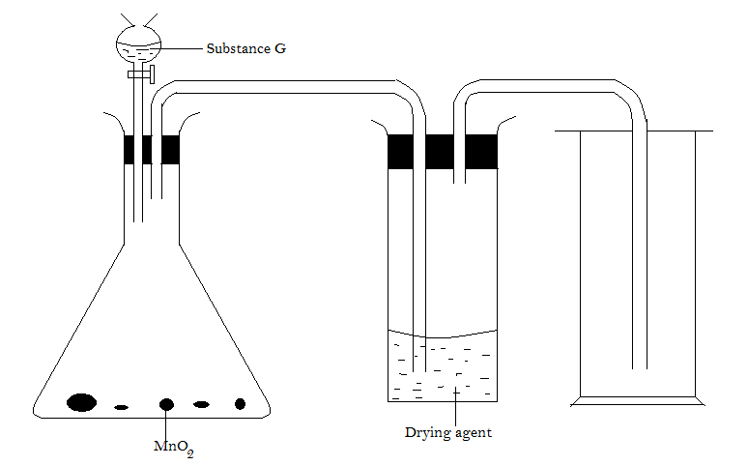

a) Name
(i) Substance G…………………………………………………………… (1mk)

(ii) A suitable drying agent……………………………………………….. (1mk)

b) What property of Chlorine makes it possible for it to be collected as shown in the diagram? (1mk)
…………………………………………………………..………………………………………

- The table below gives the energy required to remove the outermost electron for some group (I) elements
Element | I | II | III | IV
Energy KJ / mol | 494 | 418 | 519 | 376

Arrange the elements in the order of their reactivity starting with the most reactive. (2mks)
…………………………………………………………………………………………………………..………………………………………………………..……………………………………
- a) Using dots () and crosses (X) to represent electrons, draw diagrams to represent the bonding in:
(i) NH₃ (1mk)
………………………………………………………………………………………………………………………………………………………………………………………………………………………………………………………………………………………………………………………………………………………………………………………………………………………………………………………………………………………………
(ii) NH⁺₄ (1mk)
……………………………………………………………………………………………………………………………………………………………………………………………………………………………………………………………………………………………………………………………………………………………………………………………………………………………………………………………………………………..

b) State why an Ammonium molecule (NH₃) can combine with H⁺ to form NH⁺₄. Atomic numbers N = 17, H = 1) (1mk)
………………………………………………………………………………………………………..………………………………………………………..……………………………………

- Use the information below to answer the questions that follow:-
H_{2 (g)} + ½ O₂ (g) H₂O _{(l)} ΔH₁ = -286KJ /mol
C _{(s)} + O_{2 (g)} CO_{2 (g)} ΔH₂ = -393KJ /mol
CH_{4 (g)} + 4O_{2 (g)} CO₂ + 2H₂O _{(l)} ΔH₃ = -890KJ / mol
Determine the enthalpy of formation of methane using the data given above. (3mks)
………………………………………………………………………………………………………………………………………………………………………………………………………………………………………………………………………………………………………………………………………………………………………………………………………………………………………………………………………………………………………………………………………………………………………………………………………………………………………………..
- (a) Write the structural formula of
(i) 3,3-dimethylpentane. (1mk)
…………………………………………………………………………………………………………………………………………………………………………………………………………………………………………………………………………………………………………………………………………………………………………………………………………….
(ii) 2-bromo-4-methylpentan-2-ol (1mk)
……………………………………………………………………………………………………………………………………………………………………………………………………………………………………………………………………………………………………………………………………………………………………………………………………………….
(b) Below is the structure of polystyrene.

H H H H H H
⎜ ⎜ ⎜ ⎜ ⎜ ⎜
⎯ C ⎯ C ⎯ C ⎯ C ⎯ C ⎯ C
⎜ ⎜ ⎜ ⎜ ⎜ ⎜
C₆H₅ H C₆H₅ H C₆H₅ H

Draw the monomeric unit of polystyrene. (1mk)
…………………………………………………………………………………………………………………………………………………………………………………………………………………………………………………………………………………………………………………………………………………………………………………………………………………………..

- Roofing iron sheets have a shiny surface when new but they become dull after a short while. Explain this observation. (2mks)
………………………………………………………………………………………………………..………………………………………………………………………………………………...…………………………………………………………..………………………………………
……………………………………………………………………………………………………………………………………………………………………………………………………
- a) Why is group (II) metals better conductor of electricity than group (I) element? (2mks)
………………………………………………………………………………………………………..………..……………………………………………………………………………………………………..………………………………………………..………………………………………………………………………………………………………………………………………..
b) Solid Lead bromide does not conduct electricity, molten Lead bromide conducts. Explain this observation. (1mk)
………………………………………………………………………………………………..…………………………………………………………..……………………………………
- Calculate the number of Sodium ions produced when 5.85g of Sodium chloride is dissolved in water. (Na = 23, Cl = 35.5, Avogadro No. = 6.02 x 10²³) (2mks)
…………………………………………………………………………………………………………………………………………………………………………………………………………………………………………………………………………………………………………………………………………………………………………………………………………………………………………………………………………………………………………………….
- A metal X (atomic number 12) burns in Chlorine (atomic number 17) to produce a white solid.
a) Write an equation between X and Chlorine gas. (1mk)
…………………………………………………………………………………………………………………………………………………………………………………………………….
b) Draw a dot () and cross (X) diagram to show how the compound between X and Chlorine is formed. (1mk)
………………………………………………………………………………………………………………………………………………………………………………………………………………………………………………………………………………………………………………………………………………………………………………………………………………………………………………………………………………………………………………..
- a) When brine is electrolyzed using inert electrodes, Chlorine gas is liberated at the anode instead of Oxygen. Explain this observation. (2mks)
………………………………………………………………………………………………………...……………………………………….………………………………………………………….………………………………………….………………..………………………………………………………………………………………………………………………………………
b) Name the product formed at the cathode. (1mk)
………………………………………………………………………………………………………………………………………………………………………………………………
- The set up below was used to obtain a sample of Copper.
Heat Heat
Oxygen
Charcoal
Copper (II) Oxide
Boiling tube
Lime water
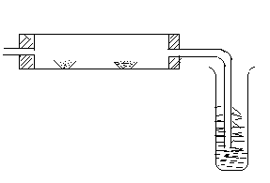
a) Write the equation for the reactions which occurs in the combustion tube. (2mks)
………………………………………………………………………………………………………………………………………………………………………………………………………………………………………………………………………………………………………ss
b) Explain the observation in the boiling tube. (2mks)
………………………………………………………………………………………………………..…………………………………………………………………..………………………………………………………………….…………..…………………………….……………………

- a) Name two ores from which Sodium is extracted (1mk)
………………………………………………………………………………………………………..………………………………………………………..……………………………………
b) State two uses of Sodium metal. (2mks)
………………………………………………………………………………………………………..………………………………………………………………………………………………

THIS IS THE LAST PRINTED PAGE

