Name……………………………………………………………………….………..…….. Class: 4

Class No……………………………. Index No…………………. Signature……………………………………

CHEMISTRY DEPARTMENT
CHEMISTRY PAPER 2
233/2

INSTRUCTIONS TO CANDIDATES:
- This paper consists of 11 (eleven) printed pages

- Attempt ALL the questions. Answers should be written only in the spaces provided.

- Electronic calculators may be used for calculations.

  - All working must be clearly shown where applicable. Slovenly work may be penalized.

For Examiner’s use only

Question number | Student’s score | Maximum marks
1 |  | 11
2 |  | 9
3 |  | 12
4 |  | 12
5 |  | 12
6 |  | 12
7 |  | 12
TOTAL |  | 80

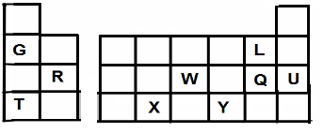
Q1. The grid below represents part of the periodic table. Study it and answer the questions that follow. The letters do not represent actual symbols of the elements.

P

- Which is the most reactive metal? ………………………… (1 mark)

- What name is given to the family of the elements L and Q?

……………………..………….………… (1 mark)

- Element Q reacts with both W and R. Write the formulae of the compounds formed between:

- W and Q ………………………… (1 mark)

- R and Q ………………………… (1 mark)

- Using dots and crosses to represent electrons, show the bonding in the compound formed when the following elements combine.
(i) X and L (ii) T and P

(2 marks)

- Compare and explain the difference between the atomic radii of X and Y. (2 marks)

……………………………………………………………………………………………………………

………………………………………………………………………………………………

………………………………………………………………………………………………

- Explain why U is unreactive. (1 mark)

………………………………………………………………………………………………

- Giving a reason, predict what the pH of an aqueous solution of the oxide of element G would be. (1 mark)

……………………………………………………………………………………………….

………………………………………………………………………………………………

Q2. The reaction scheme shows various reactions starting with ammonia. Study it and answer the questions that follow.

Ammonia

Compound J
Step I
  - Oxygen + catalyst
  - Water

Brown solid L

Nitric (V) acid
Step II
Aqueous sodium nitrate

Step IV

Copper
Step III
Sulphur

Copper (II) oxide
Heat

Solution K
Brown fumes

- Name the raw materials used for the manufacture of ammonia.

…………………………………………………………………………………………….. (1 mark)

- Write an equation for the reaction that occurs between ammonia and oxygen in step I.

…………………………………………………………………………………………… (1 mark)

- Name the process that takes place in step II.

…………………………………………………………………………………………… (1 mark)

- Explain how the reaction in step III takes place. (2 marks)

…………………………………………………………………………………………………………..

…………………………………………………………………………………………………………..

- Name: (i) A gas that can be used to carry out step (IV) …………………………..(1/2 mark)

(ii) A substance that can be added to solution K to form solid L directly.

…………………………………………………………………………………………… (1/2 mark)

- (i) Write the formula of compound J. ……………………………………………… (1 mark)

(ii) Calculate the mass of compound J that would contain 140kg of nitrogen. (2 marks)
(R.A.M. N=14, O=16 H=1)

Q3. a) What is an anode? (1mark)

………………………………………………………………………………………………

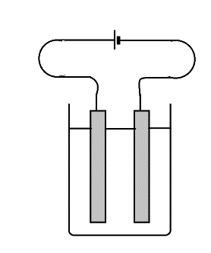
- The diagram below shows a setup that that was used to electrolyse silver nitrate solution

Platinum electrodes

Silver nitrate solution

- State the observation made at the cathode. (1mark)

………………………………………………………………………………………………

………………………………………………………………………………………………

- Write an ionic equation for the reaction taking place at the anode. (1mark)

………………………………………………………………………………………………………

- Explain why the pH of the electrolyte was found to have decreased at the end of the experiment. (2 marks)

…………………………………………………………………………………….…………………….

……………………………………………………………………………….………………………….

………………………………………………………………………………….……………………….

……………………………………………………………………………………………………………

- During the electrolysis, a current of 8A was passed through the electrolyte for 5 minutes. Determine the;

- Quantity of electricity generated. (1mark)

…………………………………………………………………………………….………………….

…………………………………………………………………………………..……………………

- Mass change at the cathode. (R.A.M Ag =108, 1F = 96500C). (2 marks)

…………………………………………………………………………………….…………………….

……………………………………………………………………………….………………………….

………………………………………………………………………………….……………………….

……………………………………………………………………………………………………………

- Use the cell representation below to answer the questions that follow.
║ Fe

Fe(s) / Fe+2
(aq)
+3
(aq)
/ Fe2+

(aq)
, Pt

- Write the equation for the cell reaction. (1mark)

………………………………………………………………………………………………

- If the e.m.f of the cell is 0.33 Volts and Eθ value for Fe2+(aq) / Fe(s) is -0.44 Volts. Calculate the Eθ value for Fe3+(aq) / Fe2+(aq) . (2 marks)

…………………………………………………………………………………….…………………….

……………………………………………………………………………….………………………….

………………………………………………………………………………….……………………….

……………………………………………………………………………………………………………

…………………………………………………………………………………….…………………….

……………………………………………………………………………….………………………….

Q4. a) Give the systematic name of the following compounds.

(i) CH3CH2COOH …………………………………………………………….…..…… (1 mark) (ii) CH3CH2CH2CHCH2 ……………………………………………………….…..…… (1 mark)
(iii) CHCCH2CH3 …………………………………………………………….…..…… (1 mark)

- Study the reaction scheme below and use it to answer the questions that follow.

M Chlorine

Prop-1-ene

Step I
CO2(l)

Products

Step III
Sodium metal

Propan-1-ol

Step II

H2O(l)

CH3CH2COOH
Na2CO3

CH CH COONa

3 2

Organic compound K
Soda lime

(i) Identify the organic compound K ……………………………………………….. (1 mark) (ii) Name compound M ……………………………………………………………….. (1 mark)
- Write the structural formula of M. (1 mark)

- Give the reagent that can be used in:

Step I …………………………….……………………………………….. (1 mark)

Step II …………………………………………………….……………….. (1 mark)

- Write the equation of the reaction in step III

……………………………………………………………………………..……………….. (1 mark)

- The structure shown below represents a type of cleansing agent.

R SO3
-
Na+

Describe how the cleansing agent removes grease from a piece of cloth. (2 marks)

…………………………………………………………………………………….…………………….

……………………………………………………………………………….………………………….

………………………………………………………………………………….……………………….

……………………………………………………………………………………………………………

…………………………………………………………………………………….…………………….

Q5. a) Study the diagram below and answer the questions that follow.

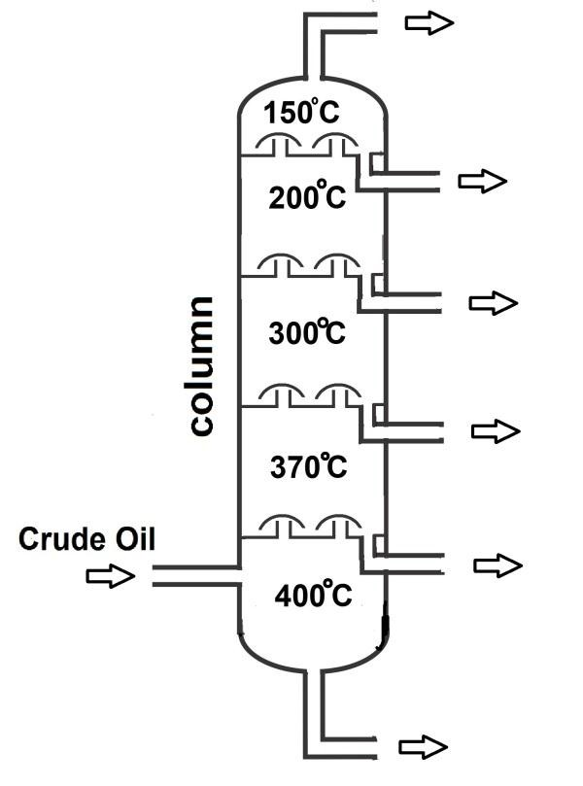

- Name the method of separation above. …………………………….……………….. (1 mark)

- Bitumen has a boiling point of more than 500oC. Indicate on the diagram where bitumen can be collected. (1 mark)

- State one use of bitumen. …………………………………………………….………. (1 mark)

- Explain how the column works. (1 mark)

…………………………………………………………………………………….…………………….

……………………………………………………………………………….………………………….

- Give one town in Kenya where crude oil is refined. ……………………………….. (1 mark)

b) The apparatus below shows the setup used to determine the percentage of oxygen in air.

Combustion tube
Copper turnings

Air Heat
Syringe

The air was slowly and repeatedly passed through the copper turnings until a constant volume was obtained.

- Explain why air was passed slowly and repeatedly. (1 mark)

…………………………………………………………………………………….…………………….

……………………………………………………………………………….………………………….

………………………………………………………………………………….……………………….

- State the observation made at the end of the experiment. (1 mark)

…………………………………………………………………………………….…………………….

……………………………………………………………………………….………………………….

- Is it advisable to use potassium in this experiment? Give a reason. (1 mark)

…………………………………………………………………………………….…………………….

……………………………………………………………………………….…………………………. c) (i) What is rust? (1 mark) …………………………………………………….……………………
…………………………………………………………………………………….…………………….

- Give the chemical formula of rust ………………………………………………….. (1 mark)

- Define the term galvanisation. (1 mark)……………………………………………………….

…………………………………………………………………………………….…………………….

……………………………………………………………………………….………………………….

Q6. Study the energy level diagram below and answer the questions that follow.

C(S) + 2H2(g)

CO2(g) + 2H2(g)

ΔH1 = -393 KJ mol-1

CH4(g)
ΔH4

-1
Energy

ΔH2 = -582 KJ mol
ΔH3 = -750 KJ mol-1

CO2(g) + 2H2O(g)

a) Name the enthalpy change represented by

(i) ΔH1 ……………………………………………………………………… (1mark) (ii) ΔH4 ……………………………………………………………………… (1mark)
c) Calculate the value of ΔH4 (1mark)

………………………………………………………………………………………………

………………………………………………………………………………………………

………………………………………………………………………………………………

- The table below gives the bond energies of some bonds.

Bond | H – H | Cl – Cl | C - H | H – Cl | C – Cl
Bond energy (kJ/ mol) | 435 | 243 | 415 | 431 | 339

Calculate the enthalpy changes for the following reactions.

- H 2(g) + Cl2(g) 2HCl(g) (2 marks)

…………………………………………………………………………………….…………………….

……………………………………………………………………………….………………………….

………………………………………………………………………………….……………………….

- CH4(g) + Cl2(g) CH3Cl(g) + HCl(g) (2 marks)

…………………………………………………………………………………….…………………….

……………………………………………………………………………….………………………….

………………………………………………………………………………….……………………….

θ -1

- Given that:
ΔH f (C4H10) = -275 kJ mol

θ -1
ΔH f (CO2) = -393 kJ mol

θ -1
ΔH f (H2O) = -286 kJ mol

- Calculate the molar heat of combustion of butane (C4H10) (2 marks)

…………………………………………………………………………………….…………………….

……………………………………………………………………………….………………………….

………………………………………………………………………………….……………………….

……………………………………………………………………………………………………………

- A portable burner containing butane is weighed and found to have a mass of 798g. What mass would it weigh if it was used to heat 5 litres of water at 18oC to a boil? (3 marks)

…………………………………………………………………………………….…………………….

……………………………………………………………………………….………………………….

………………………………………………………………………………….……………………….

……………………………………………………………………………………………………………

…………………………………………………………………………………….…………………….

Q7. The flow chart below outlines some of the processes involved during the extraction of copper from copper pyrites. Study it and answer the questions that follow.

Hot air
Gas K

Silica (SiO2)

Gas K

Copper pyrites 1st

Cu S
2nd

CuFeS2

roasting furnace
Cu2S(l)
FeO(l)
Smelting furnace
2 (l)
roasting
furnace

Gas P

Coke

Slag M
Cu + CuO

Cu(l)
Chamber N

a) (i) Name gas K …………………………………………………….……………….. (1 mark)

- Write an equation for the reaction that takes place in the 1st roasting furnace (1 mark)

…………………………………………………………………………………….…………………….

- Write the formula of the cation present in the slag …………………………….. (1 mark) (iv) Identify gas P ………………………………………………………….. (1 mark)
(v) What name if given to the reaction that occurs in chamber N? Give a reason for your answer. (2 marks)

……………………………………………………………………………….………………………….

………………………………………………………………………………….……………………….

- The copper obtained from chamber N is not pure. Draw a well labelled diagram to show the setup you would use to refine the copper by electrolysis. (3 marks).

- Given that the mass of copper obtained from the above extraction was 210kg. Determine the percentage purity of copper in the ore if 14000kg of it was fed into the 1st roasting furnace. (1 mark)

…………………………………………………………………………………….…………………….

……………………………………………………………………………….………………………….

- Give two adverse effects of the process of extracting copper on the environment. (2 marks)

…………………………………………………………………………………….…………………….

……………………………………………………………………………….………………………….

………………………………………………………………………………….……………………….

This is the last printed page.

