Name……………………………………………………….index number……………….../……….
233/2 candidate’s signature……………………
CHEMISTRY date…………………………………..
Paper 2
2 HOURS
Kenya certificate of secondary education

Instructions to candidates.
(a)Write your name and index number in the spaces provided above.
(b)Sign and write the date of examination in the space provided.
(c)Answer ALL questions in the space provided.
(d)ALL working MUST be clearly shown.
(e) Non-programmable silent electronic calculators and KNEC mathematical tables may be used.
(f)This paper consists of 14 printed pages.
(g)Candidates should check the question paper to ascertain that all pages are printed as indicated and that no questions are missing.
For examiner use only
question | Maximum  score | Candidate’s  score
1 | 08
2 | 12
3 | 11
4 | 13
5 | 14
6 | 12
7 | 10
Total  score | 80

- During a practical session students were asked to prepare magnesium carbonate. During the experiment, magnesium was burnt in air and the product collected. The students added dilute sulphuric (vi) acid to the mixture then filtered and cooled. Sodium carbonate was added to the filtrate and the contents filtered. The residue was then washed and dried to give a white powder.
(a) Name the product formed in the first procedure (1 mark)
……………………………………………………………………………………………………………………
(b) Write a chemical equation for the product formed in (a) above (1mark)
……………………………………………………………………………………………………………………
(c) (i)name the filtrate collected after sodium carbonate was added (1mark)
……………………………………………………………………………………………………………………
(ii) Write down the chemical formula for the white powder (1mark)
……………………………………………………………………………………………………………………
(d) Write a chemical equation for the reaction between the product in (a) above and the acid (1mark)
……………………………………………………………………………………………………………………
(e) Write an ionic equation to show the formation of the white powder in (c) (ii) above (1mark)
……………………………………………………………………………………………………………………
(f) Explain what will happen if the gas produced when the white powder is heated strongly is passed over slaked lime till excess.(1mark)
………………………………………………………………………………………………………………………………………………………………………………………………………………………………………..
…………………………………………………………………………………………………………………………………………………....................................................................................................................................
(g) Identify the ions present in the filtrate after addition of sodium carbonate (1mark)
……………………………………………………………………………………………………………………

- Study the ionization energies in kilojoules per mole and answer the questions below.

Element | Ionization | Energy in kilo joules per mole
 | 1st | 2nd | 3rd | 4th | 5th | 6th
A | 1,590 | 2780 | 4700 | 6500 | 8100 | 12,500
B | 1,010 | 1900 | 4900 | 5000 | 6300 | 7,300
C | 940 | 4800 | 6300 | 9,180 | 12,000 | 16,500
D | 1680 | 2010 | 3400 | 10,900 | 12,400 | 16,500

a)(i) Identify the group to which each element belong to: (2mks)
A………………………………………………………………………………………………………..
B………………………………………………………………………………………………………..
C………………………………………………………………………………………………………..
D………………………………………………………………………………………………………..
ii) Write the formula of the oxide of D. (1mk
…………………………………………………………………………………………………………
iii) What type of bond will be formed when C reacts with fluorine? Explain. (2mks)
…………………………………………………………………………………………………………………………………………………………………………………………………………………………………………………………….
b) Use the table below to answer the questions that follow. The tables show the physical properties of elements A,B,C,D and E. The letters do not represent the actual symbols of elements.
element | Atomic number | Melting point
A | 11 | 97.8
B | 13 | 665
C | 14 | 1430
D | 17 | -101
E | 19 | 64

Select the element which is:-
(i) A poor conductor of electricity. Explain? (1½mrks)
………………………………………………………………………………………………………………………
……………………………………………………………………………………………………………………….ss
(ii) To which period does element E belong? Explain. (1½mrks)
…………………………………………………………………………………………………………………
c) Using dots (.) and crosses (x) to represent electrons, shows the bonding in the compound formed between elements C and D. (2mks)
……………………………………………………………………………………………………………………………………………………………………………………………………………………………………………………..………………………………………………………………………………………………………………………………. …………………………………………………………………………………………………………………………………………………………………………………………………………………………………………………………….

d) Explain why the melting point of element B is higher than that of element A. (2mks)
……………………………………………………………………………………………………………………… ……………………………………………………………………………………………………………………………… ……………………………………………………………………………………………………………………………….
3. Use the standard electrode potentials to answer the questions that follow.
Half reaction E^{θ} volts
Zn²⁺_{(aq)} + 2e⁻ Zn_{(s)} -0.76 v
Pb²⁺_{(aq)} + 2e- Pb_{(s)} -0.13V
Ag⁺_{(aq)} + e- Ag_{(s)} + 0.80V
Cu²⁺ _{(aq)} + 2e- Cu_{(s)} +0.34V

a) A cell containing zinc and lead electrodes was set as shown.
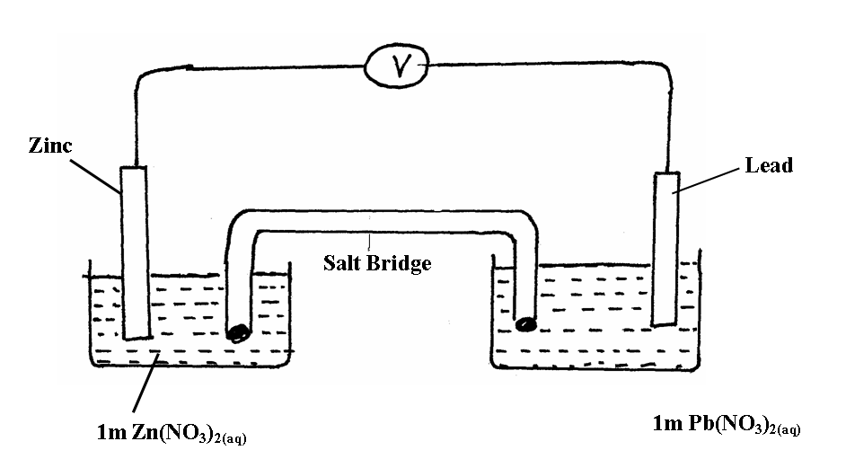
(i) Write half equation for each half cell. (1mk) ……………………………………………………………………………………………………………………………………………………………………………………………………………………………………………………………..
……………………………………………………………………………………………………………………………..

(ii) Write the overall equation for reaction. (1mk)
………………………………………………………………………………………………………………………………………………………………………………………………………………………………………………………
………………………………………………………………………………………………………………………………
(iii) Calculate the E^{θ} value for the cell. (1mk)

………………………………………………………………………………………………………………………………………………………………………………………………………………………………………
…..…………………………………………………………………………………………………………………… ………………………………………......................................................................................................................................

(iv)What is the suitable compound used in the salt bridge? (1mk)

………………………………………………………………………………………………………………………
b) (i) Draw a well labeled diagram to show how a copper spoon can be electroplated with silver.
(2mks)
……………………………………………………………………………………………………………………….. ……………………………………………………………………………………………………………………………………………………………………………………………………………………………………………………………….
……………………………………………………………………………………………………………………………….
……………………………………………………………………………………………………………………………………………………………………………………………………………………………………………………………………………………………………………………………………………………………………………………………
(ii) How many grams of silver would be deposited on the spoon in two hours if a current of 0.03A is passed?(If = 96500C, Ag = 108, Cu = 63.5) (3mks)
…………………………………………………………………………………………………….
…..………………………………………………………………………………………………………….
………………………………………………………………………………………………………………
…..…………………………………………………………………………………………………………..
c) Can a solution of silver nitrate be stored in a container of Zinc? (2mks)
………………………………………………………………………………………………………………………………………………………………………………………………………………………………………………………………………………………………………………………………………………

4. The scheme below shows various reactions and processes for some organic compounds. Study it and answer the questions that follow.
a) Name process I and name any other product formed in the process. (2mks) (i) Process I
………………………………………………………………………………………………………………………………
(ii) Product
………………………………………………………………………………………………………………
b) Name the reagent and condition required in process II. (2mks)
Reagent
………………………………………………………………………………………………………………
Condition
………………………………………………………………………………………………………………
c) i) Give the name of the product formed in process III. (1mk)
………………………………………………………………………………………………………………
(ii) State two conditions required in process III. (1mk)
………………………………………………………………………………………………………………………………………………………………………………………………………………………………
(iii) Give one characteristics property of the product formed in process III (1mk)
…………………………………………………………………………………………………………………………………………………………………………………
d) Name the catalyst and reagent required in step IV.
Catalyst (2mks)
………………………………………………………………………………………………………………
Reagent
……………………………………………………………………………………………………………

e) Give any one use of the product formed in process (V) (1mk)
………………………………………………………………………………………………………………
f) Name process (VI) (1mk)
………………………………………………………………………………………………………………
g) Process VII requires a catalyst and goes through an intermediate product.
Name:-
(i) The catalyst………………………………………………………………………………(1mk)
(ii) The intermediate product…………………………………………………………………... (1mk)
5.( a) Define Hess’s law (1mk)
…………………………………………………………………………..…………………………………………………………………………………………………………………………………………………………………………………….
……………………………………………………………………………………………………………………………….
b) Use the information below to answer the questions that follow
Ca _{(s)} + ½ O_{2 (g)} CaO_{(s)} ΔH = -635KJ /mol
C _{(s)} + O_{2 (g)} CO_{2 g)} ΔH = -394KJ / mol
Ca _{(s)} + C _{(s)} + 3/₂ O_{2 (g)} CaCO_{3(s)}, ΔH = -1207 KJ / mol
Calculate the enthalpy change for the reaction.
CaO _{(S)} + CO_{2 (g)} CaCO_{3(s)} (3mks)
………………………………………………………………………………………………………………………………………………………………………………………………………………………………………………………………
………………………………………………………………………………………………………………………………………………………………………………………………………………………………………………………………
………………………………………………………………………………………………………………………………
c) The table below gives the bond enthalpies in KJ/ mol. For some elements
BOND | BOND ENTHALPY KJ/mol.
C – H  C – C  O - O  C = O  O - H | 413  612  498  686  465
Use the bond enthalpies given above to find the heat of reaction for the oxidation of ethane.(3mrks)
………………………………………………………………………………………………………………………………………………………………………………………………………………………………………………………………
……………………………………………………………………………………………………………………………………………………………………………………………………………………………………………………………….
……………………………………………………………………………………………………………………………….
d) When 0. 6g of element W were completely burnt in oxygen and all the heat evolved was Used to heat 500cm³ of water, the temperature of the water rose from 28ºc to 37ºc. Calculate the relative atomic mass of element W given that the specific heat capacity of Water is 4200j / k / Kg. Density of water is 1g / cm³ and molar heat of combustion of W
is 380 KJ /mol. (3mks)
……………………………………………………………………………………………………………………………………………………………………………………………………………………………………………………………..
…………………………………………………………………………………………………………………………………………………………………………………………………………………………………………………………… (e) Define the term heat value (1mrk)
………………………………………………………………………………………………………………………………………………………………………………………………………………………………………………………………
………………………………………………………………………………………………………………………………
(f) Apart from heat value give other 3 factors that one needs to consider when choosing a source of fuel.(3mrks)
………………………………………………………………………………………………………………………………………………………………………………………………………………………………………………………………
………………………………………………………………………………………………………………………………………………………………………………………………………………………………………………………………
6. (a) Study the diagram below and use it to answer the questions that follow.
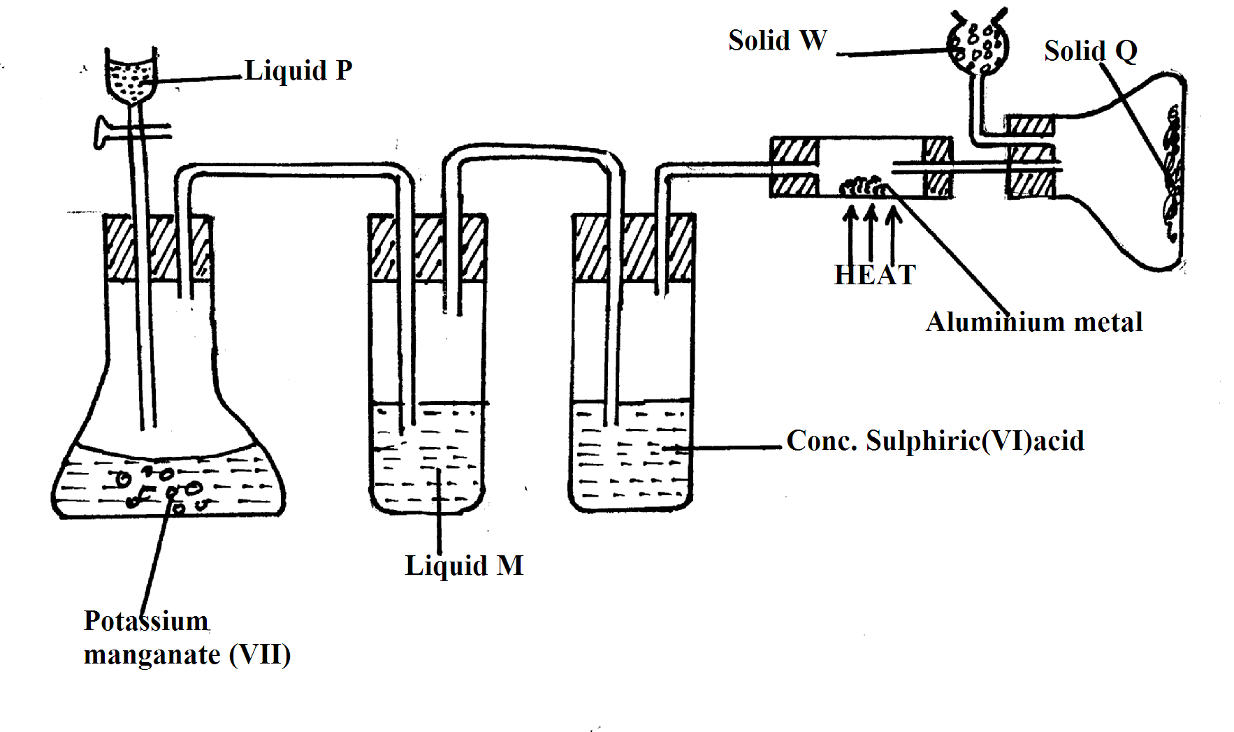
(i) Name liquid:
P…………………………………………………………………………. (1mk)
M………………………………………………………………………… (1mk)
(ii) What is the function of concentrated sulphuric (VI) acid in the set-up? (1mk)
……………………………………………………………………………………………………………………
(iii) Suggest a suitable reagent that can be used as solid W. (1mk)
……………………………………………………………………………………………………………………
(iv) State the role of solid W in the set-up. (1mk)
………………………………………………………………………………………………………………………………………………………………………………………………………………………………………………………………………………………………………………………………………………………………………
(v) Explain why solid Q collects further away from heated aluminium metal. (1mk)
………………………………………………………………………………………………………………………………………………………………………………………………………………………………………………………………………………………………………………………………………………………………………

(vi) In the reaction above, 0.645g of aluminium metal reacted completely with 1800cm³ of chlorine gas at room temperature. Determine the molecular formula of solid Q, given that its relative formula mass is 267 (Al = 27.0, Cl = 35.5, molar volume of gas at r.t.p is 24.0 litres) (3mks) ……………………………………………………………………………………………………………………… ……………………………………………………………………………………………………………………………..
………………………………………………………………………………………………………………………………………………………………………………………………………………………………………………………
……………………………………………………………………………………………………………………
(b) The flow chart below shows part of an analysis of a mixture that contains two salts.
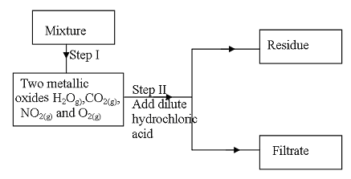
(i) What condition is necessary for the process in step I to take place? (1mk)
………………………………………………………………………………………………………………………
(ii) Draw a well labeled set-up of apparatus that could be used to separate the mixtures formed in step II. (2mks) ………………………………………………………………………………………………………………………………………………………………………………………………………………………………………………………………………………………………………………………………………………………………………………………………………………………………………………………………………………………………………………………………………………………………………………………………………………………………………………………

7. The reaction between bromine and methanoic acid at 30⁰C. Proceeds according to the
Information given below.
Br_{2(aq)} + HCOOH_{(aq)} H⁺_{(aq)} 2Br⁻_{(aq)} + 2H⁺_{(aq)} + CO_{2(g}
Concentration of  Br_{2(aq)} (Mol dm⁻³) x 10 ⁻³ | 10.0 | 8.1 | 6.6 | 4.4 | 3.0 | 2.0 | 1.3
Time (minutes) | 0 | 1 | 2 | 4 | 6 | 8 | 10

a) Plot a graph of concentration of bromine (vertical axis) against time (3mks)

b) From the graph determine;
i) The concentration of bromine at the end of 3 minutes. (1mk)
………………………………………………………………………………………………………………………
ii) The rate of reaction at time t where t = 1 ½ minutes (2mks)
………………………………………………………………………………………………………………………………………………………………………………………………………………………………………………………
……………………………………………………………………………………………………………..

c) Explain how the concentration of bromine affects the rate of the reaction (2mks)
………………………………………………………………………………………………………………………………………………………………………………………………………………………………………………………. ………………………………………………………………………………………………………………………………………………………………………………………………………………………………………………………
d) On the same axis, sketch the curve that would be obtained if the reaction was carried
Out at 20⁰C and label the curve as curve II. Give a reason for your answer. (2mks)
………………………………………………………………………………………………………………………………………………………………………………………………………………………………………………………
………………………………………………………………………………………………………………………………
THIS IS THE LAST PRINTED PAGE.

