NAME: ________________________________________________________

ADM NO: _______________________________ CLASS: __________

233/2
CHEMISTRY
PAPER 2
JULY 2015
TIME: 2 HOURS

Kenya Certificate of Secondary Education

- Answer ALL the questions in the spaces provided.

This paper consists of 8 printed pages.
Make sure that all the pages are printed and that no page is missing.

Turn Over

- The grid below is a section of a periodic table. Study it and answer the questions that follow. (The letters do not represent the actual symbol)

 | A
B |  |  | C |  |  |  | D
E |  | Z |  |  |  |  | P

- State the name given to the family of B and E (1mk)
----------------------------------------------------------------------------------------------------------------------------------------------
- Identify the most reactive metal (1mk)

----------------------------------------------------------------------------------------------------------------------------------------------
- State the type of bond that exists in the compound of element
B and D (1mk)

----------------------------------------------------------------------------------------------------------------------------------------------

- Write an equation for the reaction between B and water (1mk)
----------------------------------------------------------------------------------------------------------------------------------------------

- Using dots (.) and crosses (x) diagram, show bonding E and D
(1mk)
----------------------------------------------------------------------------------------------------------------------------------------------

- What is the name of type of bond and the structure of the
compound formed by E and D? (2mks)

----------------------------------------------------------------------------------------------------------------------------------------------

- When gas D is passed through a solution of potassium bromide, this solution turns from colourless to brown. (2mks)

- Write the ionic equation for the reaction
--------------------------------------------------------------------------------------------------------------------------------------
- Identify the oxidizing agent
--------------------------------------------------------------------------------------------------------------------------------------

- What name is given to elements in which element z belongs? (1mk)
------------------------------------------------------------------------------------------------------------------------------------------------------

- The oxide of C reacted with both the solutions resulting when B reacts with water and when D dissolves in water. What is the nature of oxide C. (1mk)
------------------------------------------------------------------------------------------------------------------------------------------------------

- State and explain the observations made when both red and blue litmus paper are dipped in a solution formed when gas P is bubbled in water. (2mks)
------------------------------------------------------------------------------------------------------------------------------------------------------
---------------------------------------------------------------------------

- When xcm³ of a solution of 0.5m magnesium nitrate were reacted excess ammonium carbonate solution, the mass of the white precipitate formed was 8.4g.
- Write the ionic equation for the reaction that took place
(1 mark)
--------------------------------------------------------------------------------------------------------------------------------------
- Calculate the value of X (C=12.0, Mg=24, O=16) (2mks)

---------------------------------------------------------------------------------------------------------------------------------------------------------------------------------------------------------

- (a) (i) Define the term efflorescence (1mk)
---------------------------------------------------------------------------------------------------------------------------------------------------------------------------------------------------------------------
(ii) On heating Iron II sulphate heptahydrate gently. It turns from pale green to yellow. On further heating solid turns from yellow to black. Write equations for the reactions (2mks)
---------------------------------------------------------------------------------------------------------------------------------------------------------------------------------------------------------------------

(b) Study the flow diagram below and answer the questions that follow.

White precipitate
Colourless Solution
Step II
excess NaOH
White precipitate
Step I Excess Ammonia solution

HNO₃ Step III

Colourless
Solution
NaCl_{(aq)}
Colourless Solution

- Identify the cation present in the white precipitate (1mk)

---------------------------------------------------------------------------------------------------------------------------------------------------------------------------------------------------------------------

- Write the equation for the formation of the colourless solution in step II (1mk)
---------------------------------------------------------------------------------------------------------------------------------------------------------------------------------------------------------------------

(c) The equation below shows ionization of ethanoic acid
CH₃COOH_{(aq)} + H₂O _{(l)} CH₃COO⁻_{(aq)} + H₃O⁺_{(aq)}

- Explain why the pH of the acid is 5 (2mks)
---------------------------------------------------------------------------------------------------------------------------------------------------------------------------------------------------------------------
- Identify the species acting as a base in the forward reaction
(1mk)
---------------------------------------------------------------------------------------------------------------------------------------------------------------------------------------------------------------------

- The results below were obtained in an experiment at 30ºC.
Mass of empty evaporating dish = 26.2g
Mass of evaporating dish + saturated solutions =42.4g
Mass of evaporating dish + dry solid Y = 30.4g

- What is the percentage by mass of solid Y that would form 1g of solution at 30ºC (2mks)
---------------------------------------------------------------------------------------------------------------------------------------------------------------------------------------------------------------------
- State the solubility of solid Y (1mk)
---------------------------------------------------------------------------------------------------------------------------------------------------------------------------------------------------------------------

- (a) (i) A student wanted to convert ethyne to ethanoic acid. Outline
In order the types of reactions and reagents he would use to achieve this. (3 mks)

Types of reaction Reagents

(ii) Using equations outline how you can obtain methane form
ethanoic acid (2 mks)
---------------------------------------------------------------------------------------------------------------------------------------------------------------------------------------------------------------------

(b) Study the scheme below and use it to answer the questions that
follow.
R

Step (IV) Na

Step I
H₂Ni200ºC
Q
Butanol
Step II
CH₃ CH₂ CH = CH₂

Step III
few drops of conc. H₂SO₄ + Ethanoic acid
Polymerisation

S
V

- Name compounds (2mks)
R ____________________ S ________________________
- State the types of reactions in (2mks)
Step II _______________________
Step III _______________________
- Give the reagents used in step II (1mk)
---------------------------------------------------------------------------------------------------------------------------------------------------------------------------------------------------------------------
- The molecular mass of V was found to be 149,520. How many monomers made compound V (2mks)

---------------------------------------------------------------------------------------------------------------------------------------------------------------------------------------------------------------------

(c) The scheme below represents the manufacture of cleaning agent L
O
O
R
R
SO₃H
L
NaOH
Conc.

H₂SO₄
Alkylbenzene Suphuric acid
Alkylbenzene

(i) Draw the structure of L and state the type of cleansing
agent in which it belongs. (2mks)

4.
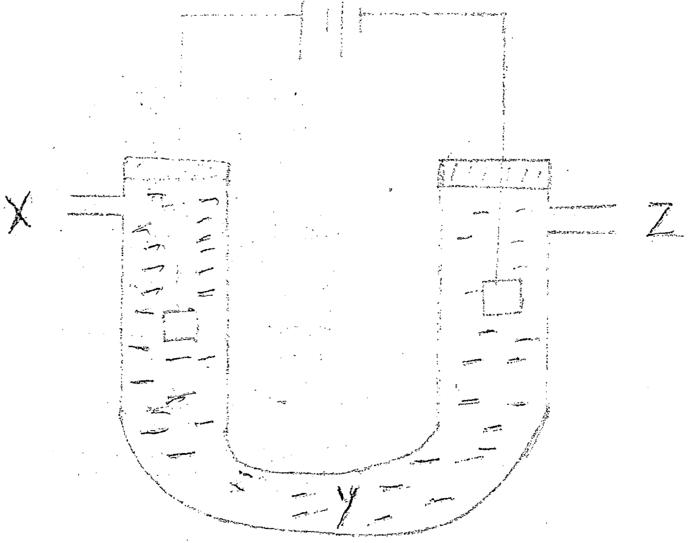
The diagram above is of the apparatus used to investigate the effect of electricity on iron (II) chloride using platinum electrodes. Iron (II) chloride solution is green. The cathode was weighed and then a current of 0.1A was passed through the circuit for 30 minutes. A few bubbles of a gas were seen at the cathode and a colourless gas was observed at the anode. A deposit of iron metal was formed on the cathode. At the end of the experiment, the cathode was washed dried and re-weighed.
- Calculate the number of coulombs of electricity that went through the circuit (1mk)
---------------------------------------------------------------------------------------------------------------------------------------------------------------------------------------------------------------------------------------
- The charge carried by 1 mole of electrons may be taken to be 100,000 coulombs. How many moles of electrons flowed through the circuit?
(1 mk)
---------------------------------------------------------------------------------------------------------------------------------------------------------------------------------------------------------------------------------------

- Write the ionic equation for the cathode reaction (1 mk)
---------------------------------------------------------------------------------------------------------------------------------------------------------------------------------------------------------------------------------------

- Calculate the number of moles of iron atoms to be deposited on the cathode. (1mk)
---------------------------------------------------------------------------------------------------------------------------------------------------------------------------------------------------------------------------------------

- Calculate the increase in mass of the cathode. (Fe=56) (1mk)
---------------------------------------------------------------------------------------------------------------------------------------------------------------------------------------------------------------------------------------

- The actual increase of the cathode was found to be about 0.0404g. Explain the difference between the expected and the observed increase in mass. (1mk)
---------------------------------------------------------------------------------------------------------------------------------------------------------------------------------------------------------------------------------------
(vii) How would you test your explanation (1mk)
---------------------------------------------------------------------------------------------------------------------------------------------------------------------------------------------------------------------------------------
(viii) (a) What gas is produced at the anode? Write equation of the
reaction (2mks)
---------------------------------------------------------------------------------------------------------------------------------------------------------------------------------------------------------------------
(b) Sketch a diagram to show how you would measure the volume
of the gas produced at the anode. (1mk)

(ix) What would you observe at Y when electrolysis goes on for a long time (1mk)
---------------------------------------------------------------------------------------------------------------------------------------------------------------------------------------------------------------------------------------
(x) If the experiment is repeated, using carbon anode in place of the
platinum one, the anode is found to lose mass. Explain (2mks)
---------------------------------------------------------------------------------------------------------------------------------------------------------------------------------------------------------------------------------------
(xi) The experiment was repeated using a higher voltage to increase the current. A choking gas was evolved at the anode. The gas was bubbled through iodide solution and black solid was deposited. Identify
- The gas (1mk)
---------------------------------------------------------------------------------------------------------------------------------------------------------------------------------------------------------------------
(b) Write equation for the formation of black solid (1mk)
---------------------------------------------------------------------------------------------------------------------------------------------------------------------------------------------------------------------

- Study the energy level diagram below and answer the questions that follow.

2H_{(g)} + O_{(g)}

∆ H₂ H₃

2H_{(g)} +½ O_{2(g)} H₂O_{(g)}

∆H₁ ∆H₄

H_{2(g)} + ½O_{2(g)}
H₂O _{(l)}

- (i) Which H values have a positive sign. (1mk)
---------------------------------------------------------------------------------------------------------------------------------------------------------------------------------------------------
(ii) Which H values have a negative sign (1mk)
------------------------------------------------------------------------------------------------------------------------------------------------------------------------------------------------
- What chemical changes is being represented by (2mks)
H₁ ____________________

H₄ ____________________

- The hydration energy of Al³⁺ and Cl⁻ are -4690 and -364kJmol⁻¹ respectively. The heat of solution of alluminium chloride is -332kJ mol-¹.

- Calculate the lattice energy of alluminium chloride (2mks)
--------------------------------------------------------------------------------------------------------------------------------------------------------------------------------------------------------------------------------------------------------------------------------
- Draw an energy level diagram for dissolving of alluminium
chloride (2mks)
------------------------------------------------------------------------------------------------------------------------------------------------------------------------------------------------------------

- When one mole of butanol is burnt. 2676kJ are liberated
- Write a chemical reaction for combustion of butanol. (1 mk)
------------------------------------------------------------------------------------------------------------------------------------------------------------------------------------------------------------
- Considering the following heats of combustion
H^{θ}C (Graphite) = -393kJ mol⁻¹
H^{θ}C (H₂) _{(g)} = -286kJ mol⁻¹
H^{θ}C (Butanol) = -2676kJ mol⁻¹

Draw an energy cycle for the above energy changes
(2mks)

- Calculate the heat of formation of butanol (2mks)
----------------------------------------------------------------------------------------------------------------------------------------
----------------------------------------------------------------------------------------------------------------------------------------

- Study the diagram below on extraction of iron and answer the questions that follow.

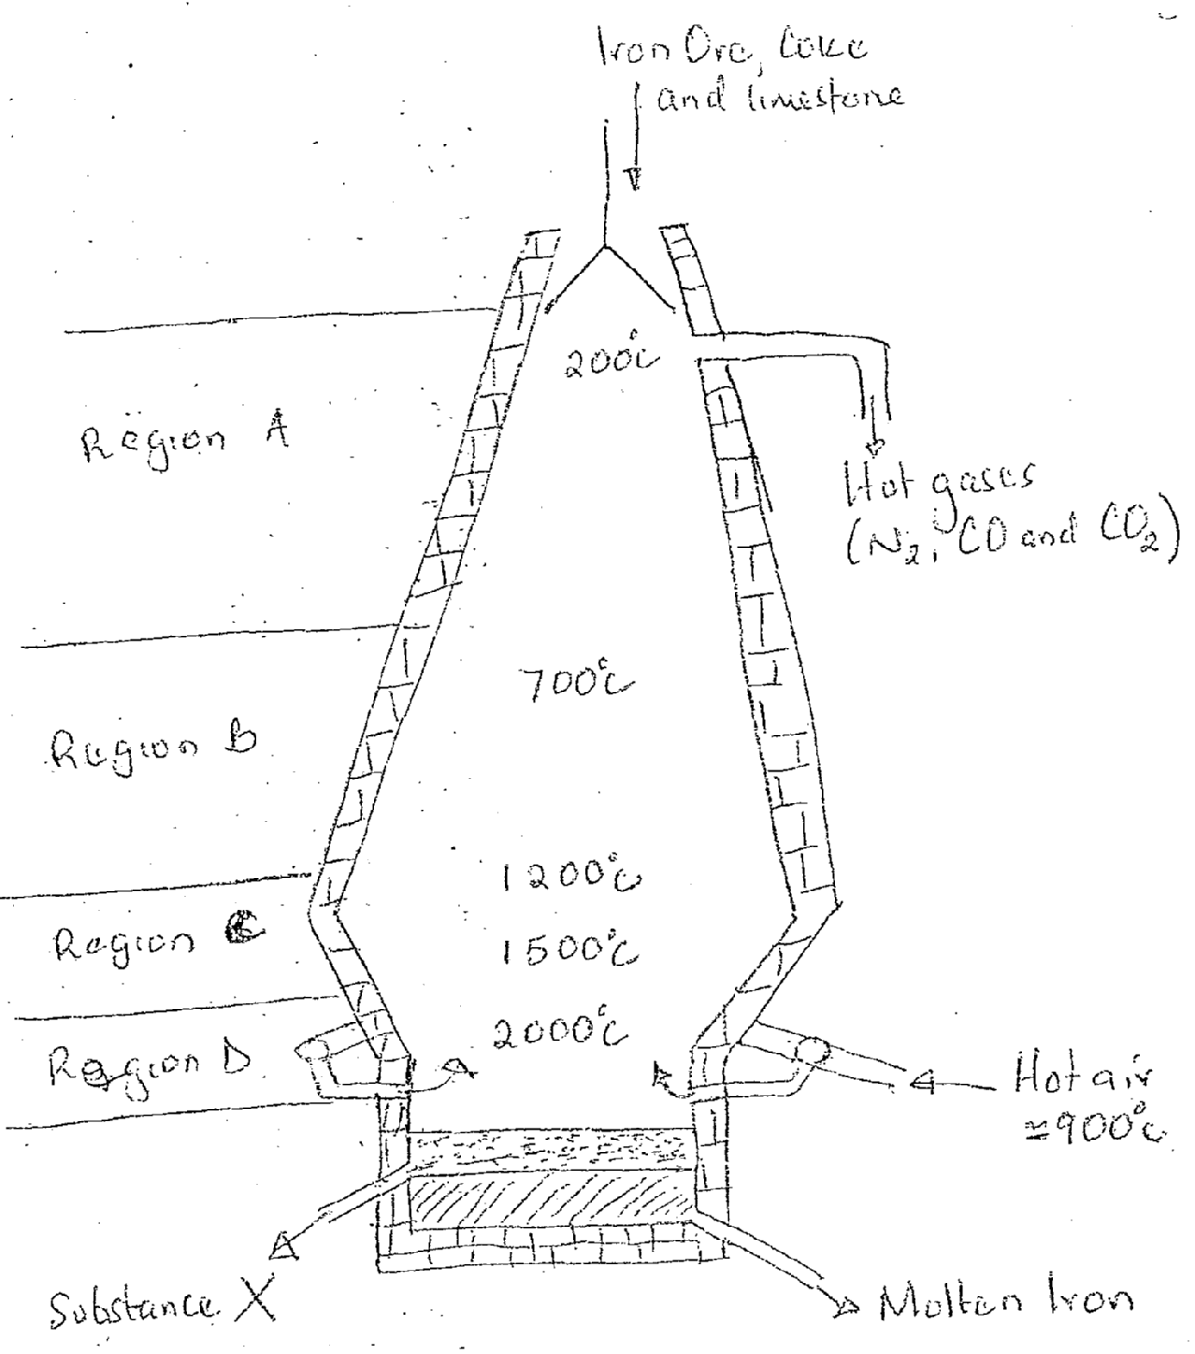

- (i) Name the structure above used in extraction of iron (1mk)
------------------------------------------------------------------------------------------------------------------------------------------------------------------------------------------------------------
(ii) Write the formula of two main ores of iron (1mk)
------------------------------------------------------------------------------------------------------------------------------------------------------------------------------------------------------------
- State two uses of substance X in this process (1mk)
--------------------------------------------------------------------------------------------------------------------------------------------------------------------------------------------------------------------------------------------------------------------------------------------------------

- (i) Name the main reducing agent in the process (1mk)
----------------------------------------------------------------------------------------------------------------------------------------
--------------------------------------------------------------------
(ii) Write the equation for the reaction that occurs in region (1mk)
----------------------------------------------------------------------------------------------------------------------------------------
--------------------------------------------------------------------

- State the difference between cast iron and wrought iron (2mks)
------------------------------------------------------------------------------------------------------------------------------------------------------------------------------------------------------------------------------

- Iron II sulphate solution and conc. sulphuric VI acid can be used
to test for nitrates.
- State the name of the test used (1mk)
-----------------------------------------------------------------------------------------------------------------------------------------------------------------------------------------------------------
- State the use of conc. sulphuric VI acid in the test (1mk)
-----------------------------------------------------------------------------------------------------------------------------------------------------------------------------------------------------------
- Name and write the formula of the compound that shows the present of nitrate ions (2mks)
------------------------------------------------------------------------------------------------------------------------------------------------------------------------------------------------------------

