Name_____________________Adm. No___________ Class___________

Index No.______________ Candidates Signature________ Date_______

233/3
Chemistry
Paper 3
PRACTICAL
2½ Hours

Kenya Certificate of Secondary Education

Instructions to candidates.
- Write your name, index and Adm. number and class in the spaces
provided.
b) Sign and write the date of examination in the space provided.
c) Answer ALL questions in the spaces provided.
d) You are required to spend the first 15 minutes of the 1 ¾ hours allowed for this paper reading the whole paper before commencing your work.
e) This paper consists of 7 printed papers.
f) Candidates should check the question paper to ascertain that ALL the pages are printed as indicated and that no questions are missing.

For Examiners Use Only
Question | Maximum score | Candidates score
1 | 23
2 | 12
3 | 05
Total | 40

1. You are provided with:-

- 5.0 g of Solid T, in a boiling tube
- Solution Q , 0.3 M solution of sodium hydroxide

You are required to determine:
- Solubility of solid T.
- The number of moles of water of crystallization in Solid T

Procedure I

- Fill the burette with distilled water
- Place solid T in the boiling tube
- Transfer 4cm³ of distilled water from the burette into the boiling tube
containing solid T. Heat the mixture while stirring with the thermometer to a temperature of 80⁰
- Allow the solution to cool while stirring with the thermometer. Record
the temperature at which crystals start to form in the table 1 below
- Add a further 2cm³ of distilled water from the burette to the mixture. Repeat the procedure (iii) and (iv) above and record the crystallization temperature. Complete the table I below by adding the volumes of distilled water as indicated
(Preserve the contents of the boiling for procedure II)

Table 1

Volume of distilled water in boiling tube | Crystallization temperature | Stability of solid T in g/100g water
4
6
8
10

- On the grid provided, plot a graph of solubility of solid T (y-axis) against crystallization temperature (3 marks)

From the graph determine
  - Solubility of T at 55⁰C (1 mark)
…………………………………………………………………………………………………………………………………………………………………………………………………………………………………………
  - The temperature at which 80g of T dissolve in 100g of water (2 marks)
……………………………………………………………………………………………….…………………………………………………………………………………………………………………………………………..

Procedure II
- Transfer the contents of the boiling tube in procedure I to a clean 250ml volumetric flask. Add distilled water to the mark. Label the resulting solution T
- Fill the burette with solution T. Pipette 25cm³ of Q into a clean 250ml conical flask. Add 3 drops of phenolphthalein indicator
- Titrate T against Q to an accurate end point. Record your results in the table II below
- Repeat the experiment two more times and complete the table II below

Table II
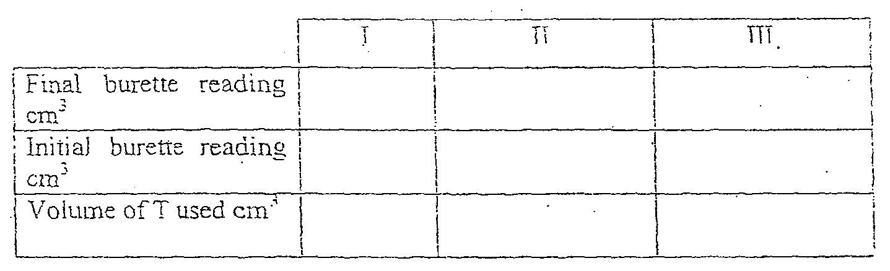

Calculate the:-
- Average volume of solution T (1 mark)
…………………………………………………………………………………………………………………………………………………………………………………………………………………………………………
- Number of moles of sodium hydroxide solution Q used (1mark)
………………………………………………………………………………………………………………………………………………………………………………………………………………………………………….
- Number of moles of solution T in the titre volume given that the formula of solid T is H₂D. xH₂O (1 mark)
…………………………………………………………………………………………………………………………………………………………………………………………………………………………………………

- The relative formula mass (RFM) of solid T (3 marks)
……………………………………………………………………………………………….…………………………………………………………………………………………………………………………………………..
- Determine the value of x in the formula given that the RAM of D is 88. (O = 16, H = 1) (1 mark)
…………………………………………………………………………………………………………………………………………………………………………………………………………………………………………

  - You are provided with solid E. You are required to carry out the tests on the solid and record your observations and inferences in the space provided

- Place a half spatula of solid E in a dry test tube, heat gently then strongly.

Test for any gas produced using a litmus and wooden splint
Observations Inference

(1 mark) (1 mark)

- To the remaining solid add about 10cm³ of distilled water and divide the resulting solution into 2 portion

Observations Inference

(1 mark) (1 mark)

- To the first portion, add 3 drops of potassium iodine solution

Observations Inference

(1 mark) (1 mark)

- To the second portion add 5cm³ of dilute hydrochloric acid and warm. Leave it to cool and filter

Observations Inference

(1 mark) (1 mark)

- To one portion, add sodium hydroxide drop-wise until in excess
Observations Inference

(1 mark) (1 mark)

- To 2nd portion, add aqueous ammonia drop-wise till in excess
Observations Inference

(1 mark) (1 mark)

  - You are provided with solid W. Carry out the following tests

- Place all of solid W in a boiling tube. Add about 20cm³ of distilled water and shake well. Divide the solution into five separate test tubes
Observations Inference

(½ mark) (½ mark)

- To the first portion of solution W, add a spatula full of sodium carbonate solid
Observations Inference

(½ mark) (½ mark)

- To the second portion o solution W, add a few drops of universal indicator and test the pH
Observations Inference

(½ mark) (½ mark)
- To the third portion of solution W, add 2cm³ of ethanol followed by 2 drops of concentrated Sulphuric (VI) acid

Observations Inference

(1 mark) (1 mark)

