NAME………………………………………………………. INDEX NO.…………………/…….
SCHOOL…………………………………………………… DATE ………………………….…..
CANDIDATE’S SIGNATURE……………………………

233/1
CHEMISTRY
PAPER 1
THEORY
TIME: 2 HRS

Kenya Certificate of Secondary Education

for examiner’s use only
QUESTIONS | MAXIMUM SCORE | CANDIDATE’S SCORE
1 - 30 | 80

This paper consists of 12 printed pages.
Candidates should check the question paper to ensure that all
pages are printed as indicated and no questions are missing

1. (a) What is the role of the following parts during fractional distillation of a mixture of water and ethanol.
(i) Fractionating column (1 mark)
…………………………………………………………………………………………………………………………………………………………………………………….
(ii) Class beads in the fractionating column (1 mark)
…………………………………………………………………………………………………………………………………………………………………………………….
(b) State any one application of fractional distillation process (1 mark)
……………………………………………………………………………………………………………………………………………………………………………………………………
2. Below is a set up used to prepare oxygen in a laboratory?
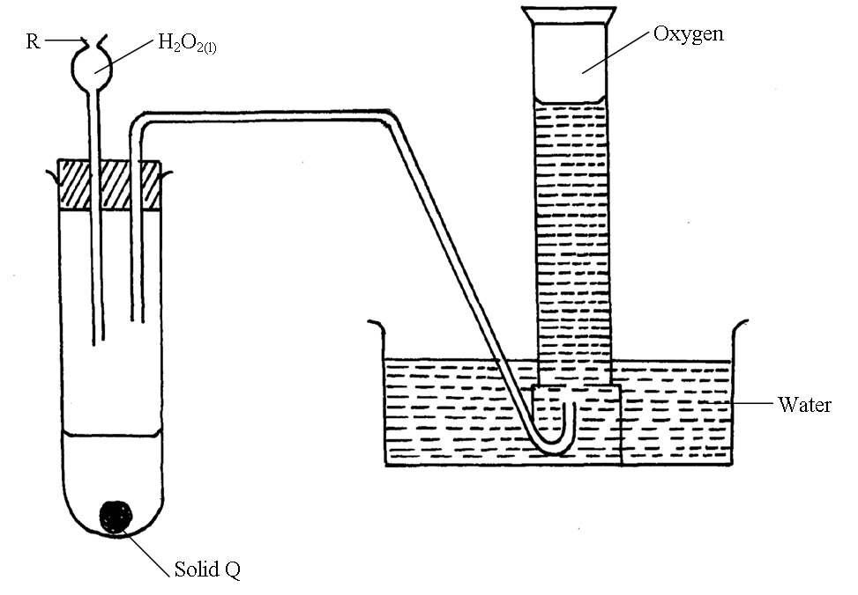

(a) Identify
(i) Solid Q (½ mark)
…………………………………………………………………………………………
(ii) Apparatus R (½ mark)
…………………………………………………………………………………………
(b) Write a balanced equation for reaction in which oxygen is produced in the above set up.
……………………………………………………………………………………………………………………………………………………………………………………………………
(1 mark)
(c) State and explain observation which is made when white phosphorus is introduced into a gas
jar full of oxygen. (1mark)
……………………………………………………………………………………………………………………………………………………………………………………………………
3. (a) State one way in which the strength of an acid or a base can be determined in the laboratory
………………………………………………………………………………………………………………………………………………………………………………………………… (1mark)
(b) Give the basicity of the following acids.
(i) Sulphuric acid (½ mark)
…………………………………………………………………………………………………………………………………………………………………………………….

(ii) Phosphoric acid (½ mark)
…………………………………………………………………………………………………………………………………………………………………………………….
4. Name the process which takes place when:
(i) Iodine changes directly from solid to gas (1 mark)
…………………………………………………………………………………………………………………………………………………………………………………….
(ii) Fe ²⁺ _{(aq)} changes to form Fe ³⁺ _{(aq)} (1 mark)
…………………………………………………………………………………………………………………………………………………………………………………….
(iii) White sugar changes to black solid when mixed with excess concentrated Sulphuric (vi) acid (1 mark)
…………………………………………………………………………………………………………………………………………………………………………………….
5. The grid below represents part of the periodic table. Study it and answer questions that follow. The letters do not represent the actual symbols of the elements.
P |  |  | Q | R |  |  | N
 |  |  |  |  |  |  |  | V
S | X |  |  |  |  | M
 |  |  |  |  |  |  | T

(a) Identify the most reactive non-metal (1 mark)
……………………………………………………………………………………………………………………………………………………………………………………………………
(b) Give a reason why the ionic radii of S are smaller than that of M. (1mark)
……………………………………………………………………………………………………………………………………………………………………………………………………
(c) Give the formulae of the compound formed between X and N (1mark)
……………………………………………………………………………………………………………………………………………………………………………………………………
6. State two properties of carbon (iv) oxide that makes it suitable for extinguishing fire. (2 marks)
……………………………………………………………………………………………………………………………………………………………………………………………………………………
7. Use the information in the table below to answer the questions that follow
Element | Sodium | Magnesium | Phosphorus | Chlorine
Electric conductivity | Good | Good | Poor | Poor
M.P (ºC) | 98 | 660 | 44/115 | -173
(a) Explain why both Sodium and Magnesium conducts electricity while phosphorus and chlorine
do not. (1mark)
……………………………………………………………………………………………………………………………………………………………………………………………………
(b) Suggest a reason why phosphorus has been assigned two melting point values. (1mark)
…………………………………………………………………………………………………………………………………………………………………………………………………………
(c) Explain why atomic radii of elements in period 3 decreases generally from left to right in the periodic table (1mark)
…………………………………………………………………………………………………………………………………………………………………………………………………………
8. (a) Define half-life of radioisotopes (1mark)
…………………………………………………………………………………………………………………………………………………………………………………………………………
(b) X grams of a radioactive isotope takes 100 days to decay to 20gms. If half-life of the element is 25 days. Calculate the initial mass of X of the radio-isotope. (2marks)
……………………………………………………………………………………………………………………………………………………………………………………………………………………………………………………………………………………………………………………………………………………………………………………………………………………
9. When a hydrocarbon was completely burnt in Oxygen 4.2g of CO₂ gas and 1.71g H₂O of water were formed. (Determine the empirical formulae of the hydrocarbon) (2 marks)
(C=120, H=1.0, O=16.0)
…………………………………………………………………………………………………………………………………………………………………………………………………………………………………………………………………………………………………………………………………………………………………………………………………………………………………………
10. Use the information in the scheme diagram below to answer the questions that follow.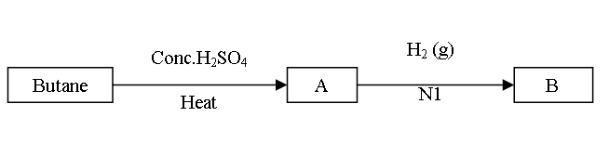

(a) Draw two structures of isomers of compound A. Name each isomer. (2marks)
……………………………………………………………………………………………………………………………………………………………………………………………………………………………………………………………………………………………………………………………………………………………………………………………………………………
(b) Name two products produced when B is burnt in excess oxygen. (1 mark)
…………………………………………………………………………………………………………………………………………………………………………………………………………
11. (a) State Charles’s law (1mark)
………………………………………………………………………………………………………………………………………………………………………………………………………
(b) The volume of a sample of nitrogen gas at a temperature of 298k and 600minHg pressure was 4.8 x 10⁻² m³. Calculate the temperature at which the volume of the gas would be 3.2 x 10⁻² m³ if pressure is constant. (2 marks) ……………………………………………………………………………………………………………………………………………………………………………………………………………………………………………………………………………………………………………………………………………………………………………………………………………………
12. Aluminium is extracted from its ore by the process of electrolysis
(a) Name the ore from which aluminium is normally extracted. (1mark)
…………………………………………………………………………………………………………………………………………………………………………………………………………
(b) Aluminium Ore in (a) above has a very high melting point (2015⁰C) through it is electrolyzed at a lower temperature of about 900⁰C. Explain how the low temperature is achieved. (1mark)
……………………………………………………………………………………………………………………………………………………………………………………………………
(c) Graphite electrodes are used in the above process. Give the advantage of using graphite electrodes in the above process (1mark)
……………………………………………………………………………………………………………………………………………………………………………………………………
13. (a) Name a suitable drying agent to be used to dry chlorine gas. (1mark)
……………………………………………………………………………………………………………………………………………………………………………………………………
(b) Chlorine reacts with red hot Iron powder to give iron (iii) chloride but not Iron (ii) chloride. Explain (1mark)
……………………………………………………………………………………………………………………………………………………………………………………………………
(c) Sodium hydroxide reacts with chlorine to form bleaching powder. Write a balanced equation for the reaction. (1mark)
……………………………………………………………………………………………………………………………………………………………………………………………………
14. The table below gives some bond energies of some bonds.
Bond | Bond energy (lgmol-¹)
H-H | 435
Cl-Cl | 243
H-Cl | 431
Calculate the enthalpy change of the reaction below.
H_{2 (g)} +Cl_{2 (g)} 2HCl _{(g)} (2 marks)

15. When a mixture of iron filings and Sulphur was heated, a red glow spreads through the mixture and a dark grey solid was formed.
(a) Identify the dark grey solid formed. (1mark)
……………………………………………………………………………………………………………………………………………………………………………………………………

(b) Write a chemical equation in which the dark grey solid is formed during healing. (1mark)
……………………………………………………………………………………………………………………………………………………………………………………………………
(c) What observations can be made when the dark grey solid reacts with dilute Hydrochloric acid. (1mark)
……………………………………………………………………………………………………………………………………………………………………………………………………
16. Study the reversible reaction below
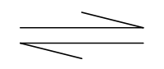
2CrO₄⁻ _{(aq)} + 2H⁺ _{(aq)} Cr₂O₇²_{(aq)} + H₂O _{(l)}
(Yellow) (Orange)
(a) State the colour change if few drops of sodium hydroxide was added to the mixture. (1mark)
……………………………………………………………………………………………………………………………………………………………………………………………………
(b) Explain the observation in (a) above (1mark)
……………………………………………………………………………………………………………………………………………………………………………………………………

17. Nitric (V) acid rarely give hydrogen with metals e.g. Zn.
(a) Give reasons for this. (1mark)
……………………………………………………………………………………………………………………………………………………………………………………………………
(b) Give a condition under which nitric (v) avid can produce hydrogen with the metal (1mark)
……………………………………………………………………………………………………………………………………………………………………………………………………
(c) State one use of hydrogen gas. (1mark)
……………………………………………………………………………………………………………………………………………………………………………………………………
18. The structure shown below represents two cleansing agents, A and B
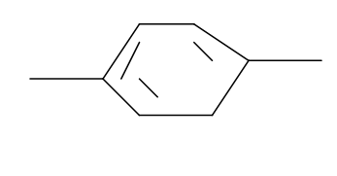
R COO ⁽⁻⁾ Na ⁽⁺⁾ R OSO₃ ⁽⁻⁾ Na⁺
(A)
(B)
(a) Which cleansing agent would be more suitable for the washing in water containing calcium sulphate? (1mark)
……………………………………………………………………………………………………………………………………………………………………………………………………
(b) Give one advantage of B over A (1mark)
……………………………………………………………………………………………………………………………………………………………………………………………………

19. Study the flow chart below and answer the following questions.
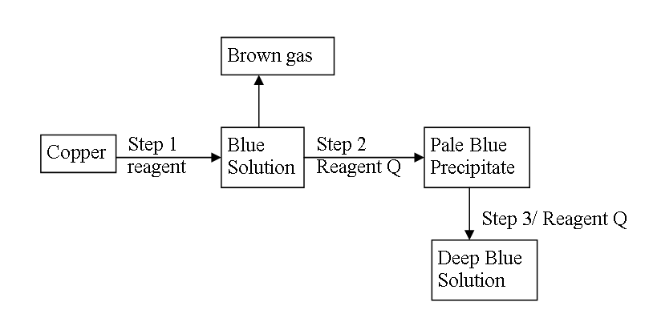
P
(a) Name reagents P and Q (2marks)
…………………………………………………………………………………………………………………………………………………………………………………………………………………………………………………………………………………………………………………………………………………………………………………………………………
(b) Write the formulae of the complex ions present in the deep blue solution (1mark)
……………………………………………………………………………………………………………………………………………………………………………………………………
20. In an experiment to determine the solubility of potassium nitrate at 30⁰c, a saturated solution was heated in an evaporation dish until there was no further change in mass. The following date was obtained.
Mass of dish + Solution = 128.9g
Mass of dish + Dry salt = 103.9g
Mass of empty dish = 94.3g

Determine the solubility of Potassium nitrate at 30⁰c (2marks) …………………………………………………………………………………………………………………………………………………………………………………………………………………………………………………………………………………………………………………………………………………………………………………………………………………………………………
21. You are given the following half equations
I₂(s) +2e⁻2I⁻_{(aq)} $E^{θ}$= +0.54V
Br₂ (I) +2e⁻2Br_{-(aq)} $E^{θ}$= + 1.09V
(a) Write an overall equation of the cell reaction (1mark)
……………………………………………………………………………………………………………………………………………………………………………………………………
(b) Calculate the $E^{θ}$value of the cell (1mark)

(c) Name the Oxidizing agent (1mark)
……………………………………………………………………………………………………………………………………………………………………………………………………
22. Describe how a solid sample of calcium sulphate can be prepared using the following reagents, dilute nitric acid, dilute sulphuric acid and calcium carbonate. (1mark)
……………………………………………………………………………………………………………………………………………………………………………………………………………………

23. Study the table below and answer the questions that follow.
The letters do not represent the actual symbols of elements.
Formulae of Ion Electronic configuration of Ion
U²⁺ 2
V⁻ 2.8
W²⁻ 2.8.8
X³⁺ 2.8
Y²⁺ 2.8
(a) Select the elements in
(i) Same group (½ mark)
……………………………………………………………………………………………………………………………………………………………………………………
(ii) Period II (½ mark)
…………………………………………………………………………………………………………………………………………………………………………………...
(b) Write the electronic configuration of elements
(i) W (½ mark)
……………………………………………………………………………………………………………………………………………………………………………………
(ii) X (½ mark)
……………………………………………………………………………………………………………………………………………………………………………………

24. The formula given below represents a potion of polymer
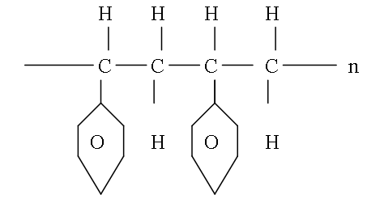
a) Give the name of the polymer. (1mark) ……………………………………………………………………………………………………………………………………………………………………………………………………
(b) Draw the structure of the monomer used to manufacture the polymer (1mark)
……………………………………………………………………………………………………………………………………………………………………………………………………
25. In an experiment 3.36g of iron fillings were added to excess of copper (ii) Sulphate. Calculate the mass of copper that was deposited. (Cu=63.5, Fe=56.0) (3marks)
……………………………………………………………………………………………………………………………………………………………………………………………………………………………………………………………………………………………………………………………………………………………………………………………………………………………………………………………………………………………………………………………………………………………………………………………………………………………………………………………….

26. Below is a set up of apparatus used to react ammonia gas with Iron (ii) Chloride.
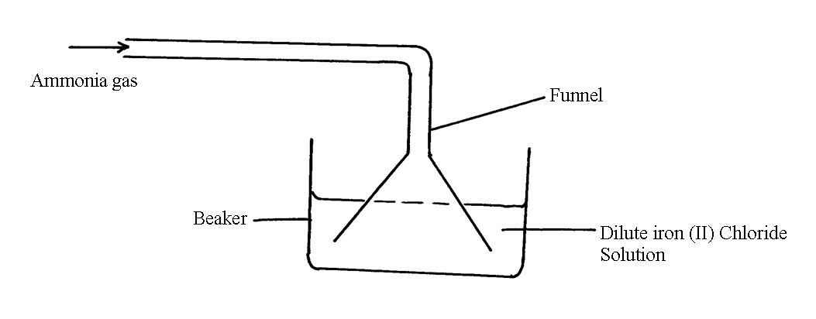
- State observation made in the beaker (1mark)
……………………………………………………………………………………………………………………………………………………………………………………………………
(b) Give reason of using a funnel to deliver the ammonia to the beaker. (1mark)
……………………………………………………………………………………………………………………………………………………………………………………………………
27. Using dots (.) and crosses(x) to represent -electrons show the bonding between oxygen and carbon to form carbon (ii) oxide. (2marks) …………………………………………………………………………………………………………………………………………………………………………………………………………………………………………………………………………………………………………………………………………………………………………………………………………………………………………
28. An atom of hydrogen can form two ions. Write two equations to show how a neutral atom of hydrogen can form the two ions. In each case show the sign of the energy change involved. (2marks)
…………………………………………………………………………………………………………………………………………………………………………………………………………………………………………………………………………………………………………………………………………………………………………………………………………………………………………

29. Elements X and Y reacted forming a compound Z. The compound has the following properties.
(i) It does not conduct electricity in solid.
(ii) It has low melting and boiling points.
(a) What type of elements are X and Y? (1mark)
……………………………………………………………………………………………………………………………………………………………………………………………………
(b) What type of structure is compound Z has (1mark)
……………………………………………………………………………………………………………………………………………………………………………………………………

END

