Name. | Class. | Index No. /
 |  | Date.
 |  | Signature

451/2
COMPUTER STUDIES
Paper 2
(Practical)
2½ hours.

SET 3

INSTRUCTIONS TO CANDIDATES
- If not instructed in the question on where to Type your name and index number , you must then type them at the top right hand corner of each printout
- Write your name and index number on the CD
- Write the name and version of the software used for each question attempted in the answer sheet.
- Answer all the questions.
- All questions carry equal marks
- Passwords Should not be used while saving in the CD
- All answers must be saved on your CD
- Make a print out of the answers on the answer sheets provided
- Arrange your printouts and tie/staple them together
- Hand in all Printouts and the CD.

This paper consists of 4 printed pages
Candidates should check the question paper to ensure that all the
printed pages are printed as indicated and no questions are missing.

Question 1
- MOKASA joint exam organizers have contacted you to help them analyze their results during April holidays. Create a new workbook and name it as MO_KA_SA EXAM

 | A | B | C | D | E | F | D | H
1 | NAME | CLASS | REG NO | RAT1 | RAT2 | RAT1 | TOTAL | MEAN
2 | Kerubo Michelle | RED | 7984 | 80 | 70 | 59
3 | Ann Kosgei | BLUE | 7896 | 75 | 55 | 72
4 | Baraka Odhiambo | RED | 8092 | 86 | 59 | 75
5 | Catherine Naserian | RED | 7460 | 80 | 79 | 70
6 | Carren Kwamboka | BLUE | 7892 | 76 | 75 | 80
7 | Hassan Maasai | RED | 7800 | 38 | 48 | 25
8 | Naomi Otieno | BLUE | 8490 | 37 | 51 | 29
9 | Wafula Paul | BLUE | 8184 | 30 | 86 | 75
10 | Gentrix Ogiek | RED | 8082 | 25 | 27 | 20
11 | Waithera Njeri | RED | 8033 | 30 | 25 | 25
12 | Sarah Njoroge | BLUE | 8047 | 39 | 24 | 25

- Enter the following data in sheet 1 (10 Marks)
- Rename the sheet 1 as SA_CHO (1 Mark)
- Copy the contents of sheet 1 to sheet 2 and rename it as KA_BA_RA_K (1 Mark)

- Use formulars that references the cells to calculate
- Totals (2 Marks)
- Average (3d.p) (3 Marks)

- Insert a title JOINT EXAM and format it as indicated below:
- Font type viner hand ict
- Font size 16.
- Left align the title.
- The other subtitles should be rotated 66⁰, bolded and italised. (5 Marks)

- Use the IF function to award remarks to the students as follows: (3 Marks)
MEAN REMARKS
>65 Gold
55 – 64 Silver
<54 Bronze

- Insert a column showing positions and award positions to students basing the scores on means (3 Marks)
- On the last rows enter formulas to count the total number of students from each class (2 Marks)
- Sort the students list by class position in descending order. (2 Marks)
- Copy the entire worksheet onto worksheet 2 and rename it ‘MOI_GIRLS’.(2 Marks)
- Filter MOI_GIRLS worksheet to show student (s) from ‘RED’ class and whose mean score is less than 50 (4 Marks)
- Insert a bar graph to display the three RATS and Names (1 Mark)
- Title as JOINT EXAM and label the X-axis as marks and Y-axis as Names (3 Marks)
- Place the legend at the bottom of the graph. (1 Mark)
- Save the chart on a new sheet and name it GRAPHICAL ANALYSIS. (1 Mark)
- Re-arrange your worksheets tabs so that GRAPHICAL_ ANALYSIS comes first then SA_CHO, MOI_GIRLS and finally KA_BA_RA_K. (2 Marks)
- Create a worksheet based on MOI_GIRLS and use show all the formulas used in your calculations and name it FORMULARS (2 Marks)
- Print: GRAPHICAL_ ANALYSIS, SA_CHO, MOI_GIRLS and KA_BA_RA_K. (4 Marks)
Question 2
The figure below is a sample design of an advertisement for Maisha Bora Company. Use a desktop publishing package to design the advertisement as follows. (50 Marks)

- Create a new publication named advert with the following page layout
- Paper size: A4,
- Orientation: landscape
- Margins: 5 cm all round
- Set the footer of your publication to display your name on the left edge of the page and index number on the right edge of the page

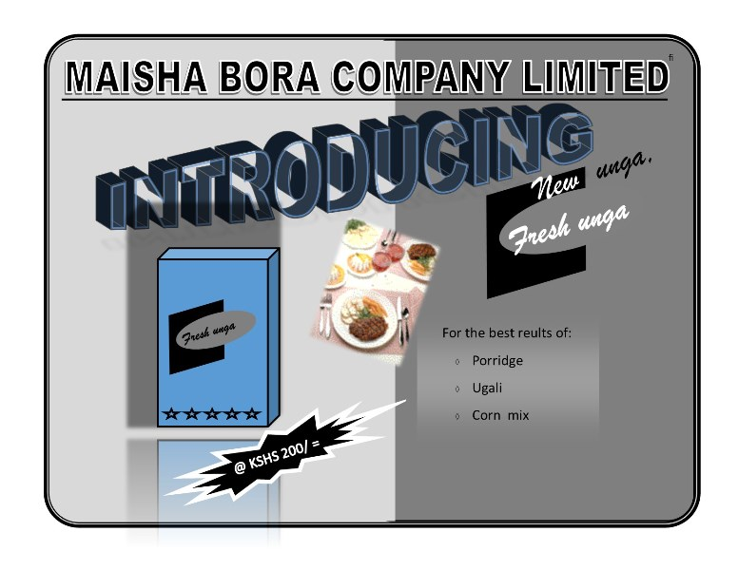
- Enter text and images as they appear in the sample design.

- Save your publication as Maisha Bora
- print your publication

