451/1
COMPUTER STUDIES
PAPER 1
(THEORY)
TIME: 2¹/₂HOURS

FORM 4
Kenya Certificate of Secondary Education (K.C.S.E)

INSTRUCTIONS TO STUDENTS

- This paper consists of TWO sections; A and B.
- Answer all the questions in section A and B.
- ALL answers should be written in the spaces provided on the question paper.

For official use only
Section | Question | Score
A | 1-15
B | 16
B | 17
B | 18
B | 19
TOTAL MARKS

This paper consists of 8 printed pages. Candidates should check the question paper to ensure that all pages are printed as indicated and no questions are missing
ANSWER ALL QUESTIONS IN THIS SECTION.
1. a) Define the term distributed processing (2 marks)
………………………………………………………………………………………………………………………………………………………………………………………………………………………………………………………………………………………………………………………………………
b) Differentiate the term in 1(a) above from centralized processing (2 marks)
………………………………………………………………………………………………………………………………………………………………………………………………………………………………………………………………………………………………………………………………………
2. Outline two disadvantages of serial file organization (2 marks)
………………………………………………………………………………………………………………………………………………………………………………………………………………………………………………………………………………………………………………………………………
3. State any four criteria for choosing an operating system (4 marks)
………………………………………………………………………………………………………………………………………………………………………………………………………………………………………………………………………………………………………………………………………
………………………………………………………………………………………………………………………………………………………………………………………………………………………………………………………………………………………………………………………………………
4. Give the acronym of the following and explain briefly
i) BIOS (2 marks)
………………………………………………………………………………………………………………………………………………………………………………………………………………………………………………………………………………………………………………………………………
ii) HTML (2 marks)
………………………………………………………………………………………………………………………………………………………………………………………………………………………………………………………………………………………………………………………………………
5. Differentiate between the following terms (3 marks)
Interpreters | Compilers
i)  ii) | i)  ii)
6. A student in form three came across the mnemonics below when he was learning about the
assembly programming language. Describe what they mean. (2 marks)
i) MOV AX, 15
………………………………………………………………………………………………………………………………………………………………………………………………………………………………………………………………………………………………………………………………………
ii) SUB AX, 10
………………………………………………………………………………………………………………………………………………………………………………………………………………………………………………………………………………………………………………………………………
7. Explain why a computer room must (3 marks)
a) have good ergonomics
………………………………………………………………………………………………………………………………………………………………………………………………………………………………………………………………………………………………………………………………………
b) be well ventilated
………………………………………………………………………………………………………………………………………………………………………………………………………………………………………………………………………………………………………………………………………
c) have a non-water based fire extinguishers
………………………………………………………………………………………………………………………………………………………………………………………………………………………………………………………………………………………………………………………………………
8. Explain the term hot-swapping as used in drives (1 mark)
………………………………………………………………………………………………………………………………………………………………………………………………………………………………………………………………………………………………………………………………………
9. a) What is a warranty? (1 mark)
………………………………………………………………………………………………………………………………………………………………………………………………………………………………………………………………………………………………………………………………………
b) State three qualities of a good warranty (3 marks)
………………………………………………………………………………………………………………………………………………………………………………………………………………………………………………………………………………………………………………………………………
……………………………………………………………………………………………………………

10. State two advantages of NTFS over FAT (2 marks)
………………………………………………………………………………………………………………………………………………………………………………………………………………………………………………………………………………………………………………………………………
11. What is a relationship database? (2 marks)
………………………………………………………………………………………………………………………………………………………………………………………………………………………………………………………………………………………………………………………………………
12. As regards to communication within a computer network, what do you understand by the following terms: (2 marks)
i) Point –to-point
………………………………………………………………………………………………………………………………………………………………………………………………………………………………………………………………………………………………………………………………………
ii) Broadcast
………………………………………………………………………………………………………………………………………………………………………………………………………………………………………………………………………………………………………………………………………
13. Give any two types of data entries that may be input into a worksheet cell (2 marks)
………………………………………………………………………………………………………………………………………………………………………………………………………………………………………………………………………………………………………………………………………
……………………………………………………………………………………………………………
14. Give any two function of a system analyst. (2 marks) ………………………………………………………………………………………………………………………………………………………………………………………………………………………………………………………………………………………………………………………………………
……………………………………………………………………………………………………………
15. List any three program control structures used in programming (3 marks)
………………………………………………………………………………………………………………………………………………………………………………………………………………………………………………………………………………………………………………………………………
…………………………………………………………………………………………………………………………………………………………………………………………………………………………

SECTION B (60MKS)

16. (a) What is meant by each of the following terms:

(i) Pseudo code (1½ marks)
………………………………………………………………………………………………………………………………………………………………………………………………………………………………………………………………………………………………………………………………………

(ii) Flowchart (1½ marks)
………………………………………………………………………………………………………………………………………………………………………………………………………………………………………………………………………………………………………………………………………

b) A program is required to list the first 1000 numbers in the series 2, 4, 6, 8, 10 ……. Draw a flowchart and write a program that can be carry out this task (12 marks)

17. a) What is meant by data communication in a computer network? (2 marks)
………………………………………………………………………………………………………………………………………………………………………………………………………………………………………………………………………………………………………………………………………
b) State what is meant by each of the following transmission media and give one advantage and one disadvantage for each .
i) Twisted pair cables (3 marks)
………………………………………………………………………………………………………………………………………………………………………………………………………………………………………………………………………………………………………………………………………
ii) Coaxial cables (3 marks)
………………………………………………………………………………………………………………………………………………………………………………………………………………………………………………………………………………………………………………………………………
iii) Optic fibre cables (3 marks)
………………………………………………………………………………………………………………………………………………………………………………………………………………………………………………………………………………………………………………………………………
c) List four network elements in a location area network. (4 marks)
………………………………………………………………………………………………………………………………………………………………………………………………………………………………………………………………………………………………………………………………………
18. a) One of the functions of an operating system is job scheduling. Explain what is mean by
job scheduling. (1 mark)
………………………………………………………………………………………………………………………………………………………………………………………………………………………………………………………………………………………………………………………………………
b) List and explain three types of user interfaces. (6 marks)
………………………………………………………………………………………………………………………………………………………………………………………………………………………………………………………………………………………………………………………………………
………………………………………………………………………………………………………………………………………………………………………………………………………………………………………………………………………………………………………………………………………
…………………………………………………………………………………………………………………………………………………………………………………………………………………………
c) Describe the following categories of software:
i) Firmware (1 mark)
………………………………………………………………………………………………………………………………………………………………………………………………………………………………………………………………………………………………………………………………………
ii) Proprietary software (1 mark)
………………………………………………………………………………………………………………………………………………………………………………………………………………………………………………………………………………………………………………………………………
d) A new company XYZ intends to go into the business of desktop publishing. Advise the company on three computer hardware system specification features to consider as a measure of enhancing performance. (6 marks)
………………………………………………………………………………………………………………………………………………………………………………………………………………………………………………………………………………………………………………………………………
………………………………………………………………………………………………………………………………………………………………………………………………………………………………………………………………………………………………………………………………………
………………………………………………………………………………………………………………………………………………………………………………………………………………………………………………………………………………………………………………………………………
………………………………………………………………………………………………………………………………………………………………………………………………………………………………………………………………………………………………………………………………………
19. a) The diagram below shows four common network topologies A, B, C and D
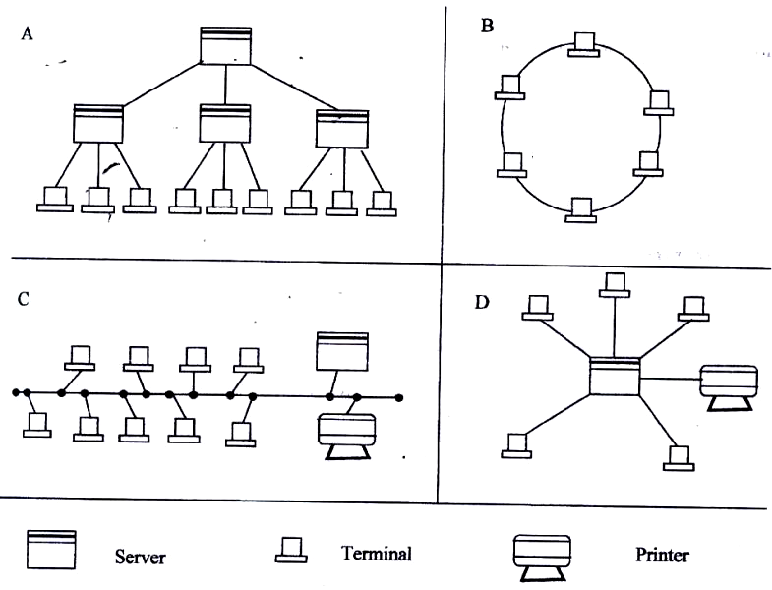
X

i) Name the network topologies labeled A, B, C and D (4 marks)
………………………………………………………………………………………………………………………………………………………………………………………………………………………………………………………………………………………………………………………………………
ii) Explain what happens if server X in topology A fails. (1 Mark)
………………………………………………………………………………………………………………………………………………………………………………………………………………………………………………………………………………………………………………………………………
iii) List two problems associated with network topology B. (2 Marks)
………………………………………………………………………………………………………………………………………………………………………………………………………………………………………………………………………………………………………………………………………
iv) List two disadvantages associated with network topology D. (2 Marks)
………………………………………………………………………………………………………………………………………………………………………………………………………………………………………………………………………………………………………………………………………
b) Differentiate between Internet and World Wide Web. (2 Marks)
………………………………………………………………………………………………………………………………………………………………………………………………………………………………………………………………………………………………………………………………………
c) Describe the following network services and identify their applications. (2 Marks)
i) Voice mail ……………………………………………………………………………………………………………………………………………………………………………………………………………………………………………………………………………………………………………………………………
ii) Video conferencing. (2 Marks)
………………………………………………………………………………………………………………………………………………………………………………………………………………………………………………………………………………………………………………………………………

