NAME: ………………………………………………………CLASS:……………………………

INDEX NO:………………………

312/1
GEOGRAPHY
PAPER 1
TIME: 2 ¾ HOURS

FORM 4
Kenya Certificate of Secondary Education (K.C.S.E)

INSTRUCTIONS:

- The paper comprises of 2 sections A and B.
- Attempt all question in section A.
- In section B, answer question 6 and choose any other two questions.
- Use separate answer sheets for section A and each question in section B.

This paper consists of 4 printed pages. Candidates should check the question paper to ensure that all pages are printed as indicated and no questions are missing.
SECTION A
Answer ALL the questions in this section.
- a) Give two forces that are responsible for the shape of the earth. (2 marks)
b) State three evidences that proof the earth is a sphere. (3 marks)
- (a) Give the metamorphic equivalent of the following rocks. (2 marks)
Granite
Limestone
(b) State three ways in which rocks contribute to the economy of Kenya. (3 marks)
- (a) Differentiate between symmetrical and asymmetrical folds. (2 marks)
(b) Apart from Fold Mountains, name three features produced by folding. (3 marks)
- (a) State two reasons that make wind action more effective in deserts. (2 marks)
(b) Give three ways in which wind transports materials in deserts. (3 marks)
- (a) Give two characteristics of desert soils. (2 marks)
(b) State three factors that influence development of soil catena. (3 marks)
SECTION B
Answer question 6 and any other TWO questions from this section.
- Study the map of Migwani 1:50,000 (sheet 151/1) provided and answer the following questions.
a) (i) Give two methods used in the map to represent relief . (2 marks)
(ii) Give the bearing of air photo principal point in grid square 0075 from air photo principal point in
square 9478. (2 marks)
b) (i) Calculate the area of Gwani trading centre enclosed by all weather road loose surface (C 94).
(2 marks)
(ii) Measure the length of dry weather road D 502 found on the north western part of the area covered by the map (give your answers in km and m ) (2 marks)
c) Draw a rectangle measuring 12cm by 10 cm:
On it insert the following. (4 marks)
d) (i) Name three types of natural vegetation found in the area covered by the map . (3 marks)
(ii) Describe the relief of the area covered by the map. (6 marks)
(ii) Explain two physical factors that that lead to establishment of Mutito (Ndooa) trading centre.
(4 marks)
- a) (i) Name two external layers of the earth. (2 marks)
b) Describe the composition of:
(i) The crust. (3 marks)
(ii) The core. (2 marks)
c) (i) Explain the origin of the earth according to the passing star theory. (4 marks)
(ii) State two weakness of passing star theory. (2 marks)
d) (i) State three characteristics of sedimentary rocks. (3 marks)
(ii) State three differences between plutonic and volcanic rocks. (3 marks)
(iii) Explain three processes through which rocks become metamorphic. (6 marks)
- a) (i) What is faulting . (2 marks)
(ii) Give differences between normal and reverse fault. (2 marks)
b) (i) Apart from rift valley name two other features produced by faulting . (2 marks)
(ii) With aid of a well labeled diagram, explain how rift valley is formed through tension forces. (7 marks)
c) Explain three ways in which faulting influences drainage. (6 marks)
d) Your class carried out a field study along the rift valley.
(i) State two objectives of your field study (2 marks)
(ii) Give two sources of information that you would use in preparation for the study. (2 marks)
(iii) State two follow up activities. (2 marks)
- a) (i) What is hydrological cycle . (2 marks)
(ii) Differentiate between infiltration and percolation. (2 marks)
(iii) State three significance of the hydrological cycle. (3 marks))
b) (i) Explain how rivers erode through the following processes
Abrasion process (2 marks)
Hydraulic action (2 marks)
(ii) State three factors that influence river transportation. (3 marks)
c) With aid of well labeled diagrams describe how meanders are formed. (6 marks)
d) You intend to carry out a field study along lower course of a river.
(i) Give three reasons why you would conduct reconnaissance. (3 marks))
(ii) State two problems you are likely to encounter during the study. (2 marks)
- a) (i) Give three sources of underground water . (3 marks)
(ii) State three factors that influence the existence of underground water. (3 marks)
b) i) Define the term spring. (2 marks)
(ii) State three ways through which spring form. (3 marks)
c) (i) State four factors that influence the development of karst scenery. (4 marks)
(ii) Describe the formation of a stalagmite. (4 marks)
(d) Explain three ways through which limestone landscapes influence human activities. (6 marks)

312/1 GEOGRAPHY PAPER 1 MARKING SCHEME
SECTION A
Answer ALL the questions in this section.
- a) Give two forces that are responsible for the shape of the earth.
- Centripetal force.
- Centrifugal force.
- Force of gravity.
2x1=2mks
b) State three evidences that proof the earth is a sphere.
- Satellite photos show that the earth is a sphere.
- During lunar eclipse the earth’s shadow casted on the moon is a sphere.
- The sun rises and set at different times in different places. If the earth was flat all the parts of the earth would have sun rise at the same time.
- If all the planets are spheroid, earth cannot be exception.
- When three survey poles of equal length are driven into the ground at the holes of same depth the middle pole appears longer than others.
3x1=3mks
- (a) Give the metamorphic equivalent of the following rocks.
- Granite – gneiss.
- Limestone – marble.
2x1=2mks
(b) State three ways in which rocks contribute to the economy of Kenya.
- Some rock formations are tourist attraction. This brings foreign exchange.
- Some rocks are exploited for building and construction.
- Some rocks have weathered into soil which support agriculture
- Some rocks are sources of food e.g. rock salt.
- Some rocks act as raw materials to industries e.g. limestone.
3x1=3mks
- (a) Differentiate between symmetrical and asymmetrical folds.
- Symmetrical folds are formed when compressional forces of equal magnitude are subjected to a layer of rocks causes the rocks to bend evenly while asymmetrical folds are formed when one of the compressional forces is stronger than the other resulting in a fold that has one limb steeper than the other.
2x1=2mks
(b) Apart from Fold Mountains, name three features produced by folding.
    - Rolling plains.
    - Ridge and
    - Valley land space.
3x1=3mks
- (a) State two reasons that make wind action more effective in deserts.
- The presence of loose unconsolidated dry masses of mud, sand and gravel.
- The absence of vegetation cover.
- The occurrence of strong storms within the desert.
2x1=2mks
(b) Give three ways in which wind transports materials in deserts.
  - Suspension – The very fine and light particles are held by wind turbulence and transport over long distances.
  - Saltation – The medium size particles are transported through short jumps and hops.
  - Surface creep – The heavy load is rolled or dragged along the surface.
3x1=3mks
- (a) Give two characteristics of desert soils.
- The soils are saline.
- The soils are reddish-brown in colour.
- The soils are thin.
- The soils have no organic matter.
2x1=2mks
(b) State three factors that influence development of soil catena.
- Relief. On very steep slopes soils are thin due to high rate of erosion while in gentle slopes the soils are thick.
- Drainage. One steep slopes the soils are thin whiles at hill tops the soils are mature
- Transport of soil debris.
- Leaching.
3x1=3mks
Section B: Answer question 6 and any other two
- a) (i) Give two methods used in the map to represent relief .
  - Contour lines
  - Trigonometrical station. 2x1=2mks
(ii) Give the bearing of air photo principal point in grid square 0075 from air photo principal point in square 9478.
b) (i) calculate the area of Gwani trading centre enclosed by all weather road loose surface (C 94).
Full square = 4
Others =13/2 = 6.5 + 4
= 10.5 full squares
1 sq=1km
10 sq=? 10.5 sq x 1km
1sq
=10.5 km 2x1=2mks

(ii) Measure the length of dry weather road D 502 found on the north western part of the area covered by the map (give your answers in km and m)
14 km 800 m
c) Draw a rectangle measuring 12cm by 10 cm:
On it insert the following. (4 marks)
    - All weather road.
    - Kyome hill.
    - Mui dam.
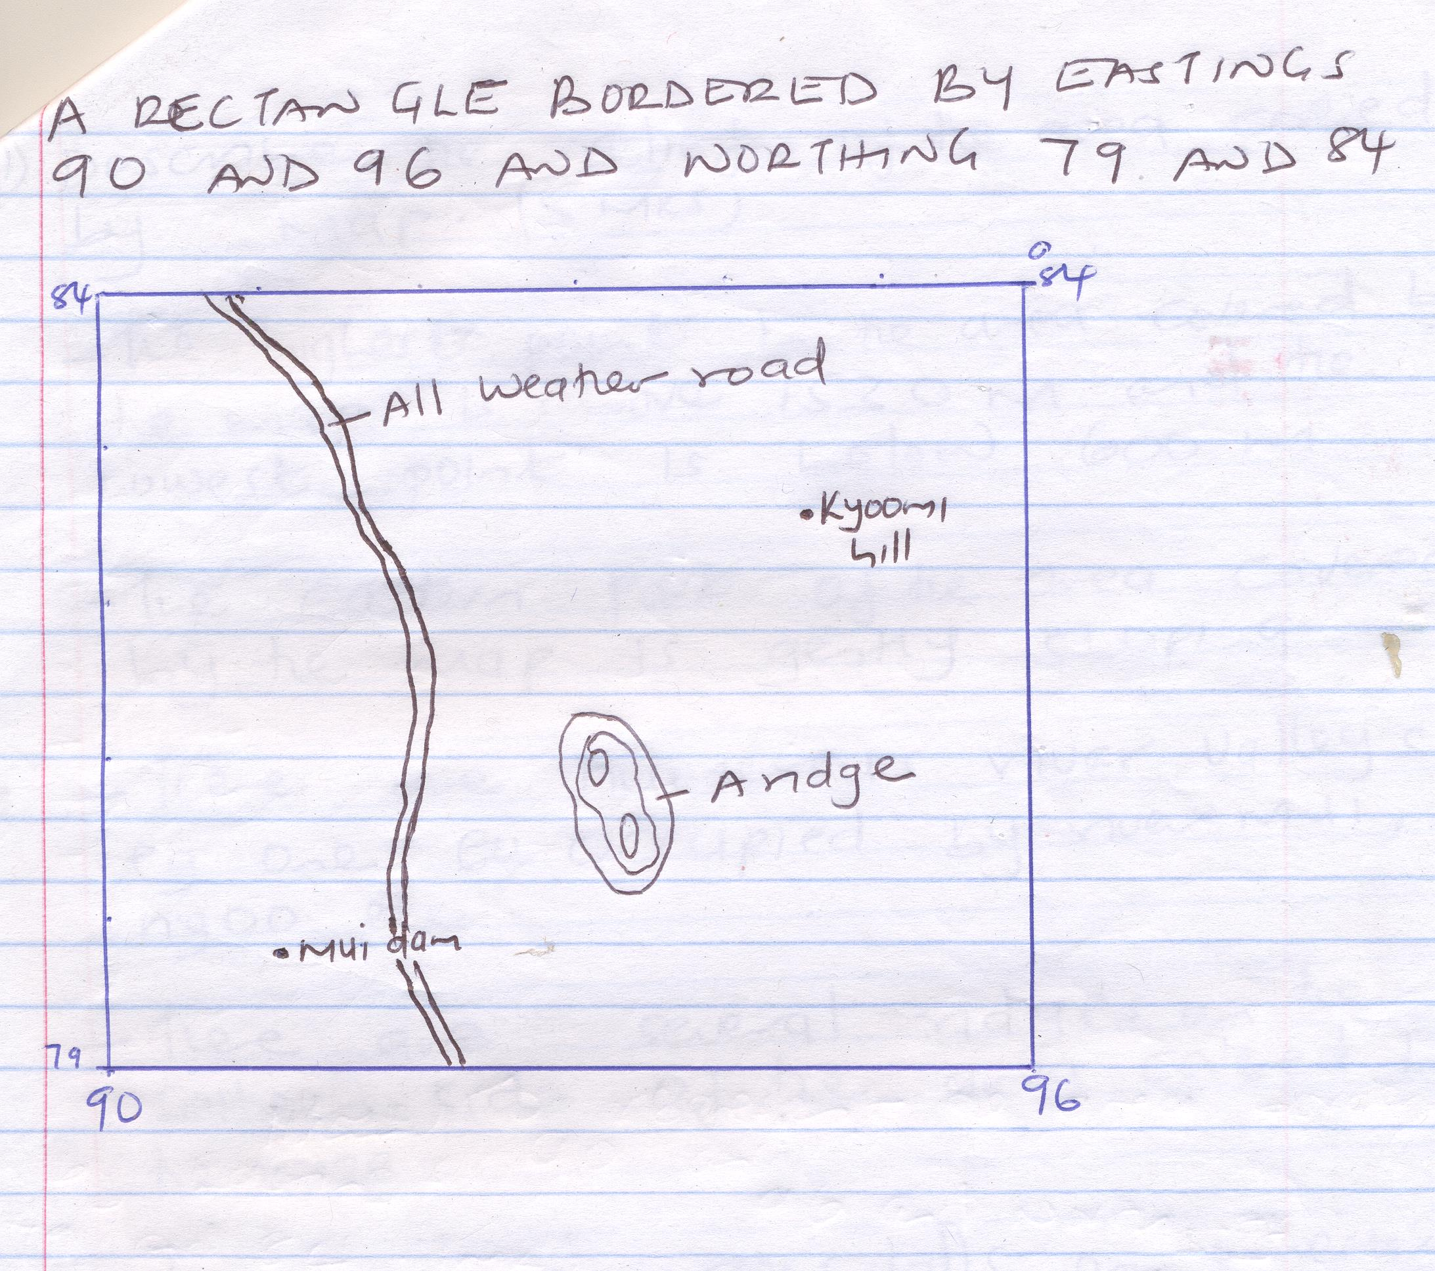
d) (i) Name three types of natural vegetation found in the area covered by the map
    - Scattered trees.
    - Scrubs.
    - Wood land.
    - Forest.
3x1=3mks

(ii) Describe the relief of the area covered by the map.
- The highest point in the area covered by the map is above 1530 m and lowest point is below 600m.
- The eastern part of the area covered by the map is gently sloping.
- There are numerous river valleys e.g. one occupied by river Muli, Ngoa e.t.c.
- There are several ridges on the southern side of the area covered by the map.
- There are numerous hills on the western side on the area covered by the map is steep.
6x1=6mks
(iii) Explain two physical factors that that lead to establishment of Mutito (Ndooa) trading centre.
    - Presence of gently sloping topography which made it easy for the construction of buildings and transport lines.
    - Availability of many permanent rivers e.g. Ikoo which provided water for domestic use.
2x1=2mks
- a) (i) Name two external layers of the earth.
  - Atmosphere.
  - Hydrosphere.
2x1=2mks
b) Describe the composition of:
(i) The crust.
    - It’s made up of sial and sima.
    - The sial is rich in silica and aluminum while sima is made up of silica and magnesium.
    - The rock in sial has a density of 2.7 g\cc. while sima has a density of 2.8 – 3.0 g\cc.
    - The sial is made up of granitic rocks while sima is made up of basaltic rocks.
    - The sial holds the continent while sima hold ocean. 3x1=3mks
(ii) The core.
    - It has a radius of about 3470 km.
    - Its divided into the outer core and inner core.
    - The temperatures range from 3700º-4500ºC.
    - The outer core is made up of hot molten materials while inner core is solid.
    - The dominant rock mineral in the outer core is iron and nickel while inner core is iron. 2x1=2mks
c) (i) Explain the origin of the earth according to the passing star theory.
    - It states that sun existed earlier than the planet.
    - A big star with greater gravitational pull than that of the sun, passing near the sun.
    - It attracted large quantity of materials from the sun; which were in form of gases.
    - The materials split into portions as they cooled and condensed to form planets.
    - The planets were set in orbit round the sun while smaller materials formed heavenly bodies like the moon and the asteroids. 4x1=4mks
(ii) State two weakness of passing star theory.
    - Chances of another star passing near the sun are minimal.
    - The materials that split from the sun would have dispersed rather than condense.
    - The forces that set in orbit could have now diminished. 2x1=2mks
d) (i) State three characteristics of sedimentary rocks.
    - They have fossils.
    - They are non-crystalline.
    - Made up of strata. 3x1=3mks
(ii) State three differences between plutonic and volcanic rocks.
PLUTONIC ROCKS | VOLCANIC ROCKS
They are formed when magma cools and solidifies deep below the surface. | They are formed when lava cools and solidifies on the surface of earth.
The rocks have large crystals. | The rocks have small crystals.
The rocks are coarse grained. | The rocks have fine grained.
The rocks are found deep beneath the surface. | The rocks are found on the surface of the earth.
3x1=3mks
(iii) Explain three processes through which rocks become metamorphic.)
- Dynamic metamorphism. It occurs when the weight of the overlying rock layer creates pressure on the lower layers. It leads to change in structure.
- Thermal \ contact metamorphic. During volcanic eruptions, hot magma may intrude into the layers of sedimentary rocks. The rock grains will re-crystalline due to heat to form new minerals.
- Thermal-Dynamic metamorphism.
- During the mountain building process sedimentary rocks are compressed and due to this pressure and heat is generated which modifies the structure of the original rocks. 3x2=6mks
- a) (i) What is faulting . (2 mks )
- This is the process through which brittle structural rocks fracture due to tectonic forces.
(ii) Give differences between normal and reverse fault. 2x1=2mks
Normal | Reverse
Formed when tension forces are subjected to crustal rocks . | Formed when compressional forces are subjected to crustal rocks .
One block of land slides downwards. | One block of land is pushed over .

b) (i) Apart from rift valley name two other features produced by faulting .
    - Fault step.
    - Fault block.
    - Tilt block fault scarp.
    - Fault scarp. 2x1=2mks
(ii) With aid of a well labeled diagram, explain how rift valley is formed through tension forces.
    - Layer of crustal rocks are subjected to tensional forces.
    - Lines of weakness occur due to formation of normal faults.
    - Continued tensional forces pull the side blocks apart resulting to the central subduing under the influence of gravity.
    - The trough that results is known as rift valley. 4x1=4mks drawing 3x1=3mks =7mks
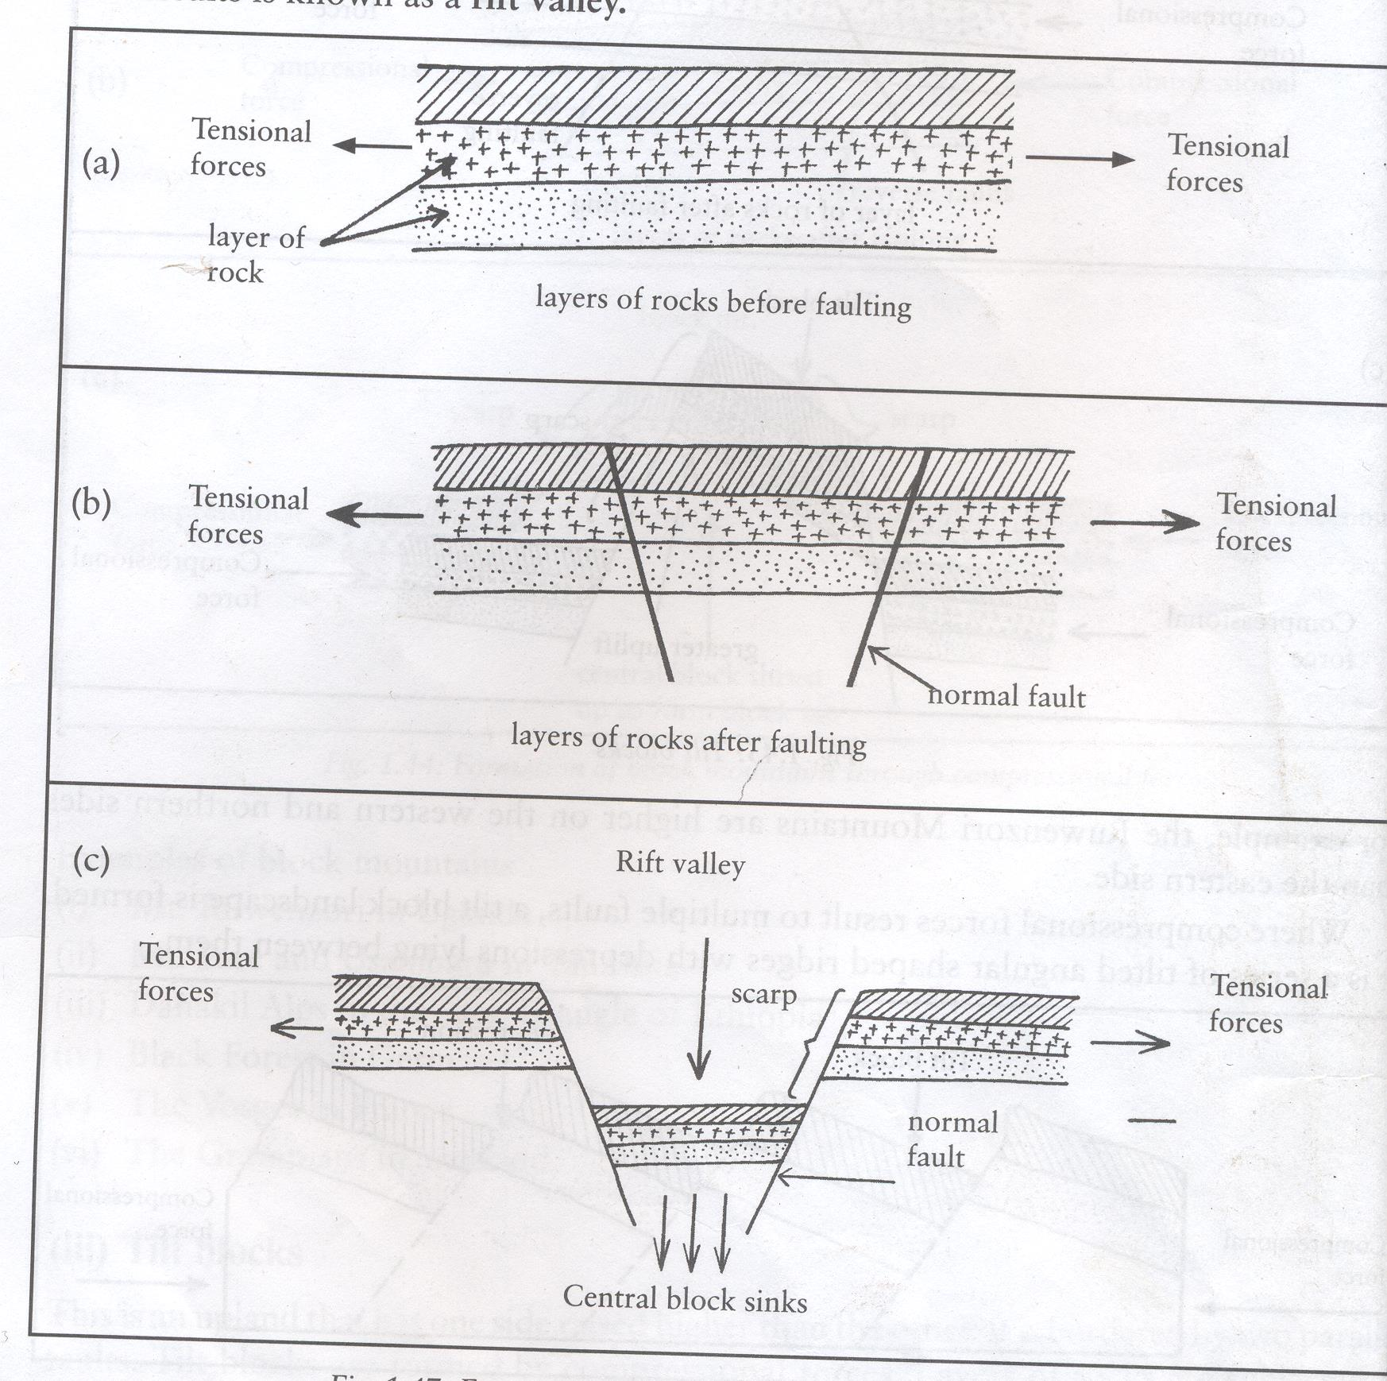
c) Explain three ways in which faulting influences drainage.
- Vertical faulting across a river valley leads to the forming of a waterfall.
- Rift faulting leads to formation of deep basins which may be occupied by under-ground water to form rift valley lakes.
- Faulting may create cracks on the rocks along which rivers may flow resulting to formation of fault guided drainage.
- When vertical faulting occurs across a river valley it may disappear into the fault.
- Tilting along a river valley may cause a river to reverse in direction of flow. 3x2=3mks
d) Your class carried out a field study along the rift valley.
(i) State two objectives of your field study
  - To identify features formed along the rift valley by faulting.
  - To investigate the economic importance of faulting to man.
  - To establish the relationship between features formed by faulting and man. 2x1=2mks
(ii) Give two sources of information that you would use in preparation for the study.
    - Written material / books / magazine / newspaper.
    - Photographs / films /video /slides.
    - Resource persons. 2x1=2mks
(iii)State two follow up activities.
  - Discussion in class.
  - Presentation in class.
  - Displaying photograghs.
  - Compiling the data. 2x1=2mks
- a) (i) What is hydrological cycle . (2 mks )
- This is the endless interchange of water the sea , the atmosphere and the land
(ii) Differentiate between infiltration and percolation
- Infiltration is the entry of water into the soil while percolation is the vertical and horizontal movement of infiltrated water by gravity. 2mks
(iii) State three significance of the hydrological cycle
    - It leads to formation of clouds in the atmosphere.
    - It leads to formation of rain which assists n agricultural production and vegetation growth.
    - It creates an ecological balance in the water supply between the atmosphere and the ground.
    - It unites the atmosphere and the earth crust.
    - It leads to distribution of water on the earth crust. 3x1=3mks
b) (i) Explain how rivers erode through the following processes
Abrasion process (2 mks)
- This is the wearing down of river channels by the load carried in the water.
Hydraulic action (2 mks)
- This is the direct action of river water in removing loose materials by hitting the bank and beds .When the water is forced into the cracks, it compresses the air in them creating pressure which widens the cracks.

(ii) State three factors that influence river transportation.
    - A fast-flowing river has more energy to transport more materials than slow moving river.
    - A small volume of water can only carry a small load while a large volume of water can carry a large load.
    - Very small and light particles can be transported over long distances while a heavy transported over long distances while a heavy load is transported over short distances due to friction. 3x1=3mks
c) With aid of well labeled diagrams describe how meanders are formed.
- When a river enters into the old stage, it flows at a slow rate due to reduced gradient.
    - When it meets obstacles it flows round them hence forming a bend.
    - Once a bend forms , the water tends to push hard on the outer-bank of the bend causing maximum
    - Eventually a bluff is formed on the outer side of the bend. Water comes to a standstill on the inner side of the bend causing the river to deposit alluvium there.
    - The bend grows bigger and more conspicuous to form a feature known as meander
3x1=3mks + drawings 3x1=3mks
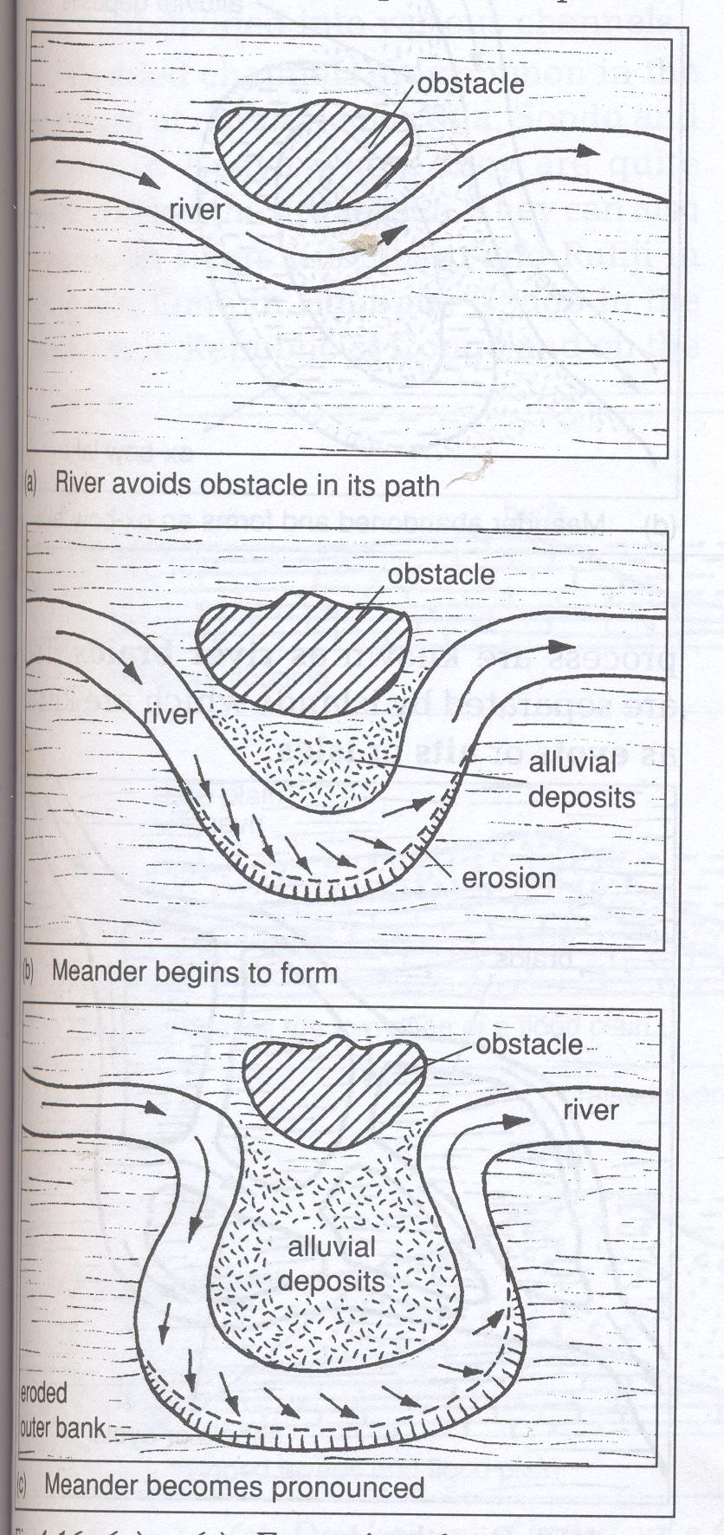
d) You intend to carry out a field study along lower course of a river.
(i)Give three reasons why you would conduct reconnaissance.
- To familiarize yourself with the area of study.
- To identify the problem you are likely to encounter.
- To introduce yourself to the authority. 3x1=3mks
(ii)State two problems you are likely to encounter during the study.
  - Inaccessibility of the area due to presence of a swampy area.
  - Attack by snakes and scorpions.
- Injuries as students fall from steep rock face. 2x1=2mks
- a) (i) Give three sources of underground water
    - Rain water.
    - Melt water.
    - Lake / sea water.
    - Magmatic water. 3x1=3mks
(ii) State three factors that influence the existence of underground water.
      - In filtration is greater on gentle sloping land than on steeply sloping topography that encourages surface runoff.
      - Light rainfall for a long period is able to infiltrate more than heavy rainfall falling for a short 3x1=3mks
b) i) Define the term spring(2 marks)
- A spring is a point or place where underground water flows out naturally onto the land surface
(ii) State three ways through which spring form.
    - When a permeable rock lies on top of an aquifer.
    - When well-jointed rocks forming a hilly region absorb water via this joints.
    - When a dyke cut across a layer of permeable rock and and water on the upper slope of the dye is impounded.
    - When the limestone rock lies over impermeable rocks on a scarp slope.
    - When gently sloping layers of permeable rocks alternate with layers of impermeable rock resulting in springs at a point where the permeable one is exposed to the surface.
    - When limestone rocks overly impermeable rocks. 3x1=3mks
c) (i) State four factors that influence the development of karst scenery .
  - The surface rock and the rock beneath should be thick lime stone dolomite or chalk.
  - The climate should be hot and humid to enhance climate weathering.
  - The water table in the limestone should e deep below the surface.
  - The rock should be hard and well-jointed. 4x1=4mks

(ii) Describe the formation of a stalagmite.
  - Rain water dissolves carbon dioxide as it passes through the air to form carbonic acid.
  - The rain water dissolves calcium carbonate as it percolates through limestone joints.
  - The solution in form of calcium hydrogen carbonate drips from the roof of the cave to the floor of the cave .
  - Some water and carbon dioxide are released from the calcium bicarbonate solution on the floor of the cave leaving behind deposits of calcium carbonate which grow upward from the floor to form finger like projections – called stalagmite. 4x1=4mks
(d) Explain three ways through which limestone landscapes influence human activities .
  - The surface and under-ground features attract tourists who in turn bring revenue / foreign exchange.
  - Limestone landscapes discourage settlement due to their rugged nature and thin soils.
  - Limestone rocks are used as building materials and for cement manufacture .
  - Limestone areas have thin soils that are suitable for grazing. 3x2=6mks

