NAME: ………………………………………………………CLASS:……………………………

INDEX NO:……………………………….

312/1
GEOGRAPHY
PAPER 1
TIME: 2 ¾ HOURS

FORM 4

INSTRUCTIONS:

- The paper comprises of 2 sections A and B.
- Attempt all question in section A.
- In section B, answer question 6 and choose any other two questions.
- Use separate answer sheets for section A and each question in section B.

This paper consists of 4 printed pages. Candidates should check the question paper to ensure that all pages are printed as indicated and no questions are missing.

SECTION A
Answer all questions in this section
1. a) Identify Two forces responsible for the spherical shape of the earth. (2 marks)
b) Give Three reasons why the interior of the earth is still hot. (3 marks)
2. a) Outline Two characteristics of the troposphere. (3 marks)
b) Apart from cloud cover, identify Two other factors which influence the amount of solar radiation received on the earth's surface. (2 marks)
3. a) What is river rejuvenation. (2 marks)
b) The diagram below represents a river capture,

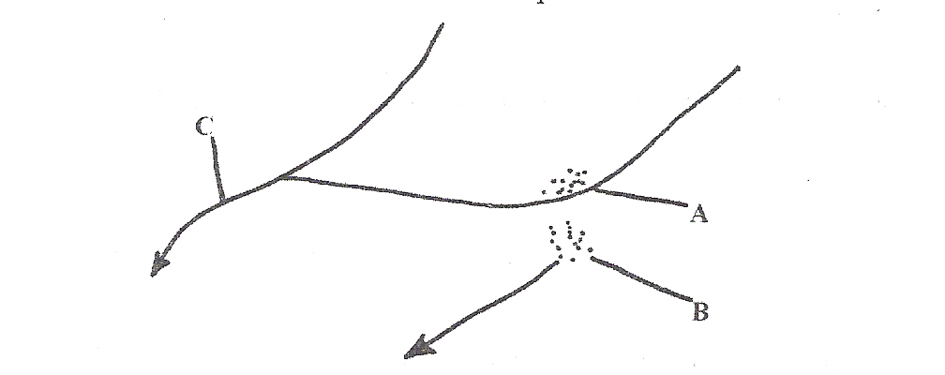

Name the features marked A, B, C. (3 marks)
4. a) Name a place in Kenya where tarns are found. (1 mark)
b) Describe how a tarn is formed. (4 marks)
5. (a) Give two main zones of the atmosphere. (2 marks)
(b) What is?
(i) Zero lapse rate. (2 marks)
(ii) Negative lapse rate. (2 marks)

SECTION B:
Answer question 6 any other two questions from this section.
6. Study the map of Migwani 1:50,000 (sheet 151/1) provided and answer the following questions.
(a) (i) What is the altitude of the lowest contour shown on the map? (1 mark)
Give the six-figure grid reference of Mboni dam. (2 marks)
(iii) What is the length in Kilometres of the All Weather Road Bound Surface C94 from
the junction with the Dry Weather Road D502 to Northing 84? (2 marks)

b) Draw a rectangle measuring 10 cm by 8 cm to represent the area enclosed by Eastings 90 and 00 and Northings 62 and 70. (1 mark)
On the rectangle, mark and name the following features:
- Musengo school
(ii) Road E742
(iii) Kitui Hills (3 marks)
(c) (i) Citing evidence from the map, identify four social services offered in Mutitu (Ndooa) township. (4 marks)
(ii) Describe the relief of the area covered by the map. (6 marks)
(d) Describe the characteristics of the long profile of river Ikoo. (6 marks)
7. a) State three characteristics of the inter-tropical convergence zone (ITCZ). (3 marks)
b) With the aid of a well labeled diagram describe how relief rainfall is formed. (6 marks)
c) State five characteristics of the hot desert climate. (5 marks)
d) You are required to carry out a field study to determine the relationship between climate and
vegetation in your district.
i) Give three reasons why you would need the map of the district. (3 marks)
ii) Name two sampling techniques you are likely to use during the field study. (2 marks)
iii) Give two reasons why sampling would be appropriate for this field study. (2 marks)
iv) State four methods you would use to record data during the field study. (4 marks)
8. a) (i) What is a lake? (2 marks)
(ii) State three factors that determine the permanency of a lake. (3 marks)
b) Describe how Lake Kanyaboli was formed. (6 marks)
c) Explain four causes of salinity of lake Magadi. (8 marks)
d) Explain three negative effects of lakes on human activities. (6 marks)
9. (a) State four causes of mechanical weathering. (4 marks)
(b) (i) Describe the carbonation process of chemical weathering. (3 marks)
(ii) Name two rocks that can be weathered through the carbonation process. (2 marks)
(iii) Name two features that can be formed on the earth's surface as the carbonation process of
weathering takes place. 2 marks)
(c) (i) What is an exfoliation dome? (1 mark)
(ii) Describe how an exfoliation dome is formed. (3 marks)
(d) Explain three ways in which weathering positively influence man's activities and two negative
effects of weathering. (10 marks)

10. (a) What is the difference between faulting and folding? (2 marks)
(b)Name
(i) Two types of faults. (2 marks)
(ii) Three types of folds. (3 marks)
On the outline map of Africa provided name the fold mountains marked X,Y, Z (3 marks)
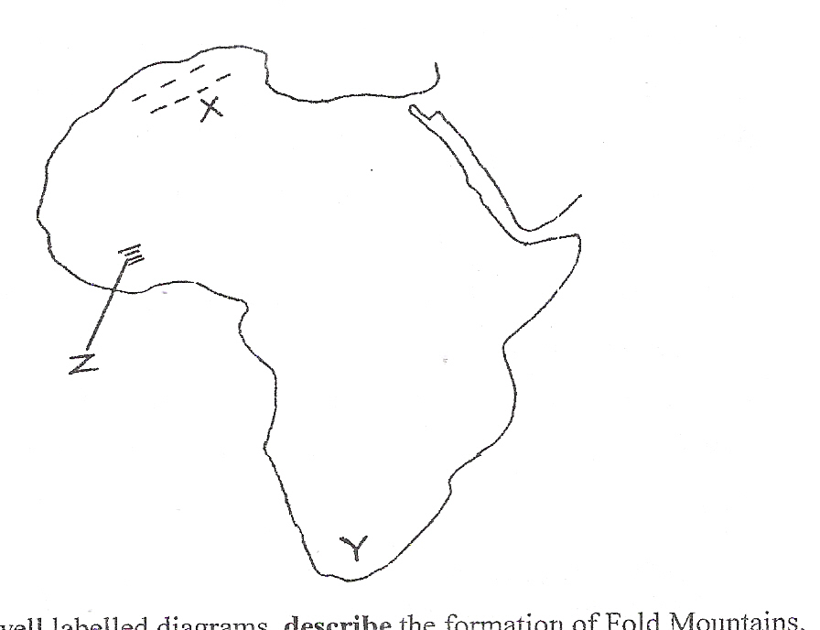

(c) With the aid of well labeled diagrams, describe the formation of Fold Mountains. (10 marks)
(d) (i) What is the name given to the period of mountain building? (1 mark)
(ii) Identify four main mountain buildings periods ever known in history. (4 marks)

312/1 GEOGRAPHY PAPER 1 MARKING SCHEME
1. a) Forces responsible for the spherical shape of the earth.
- Force of gravity
- Centrifugal force (2x1= 2mks)
b) Reasons why the interior of the earth is still hot
- Pressure exerted by overlying rock masses
- Radio - active decay
- Heat retained during formation of the earth (3x1= 3mks)
2. a) Characteristics of the troposphere
- Temperature decreases with height
- Has high amount of water vapour, solid particles
- Speed of wind increases with height (3x1= 3mks)
b) Factors influencing the amount of sunshine received on the earth's surface.
- Length of day
- Scattering of dust particles
- Absorption by humidity (2x 1 = 2mks)
3. a) River Rejuvenation is the renewal of the erosive activity of a river.
b) A -An elbow of capture (1mk)
B -Wind gap (1mk)
C - Pirate River / stream (1mk)
4. a) Tarns are found on Mt. Kenya. (1mk)
b) - Snow accumulation in a shallow pre-existing hollow on a mountain side.
- Snow gets compacted into the ice to form a cirque glacier.
- Accumulated ice erodes the hollow making it deep and wide.
- Eventually a deep arm-chair shaped depression called a corrie is formed.
- The depression is filled with melt water/rain water to form a lake called tarn. (4xl=4mks)
5.a) Main zones of the atmosphere.
- Troposphere
- Stratosphere . '
- Mesosphere - Thermosphere/ionosphere (2xl=2mks)
b) Meaning of:-
(i) Zero lapse rate is a situation where there is no change in temperature with increase in height or altitude.
ii) Negative lapse rate is a situation in the atmosphere where there is increase in temperature with increase
in altitude. (2mks)

SECTION B
Answer question 6 and any other TWO questions from this section.
6. Study the map of Migwani 1:50,000 (sheet 151/1) provided and answer the following questions.
(a) (i) What is the altitude of the lowest contour shown on the map?
660m (1 mark)
(ii) Give the six-figure grid reference of Mboni dam. (2 marks)
073784
(iii) What is the length in Kilometres of the All Weather Road Bound Surface C94 from the
junction with the Dry Weather Road D502 to Northing 84?
5.6km (2 marks)
Draw a rectangle measuring 10 cm by 8 cm to represent the area enclosed by Eastings 90 and 00
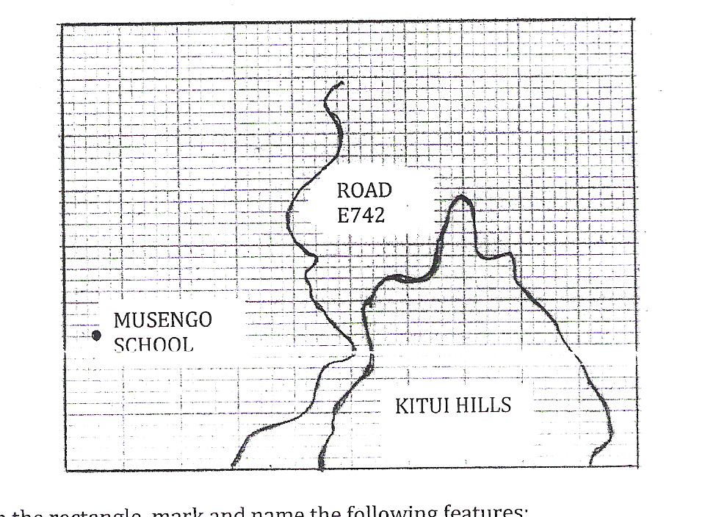
and Northings 62 and 70. (1 mark)

On the rectangle, mark and name the following features:
(i) Musengo school
(ii) Road E742
(iii) Kitui Hills (3 marks)
(c) (i) Citing evidence from the map, identify/our social services offered in Mutitu (Ndooa) township. (4 marks)
Services | Evidence
- Health/medical services  - Administration services  - Water supply services  - Education services  - Housing services | - Health centre  - Court house/Chief's office  - Pipeline/water tank  - School  - Built up area/huts

(ii) Describe the relief of the area covered by the map. (6 marks]
- The lowest altitude is 660m/ the highest altitude is 1515m above
- sea level.
- The land rises from the East to the West
- To the east of Easting 08, the landscape is generally hilly/has many hills.
- There are many interlocking spurs along river valleys
- There are some abroad valleys in the South East,
- The landscape is dissected by river valleys,
- There are many narrow river valleys in the highlands.
- The land is gently sloping in the east
- There are steep slopes in the hilly areas/ to the West.
- Some areas in the east are flat.
- There are ridges in the central and South Western part.
(d) Describe the characteristics of the long profile of river Ikoo. (6 marks)
- River Ikoo flows to the South East.
- The river has many meanders .
- The river becomes wider from grid square 0769.
- There are interlocking spurs along the course of the river.
- The river has many small tributaries that form a dendritic pattern along the course.
- Some parts of the long profile have a steep gradient.
- There are sand/mud deposits downstream
7. a)
- It is a zone of low atmospheric pressure (doldrums)
- It is a zone within the tropics/between 23 ^{l}/2 ° N and 23 Vz ° S.
- It is a zone where South - East and North -East trade winds converge.
- It migrates to the North and to the South of the equator with the apparent movement of the overhead sun.
- It is associated with conventional rain and thunderstorms.
- It is characterized by high temperature. (3xl=3mks)
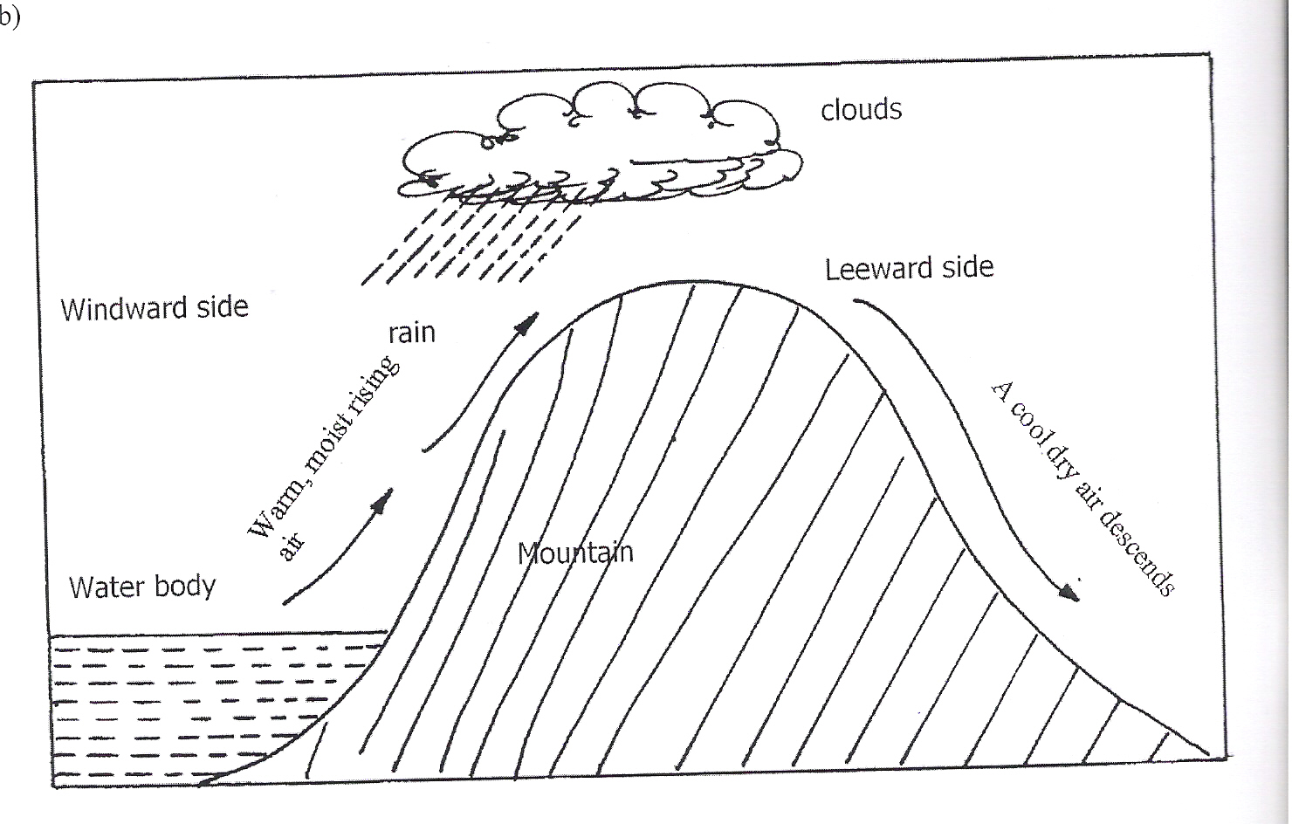

- A water body/sea/Lake is heated causing evaporation of water.
- Moist air from the sea is forced to ascend up a hill/mountain side.
- Forced ascend leads to expansion and cooling of air.
- The moisture in the air condenses forming clouds.
- Rain falls mainly on the wind ward side of the hill/mountain.
- Descending air are dry and cause dry condition on the leeward side of the mountain/hill
with little or no rain.
Diagram - 3mks Explanation - 3mks Total 6mks
c)- Low annual rainfall/less than 250 mm p.a/dry climates.
- Occasional flash floods/sporadic rains
- Clear sunny days/high terrestrial radiation.
- High temperatures during the day/relatively low temperatures during the night/a large diurnal range of temperatures.
- Strong winds
- Low pressure in summer/high pressure in winter.
- High mean annual temperature/hot climate 27° C or more.
- Large mean annual range of temperature.
- Rainfall is unreliable /erratic
- Low humidity throughout the year.
- High evaporation rates. (5xl=5mks)

d)i)
- To show the extent of the area/size of the district.
- Show the routes to be followed during the field study/identify obstacles.
- To show the distribution of vegetation in the district.
- To show the variation in the elements of climate within the district.
- To show the distribution of relief features in the district.
- To help in estimating distances to be covered during the study.
- To estimate the time required for the study.
- To be able to plan for a work schedule.
- To decide on techniques of data collection. (3xl=3mks)
ii)
- Random sampling
- Stratified sampling
- Systematic sampling (2xl=2mks)
iii)
- It would save time.
- It would be less expensive.
- It would focus on relevant areas
- It allows for detailed study.
- A district is too large to be covered as a whole.
- Vegetation grows randomly
- It reduces bias (biasness) (2xl=2mks)
iv
- Field sketching/drawing sketch maps
- Taking photographs.
- Note taking, filling in questionnaires.
- Labeling of samples
- Tabulating/tabulation/drawing tables
- Tape recording
- Tallying
(4x1 = 4mks)
8. a) (i) What is a lake?
- A large body or accumulation of water contained in a large depression / basin/ hollow on the
earth's surface. (2mrks)

(ii) State two factors that determine the permanency of a lake.
-The depth of the lake
-The amount of incoming water."
- The loss of water through evaporation, Outflow and seepage through the rocks.
(2x1= 2mrks)
b) Describe how lake Kanyaboli was formed.
- At old stage, a river develops pronounced meanders.
- Undercutting is more on the outer bank while deposition is active on the outer bank.
- More undercutting on the outer bank deepens it.
- The increased deposition on the inner bank make the meander loop narrow.
- The river eventually cuts through the rock while deposition at the mouth of the meander cut off seals it.
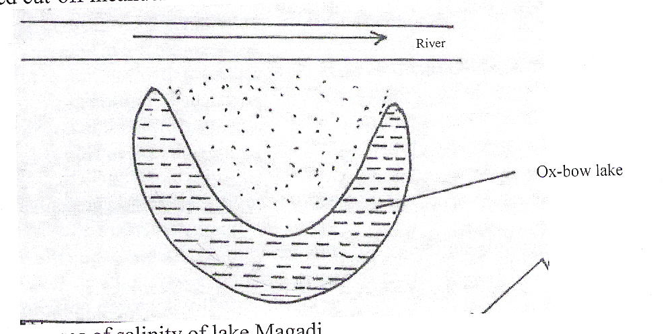
- The abandoned cut-off meander channel is called an ox-bow lake if it has water. (6mrk)

c) Explain four causes of salinity of lake Magadi.
- The lake lack an outlet to the sea thus mineral salts accumulate in its water.
- The presence of salt bearing rocks on the lake bed leads to mineral salt dissolving in the water in the lake.
- The high temperature in the area leads to high evaporation rate from the lake resulting to high concentration of mineral salts in the lake.
- Underground seepage of water that is rich in mineral salts results into lake being saline.
- Mineral salts are deposited into the lake by surface run-off thus increasing concentration of salts in the lake
(4x2 = (8mrks)
d) Explain three negative effects of lakes on human activities.
- During rainy seasons, some lakes swell thus flooding the surrounding areas leading to loss of lives and destruction to property.
- Some lakes are bleeding grounds for pest and diseases vectors which cause human diseases to people living nearby.
- Same lakes are not used for irrigation, domestic and industrial purposes.
- Large lakes cause barriers to land transport. (3x2 =6mrks)
9. (a) causes of mechanical weathering
-changes in temperature
-effect of rain water
-freeze and thaw action of ice
-crystal growth (4xl=4mks)
(b) (i) carbonation process of chemical weathering
-rain water mixes with carbon dioxide in the atmosphere to form a weak carbonic acid
-weak carbonic acid reacts with limestone and chalk carbonates to form calcium bicarbonate
-the calcium bicarbonate is removed in solution form from the rock through the joints causing the rock to disintegrate (3xl=3mks)
(ii)-limestone rock -chalk rock
(iii) Earth's surface features formed due to carbonation process
-grikes -dints -uvalas -poljes (2x 1 =2mks)
(c) (i) an exfoliation dome is a rounded- off mass of rock left behind after peeling-off of outer layer due to temperature changes Imk
(ii) How an exfoliation dome is formed
-high temperature heat outer surface layer of rock during the day in hot and arid areas. Outer layer expands at a faster rate than the inner layers. -low temperatures during the night cause outer layer to contract at a more than the inner layer due to cooling -repeated expansion and contraction cause stress within outer layer of the rock mass causing it to peel off as curved shells (3x1=3mks)
(d) Ways in which weathering positively influence mans activity
-formation of fertile soils for mans agriculture
-minerals - broken small rocks particles may contain valuable minerals such as iron ore, manganese and nikel which can be exported for foreign exchange
-tourism, tors exfoliation domes, inselbergs attract tourists who in turn creates employment
-pottery, brick making industries use clay and bauxite produced by weathering
- Building and construction materials such as rocks and sand are more accessible where weathering has taken place.
-quarring and mining made easier for man by weathering (3x2=6mks) Negative effects of weathering
-destruction of landforms formed by faulting, folding and vulcanicity
-speeding up the process of erosion in which the landscape is worn out
-weathered landscape is unsuitable for man's activities such as agriculture and transport where features such as grikes and dints, poljes and uvalas may be formed (2x2=4mks)

10. (a) Faulting and folding
Faulting is the fracturing or cracking of rocks in the crust due to tectonic forces while folding is the distortion or crustal crumbling or bending of rocks within the crust either upwards or down wards (2mks)
(b)(i) Types of faults.
- Normal faults
- Reverse faults
- Shear / tear faults
- Thrust faults
- Anticlinal faults (2x1= 2mks)
(ii) Types of folds.
- Simple symmetrical folds
- Asymmetrical folds
- Overfolds
- Isoclinal folds
- Recumbent folds
- Nappe or overthrust folds
- Anticlinorium and synclinorium complex
Fold mountains marked X,Y, Z
X - Atlas mountains
Y - Cape ranges
Z - Akwapim hills (3xl=3mks)
(c) Formation of Fold Mountains.
- An extensive depression called geosycline formed on the surface of the earth
- It became filled with water, forming a sea
- The surrounding land masses were intensively eroded.
- The resultant sediments were deposited in the geosycline in layers
- Their accumulation caused the geosycline to subside even further.
- As more sediments were added the geosycline became thicker forming layers
- The sediments were later subjected to compressional forces which caused
- continued subsidence of geosycline drawing the land mass together.
- The compressional forces could have been triggered off by convectional
- currents in the mantle which pulled the continental crusts towards the geosycline.
- The layers of sediments in the geosycline then folded, building upwards to form mountains.
- The main mountain features developed the continental edges of the geosycline because
these forces are closer to the origin of the forces (10xl=10mks)
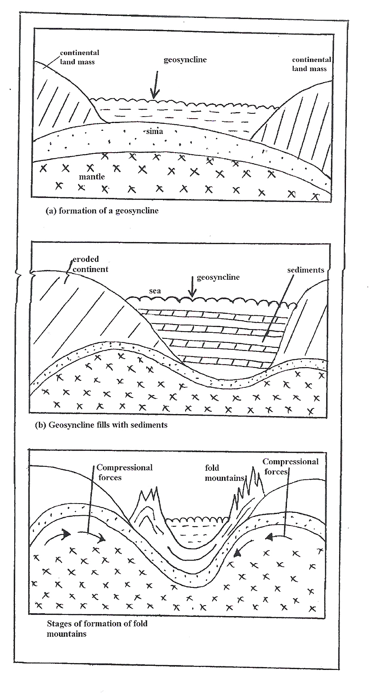

d (i) Period of mountain building
- Orogeny
ii) Main mountain buildings periods ever known in history
- Charnian orogeny
- Caledonian orogeny
- Herynian orogeny

